Unit 8: Instructor Graded Assignment - Version 3

Business Graphs

Unit 8 focus on business graphs, which is covered in your reading of Chapter 7: “Business Statistics.”

Note: In this Assignment you will have both Assignment problems and an essay component.

For this Assignment you will write an essay to address the requirements described below. Your essay must be carefully planned and written using well-constructed sentences and paragraphs. Make sure that your grammar and spelling are correct. Points will be awarded for content as well as composition. Your essay must be a minimum of 1 half of a full page in length, with standard 1 inch margins and is required to have at least one reference from a reliable source. This means that you cannot use sites like Wikipedia, Ask.com®, and Yahoo® answers and that only references from reliable sources will earn points. All resources should be cited both as an in-text citation as well as being listed on a reference page in APA format.

Assignments must be submitted as a Microsoft® Word® document and uploaded to the Dropbox for Unit 8. Include your essay directly in this document following the instructions.
All Assignments are due by Tuesday at 11:59 p.m. ET of the assigned unit.

Essay Assignment (40 points)
Question 1: (10 Points)

- Create a bar graph or line graph for the following data including labels:
Fast Printing Company sales for one week, beginning February 2:
$9,700
$7,900
$5,809
$5,876
$5,820
$3,769
$3,900

- Create a circle graph with the following data including labels:
Food expenses $400
Gasoline $200
Child’s Tuition $50
Rent $750
Medicine $50
Car Payment $250
Auto Insurance $150
Health care $150
Total $2,000

Question 2: (10 Points)

The following graph represents the percentage of each fruit I prefer.
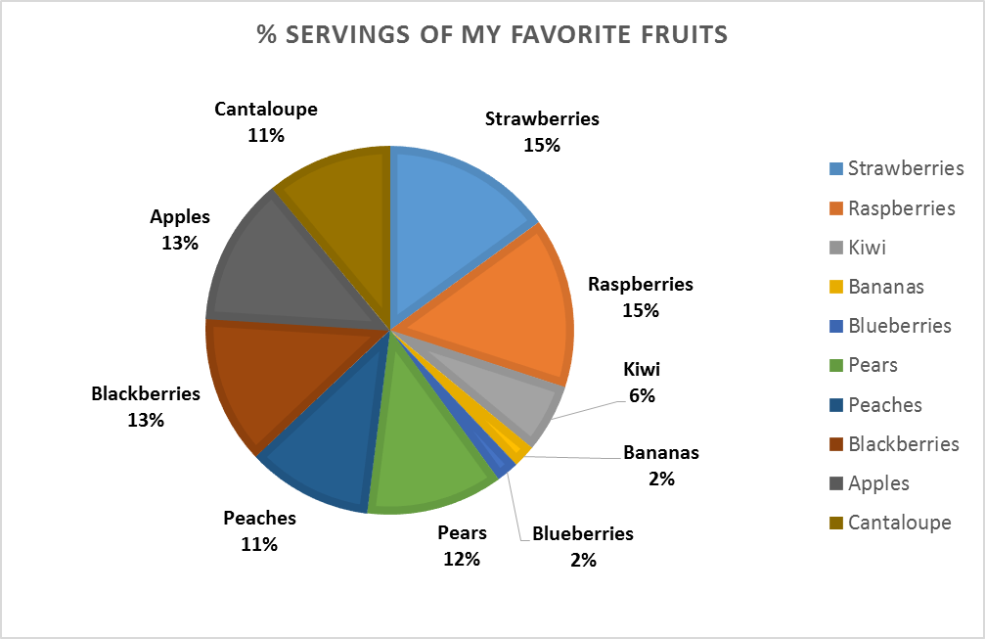

If I eat 1,300 pieces of fruit per year, based on my serving preference, how many of each types of fruit will I consume next year?

Question 3: (20 Points)
Search the internet for a line, circle, or bar graph that either misrepresents the information being portrayed, is confusing, or doesn’t do a good job representing the information. Copy and paste the graph below. Do not use graphs from other schools or college sites like Khan Academy, but rather find a graph used in a news article, finance article, whitepaper, or other story.

Explain in a well-constructed essay why you chose the graph, what the graph’s shortcomings are, and how you would suggest fixing it. Be sure to cite the graph’s source, title, legend, labels, colors chosen, axis labels, and general layout.

Your essay should be complete and cover each point as outlined above. Be sure to include at least one text citation.

You may submit your Assignment to the Math Center for review. Tutors will not grade or correct the Assignment, but they will provide guidance for improvement. In addition, tutors will not help you find websites for the Assignment. Be sure to submit Assignments early enough to receive feedback and make corrections before the Assignment due date (24 hour turn-around times Monday-Thursday and 48 hour turn-around times on weekends are typical). Email Assignments to: kumc@kaplan.edu. Please put “MM255 Assignment Review” in the subject line of the message.

