IT 505 Network Diagram

This is an illustration of the network configuration for the organization. Use this diagram for Milestone Two and the Final Project.

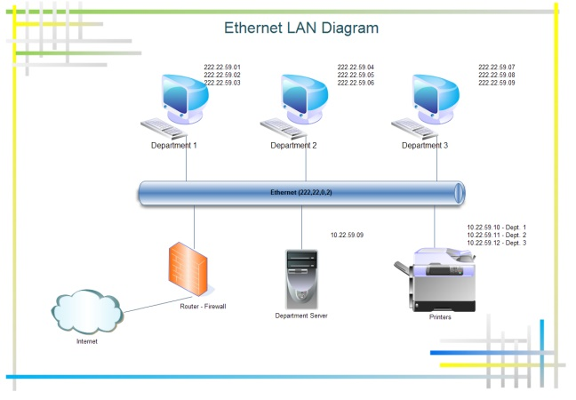

Source: http://www.edrawsoft.com/templates/images/ethernet-lan-diagram.png

