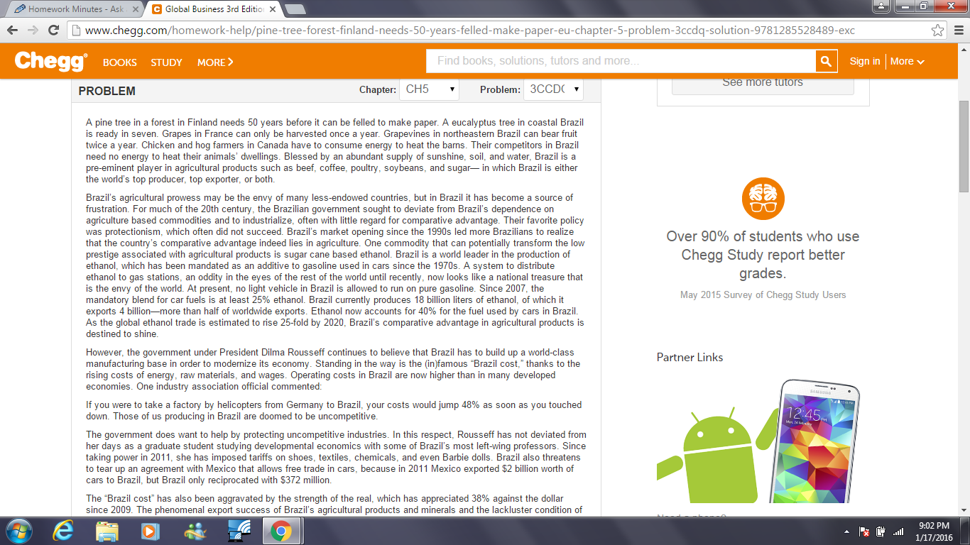

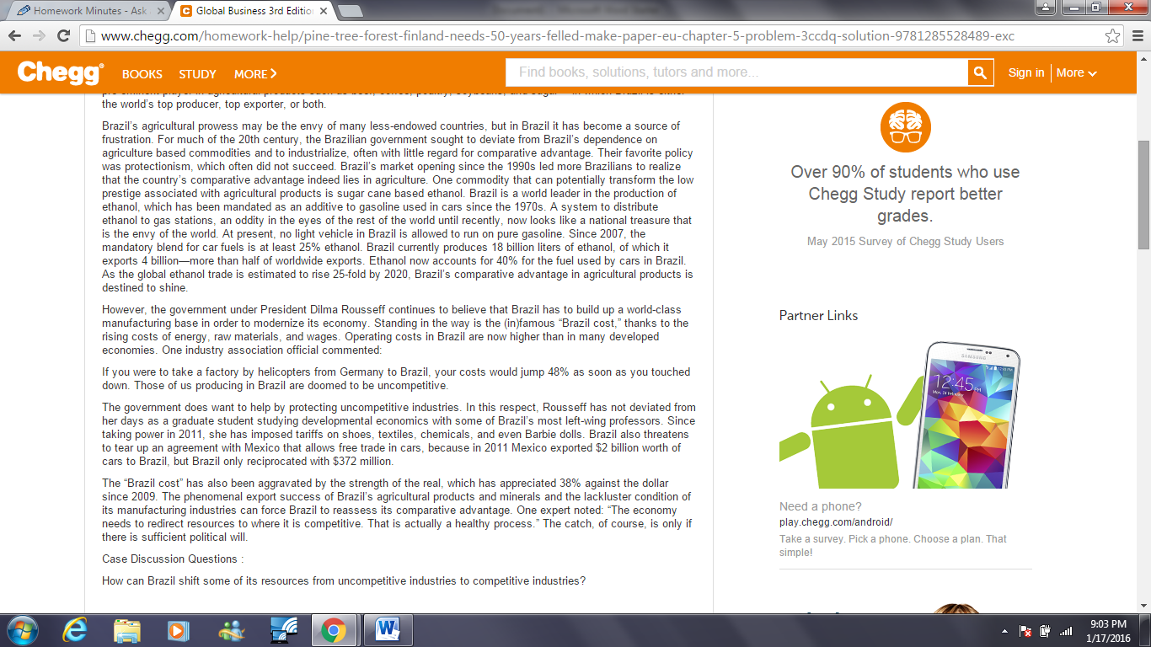

QUESTIONS:
- WHAT IS BRAZIL’S AGRICULTURE SO COMPETITIVE? WHY DO ITS MANUFACTURING INDUSTRIES LACK COMPETITIVENESS?
- WHY HAVE BRAZIL’S GOVERNMENTS IN BOTH THE 20TH AND 21ST CENTURY BEEN EAGER TO DEVELOP WORLD-CLASS MANUFACTURING?
- HOW CAN BRAZIL SHIFT SOME OF ITS RESOURCES FROM UNCOMPETITIVE INDUSTRIES TO COMPETITIVE INDUSTRIES?
- ON ETHICS: WHILE PRESIDENT ROUSSEFF’S CRITICS ACCUSE HER OF IGNORING BRAZIL’S LACK OF COMPARATIVE ADVANTAGE IN MANUFACTURING, HER SUPPORTERS ARGUE THAT HER POLICIES FORCE BRAZIL TO REDUCE ITS DEPENDENCE ON FOREIGN-MADE MANUFACTURING GOODS. IF YOU WERE TO PARTICIPATE IN THIS DEBATE, WHICH SIDE WOULD YOU BE ON?

