Section 10.1 - numbers 18, 2, 35 a-c
In Problems 15–22, (a) determine the null and alternative hypotheses, (b) explain what it would mean to make a Type I error, and (c) explain what it would mean to make a Type II error.
18. Fair Packaging and Labeling Federal law requires that a jar of peanut butter that is labeled as containing 32 ounces must contain at least 32 ounces. A consumer advocate feels that a certain peanut butter manufacturer is shorting customers by underfilling the jars.
VOCABULARY AND SKILL BUILDING:
___________ ______ is a procedure, based on sample evidence and probability, used to test statements regarding a characteristic of one or more populations.
APPLYING THE CONCEPTS:
35. Popcorn Consumption According to popcorn.org, the mean consumption of popcorn annually by Americans is 54 quarts. The marketing division of popcorn.org unleashes an aggressive campaign designed to get Americans to consume even more popcorn.
(a) Determine the null and alternative hypotheses that would be used to test the effectiveness of the marketing campaign.
(b) A sample of 800 Americans provides enough evidence to conclude that the marketing campaign was effective. Provide a statement that should be put out by the marketing department.
(c) Suppose, in fact, that the mean annual consumption of popcorn after the marketing campaign is 53.4 quarts. Has a Type I or Type II error been made by the marketing department? If they tested the hypothesis at the α = 0.05 level of significance, what is the probability of making a Type I error?
Section 10.3 - numbers 10a, 11
SKILL BUILDING:
10. To test H0: μ = 45 versus H1: μ ≠ 45, a simple random sample of size n = 40 is obtained.
(a) Does the population have to be normally distributed to test this hypothesis by using the methods presented in this section? Why?
APPLYING THE CONCEPTS:
11. You Explain It! ATM Withdrawals According to the Crown ATM Network, the mean ATM withdrawal is $67. PayEase, Inc., manufacturers an ATM that allows one to pay bills (electric, water, parking tickets, and so on), as well as withdraw money. A review of 40 withdrawals shows the mean withdrawal is $73 from a PayEase ATM machine. Do people withdraw more money from a PayEase ATM machine?

(a) Determine the appropriate null and alternative hypotheses to answer the question.
(b) Suppose the P-value for this test is 0.02. Explain what this value represents.
(c) Write a conclusion for this hypothesis test assuming an α = 0.05 level of significance.
Section 4.1 - numbers 10, 14, 24
In Problems 9–12, determine whether the scatter diagram indicates that a linear relation may exist between the two variables. If the relation is linear, determine whether it indicates a positive or negative association between the variables.
10.
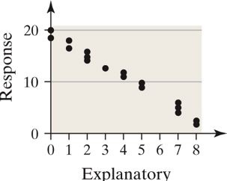
14. Match the linear correlation coefficient to the scatter diagram. The scales on the x- and y-axes are the same for each diagram.
(a) r = −0.969
(b) r = −0.049
(c) r = −1
(d) r = −0.992
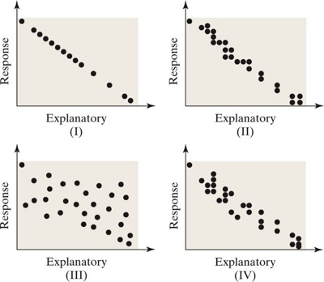

APPLYING THE CONCEPTS:
24. The TIMMS Exam Part II (See Problem 23) For the 41 nations that participated in TIMMS, the correlation between the percentage of students who skipped class at least once in the past month and the mean score on the exam was −0.52. Does this suggest there is a linear relation between attendance and achievement score? Write a sentence that explains what this result might mean.

