Week 4: Chapter 6 and 7 Problems
In Problems 5–8, determine whether the random variable is discrete or continuous. In each case, state the possible values of the random variable.
Section 6.1 - numbers 8, 12, 16, 20a, c-e,
8. (a) The number of defects in a roll of carpet.
(b) The distance a baseball travels in the air after being hit.
(c) The number of points scored during a basketball game.
(d) The square footage of a house.
In Problems 9–14, determine whether the distribution is a discrete probability distribution. If not, state why.
12. x p(x)
1 0
2 0
3 0
4 0
5 1
In Problems 15 and 16, determine the required value of the missing probability to make the distribution a discrete probability distribution.
16. x p(x)
3 0.4
4 ?
5 0.1
6 0.2
20. Waiting in Line A Wendy’s manager performed a study to determine a probability distribution for the number of people, X, waiting in line during lunch. The results were as follows:
(a) Verify that this is a discrete probability distribution.
(c) Compute and interpret the mean of the random variable X.
(d) Compute the standard deviation of the random variable X.
(e) What is the probability that eight people are waiting in line for lunch?
Section 6.2 - numbers 10, 36
In Problems 7–16, determine which of the following probability experiments represents a binomial experiment. If the probability experiment is not a binomial experiment, state why.
10. A poll of 1200 registered voters is conducted in which the respondents are asked whether they believe Congress should reform Social Security.
APPLYING THE CONCEPTS:
36. Smokers According to the American Lung Association, 90% of adult smokers started smoking before turning 21 years old. Ten smokers 21 years old or older are randomly selected, and the number of smokers who started smoking before 21 is recorded.
(a) Explain why this is a binomial experiment.
(b) Find and interpret the probability that exactly 8 of them started smoking before 21 years of age.
(c) Find and interpret the probability that fewer than 8 of them started smoking before 21 years of age.
(d) Find and interpret the probability that at least 8 of them started smoking before 21 years of age.
(e) Find and interpret the probability that between 7 and 9 of them, inclusive, started smoking before 21 years of age.
In Problems 25–28, the graph of a normal curve is given. Use the graph to identify the values of μ and σ.
Section 7.1 - numbers 26, 36
26.
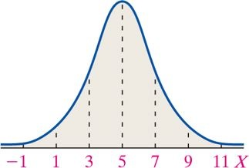
36. You Explain It! Miles per Gallon Elena conducts an experiment in which she fills up the gas tank on her Toyota Camry 40 times and records the miles per gallon for each fillup. A histogram of the miles per gallon indicates that a normal distribution with a mean of 24.6 miles per gallon and a standard deviation of 3.2 miles per gallon could be used to model the gas mileage for her car.
(a) The figure represents the normal curve with μ = 24.6 miles per gallon and σ = 3.2 miles per gallon. The area under the curve to the right of x = 26 is 0.3309. Provide two interpretations of this area.
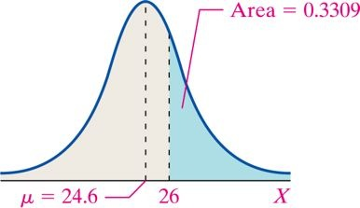
(b) The figure at the top of the next column represents the normal curve with μ = 24.6 miles per gallon and σ = 3.2 miles per gallon. The area under the curve between x = 18 and x = 21 is 0.1107. Provide two interpretations of this area.
Section 7.2 - numbers 20, 24, 28, 34
In Problems 19–22, find the value of zα.
20. z 0.02
In Problems 23–32, assume that the random variable X is normally distributed, with mean μ = 50 and standard deviation σ = 7. Compute the following probabilities. Be sure to draw a normal curve with the area corresponding to the probability shaded.
24. P(X > 65)
28. P(56 < X < 68)
In Problems 33–36, assume that the random variable X is normally distributed, with mean μ = 50 and standard deviation σ = 7. Find each indicated percentile for X.
34. The 90th percentile
APPLYING THE CONCEPTS:
Section 7.4 - numbers 22, 28
22. Smokers According to Information Please Almanac, 80% of adult smokers started smoking before they were 18 years old. Suppose 100 smokers 18 years old or older are randomly selected. Use the normal approximation to the binomial to

(a) approximate the probability that exactly 80 of them started smoking before they were 18 years old.
(b) approximate the probability that at least 80 of them started smoking before they were 18 years old.
(c) approximate the probability that fewer than 70 of them started smoking before they were 18 years old.
(d) approximate the probability that between 70 and 90 of them, inclusive, started smoking before they were 18 years old.
28. Liars According to a USA Today “Snapshot,” 3% of Americans surveyed lie frequently. You conduct a survey of 500 college students and find that 20 of them lie frequently.

(a) Compute the probability that, in a random sample of 500 college students, at least 20 lie frequently, assuming the true percentage is 3%.
(b) Does this result contradict the USA Today “Snapshot”? Explain.

