School of Business

BUACC 2606 Financial Accounting

Summer 2012/13

ASSIGNMENT

This assignment can either be completed in groups of two and constitutes 20 per cent of the marks in this unit. Both parts are to be completed.

Assessment Criteria:

Student work will generally be assessed in terms of the following criteria:

The assessment criteria for this assignment will be the appropriateness or accuracy of submitted answers, and the demonstration of understanding of the accounting concepts germane to the assignment topic.
Note:

1. All written work must conform with the University of Ballarat General Guide for the Presentation of Academic Work.

2. Effectiveness of communication - ie readability, legibility, grammar, spelling, neatness, completeness and presentation will be a minimum threshold requirement for all written work submitted for assessment. Work that is illegible or incomprehensible and does not meet the minimum requirement will be awarded a fail grade.

3. Demonstrated understanding - This will be evidenced by the student's ability to be dialectical in the discussion of contentious issues. Few, if any, accounting concepts are scientific facts and stereotype answers will demonstrate poor understanding on the part of the student.

4. Evidence of research - This will be evidenced by the references made to the statutes, accounting standards, books, journal articles and inclusion of a bibliography.

5. For all written work students must ensure that they submit their own original work. Any act of plagiarism will be severely penalised.

Part A (1000 words) (50 marks)

Watts and Zimmerman’s ‘The Demand and Supply of Accounting Theories: The Market for Excuses’ suggested the ‘normative’ project of accounting academics and other social critics of corporate accounting practice to be invalid; that there are no objective grounds in accounting theory for judging accounting practice as ‘good’ or ‘bad’; all such judgements are mere excuses or apologies for advancing the interests of particular social constituencies, couched in a language of academic impartiality and objectivity.

Tony Tinker [Policing Accounting Knowledge: the market for excuses affair] has suggested that the positive accounting theory proposed by Watts and Zimmerman is being replaced by a new paradigm: one that emphasises usefulness, vocational training and practical application.

Contrast ‘normative’ theories with ‘positive accounting’ theory. Have we moved to a new paradigm and if so what is it.

Part B (1000) (50 marks)

Consider the concept of historic cost and discuss the following questions

- The historical cost model and its application
- The reasons for the dominance of the historical cost model, and the arguments against the model
- Historical cost valuation issues, and the equity perspective adopted
- Criticisms of historical cost accounting.

Mind Map
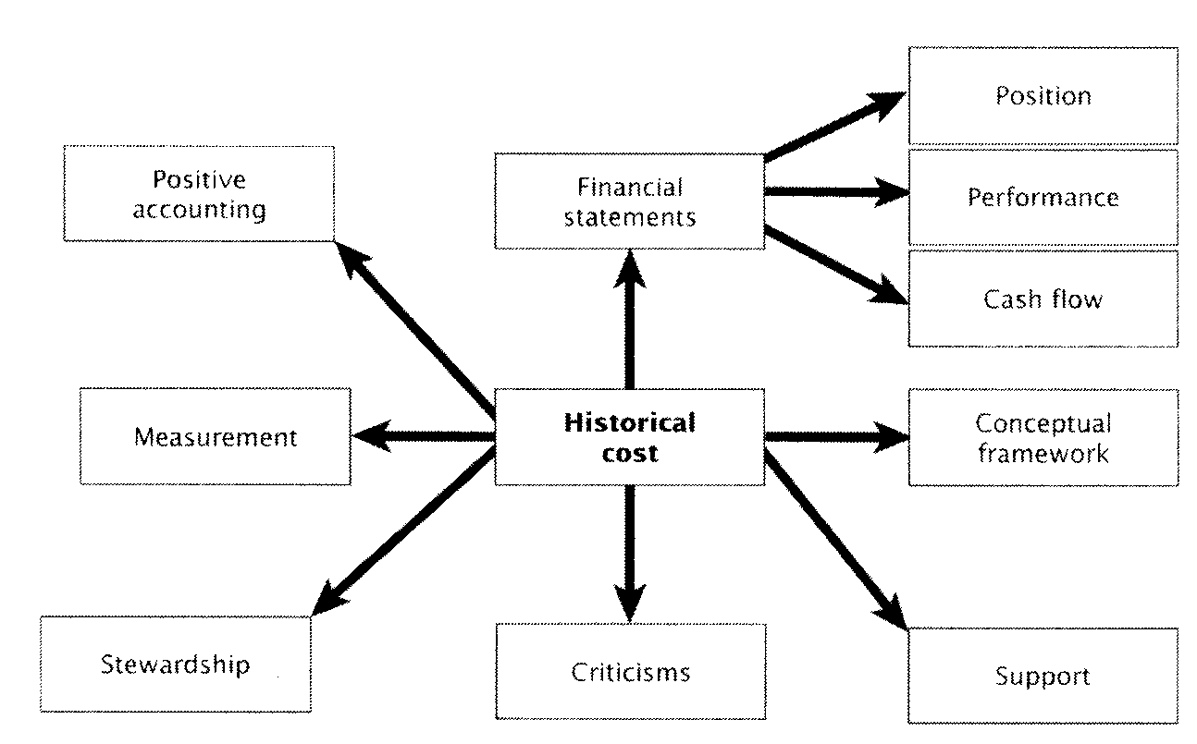

Part A (50marks)
Assessment criteria
1000 words max. | Excellent  (HD) | Very Good  (D) | Good  (C) | Satisfactory  (P) | Unsatisfactory  (F)
1. Introduction (5)
2. Body/Discussion (15)
Critical evaluation of topic
3. Conclusion (5)
4. Examples (5)
6. Referencing, citations (5)
7. Evidence of reading, quality and quantity (10)
8. English expression, coherence, grammar and spelling. Logical flow of ideas (5)

Part B (50marks)
Assessment criteria
1000 words max. | Excellent  (HD) | Very Good  (D) | Good  (C) | Satisfactory  (P) | Unsatisfactory  (F)
1. Introduction (5)
2. Body/Discussion (15)
Critical evaluation of topic
3. Conclusion (5)
4. Examples (5)
6. Referencing, citations (5)
7. Evidence of reading, quality and quantity (10)
8. English expression, coherence, grammar and spelling. Logical flow of ideas (5)

