Cohort 5 Team 3
Danielle Batey, Xhorxhi Gjoka, Erika Hanlan (primary contact), Tristen Nguyen, Carlos Pinero

Project Proposal Stage: WPI - Personal Reimbursement Process
Organization
Worcester Polytechnic Institute (WPI) is a private university, located on a 95 acre campus in Worcester, Massachusetts. WPI is currently home to 4,123 undergraduate students, 1,934 graduate students, 478 full time faculty, as well as many staff and adjunct faculty. Degree offerings include various bachelors, masters, and PhD options. Though providing many areas of study, WPI is known for its technical, engineering, and business programs. A focus on project based learning is a differentiating feature for the university, extending into providing training for other higher education institutions on the pedagogy.
Besides academics, WPI also has a rich campus life complete with over 200 student organizations. The University's motto Lehr und Kunst, “Theory and Practice,” extends into the student activities through heavy student involvement in all aspects of organizational operation. To enable both academic and student organization activities, students and staff may make purchases they intend to be reimbursed for. To comply with the needs of both students and staff, as well as ensuring timely response and uninterrupted campus operations, the current system for reimbursement approval has emerged.

Organization Group Contact
All members of the team are current Master of Business Administration candidates in WPI’s Foisie School of Business. Danielle is an alumnae of the school as well. Erika will be the team’s primary contact for interviewing and observing within WPI. In addition to being a student, Erika is an employee, adviser of two honor societies, and assistant advisor of a student organization. As an employee and an active participant in several WPI organizations, Erika has first-hand experience using the personal reimbursement process.

Organizational Process
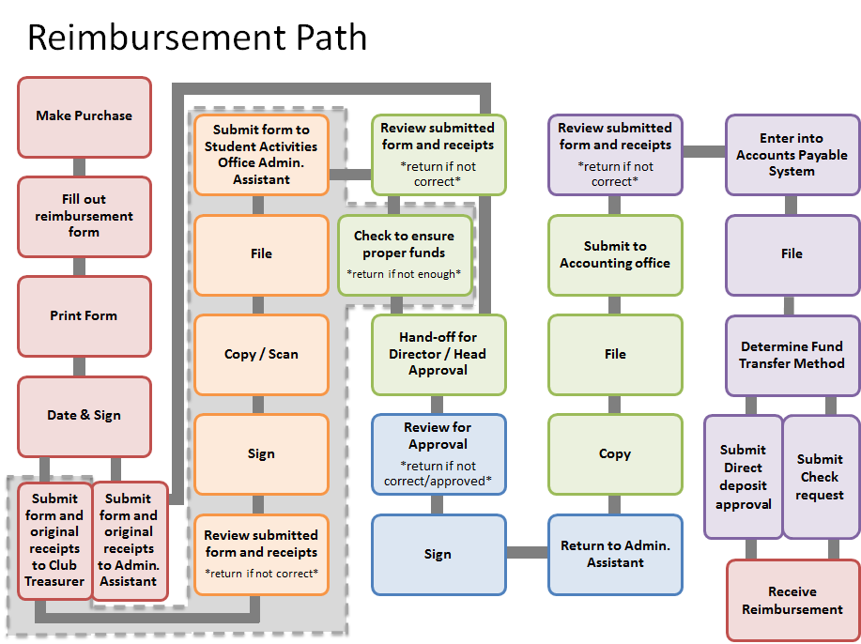
The current reimbursement process is manually intensive. First, the submitter must locate and download a copy of the current calendar year expense report spreadsheet. Then the submitter must fill out the form electronically. Once completed the form is printed, signed and dated. If a student submits an expense report, there are additional steps of submitting the packet to the student organization’s treasurer for review, signature, approval and archiving. If anytime during the process the form is deemed incomplete or inaccurate the form and receipts are returned to the submitter for correction.
The completed form plus original receipts are then submitted to the department’s administrative assistant for staff reimbursements or the Student Activities Office administrative assistant in the case of student reimbursements. The approver then reviews the form for completeness and accuracy and also ensures there are proper funds in the account budget. If the form and receipts are in order, the reviewer collects the department head’s or Director’s signature. After the approval signature is received, the form is returned to the administrative assistant who then makes copies for archiving. The originals are then submitted to the accounting office for review and approval. Once approved, the form and receipts are filed into individual folders and stored for seven years. After seven years the forms are shredded.
Common mistakes that are made which result in the form being returned for correction are not starting and ending at 100 Institute Road for mileage reimbursements, using a previous year’s form, not including submitter’s Banner ID on the form and, if a student, the form must be filled out electronically. Also mistyping a dollar amount into the form is a common mistake. Additionally, if submitting for mileage reimbursement a map must be included. If the incorrect route is used the form will be returned to the submitter.
Common mistakes made regarding the receipts submitted are using copies of receipts or a receipt that does not show the last four numbers of the submitter’s credit card, not having an itemized restaurant receipt or a credit card statement instead of the original receipt. Also receipts and forms should be paper clipped together not stapled, if the form is stapled then someone must remove the staples and paper clip the forms together. A returned reimbursement package can be corrected by the submitter and resubmitted. Any corrections restart the process prior to the first approver. An incomplete or incorrect form and/or receipt will result in a delay in getting reimbursed for expenses incurred.
At WPI the accounting department contributes to the success or survival of the organization in various ways. The reimbursement process performance is currently evaluated in three phases. The first phase is once the students and employees hand in their reimbursement form for the first time, the administrative assistant or club treasurer will make sure the student or employee has filled the reimbursement form correctly without errors or mistakes. Also the administrative assistant or club treasurer will make sure the submitter attached the correct original receipts. If the administrative assistant or club treasurer notices that the reimbursement form was not correctly filled out, they will return it back to the submitter. The importance of this first phase is to make sure the information provided is accurate, consistent through the reimbursement form along with the original receipts and follows WPI reimbursement policies.
After the reimbursement form is completely reviewed and the administrative assistant or club treasurer is satisfied the form passes to the second phase. The second phase, consists of sending the reimbursement form for review and approval by two more representatives; the payee supervisor and accounting. This ensures that those higher in the chain of command are verifying that the expense was appropriate and reviewed by their own employee. Once the routing signature process is completed and approved, the form will move to the third phase, where the reimbursement form and receipts are filed into an individual folder until seven years and the submitter is reimbursed.
Performance of the reimbursement process is currently not evaluated. The accounting department does not keep track of performance metrics such as how many reimbursement forms are submitted, returned due to an error, or time from submission to distributing funds. Based on our interviews, most students and employees find the reimbursement process straightforward and the necessary information is in the form. It should be noted that the current process reflects a system created by feedback and determined needs along the path. If a person along the way receives what they consider to be too many submissions with specific elements completed incorrectly, a policy can be added at that level to ensure smoother travel of reimbursement documents.

The following information systems are used to support the reimbursement process:
- Banner Web System which includes Banner Finance. Banner Finance is the financial management system which contain the department’s or organization's budget and a record of each transaction.
- IT infrastructure houses the server that hosts Banner Web System, and the server for the WPI web page where the policy is published and the expense reimbursement form is available for use.

During the reimbursement process the following steps are performed manually:
- Sign and date the completed form prior to submission.
- Paper clip form and receipts together.
- The delivery of the reimbursement package to each approver is completed by a person.
- Copies and scans of the reimbursement package are made by each approver.
- Filing of forms and receipts into individual folders and stored for seven years.
- Shredding any forms and receipts that are over seven years old.

The current system does not support many functions of the expense reimbursement process. The Banner Finance system is an enterprise resource planning software without any module for the expense reimbursement process. The accounting department use the Banner Finance system to re-enter all the information from the Excel reimbursement form to cut a check or request a direct deposit to the submitter. Banner Finance is also a record and book keeping tool for financial reporting. The IT infrastructure that supports this is the server that houses the Banner Finance and the web that stores the Excel form, with respect to the expense reimbursement process, the current arrangement of systems do not enhance or improve the process. Success factors for expense reimbursements can be determined by the accuracy of the expenses reported, the speed from completing the forms until reimbursement, and ease of use for submitters. The current system does not attempt to ensure that the forms are filled out correctly and submitters and reviewers need to spend more time reviewing their forms for accuracy. Since the submitters need to manually date and sign the forms and physically obtain the approver’s signature, the process moves at a snail's pace. Lastly, submitters often times make mistakes completing the Excel form.
Investment in an end-to-end digital expense system that allows forms to be completed and receipts to be attached and submitted electronically will help improve the process. A digital system can have real time complex checks for syntax and mathematics errors when the submitter is completing the form well before reaching the approvers or accounting. Not only will this improve the accuracy of expense reports but also improve the turnaround speed. Submitters can send completed forms to the approver instantly within the system so that the approver can login and review the forms. Receipts are stored digitally with the forms to eliminate the risk of losing receipts when the forms are in motion. This IT improvement will improve the overall process.
The current reimbursement process at WPI is a good candidate for improvement through IS because it is an outdated process with huge lag times which requires a large number of manual steps to complete and an excessive amount of paper hardcopies for documentation. Information systems can be leveraged to make the process paperless thereby reducing cost and environmental burden as well as the physical storage space needed to retain hardcopies for over seven years. Currently, the time between when a student/employee submits a reimbursement form and the time when they receive payment is highly variable and can take anywhere from two to five weeks.
With the appropriate information systems in place it may be possible to speed up the process so that receipt of payment is received in as little as three days after approval by reducing the number of manual steps in the process. Moreover, with a digital reimbursement process, it is possible to cut a significant amount of wait time out of the process. For example, the time in between receipt and delivery of a reimbursement request between the administrative assistant, director, and accounting office. The use of e-signatures for verification and approval of reimbursement requests should help increase process efficiency and facilitate much faster resolution times when an error has been made by the submitter, administrative assistant, director, or accounting office. Most aspects of the reimbursement process can be significantly improved by the application of information systems. However, aspects of the process that are not in control of the university, for instance the user’s preferred method of repayment, will be difficult to improve through information systems.

