Directions: Please write out each step as to how you get the answer. 5.5 (13-28 ALL, 37-70 ALL) 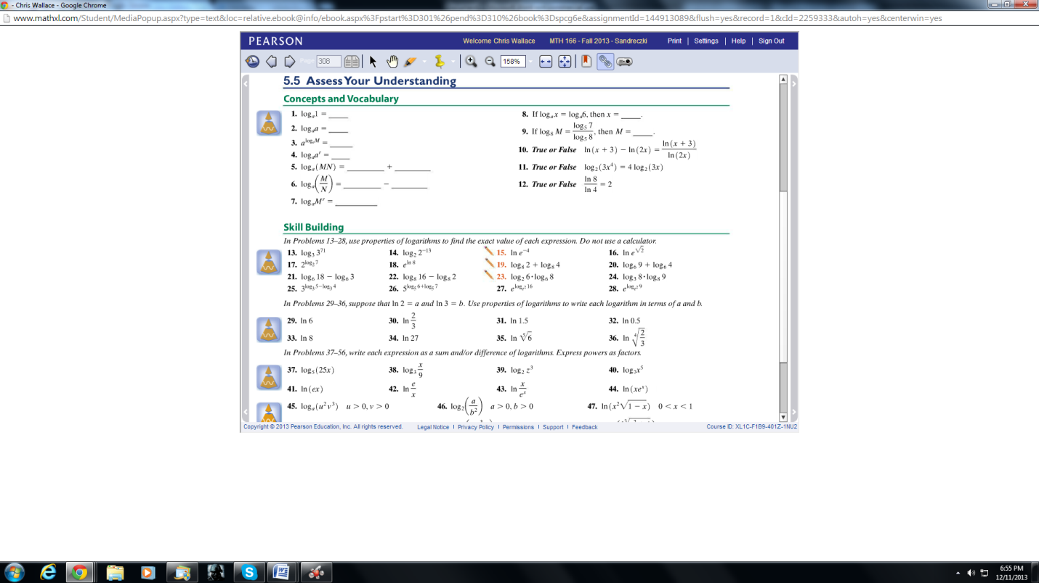
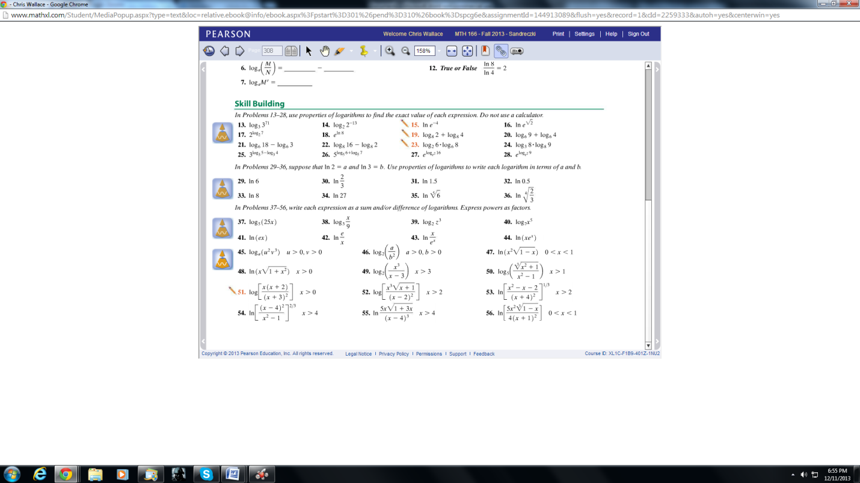
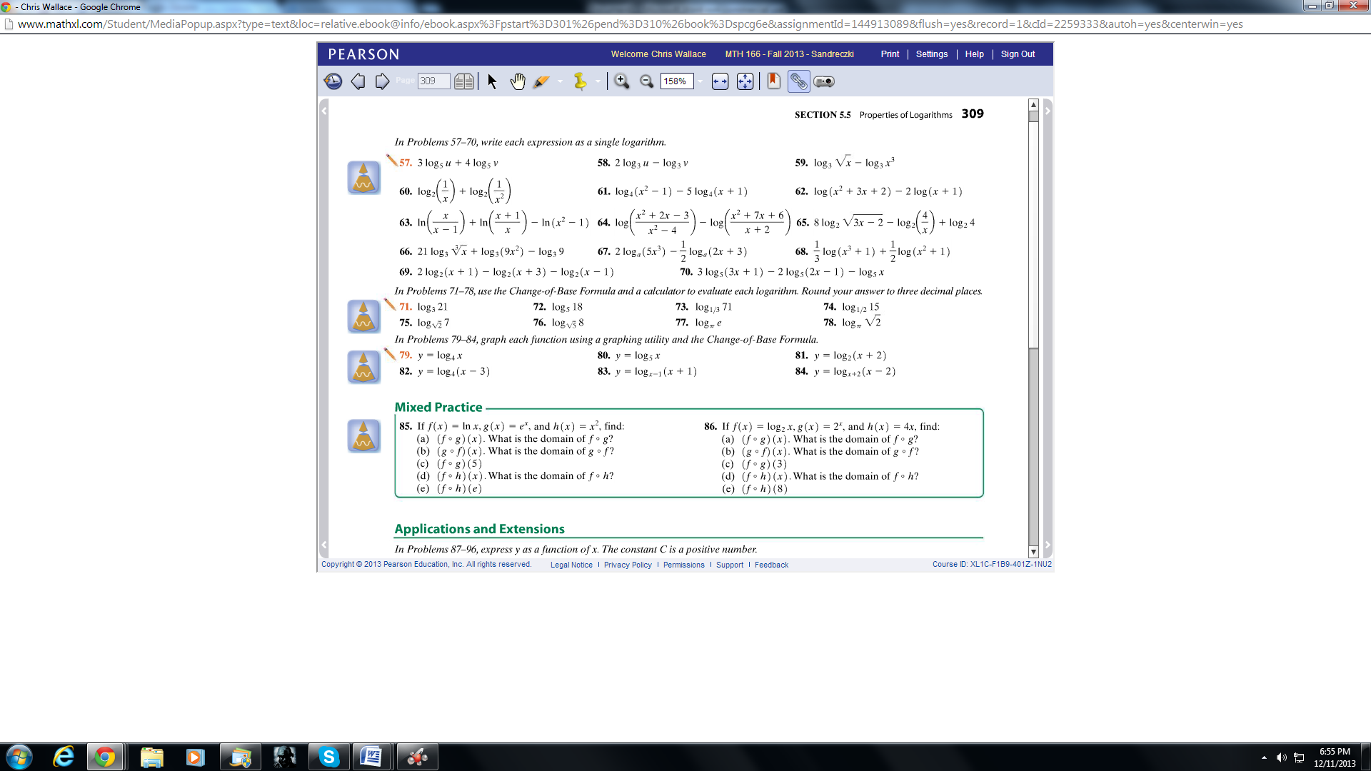
5.6 (2-32 ALL) Due 12/12 @ 1 PM
