- Digital Controls, Inc. (DCI), manufactures two models of a radar gun used by police to monitor the speed of automobiles. Model A has an accuracy of plus or minus 1 mile per hour, whereas the smaller model B has an accuracy of plus or minus 3 miles per hour. For the next week, the company has orders for 100 units of model A and 150 units of model B. Although DCI purchases all the electronic components used in both models, the plastic cases for both models are manufactured at a DCI plant in Newark, New Jersey. Each model A case requires 4 minutes of injection-molding time and 6 minutes of assembly time. Each model B case requires 3 minutes of injection-molding time and 8 minutes of assembly time. Each model B case requires 3 minutes of injection-molding time and 8 minutes of assembly time. For next week, the Newark plant has 600 minutes of injection-molding time available and 1080 minutes of assembly time available. The manufacturing cost is $10 per case for model A and $6 per case for model B. Depending upon demand and the time available at the Newark plant, DCI occasionally purchases cases for one or both models from an outside supplier in order to fill customer orders that could not be filled otherwise. The purchase cost is $14 for each model A case and $9 for each model B case. Management wants to develop a minimum cost plan that will determine how many cases of each model should be produced at the Newark plant and how many cases of each model should be purchased. The following decision variables were used to formulate a linear programming model for this problem:

AM=number of cases of model A manufactured

BM=number of cases of model B manufactured

AP=number of cases of model A purchased

BP=number of cases of model B purchased

The linear programming model that can be used to solve this problem is as follows:
10 + 6 + 14 + 9
. . | 1 + |  | + 1 + | = 100
 |  | 1 + |  | 1 = 150
 | 4 + 3 |  |  | ≤ 600
 | 6 + 8 |  |  | ≤ 1080
 | , , , ≥ 0

Quantitative Analysis BA 452 Homework 3 Questions
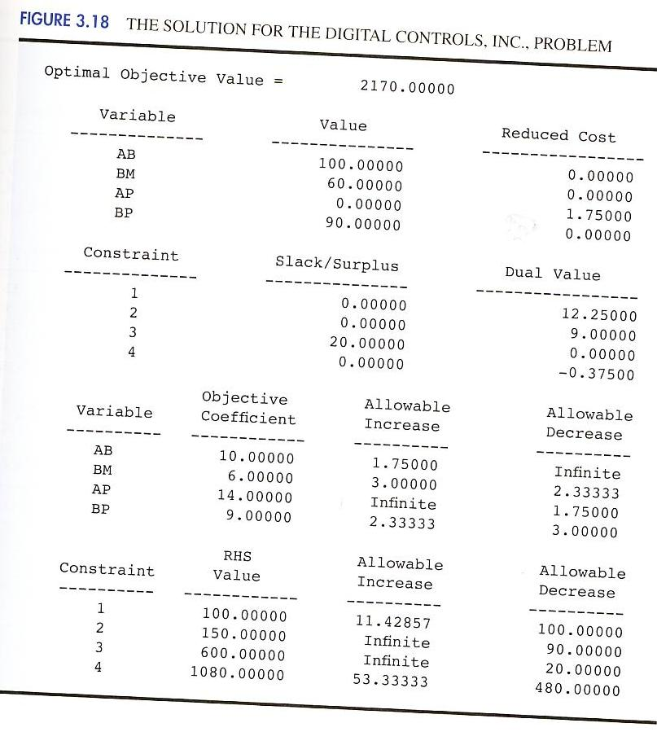

The computer solution is shown in Figure 3.18.

- What is the optimal solution and what is the optimal value of the objective function?

- Which constraints are binding?

- What are the dual values? Interpret each.

- If you could change the right-hand side of one constraint by one unit, which one would you choose? Why?

Quantitative Analysis BA 452 Homework 3 Questions

- Refer to the computer solution to Problem 14 in Figure 3.18.

  - Interpret the ranges of optimality for the objective function coefficients.

  - Suppose that the manufacturing cost increases to $11.20 per case for model A. What is the new optimal solution?

  - Suppose that the manufacturing cost increases to $11.20 per case for model A and the manufacturing cost for model B decreases to $5 per unit. Would the optimal solution change?

Quantitative Analysis BA 452 Homework 3 Questions

- Tucker Inc. produces high-quality suits and sport coats for men. Each suit requires 1.2 hours of cutting time and 0.7 hours of sewing time, uses 6 yards of material, and provides a profit contribution of $190. Each sport coat requires 0.8 hours of cutting time and 0.6 hours of sewing time, uses 4 yards of material, and provides a profit contribution of $150. For the coming week, 200 hours of cutting time, 18- hours of sewing time, and 1200 yards of fabric are available. Additional cutting and sewing time can be obtained by scheduling overtime for these operations. Each hour of overtime for the cutting operation increase the hourly cost by $15, and each hour of overtime for the sewing operation increase the hourly cost by $10. A maximum of 100 hours of overtime can be scheduled. Marketing requirements specify a minimum production of 100 suits and 75 sport coats. Let

S=number of suits produced

SC=number of sport oats produced

D1=hours of overtime for the cutting operation

D2=hours of overtime for the sewing operation

The computer solution is shown in Figure 3.19.

- What is the optimal solution, and what is the total profit? What is the plan for the use of overtime?

- A price increase fir suits is being considered that would result in a profit contribution of $210 per suit. If this price increase is undertaken, how will the optimal solution change?

- Discuss the need for additional material during the coming week. If a rush order for material can be placed at the usual price plus an extra $8 per yard for handling, would you recommend the company consider placing a rush order for material? What is the maximum price Tucker would be willing to pay for an additional yard of material? How many additional yards of material should Tucker consider ordering?

- Suppose the minimum production requirement for suits is lowered to 75. Would this change help or hurt profit? Explain.

Quantitative Analysis BA 452 Homework 3 Questions
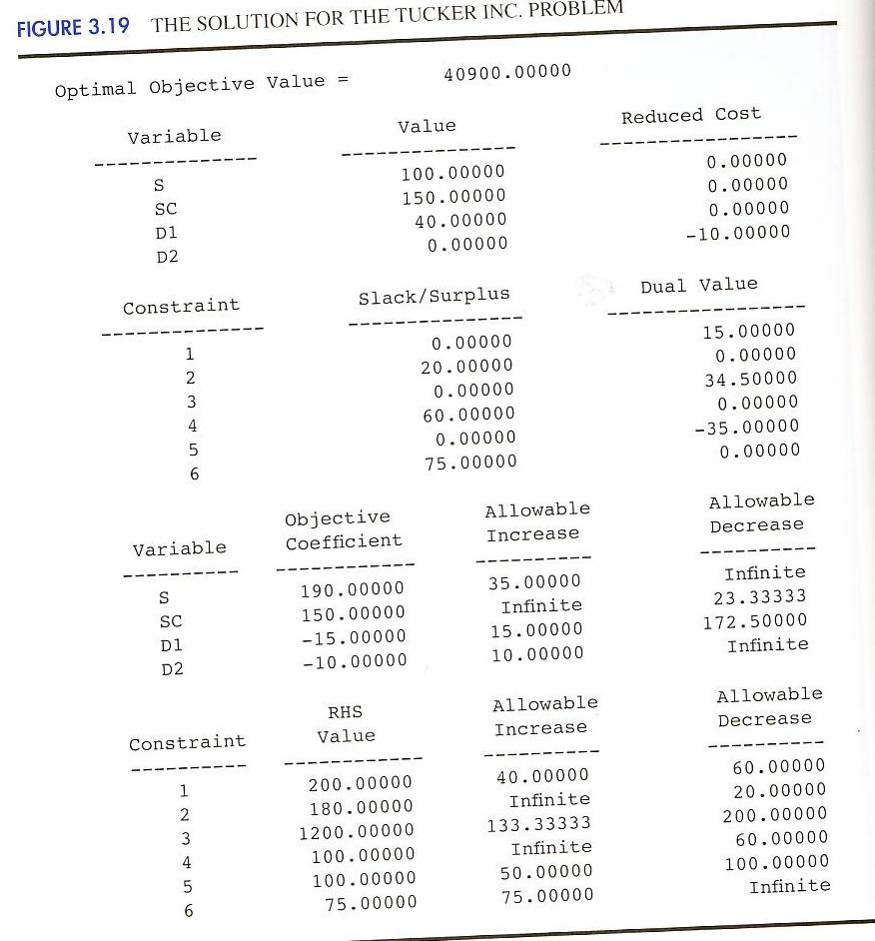
Quantitative Analysis BA 452 Homework 3 Questions

17. | The Porsche Club of America sponsors driver education events that provide high-performance
 | driving instruction on actual race tracks. Because safety is a primary consideration at such events,
 | many owners elect to install roll bars in their cars. Deegan Industries manufactures two types of roll
 | bars for Porsches. Model DRB is bolted to the car using existing holes in the car’s frame. Model DRW
 | is a heavier roll bar that must be welded to the car’s frame. Model DRB requires 20 pounds of a
 | special high alloy steel, 40 minutes of manufacturing time, and 60 minutes of assembly time. Model
 | DRW requires 25 pounds of the special high alloy steel, 100 minutes of manufacturing time, and 40
 | minutes of assembly time. Deegan’s steel supplier indicated that at most 40,000 pounds of the high-
 | alloy steel will be available next quarter. In addition, Deegan estimates that 20000 hours of
 | manufacturing time and 1600 hours of assembly time will be available next quarter. The profit
 | contributions are $200 per unit for model DRB and $280 per unit for model DRB. The linear
 | programming model for this problem is as follows:
 |  | 200+
 | . . | 20+ 25≤ 40,000
 |  | 40+ 100≤ 120,000
 |  | 60+ 40≤ 96,000
 |  | ,≥ 0
The computer solution is shown in Figure 3.20.

- What are the optimal solution and the total profit contribution/

- Another supplier offered to provide Deegan Industries with an additional 500 pounds of the steel alloy at $2 per pound. Should Deegan purchase the additional pounds of the steel alloy? Explain.

- Deegan is considering using overtime to increase the available assembly time. What would you advise Deegan to do regarding this option? Explain.

- Because of increased competition, Deegan is considering reducing the price of model DRB such that the new contribution to profit is $175 per unit. How would this change in price affect the optimal solution? Explain.

- If the available manufacturing time is increased by 500 hours, will the dual value for the manufacturing time constraint change? Explain.

Quantitative Analysis BA 452 Homework 3 Questions
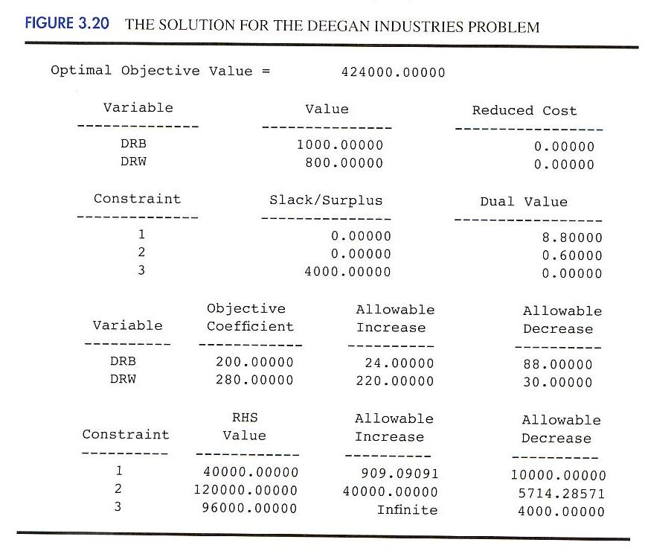
Quantitative Analysis BA 452 Homework 3 Questions

- Davison Electronics manufactures two LCD television monitors, identified as model A and model B. Each model has its lowest possible production cost when produced on Davison’s new production line. However, the new production line does not have the capacity to handle the total production of both models. As a result, as least some of the production must be routed to a higher-cost, old production line. The following table shows the minimum production requirements for next month, the production line table shows the minimum production requirements for next month, the production line capacities in units per month, and the production cost per unit for each production line:

 |  | Production Cost per
 |  | Unit
Model | New Line | Old Line | Minimum Production
 |  |  | Requirements
A | $30 | $50 | 50,000
B | $25 | $40 | 70,000
Production Line | 80,000 | 60,000
Capacity

Let:
AN= Units of model A produced on the new production line
AO= Units of model A produced on the old production line
BN = Units of model B produced on the new production line
BO= Units of model B produced on the old production line

Davison’s objective is to determine the minimum cost production plan. The computer solution is shown below.

- Formulate the linear programming model for this problem using the following four constraints:
  - Constraint 1: Minimum production for model A
  - Constraint 2: Minimum production for model B
  - Constraint 3: Capacity of the new production line
  - Constraint 4: Capacity of the old production line

- Using computer solution in Figure 3.21, what is the optimal solution, and what is the total production cost associated with this solution?
- Which constraints are binding? Explain.
- The production manager noted that the only constraint with a positive dual values is the constraint on the capacity of the new production line. The manager’s interpretation of the dual value was that a one-unit increase in the right-hand side of this constraint would actually increase the total production cost by $15 per unit. Do you agree with this interpretation? Would an increase in capacity for the new production line be desirable? Explain.

- Would you recommend increasing the capacity of the old production line? Explain.

Quantitative Analysis BA 452 Homework 3 Questions

- The production cost for model A on the old production line is $50 per unit. How much would this cost have to change to make it worthwhile to produce model A on the old production line? Explain.
- Suppose that the minimum production requirement for model B is reduced from 70,000 units to 60,000 units. What effect would this change have on the total production cost? Explain.

Optimal Objective Value |  | = 3850000.00000
Variable |  | Value | Reduced Cost
AN |  | 50000.00000 | 0.00000
AO |  | 0.0000 | 5.00000
BN |  | 30000.00000 | 0.00000
BO |  | 40000.00000 | 0.00000
Constraint |  | Slack/Surplus | Dual Value
1 |  | 0.00000 | 45.00000
2 |  | 0.00000 | 40.00000
3 |  | 0.00000 | -15.00000
4 |  | 20000.00000 | 0.00000
OBJECTIVE COEFFICIENT RANGES
Variable |  | Objective Coefficient | Allowable Increase | Allowable Decrease
AN |  | 30.00000 | 5.00000 | Infinite
AO |  | 50.00000 | Infinite | 5.00000
BN |  | 25.00000 | 15.00000 | 5.00000
BO |  | 40.00000 | 5.00000 | 15.00000
RIGHT HAND SIDE RANGES
Constraint |  | RHS Value | Allowable Increase | Allowable Decrease
1 |  | 50000.00000 | 20000.00000 | 40000.00000
2 |  | 70000.00000 | 20000.00000 | 40000.00000
3 |  | 80000.00000 | 40000.00000 | 20000.00000
4 |  | 60000.00000 | Infinite | 20000.00000

