- Refer to Figure 3.14, which shows the computer solution of Problem 7.

  - How much would the return for U.S. Oil have to increase before it would be beneficial to increase the investment in this stock?

  - How much would the return for Huber steel have to decrease before it would be beneficial to reduce the investment in this tock?

  - How much would the total annual return be reduced if the U.S. Oil maximum were reduced to 900 shares?

Quantitative Analysis BA 452 Homework 3 Questions

- Recall the Tom’s, Inc., problem (Chapter 2, Problem 28). Letting

W=jars of western Foods Salsa

M=jars of Mexico City Salsa

Leads to the formulation:

. . 1 + 1.25 5 + 7 ≤ 4480 ℎ

3 + 1 ≤ 2080 2 + 2 ≤ 1600 , ≥ 0

The computer solution is shown in Figure 3.15.

- What is the optimal solution, and what are the optimal production quantities?

- Specify the objective function ranges.
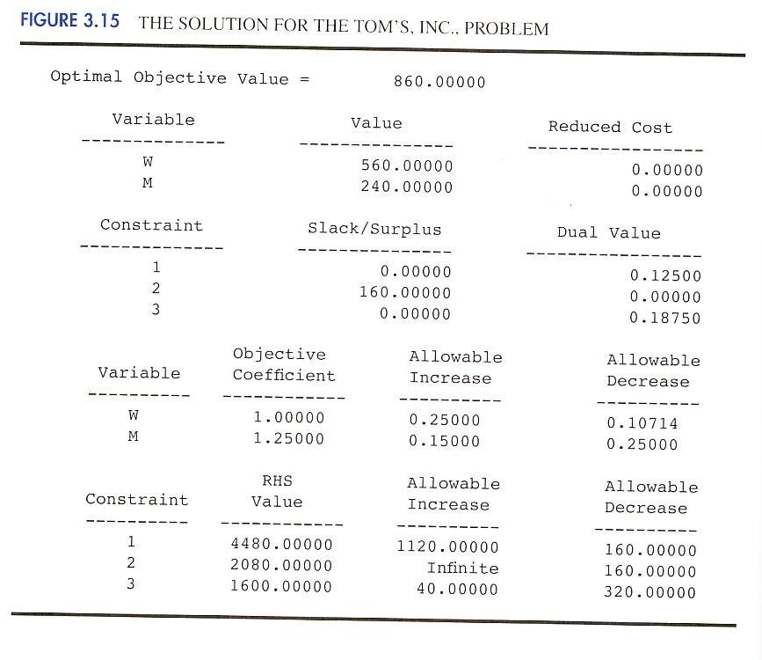

- What are the dual values for each constraint? Interpret each.

- Identify each of the right-hand-side ranges.

Quantitative Analysis BA 452 Homework 3 Questions

- Recall the Innis Investments problem (Chapter 2, Problem 39). Letting

 | S=units purchased in the stock fund
 | M=units purchased in the money market fund
leads to the following formulation:
 | 8 + 3
. . | 50 + 100 ≤ 1,200,000
 | 5 + 4 ≥ 60,000
 | ≥ 3,000
 | , ≥ 0
The computer solution is shown in Figure 3.16.

- What is the optimal solution, and what is the minimum total risk?

- Specify the objective coefficient ranges.

- How much annual income will be earned by the portfolio?
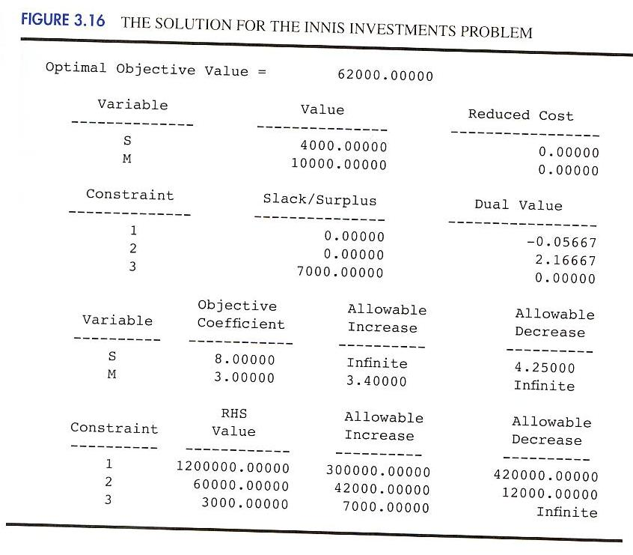

- What is the rate of return for the portfolio?

- What is the dual value for the funds available constraint?

Quantitative Analysis BA 452 Homework 3 Questions

  - What is the marginal rate of return on extra funds added to the portfolio?

- Refer to Problem 10 and the computer solution shown in Figure 3.16.

    - Suppose the risk index for the stock fund (the value of Cs) increases from its current value of 8 to 12. How does the optimal solution change, if at all?

    - Suppose the risk index for the money market fund (the value of Cm) increases from its current value of 3 to 3.5. how does the optimal solution change, if at all?

    - Suppose Cs increases to 12 and Cm increases to 3.5. How does the optimal solution change, if at all?

- Quality Air conditioning manufactures three hoe air conditioners: an economy model, a standard model, and a deluxe model. The profits per unit are $63, $95, and $135, respectively. The production requirements per unit are as follows:

 | Number of | Number of | Manufacturing
 | Fans | Cooling Coils | Time(hours)
Economy | 1 | 1 | 8
Standard | 1 | 2 | 12
Deluxe | 1 | 4 | 14

For the coming production period, the company has 200 fan motors, 320 cooling coils, and 2400 hours of manufacturing time available. How many economy models (E), standard models (S), and deluxe models (D) should the company produce in order to maximize profit? The linear programming model for the problem is as follows:
63 + 95 + 135
. . | 1 + 1 + 1 ≤ 200 | Fan motors
 | 1 + 1 + 1 ≤ 200 | Cooling coils
 | 1 + 2 + 4 ≤ 320 |  | Manufacturing time
 | 8 + 12 + 14 ≤ 2400
 | , , ≥ 0
The computer solution is shown in Figure 3.17.

- What is the optimal solution, and what is the value of the objective function

- Which constraints are binding?

- Which constraint shows extra capacity? How much?

- If the profit for the deluxe model were increased to $150 per unit, would the optimal solution change? Use the information in Figure 3.17 to answer this question.

Quantitative Analysis BA 452 Homework 3 Questions

- Refer to the computer solution of Problem 12 in Figure 3.17

  - Identify the range of optimality for each objective function coefficient.

  - Suppose the profit for the economy model is increased by $6 per unit, the profit for the standard model is decreased by 42 per unit, and the profit for the deluxe model is increased by $4 per unit. What will the new optimal solution be?

  - Identify the range of feasibility for the right-hand-side values.

  - If the number of fan motor available for production is increased by 100, will the dual value for that constraint change? Explain.


