This is an example of what a perfect paper in this class should look like. Look it over, and follow the directions as provided by your professor. While this is for an individual report, the way the report was developed is applicable to all reports in this class. You will find my comments in this paper showing you what the student did correctly. Look for those comments.

Nova Southeastern University
H. Wayne Huizenga School
of Business & Entrepreneurship
Assignment for Course: | QNT5040
Submitted to: | Dr. Phillip Rokicki
Submitted by:
Date of Submission:
Title of Assignment: Management Report for Prescott College Bookstore
CERTIFICATION OF AUTHORSHIP: I certify that I am the author of this paper and that any assistance I received in its preparation is fully acknowledged and disclosed in the paper. I have also cited any sources from which I used data, ideas or words, either quoted directly or paraphrased. I also certify that this paper was prepared by me specifically for this course.

Student's Signature:

Grade: 37.5 points

Comments: A perfect paper at last. This is the first one this term. Thanks, I enjoyed reading this paper. I’ve added a few points for such a great paper.

TITLE OF RUBRIC: Case Analysis (Page 1 of 2) | Course: QNT 5040
LEARNING OUTCOME/S: CC4, 6, 7 & 8; (see syllabus) | Date:
PURPOSE: To facilitate effective decision making under uncertain conditions by quantifying risk. | Name of Student:
VALIDITY: Forecasting | Name of Faculty: Dr. P. Rokicki
COMPANION DOCUMENTS: Assignment and format instructions, Case

Earning maximum points in each box in ‘PROFICIENT’ column and / or
points in columns to the right of ‘PROFICIENT’ meets standard.
 | <<<<<<<<<< less quality . . . . . . . . . . . . . . . . . . . . . . . . . . . . . . . more quality >>>>>>>>>>
Performance Criteria | Basic | Developing | Proficient | Accomplished | Exemplary | Score out of 100
Identify the problem  (CC4) | Does not  identify the problem, or does not identify the right problem.  (0 pts) | Identifies symptoms  (5 pts) | Identifies some elements of the problem.  (10 pts) | Substantially  identifies the problem.  (12 pts) | Effectively and succinctly  identifies the problem.  (15 pts) | 15
Describes assumptions and methods  (CC4) | Does not describe assumptions and methods used  (0 pts) | Does not precisely describe the  assumptions and methods used  (3 pts) | Somewhat describes assumptions and methods used  (7 pts) | Substantially  describes assumptions and methods used  (8 pts) | Effectively describes assumptions and methods used  (10 pts) | 10
Calculate statistics using a spreadsheet  (CC6) | Does not calculate appropriate statistics using a spreadsheet and/or  does not provide evidence of calculations  (0 pts) | Calculates appropriate statistics using a spreadsheet (most answers are not  correct)  (13 pts) | Calculates appropriate statistics using a spreadsheet (not all answers are correct)  (21 pts) | Calculates appropriate statistics using a spreadsheet (most answers are correct)  (25 pts) | Effectively  calculates statistics using a spreadsheet (almost all answers are correct)  (30 pts) | 30
Explain  implications of  output of statistical analysis  (CC7) | Does not explain  implications of  output of statistical analysis  (0 pts) | Partially  explains  implications of  output of statistical analysis  (3pts) | Somewhat explains  implications of  output of statistical analysis  (7 pts) | Substantially  explains  implications of  output of statistical analysis  (8 pts) | Effectively explains  implications of  output of statistical analysis  (10 pts) | 10

Continued . . .

TITLE OF RUBRIC: Case Analysis, cont. (Page 2 of 2) | Course: QNT 5040
LEARNING OUTCOME/S: CC4, 6, 7 & 8; (see syllabus) | Date: March 4, 2015
PURPOSE: To facilitate effective decision making under uncertain conditions by quantifying risk. | Name of Student: Found on front page
VALIDITY: Forecasting. | Name of Faculty: Dr. P. Rokicki
COMPANION DOCUMENTS: Assignment and format instructions, Case

Earning maximum points in each box in ‘PROFICIENT’ column and / or
points in columns to the right of ‘PROFICIENT’ meets standard.
 | <<<<<<<<<< less quality . . . . . . . . . . . . . . . . . . . . . . . . . . . . . . . more quality >>>>>>>>>>
Performance Criteria | Basic | Developing | Proficient | Accomplished | Exemplary | Score out of 100
Generates solutions based on analysis and context  (CC4) | Does not  generate appropriate solutions based on analysis and context.  (0 pts) | Generates solutions (does not justify conclusions).  (7 pts) | Partially: *generates and justifies solutions based on analysis and context; and *justifies conclusions.  (15 pts) | Substantially: *generates and justifies solutions based on analysis and context; and *justifies conclusions.  (17 pts) | Effectively: *generates and justifies solutions based on analysis and context; and *justifies conclusions.  (20 pts) | 20
Uses prescribed format (including cover sheet and grading rubric) and writing style (language, grammar, punctuation, and spelling)  (CC8) | Does not use prescribed format and writing style  (0 pts) | May use prescribed format OR writing style (only one)  (3 pts) | Generally uses prescribed format and writing style  (7 pts) | Substantially uses prescribed format and writing style  (8 pts) | Effectively  uses prescribed format and writing style  (10 pts) | 10
Uses APA format  (APA Style Manual 6.0)  (CC8) | Does not provide references.  (0 pts) | Does not apply APA style to references.  (1pts) | Partially applies APA style to references.  (3 pts) | Substantially applies APA style to references.  (4 pts) | Effectively applies APA style to all references.  Optimal quality and quantity of citations.  (5 pts) | 5
OVERALL GRADE (100 total possible points): |  |  |  |  |  | 100%

Correlation to Grade based on a maximum of 35 points

Points for the Grading Rubric (Max. 100) | Translation to 35 points (Max) for report | Approximate Letter Grade for the report
100 points | 35 | A
99 | 34.65 | A
98 | 34.3 | A
97 | 33.95 | A
96 | 33.6 | A
95 | 33.25 | A
94 | 32.9 | A
93 | 32.5 | A-
92 | 32.2 | A-
91 | 31.85 | A-
90 | 31.5 | A-
89 | 31.15 | A-
88 | 30.8 | B+
87 | 30.45 | B+
86 | 30.1 | B+
85 | 29.75 | B+
84 | 29.4 | B
83 | 29.05 | B
82 | 28.7 | B
81 | 28.35 | B-
80 | 28 | B-
79 | 27.65 | B-
78 | 27.3 | B-
77 | 26.95 | C+
76 | 26.6 | C+
75 | 26.25 | C+
74 | 25.9 | C+
73 | 25.55 | C
72 | 25.2 | C
71 | 24.85 | C
70 | 24.5 | C
Below 70 |  | F

Executive Summary

The Prescott College Bookstore is in jeopardy of having its operation outsourced to a third party company. The college president plans to use the proceeds from the new $1 million contract to fund a new bell tower for the campus. Dr. Mary Ann Lane, vice president of business services, fears that the new operating company will cause a considerable increase in the cost of textbooks for her students. A series of tests were conducted on the bookstore’s past 4 year’s sales data, including descriptive statistics, histograms, box-and-whisker plots, and various forecasting methods to determine whether the bookstore’s sales are growing or declining.

The study revealed that the bookstore’s sales are growing and quite substantially. It was determined that Winter’s method was the best forecasting model for the bookstore, presenting the lowest error and the most expected forecast graphically. A comparison of projected sales for 2013 to prior years revealed a growth of approximately $200,000. It was recommended that the Prescott College Bookstore remain in operation. The college should not enter into a contract with the third party company, and the college president will not be getting his bell tower.

Background

Dr. Mary Ann Lane, vice president of business services at Prescott College, is facing uncertainty about the future of her institution’s on-campus bookstore. The college has ran its own bookstore for the entirety of its 25 year history, but now the college president wants to explore the possibility of off-loading the bookstore to a third party company. The third party company will make a $1 million donation to the college if awarded the contract, and the president plans on using these proceeds to finance a new bell tower for the campus.

Dr. Lane is aware that the third party company is known for “increasing the cost of textbooks and e-books by over 20%”, and she is concerned that the students will be unable to absorb the increased costs (Rokicki, 2015). She has gathered the prior 4 years of monthly sales data and has requested a forecast be conducted for the next 12 months of sales to determine if the bookstore is a viable business. If sales are growing, she may have enough of a case to convince the president to keep the on-campus bookstore operation in-house and to save her students from textbook cost increases.

Statistical Methods used in this Report

This report is designed to examine past sales and to forecast the next 12 months of sales for the Prescott College Bookstore using four different forecasting methods. The contained report includes the following measures:

1) One-variable summary of prior 4 years sales data,

2) Histograms of historical sales data,

3) Box-and-whisker plots for each 4 years of prior sales data,

4) Forecast for the next 12 months of sales using moving average, simple exponential smoothing, Holt’s double exponential smoothing, and Winter’s exponential smoothing methods.

Problem

Determine whether sales are growing or declining by forecasting the next 12 months of sales for the Prescott College Bookstore.

Analysis

One-Variable Summary

A one-variable summary is a compilation of descriptive statistics for each variable of a data set. The one-variable summary includes the mean, median, mode, sample size, range, quartiles, percentiles, minimums and maximums, and other values that help to understand and explain the data. When looking at a large set of data, it is difficult to analyze trends or visualize what the data means just by looking at rows of numbers and figures. A one-variable summary, as shown below, organizes the data in a meaningful way that allows for easier interpretation.

Table 1: One-Variable Summary

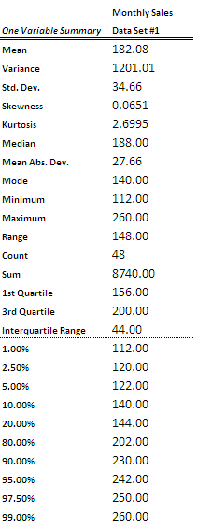

Descriptive statistics give some indications of how a set of data is distributed. A normal distribution has a bell shape and is symmetrical with the mean located directly at the center of the curve, lower values towards the left tail, and higher values towards the right tail. This is because the median, or the middle value of the data set, is equal to the mean (Groebner, et. al., 2014).

Skewness

Skewness refers to a distribution where the mean is larger or smaller than the median. The highest points of the curve are not concentrated at the center, but instead, they are concentrated to the right or left of the curve’s center. A distribution will have a higher concentration of data to the left of the curve’s center, meaning that the mean is less than the median, with positive or left-skewness, and vice versa for negative or right-skewness (Groebner, et. al., 2014).

StatTools calculates skewness, and the following principles are applied to determine the degree and direction of skewness. If skewness is greater than 0, it is right-skewed, if skewness is less than 0, it is left-skewed, and if skewness is equal to 0, then it is a perfectly normal distribution. The skewness for monthly sales is greater than 0, so the distribution is not perfectly normal and would be slightly right-skewed. This means that most values are concentrated to the left of the median.

Kurtosis

Kurtosis is another tool that is used to describe the shape of a distribution; it refers to how wide or skinny the curve is. StatTools also calculates a value for kurtosis. If the value is greater than 3, it is a leptokurtic distribution, which is tall and skinny in the center with fatter tails. If the value is less than 3, it is a platykurtic distribution, which is wide and flat in the center with smaller tails. If kurtosis is equal to 3, then it is a perfectly normal distribution (Doane & Seward, 2013). The kurtosis of monthly sales is 2.6995, which indicates a platykurtic distribution.

Table 2: Skewness and Kurtosis

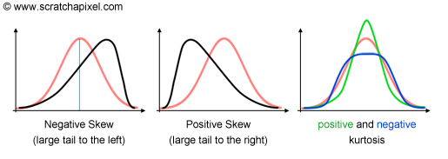

Quartiles divide a data set into four equal-sized groups. The first quartile is equal to the 25th percentile, and it is the value “at or below which there is at least 25% (one quarter) of the data” (Groebner, et. al., 2014). The second quartile corresponds to the median and is the point at or below which at least 50% of the data is contained. The third quartile, also called the 75th percentile, is the value at or below which there is at least 75% of the data. The minimum and maximum values of the monthly sales data are $112,000 and $260,000, respectively. The 1st and 3rd quartiles at $156,000 and $200,000, respectively, appear to have a fairly even distribution with no major jumps in sales between the quartiles.

The interquartile range is calculated by subtracting the 1st quartile from the 3rd quartile. The purpose of the interquartile range is to reduce the effects of extreme outliers in a data set (Groebner, et. al., 2014). Sometimes, the interquartile range is preferred to the range (difference between the max and min), but in this case, it is not favorable to exclude the extreme values because then the months with the highest sales would be excluded from the analysis. The actual range is $148,000, indicating that the monthly sales can fluctuate substantially at times, possibly due to seasonality.

Histograms

A histogram is a bar graph that illustrates the distribution of a data set. Data is separated into bins or bars, and it forms a unique shape that can help to determine how the data is distributed.

Table 3: Histogram

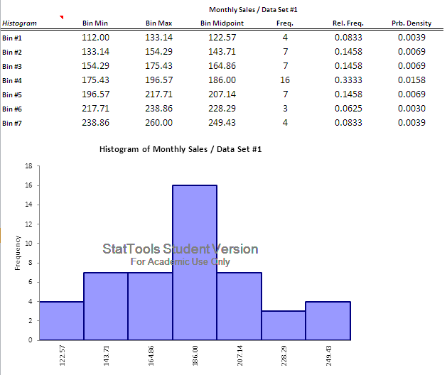

The histogram reveals a nearly perfect bell-shaped, normal distribution. The frequencies are a little more concentrated to the left, which substantiates the prior skewness analysis. The histogram indicates that sales are most commonly in the $175,000 to $196,000 range. Not only are 16 months accounted for in this bin, but bins 2, 3 and 5 account for an additional 21 months’ worth of sales and only vary from each other by around $60,000. The histogram indicates that while there is some seasonality, sales are fairly stable for the bookstore.

Box-and-Whisker Plots

A box-and-whisker plot is a way to graphically represent a data set. A box-and-whisker plot includes two parts: a box and the whiskers.

Table 4: Box-and-Whisker Plot Diagram
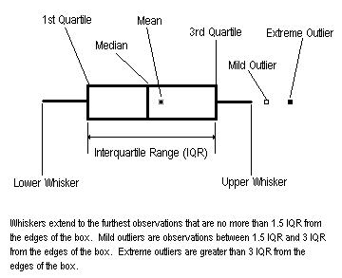

The box’s width represents the data in the first through third quartiles. A vertical line is drawn through the box representing the median and also the divide between the first and third quartile. The whiskers extend from the left and right of the box with the furthest left whisker extending to the lowest data point and the furthest right whisker extending to the highest data point (Groebner, et. al., 2014). The mean is plotted with an asterisk inside of the box and may be located at the median or on either side of the median. Mild outliers are open squares and extreme outliers are closed squares, as indicated by Table 4.

Table 5: Box-and-Whisker Plot: Monthly Sales 2009-2012

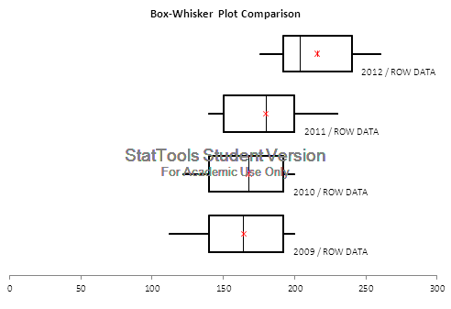

The box-and-whisker plots clearly illustrate growing sales for the bookstore with a slight increase occurring between 2010 and 2011 and a substantial increase occurring between 2011 and 2012. This is determined by the relative positions of the individual box-and-whisker plots along the x-axis. In the 2012 box, the median line is to the far left of the mean, and the third quartile is very large, meaning that the store had the highest volume of sales in the third quarter. The right whiskers of 2011 and 2012 are also proportionate to the box, as opposed to the short right tails of 2009 and 2010, which means that the fourth quarter of the year yielded a high monthly sales average. Sales are definitely trending upward for the bookstore.

Forecasting

A key component of business success hinges on the ability to effectively forecast future events. Every decision in a business can be richly supplemented with dynamic long and short-term forecasting. Forecasting begins by plotting out past data to look for seasonality and trends. Seasonality refers to a trend that repeats itself during specific periods (Hamlett, n.d.). Once nuances in the past data are understood, they can be used to predict future sales. Statistical software, such as StatTools, helps decision-makers quickly create and evaluate models using several different forecasting methods.

There is no such thing as a perfect forecast. Therefore, StatTools calculates three accuracy indicators that can be used to determine the reliability of each forecast. These three measures are the mean absolute error (MAE), the mean absolute percentage error (MAPE), and the root mean square error (RMSE). Errors are calculated over time by comparing the forecasted values to the actual values (Wood, 2012).

The MAE is simply the mean, or average, of the absolute errors. As described by Wood (2012), “the absolute error is the absolute value of the difference between the forecasted value and the actual value”. The MAE tells decision-makers how big of an error can be expected in the forecast on average.

The MAPE is another tool to evaluate the errors of a forecast, and it specifically addresses a critical issue with the MAE. With the MAE, the relative size of the error is not always obvious, making it hard to tell how big or small an error is in comparison to “forecasts of different series in difference scales” (Wood, 2012). The MAPE is simply the MAE in percentage terms to allow for easier comparison.

Both the MAE and the MAPE are based on the mean error. The constant focus on the mean error can understate large, unexpected, or infrequent errors. This is where the RMSE becomes a valuable tool. The RMSE squares the errors before calculating the mean, and then takes the square root of the mean to produce a measure that gives more weight to larger errors than to the mean error (Wood, 2012). The comparison of the RMSE and MAE is also used to determine whether or not the data has large, infrequent errors. The greater the difference between the RMSE and the MAE, the more inconsistent the error size (Wood, 2012).

Moving Average Forecast

The moving average forecast is the simplest technique to evaluate past data, look for trends, and offer predictions for the future. This forecasting method uses a grouping of means from a specified time period and moves forward each period, dropping the oldest data and incorporating the newest data as it becomes available.

In the Prescott Bookstore case, sales are averaged each month. The moving average was calculated using a span of 3 months. To begin the moving average model, monthly sales were averaged for January, February and March of 2009, and then an average of these 3 months provided the first data point. Once the average monthly sales data became available for April 2009, January’s data was dropped from the average, and April’s data was incorporated to create a new average, or the second data point. When May’s data came along, February’s data was eliminated, and May’s data was calculated to form the new average. This same process of moving the average forward continues for the rest of the monthly sales data. StatTools performs these calculations and outputs a graph of the results, as shown in Table 6.

Table 6: Moving Average Forecast

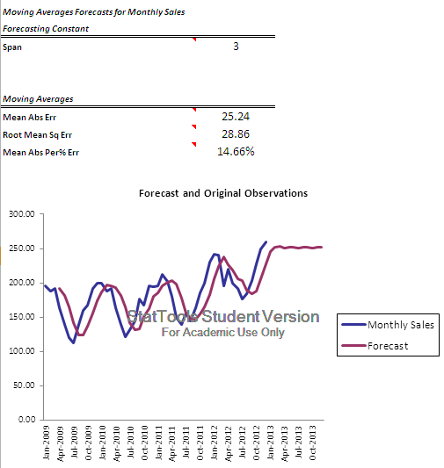

As indicated by the key, the actual data is plotted in blue, and the forecasted data is plotted in purple. The forecast does follow the overall trend of the data, but the purple line should be closer to the actual data line. The purple line is also smoother than the actual data. Decreasing the span will make the forecast less smooth, but averaging less than three months is more or less following a monthly average; it does not make a lot of sense to decrease the span. The difference between the actual and forecast could be several thousands of dollars. It is also concerning that the forecasted portion of the line does not follow past trends of the data. Instead, it plateaus when it should be trending downward to account for the seasonality of the business.

The final report had additional data that has been eliminated in this example.

Conclusions and Recommendations

The Prescott College Bookstore should remain in business. It is generating a steadily rising profit while servicing its students with low cost textbooks. It is clear, through both the initial analysis and the Winter’s forecasting model, that the bookstore is a growing business with sales expected to swell by nearly $200,000 in 2013. The Prescott College Bookstore operation should not be outsourced. The college president will not be getting his new bell tower.

Bibliography

Doane, D., & Seward, L. (2013). Business modeling: Customized readings for QNT 5040. McGraw-Hill Education.

Groebner, D., Shannon, P., & Fry, P. (2014). Business statistics: A decision-making approach (3rd ed.). Upper Saddle River: Pearson.

Hamlett, K. (n.d.). Statistical methods of sales forecasting. Retrieved March 1, 2015, from http://smallbusiness.chron.com/statistical-methods-sales-forecasting-4692.html

Rokicki, P. (2015). The Prescott College bookstore case study. Fort Lauderdale, FL: Nova Southeastern University.

Wood, T. (2012, January 23). Using mean absolute error to forecast accuracy. Retrieved March 1, 2015, from http://canworksmart.com/using-mean-absolute-error-forecast-accuracy/

