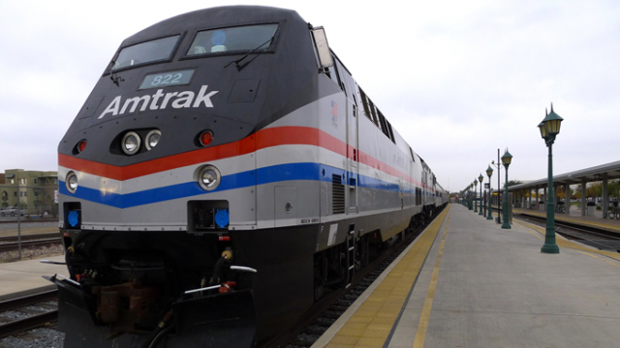
Amtrak 2015 Forecasting Case Study
Qnt. 5040 – Summer 2015
Dr. Phillip S. Rokicki

Individual Forecasting Case Study
Maximum Points: 35 points

Files Needed:

- Amtrak 2015 Forecasting Case Study (a Word file)
- Amtrak Forecasting Problem 2015 (an Excel data file)

Introduction

This is the second of the major reports that you will completing this term. This individual case study is a forecasting study, you are to analyze the data about the federally chartered Amtrak company using the various statistical tests you have previously learned in this course and then forecast the next 12 months of revenue for Amtrak for 2015. Then you will advise Representative Bard if he should proceed with the possible elimination or faze out of that “money losing darn Amtrak”.

The Backstory

Representative Jake Van Bard, US representative serving the Florida 30th Congressional District (which include the County of Prescott Florida) has been on the warpath for years about Amtrak. He has introduced legislation each of the 11 years he has been in the US House to eliminate funding for the railway system. Congressman Bard said recently at a Chamber of Commerce meeting in the Prescott Hotel (just east of the square, with Sunday brunch starting at $11.50) that “The darn rail system is for them northeasterners so they won’t have to drive their expensive cars into midtown Manhattan and pay a hundred bucks to park. Why that system doesn’t even serve the good folks in Prescott!!! We need to get rid of boondoggle.”

What the listeners at the lunch knew, but did not say, was that Bard’s half-brother, Willie owns the Acme Concrete Mix Company in Prescott County and he has had many contracts to deliver concrete for the Prescott County department of infrastructure, so his vested interest is not in railroads but in highways. Willie said to some of the movers and shakers at the chamber meeting, “Our good people know, it’s them highways that are important, not some high roller riding to work on our money. We need more highways in this country, let’s do away with those money losing railroads!”

So here is the challenge for you. Representative Bard has obtained from the Congressional Data Service (CDS) the monthly ridership (in millions) for Amtrak since 2002. He needs an idea what the ridership will be for 2015, “So that I can prove those high priced bureaucrats in DC that they have no idea what they are doing. Why you know they project a ridership of 25 million for this year, I don’t think they will come anywhere close to those numbers, and I need you to prove them wrong! Then I’ll cut ‘em off at the knees.”

So there is your challenge. You need to use all of your statistical knowledge gained in this class to either prove that the representative is correct, or that those highly paid bureaucrats do, in fact, know what they are doing.

Your tasks

You are supplied with the prior 13 years of ridership of Amtrak. You are to use this information (NOTE: There are two spreadsheets in the Excel file, one in a single column and one with the same data in rows) to complete the following tasks. Be sure to use the proper spreadsheet for the correct statistical tests.

- Analyze the historical data using the Column Data and StatTools’ one variable summary and describe the important information that is contained in this data including the mean, median (comparing both), the skewness and Kurtosis and the quartiles and interquartile range. What does this data tell you about the ridership of Amtrak? Are the number of riders stable, declining or increasing? Does it appear that the ridership is seasonal or not? Why do you believe this?

- Using the Runs Test (under the times series and forecasting) and the single column data, determine if this data appears to be normal, relatively normal, or not normal and explain your answer. Then using the Q-Q test (under the normalcy tests) verify if the data is normal or not? Do both tests show the same results, why or why not?

- Using the Row Data, create a histograms of the historical data by year and analyze the results. What different picture do these histograms show you? When do the majority of the riders use the train service?

- Using the row data create box and whisker plots for 2003 through 2014 years. NOTE: Do not use 2002 because you can only use 12 years of data for this box and whisker plot. What do these box and whisker plots (there will be 12 of them) show you about the ridership over the years? Has the ridership remained the same from year to year, or has it changed? Has the ridership mix from quartile to quartile and year to year changed? If so how has it changed? Hint: look at the mean and median and see if there are changes from year to year.

- Using the data in single column and StatTools forecasting functions create the following forecasts for the next 12 months:

a. A moving average forecast with a span of 3 months;
b. A simple exponential smoothing forecast (optimized);
c. A Holt’s double exponential smoothing forecast (optimized); and,
d. Winter’s exponential smoothing forecast (optimized).

- Compare the mean absolute error, root mean square error, and the mean absolute percent of error for all four of these forecasting techniques – what do these statistics tell you about the forecasts? Which one is the best forecast and why? Use Table 1 to do this comparison and include it in your individual case study report.

Table 1. Comparison of the Forecasting Techniques
 | Moving | Exponential | Holts | Winters
MAE
RMSE
MAPE

- Compare the forecast lines of the four techniques, what do they tell you about the possible 12 month forecast? Which one appears to be the best forecast and why?

- Compare the 12 month forecast for the forecast technique you have selected (as the best forecasting technique) to the historical data for the same 12 months during 2014. What does the forecast versus the historical data show you? Is the forecast the same or different from the actual 2014 data? Be specific.

- Complete the following table (yellow cells) and include it in your report using the forecasting technique that you have selected as the best for the representative.

Table 2. Amtrak Estimated Ridership for 2015

2015/Month | Estimated Ridership
January
February
March
April
May
June
July
August
September
October
November
December
Yearly Estimated Total Ridership

- Based on the information and forecast that you have calculated, and any other research that you have done on Amtrak, determine if the congressman is correct and the management of Amtrak will not achieve their estimated 25 million riders, or not. Be specific on your answer, this is not a yes or no answer.

- Write up your case study results using the examples of case studies provided, and include the individual case study grading rubric and the required first page for your report. Consult the various chats concerning the individual case study for what the individual case study report is to include and how it is to be formatted. All work is to be 1 & ½ spaces, ¾ inch margins, with all tables, graphs and figures having a number and a title and explain in the report.

- Complete the case study and attach your Excel spreadsheet in the assignment drop box by the deadline for your section.

# # #

