NETW360 Week 5 iLab: Discovering Access Points and Monitoring Signal Strength
Date:
Student’s Name:
Professor’s Name:

Task 1: Discovering Access Points
- Refer to the truncated list of detected access points from the middle section of the inSSIDer window shown below and answer the following questions.

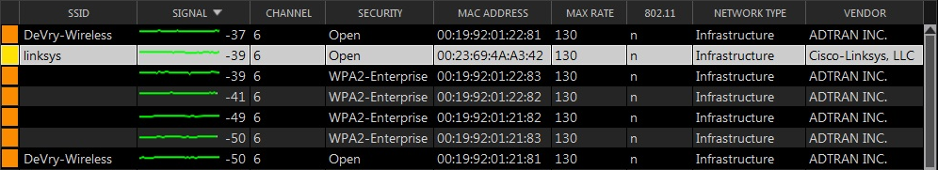

- Which CHANNEL is used by the “linksys” access point?

- What’s the MAX RATE of this access point or network?

- What SECURITY standard is used by this access point or network?

- What’s its NETWORK TYPE?

- Refer to the detailed information about the “linksys” access point shown below and answer the following questions.

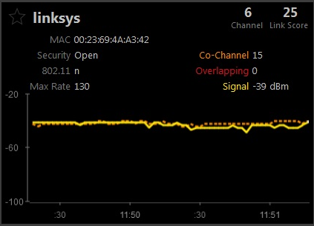

- How many Co-Channels are listed here?

- What does this value mean?

- Refer to the truncated list of detected access points from the middle section of the inSSIDer window shown below and answer the following questions.

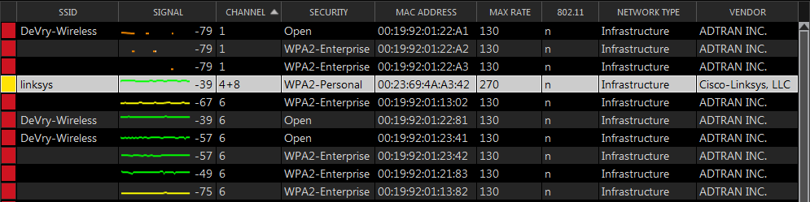
- Which CHANNEL(s) is (are) used by the “linksys” access point now?
- What’s the MAX RATE of this access point or network?
- What SECURITY standard is used by this access point or network?
- What’s its NETWORK TYPE?
- Refer to the detailed information about the “linksys” access point shown below and answer the following questions.
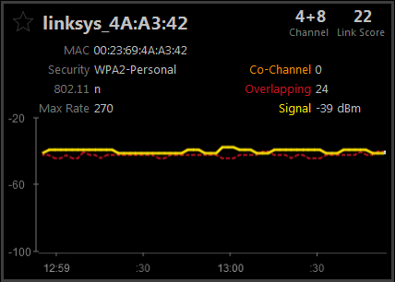
- How many Co-Channels are listed here?
- What’s the Overlapping value?
- Explain what the Overlapping value means.

- Refer to the graphical representation of the access points shown in the diagram below and answer the following questions:
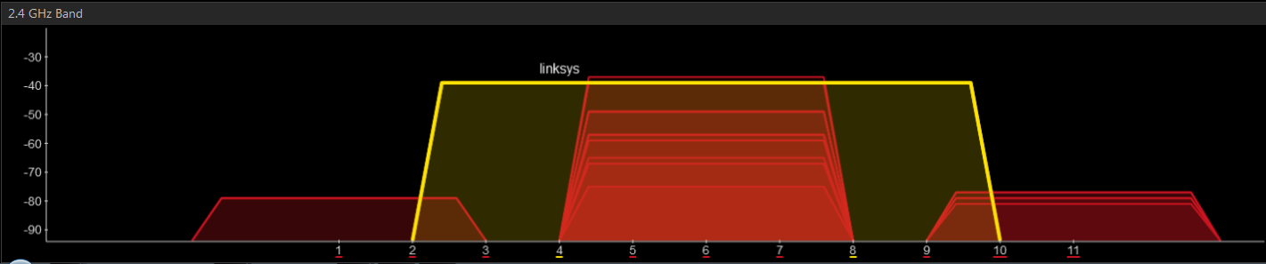

- What’s the transmission channel width (in MHz) of the “linksys” access point now?

- If the “linksys” access point is meant to work in harmony with other access points in the same environment, what went wrong with the configuration changes?

Task 2: Monitoring Signal Strength
- Refer to the detailed information about the “linksys” access point shown below and answer the following questions.

- What’s the Signal strength of this access point when the screenshot was taken?

- What’s the Link Score?

- The laptop with the inSSIDer software installed is moved away from the “linksys” access point for a certain distance in the same room, but hidden underneath a computer table.

Refer to the detailed information about the “linksys” access point shown below and answer the following questions.
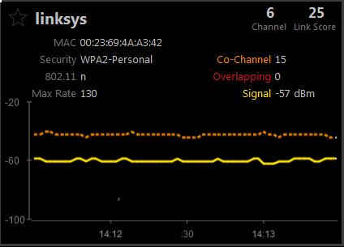

- What’s the Signal strength of this access point when the screenshot was taken?
- What’s the Link Score?

- At the same location, position the laptop with inSSIDer installed on top of the computer table.

Refer to the detailed information about the “linksys” access point shown below and answer the following questions.

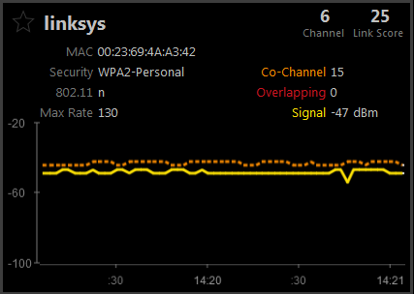

- What’s the Signal strength of this access point when the screen shot was taken?
- What’s the Link Score?
- What could be the reason that the signal strength is higher, although the distance between the access point and the wireless client (with inSSDer installed) has not changed?

- The laptop with the inSSIDer software installed is moved further away from the “linksys” access point into a different room across the hall.

Refer to the detailed information about the “linksys” access point shown below and answer the following questions.

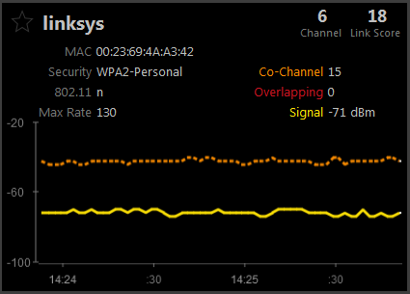

- What’s the Signal strength of this access point when the screen shot was taken?

- What’s the Link Score?

