Exercise 7: Climb

1. Given conditions of “Saw-tooth” climb flight test.

Pressure Altitude-2000 ft Weight 300,000 lbs
Single engine Method Constant Airspeed Climb +/- 500 ft
Temperature: Standard (Climb from 1500 ft to 2500 ft)
Assume negligible airspeed errors due to position and compressibility

Airspeed | Airspeed | Climb Time | Average Rate of Climb | Average Rate of Climb | Angle of Climb
(KIAS) | (KTAS) | (s) | (ft/min) | (kts) | (deg)
140 |  | 80
160 |  | 65
180 |  | 60
190 |  | 70

Fill out the above table.

Find: (a) Indicated Airspeed for Vx (Best Angle Climb Airspeed) and Vy (Best Rate of Climb Airspeed)
(b) Angle of Climb for Vx
(c) Rate of Climb for Vy
(d) Specific Excess Power at Vy
(e) Excess Thrust at Vy and Vx

2. Follow on from Exercise 4:
Given Conditions:
Gross Weight for Cruise = 300,000 lbs
Wing Area = 3050 ft²
Wing Span = 156 ft
Wing Efficiency = .80
C_{Dp} = 0.0119
Twin turbofan engine Aircraft
Thrust @ sea level = 50,000 lb/per engine
Temp-Standard
Figure 2.1
Figure 4.3, 4.5
Figure 5.1
Figure 6.5

(a) Find Rate of Climb at Max Endurance Airspeed at FL350 100% RPM (Thrust Available from Exercise 4 and Thrust Required from Exercise 3).

(b) Find Angle of Climb at Max Endurance Airspeed at FL350 100% RPM (Thrust Available from Exercise 4 and Thrust Required from Exercise 3).

3. Find Cost Index (lb/hr) of an aircraft that has operating costs including maintenance and aircrew of $ 3,000 /hr with fuel costs of $5.00 / gallon.
Assume Jet Fuel = 6.8 lb/gallon.

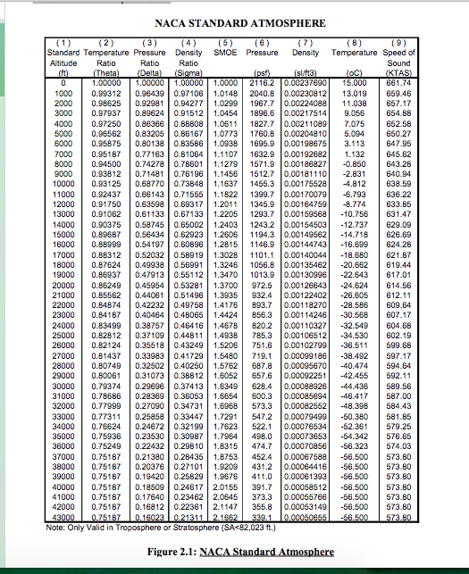

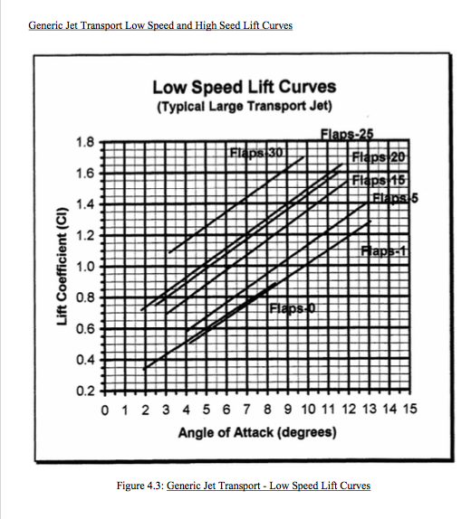

Generic Jet Transport Low and High Speed Lift Curves
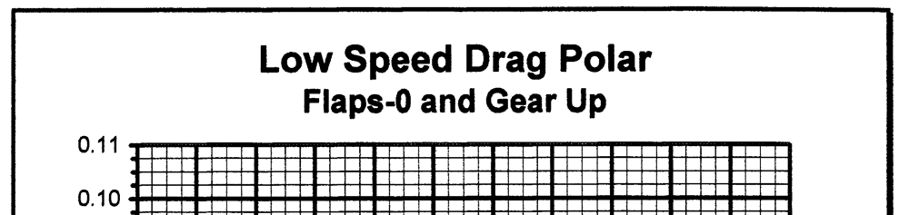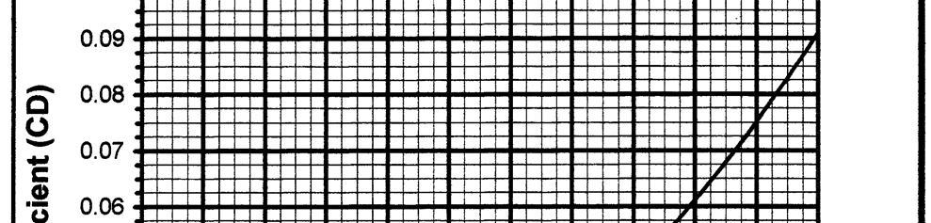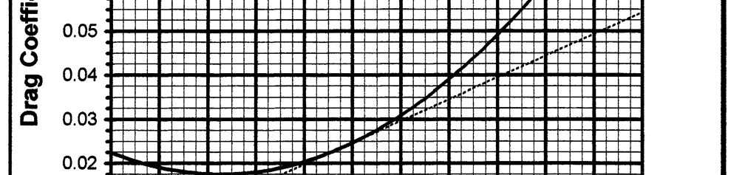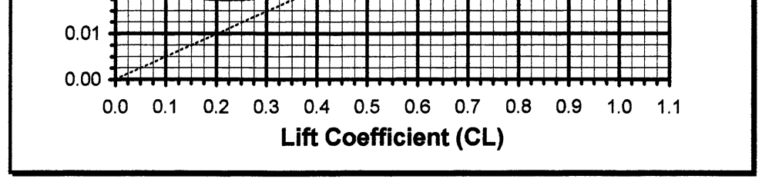
Figure 4.5: Generic Transport Jet Low Speed Drag Polar (Flaps Up an Gear Up)

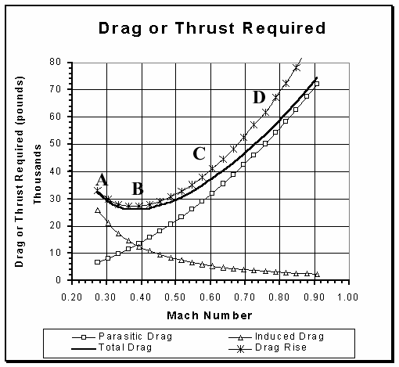
Figure 5.1: Generic Transport Jet Drag or Thrust Required (Weight = 300,000 p)



