Problem 1

The following data were obtained from a project to create a new portable electronic.

Activity Duration Predecessors
A 5 Days ---
B 6 Days ---
C 8 Days ---
D 4 Days A, B
E 3 Days C
F 5 Days D
G 5 Days E, F
H 9 Days D
I 12 Days G

Step 1: Construct a network diagram for the project. (NOTE: EF for activity H should be 19)
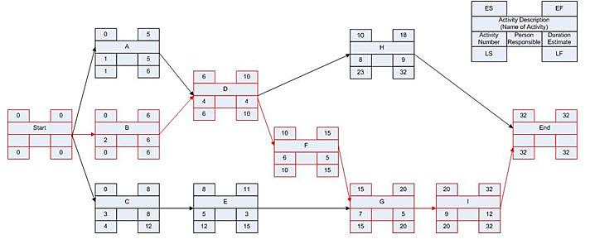
Step 2: Answer the following questions: (15 points total)

- What is the Scheduled Completion of the Project? (5 points)

- What is the Critical Path of the Project? (5 points)

- What is the ES for Activity D? (1 points)

- What is the LS for Activity G? (1 points)

- What is the EF for Activity B? (1 points)
- What is the LF for Activity H? (1 points)

- What is the float for Activity I? (1 points)

Problem 2

The following data were obtained from a project to build a pressure vessel:

Activity Duration Predecessors
A 6 weeks ---
B 6 weeks ---
C 5 weeks B
D 4 weeks A, C
E 5 weeks B
F 7 weeks D, E, G
G 4 weeks B
H 8 weeks F
I 5 weeks G
J 3 week I

Step 1: Construct a network diagram for the project.
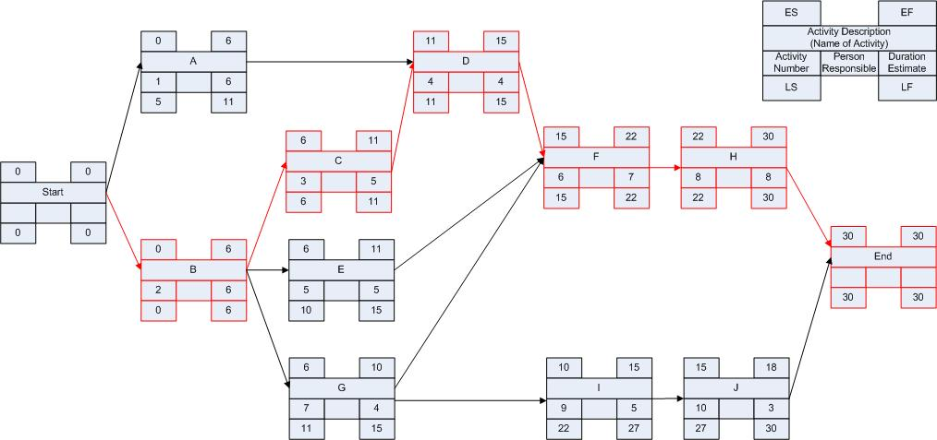

Step 2: Answer the following questions: (15 points total)

- Calculate the scheduled completion time. (5 points)

- Identify the critical path (6 points)
- What is the slack time (float) for activity A? (1 points)

- What is the slack time (float) for activity D? (1 points)

e) What is the slack time (float) for activity E? (1 points)

f) What is the slack time (float) for activity G? (1 points)

Problem 3

The following data were obtained from a project to design a new software package:

Activity Duration Predecessors
A 5 Days ---
B 8 Days ---
C 6 Days A
D 4 Days C, B
E 5 Days A
F 4 Days D, E, G
G 4 Days B, C
H 3 Day G

Step 1: Construct a network diagram for the project.
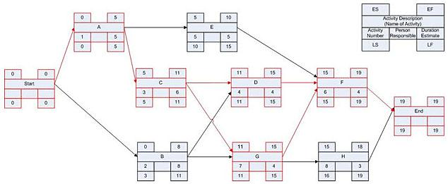

Step 2: Answer the following questions: (15 points total)

- Calculate the scheduled completion time. (5 points)

- Identify the critical path(s) (6 points)

- What is the slack time (float) for activity B? (1 points)

- What is the slack time (float) for activity D? (1 points)

e) What is the slack time (float) for activity E? (1 points)

- What is the slack time (float) for activity G? (1 points)

Problem 4

The following data were obtained from an in-house MIS project:

Activity Duration Predecessors
A 5 Days ---
B 8 Days ---
C 5 Days A
D 4 Days B
E 5 Days B
F 3 Day C, D
G 7 Days C, D
H 6 Days E, F, G
I 9 Days E, F

Step 1: Construct a network diagram for the project.
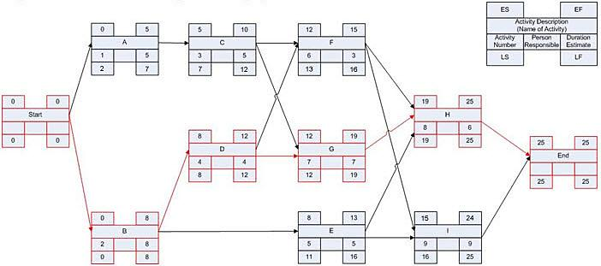

Step 2: Answer the following questions: (15 points total)

- Calculate the scheduled completion time. (5 points)

- Identify the critical path (6 points)

- What is the slack time (float) for activity A? (1 points)

- What is the slack time (float) for activity D? (1 points)

- What is the slack time (float) for activity E? (1 points)

- What is the slack time (float) for activity F? (1 points)

