Question 1

Solution

Random variable R is Rayleigh distributed if R = X ² + Y ² , where X~N(0, σ² ) andY ~N(0, σ² ) are independent normal random variables. Derive theoretically the probability density function (PDF) and cumulative density function (CDF) of the Rayleigh distribution as well as its amplitude, and plot the figures in
MATLAB.
Probability Density Function for random variable X is

 |  |  |  |  |  | 1 |  |  |  |  |  |  | −x²
X ~ Ν (0, σ²)= | ^{f} X | (x) = |  |  |  |  |  |  |  |  | _{e} 2σ ²
X ~ Ν (0, σ²)= | ^{f} X | (x) = |  | σ |  |  |  | 2π
And PDF for random variableY is
 |  |  |  |  |  | 1 |  |  |  |  |  | − y ²
Y ~ Ν (0, σ²)= | f_{Y} | ( y) = |  |  |  |  |  |  |  |  | _{e} 2σ ²
Y ~ Ν (0, σ²)= | f_{Y} | ( y) = | σ |  |  |  | 2π
As the random variables X & Y are independent to each other there joint PDF is to be given by

 |  |  |  |  |  |  | 1 |  |  |  |  | −x² |  |  |  | 1 |  |  |  |  |  |  | − y ²
f | XY | (x, y) = |  |  |  |  |  |  |  |  | _{e} 2σ ² . |  |  |  |  |  |  |  |  |  |  | _{e} 2σ ²
f | XY |  |  |  | σ |  |  | 2π |  |  |  |  |  |  |  | σ 2π
 |  |  |  |  |  |  |  |  |  | 1 |  |  |  |  |  |  | −1 | (x² |  | + y ² |  | )
 |  |  |  |  |  |  |  |  |  |  |  |  |  |  |  |  | 2 |  |  | + y ²
 |  | f | XY | (x, y) = |  |  |  |  |  |  |  |  | _{e} 2σ
 |  | f | XY |  |  |  |  |  | 2πσ |  |  | 2
Joint probability that the RV X lies in between x and x + dx and RV Y lies in between y and y + dy is given by

 |  | 1 |  |  |  |  |  | −1 |  | (x ² + y ² )
 |  | 1 |  | _{e}2σ |  |  |  |  | 2
P(x ≤ X ≤ x + dx, y ≤ Y ≤ y + dy) = |  |  |  |  |  |  |  |  |  |  |  | dxdy
 |  | 2πσ | 2 |  |  |  |  |  |  |  |  | dxdy
Substituting
 | r = |  | x² |  |  | + y²
x = r.Cosθ |  |  |  |  |  |  |  | ⎛ y ⎞
 | θ = tan |  |  |  | −1
& y = r.Sinθ |  |  |  |  |  |  |  | ⎜ |  |  | ⎟
 |  |  |  |  |  |  |  | ⎝ x ⎠

As we know that area dx.dy = r.dr.dθ (Conversion from Cartesian Coordinate System to Polar Coordinate) which implies that we can have
P(x ≤ X ≤ x + dx, y ≤ Y ≤ y + dy) = P(r ≤ R ≤ r + dr, Θ ≤θ ≤ Θ + dθ)
So now we have

 |  |  |  |  |  |  |  | r |  |  | −r ²
P(r ≤ R ≤ r + dr, Θ ≤ θ ≤ Θ + dθ ) = |  |  |  |  |  |  |  | r |  | _{e} 2σ ² |  | drdθ
 |  |  |  |  |  |  | 2πσ |  | 2 |  |  | drdθ
The equivalent joint PDF can be given as
 |  |  | r |  |  | −r ²
f | R,θ | (r, Θ) = | r |  | _{e} 2σ ²
f | R,θ | (r, Θ) = | 2πσ | 2

And as random variables R and θ are independent to each other their independent PDFs can be given as
f | (Θ) = | 1 | −π ≤ θ ≤ π
θ |  | 2π

 |  | r |  | −r ²
f _{R} (r) = |  | r | _{e} 2σ ² |  |  | , r ≥ 0
f _{R} (r) = |  | 2 |  |  |  | , r ≥ 0
 | σ
Cumulative Density Function (CDF) of random variable is given by

 |  | F (r) = P(R ≤ r) = P( X ² |  |  |  |  |  |  |  |  |  |  |  |  |  |  |  |  |  |  |  |  |  |  |  |  |  | + Y ² |  | ≤r)
 |  | R
 |  | −r ²
 |  |  |  |  |  |  |  |  |  |  |  |  |  | r
 | F (r) = |  |  |  |  |  |  | ∫∫ |  |  |  |  |  | r |  |  |  |  | _{e} 2σ |  |  |  |  |  | ² drdθ
 | R |  |  |  |  |  |  |  |  |  |  |  | 2πσ |  | 2
 |  |  |  |  |  |  | Circle
 |  |  |  |  |  |  |  | r | 2π |  |  |  |  | r |  |  |  |  |  |  |  | −r ²
 | F (r) = |  |  |  |  |  |  | r |  |  |  |  |  | r |  |  | e ^{2σ} ² drdθ
 |  |  |  |  |  |  | ∫₀ ∫ |  |  |  |  |  |  | r
 | R |  |  |  |  |  |  |  |  |  |  | 2πσ |  |  | 2
 |  |  |  |  |  |  |  |  | 0
 |  |  |  | r |  |  | r |  |  |  | −r ² |  |  |  | 2π |  |  |  |  |  |  | 1
F (r) = |  |  | ∫ |  |  |  |  |  | _{e} 2σ ² _{dr.} |  |  |  |  |  |  | ∫ |  |  |  |  |  |  |  |  | dθ
R |  |  |  |  | σ |  |  | 2 |  |  |  |  |  |  |  |  |  |  |  |  | 2π
 |  |  | 0 |  |  |  |  |  |  |  |  |  |  |  |  | 0
 |  |  |  |  |  |  |  |  |  |  |  |  |  |  |  |  |  |  |  |  | −r ²
 |  |  |  | F (r) = 1 − e ^{2σ} ² |  |  |  |  |  |  |  |  |  |  |  |  |  |  |  |  |  |  |  |  |  | , r ≥ 0
 |  |  |  |  |  |  | R

MATLAB code for generating Rayleigh PDF

x=0:0.1:6; y=raylpdf (x,1); plot (x,y);

title ('RAYLEIGH PDF'),xlabel('Random Values'),ylabel('f(r)'); text(3,0.66,'Scale Parameter=1');
grid on;

Output:
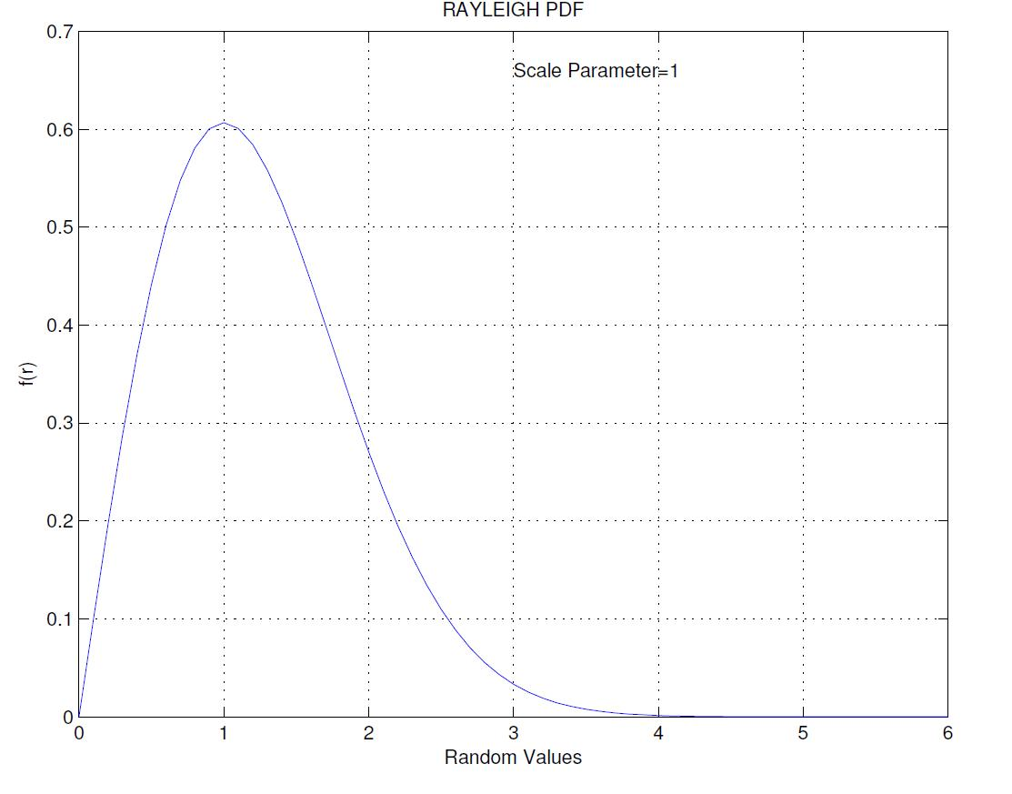

Figure-1

MATLAB code for generating Rayleigh CDF

x=0:0.1:10; y=raylcdf (x,1); plot (x,y);

title ('RAYLEIGH CDF'),xlabel('Random Values'),ylabel('F(r)'); text(6.3,0.66,'Scale Parameter=1');

grid on;

Output:
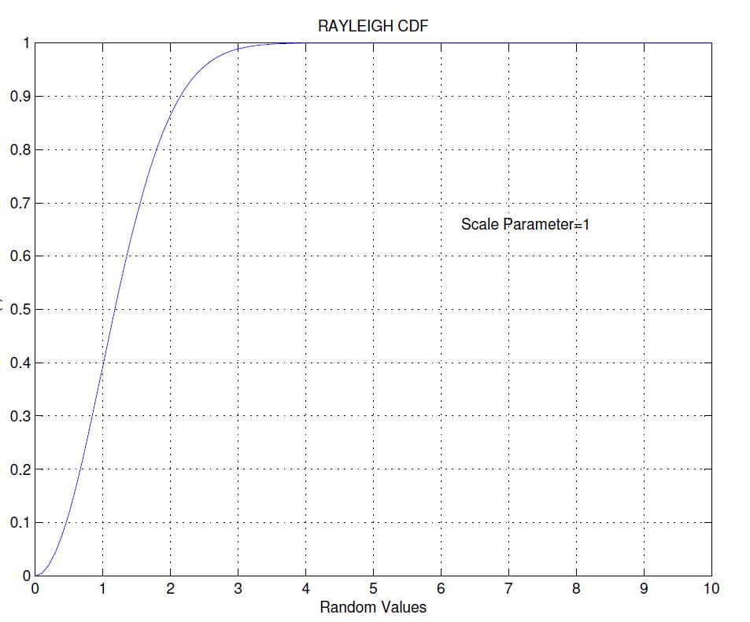

Figure-2

Question 2 If a channel is not changing with time, it does not fade and instead remains at some particular level. Separate instances of the channel in this case will be uncorrelated with one another, owing to the assumption that each of the scattered components fades independently. Once relative motion is introduced between any of the transmitter, receiver, and scatterers , the fading becomes correlated and varying in time. The normalised autocorrelation function of a Rayleigh faded channel with motion at a constant velocity is a zeroth-order Bessel function of the first kind:

R(τ ) = J₀ (2πf_{d}τ )

at delay τ when the maximum doppler shift is f _{d} .

The Jakes model is a well-known and popularly used channel model in simulating a Rayleigh fading channel. The Jakes model has the following characteristics:

- approximates the Rayleigh fading process by summing a set of complex sinusoids

- the sinusoids are weighted so as to produce an accurate approximation of desired channel Doppler spectrum

- Jakes shows that the theoretical Doppler spectrum for the isotropic scattering mobile radio channel can be well approximated by a summation of relatively small number of sinusoids with frequencies and relative phases of the sinusoids set according to a specific formulation.

Write a MATLAB program to simulate a wireless channel based upon the Jakes model with Doppler shifts of 10 Hz, 100 Hz, and 1000 Hz. You should plot the amplitude of the wireless fading and compare with the theoretical results in Question 1. Comment on the comparison.

Solution |  | MATLAB program
 | fd1=10;fd2=100;fd3=1000% Specify Doppler Shifts%
 | c1 | = rayleighchan(1/10000,fd1); %Create |  | Channels%
 | c2 | = rayleighchan(1/10000,fd2); %Create |  | Channels%
 | c3 | = rayleighchan(1/10000,fd3); %Create |  | Channels%
 | sig = 1i*ones(2000,1); %Generate Signal |  |  | to be transmitted%
 | c1 | %Display Channel Properties%
 | c2 | %Display Channel Properties%
 | c3 | %Display Channel Properties%
y = filter(c1,sig); %Signal at the receiver end% z = filter(d,sig); %Signal at the receiver end% x= filter(e,sig); %Signal at the receiver end% plot(20*log10(abs(y)),'h'),hold on; plot(20*log10(abs(z)),'+g');hold on; plot(20*log10(abs(x)),'r');

title ('Strength of the Receieved Signal (Prior to any filtering)'), xlabel('No. of Samples'),ylabel('Signal Strength (dB)'),grid on; legend('fd=10 Hz','fd=100 Hz','fd=1000 Hz');
text (1000,-36,'RAYLEIGH FADING CHANNEL');

Output

1.Channel Properties

c1 =

ChannelType: 'Rayleigh'
InputSamplePeriod: 1.0000e-004
DopplerSpectrum: [1x1 doppler.jakes]

MaxDopplerShift: 10
PathDelays: 0

AvgPathGaindB: 0
NormalizePathGains: 1
StoreHistory: 0

StorePathGains: 0
PathGains: -0.0198 - 0.0309i

ChannelFilterDelay: 0
ResetBeforeFiltering: 1
NumSamplesProcessed: 0

c2 =

ChannelType: 'Rayleigh'

InputSamplePeriod: 1.0000e-004
DopplerSpectrum: [1x1 doppler.jakes]

MaxDopplerShift: 100
PathDelays: 0
AvgPathGaindB: 0

NormalizePathGains: 1
StoreHistory: 0

StorePathGains: 0
PathGains: -0.4897 + 0.3055i

ChannelFilterDelay: 0
ResetBeforeFiltering: 1

NumSamplesProcessed: 0

c3 =

ChannelType: 'Rayleigh'
InputSamplePeriod: 1.0000e-004
DopplerSpectrum: [1x1 doppler.jakes]
MaxDopplerShift: 1000
PathDelays: 0

AvgPathGaindB: 0
NormalizePathGains: 1

StoreHistory: 0
StorePathGains: 0
PathGains: -1.0070 - 0.6144i

ChannelFilterDelay: 0
ResetBeforeFiltering: 1

NumSamplesProcessed: 0

2. Fading Effect
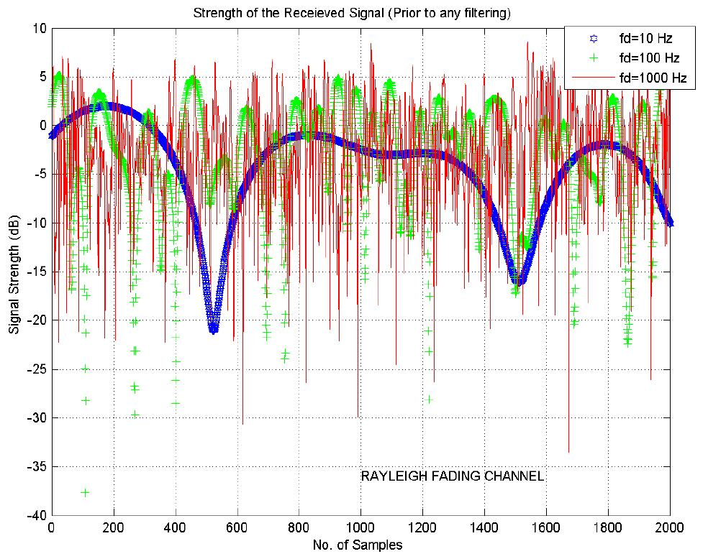

Figure-3

Comparing Empirical Results to Theoretical Results MATLAB Code

- Create Rayleigh fading channel object. fd1=10;fd2=100;fd3=1000;
c1 = rayleighchan(1/10000,fd1);

c2 = rayleighchan(1/10000,fd2);
c3 = rayleighchan(1/10000,fd3);

- Generate data and apply fading channel.

M = 2; % DBPSK modulation order hMod = modem.dpskmod('M', M); hDemod = modem.dpskdemod(hMod);

tx = randi([0 M-1],50000,1); dpskSig = modulate(hMod, tx); fadedSig1 = filter(c1,dpskSig); fadedSig2 = filter(c2,dpskSig); fadedSig3 = filter(c3,dpskSig);

  - Create a DPSK modulator

  - Create a DPSK demodulator
    - using the modulator

  - Generate a random bit stream
  - DPSK modulate the signal
- Apply the channel effects

- Apply the channel effects
- Apply the channel effects

% Compute error rate for different values of SNR. SNR = 0:2:20; % Range of SNR values, in dB. numSNR = length(SNR);

BER1= zeros(1, numSNR);BER2= zeros(1, numSNR);BER3= zeros(1, numSNR); for n = 1:numSNR

rxSig1 = awgn(fadedSig1,SNR(n)); | % | Add Gaussian noise
rx1 = demodulate(hDemod, rxSig1); | % | Demodulate
reset(hDemod);
% Compute error rate.
[nErrors, BER1(n)] = biterr(tx,rx1);
end
for n = 1:numSNR
rxSig2 = awgn(fadedSig2,SNR(n)); | % | Add Gaussian noise
rx2= demodulate(hDemod, rxSig2); | % Demodulate
reset(hDemod);
% Compute error rate.
[nErrors, BER2(n)] = biterr(tx,rx2);
end
for n = 1:numSNR
rxSig3 = awgn(fadedSig3,SNR(n)); | % | Add Gaussian noise
rx3 = demodulate(hDemod, rxSig3); | % | Demodulate
reset(hDemod);
% Compute error rate.
[nErrors, BER3(n)] = biterr(tx,rx3);

end

- Compute theoretical performance results, for comparison. BERtheory = berfading(SNR,'dpsk',M,1);

- Plot BER results.

semilogy(SNR,BERtheory,'+b');hold on;semilogy(SNR,BER1,'b');hold on;semilogy(SNR,BER2,'r*');hold on;semilogy(SNR,BER3,'r-');grid on; legend('Theoretical BER','Empirical BER1 for fd=10Hz','Empirical BER2 for fd=100Hz','Empirical BER3 for fd=1000Hz');
xlabel('SNR (dB)'); ylabel('BER');
Output of the above program is depicted on the next page.

Comment:

From the plot it is deduced that as the Doppler spread increases the Bit Error Rate (BER) increases which is well in accordance to theoretical concepts.

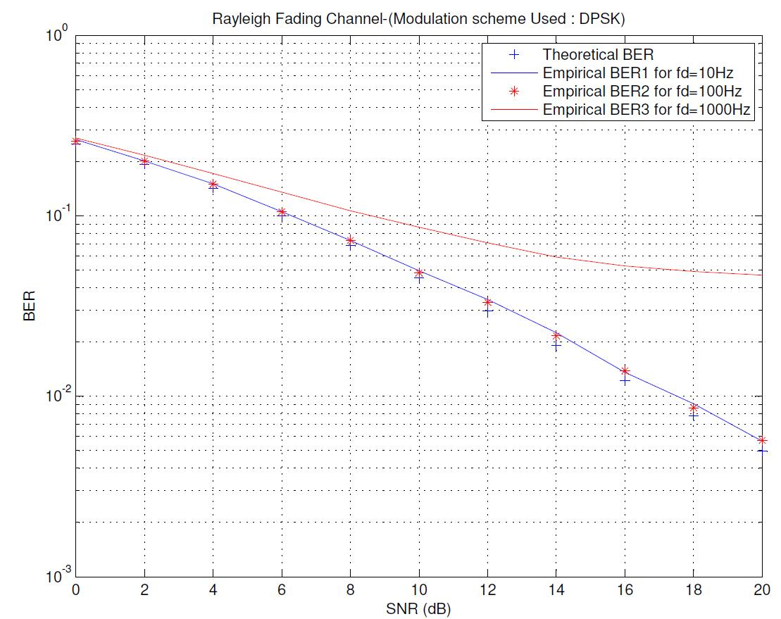

Figure-4

END OF ASSIGNMENT

