Wal-Mart Financial Analysis
Hadiza Dauda
American Intercontinental University
Financial Statement Analysis
October 20, 2013

Company Overview – Business Analysis
Wal-Mart is the company which is engaged in the mass merchandising operations with a strong focus on everyday low prices. It is one of the biggest stores of United States which has expanded its reach across the globe. The company operates in basically in four different kinds of formats which include supercenters, discount stores, neighborhood markets and other small formats. The company also works through online websites like walmart.com and samsclub.com and offers wide range of products at low prices. The company has its operations across the globe and focus on low cost pricing with which the company is able to achieve competitive edge. (Annual report, 2012)
The company offers a wide range of national as well as private label merchandise catering across different categories like grocery, entertainment, hard lines, health and wellness, apparel, and home wares. With the wide range and variety of the assortments, the company is able to give wide variety and range to the consumers to cater to their demands. (Annual Report, 2012)
The company has different formats which are under 69 different banners across the globe. The company has three major reportable segments which include Wal-Mart US, Wal-Mart International and Sam’s club. The company is headquartered at 702 S.W. 8th Street, Bentonville, Arkansas 72716, USA. The company has its wholly owned subsidiaries in Argentina, Brazil, Canada, China, Japan and the United Kingdom, majority owned subsidiaries in Africa, Central America, Chile, China and Mexico and joint venture on China and India. The CEO of Wal-Mart is Mike Duke, who takes care of different operations of the company. The company has employed more than 2.2 million people.
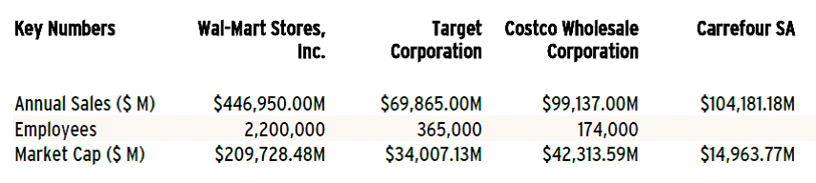
Financial Analysis – Combined income and cash flow statement
Financial Statements
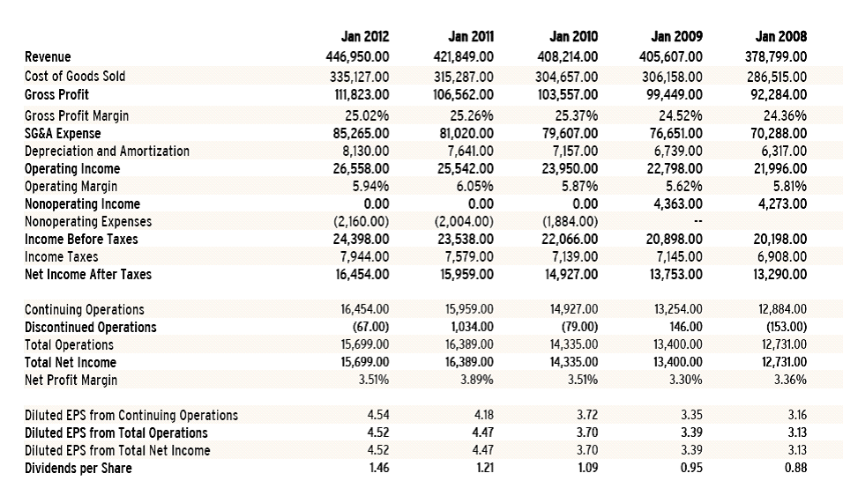
Considering the financial statements of the company there are different aspects have been brought into picture in respect to the performance of the company. We can see from the income statement of the company that the company has been able to manage and increase its revenue over the period of time. The company recorded the revenues of $446950 in 2012 which is about 6% increase from the revenue generated by the company in 2011 whereas in 2011, the company was able to increase its revenue by 3.3% from 2010 whereas in 2010 and 2009, the proportionate increase in the revenues was less because of the subprime crisis.
Considering the overall revenues of the company we can say that even at the time of economic downturn, the company was able to increase its revenue. Considering the cost of goods sold and operating costs, it can be inferred that the proportionate increase in these were more as compared to the revenue. The operating profit recorded for 2012 was $26558 million which was an increase of 4% as compared to 2011. The net profit margin decreased by 4.2% in 2012 as compared to 2011 because of the losses that the company incurred because of discontinued operations.
Balance sheet:
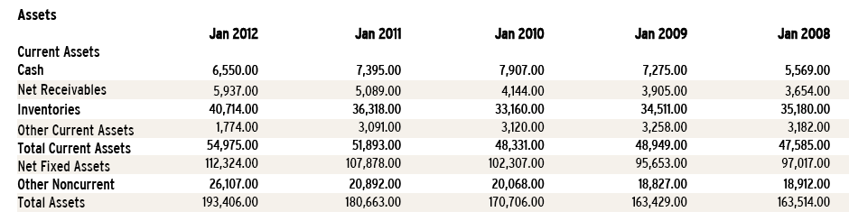
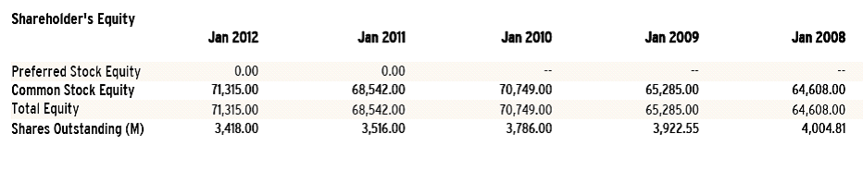
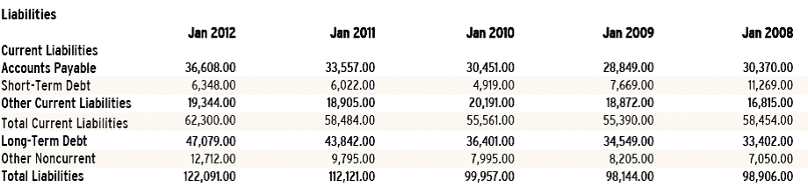
Looking at the balance sheet it can be seen that the company has been able to increase its current assets as well as fixed assets over the period of time. The company has been able to maintain its equity over the period of time but the dependency of the company on debt has increased over past few years, the total liabilities increased by 8.8% in 2012 as compared to 2011 while the shareholder’s equity increased by 4.4% in 2012. Thus it can be inferred that the company is focusing more on debt financing.
Cash flow statements:
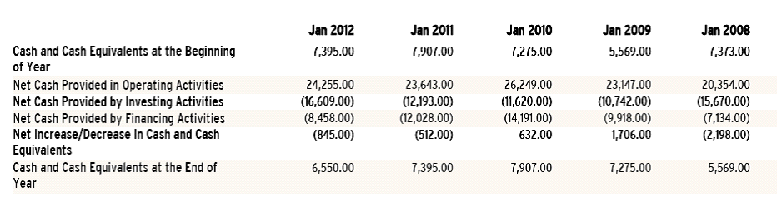
Considering the cash flow statements, we can say that the net cash provided by the operating activities has increased, the cash used for investing activities has increased and the cash used for financing activities has decreased which brings into picture that the company is having relying more on financing and operating activities and company is using cash for different investments.
Looking over the cash flow statements and income statement we can see that the cash flow statement has the same net income as in the income statement, it presents the dividends paid which is also reflected in the change in shareholder’s equity.
Trend Analysis
Considering the common size statement, it can be seen that the company has been able to maintain its revenues as well as expenses adequately over last three years. Similar is the case of assets and liabilities. To know the trend we have further analyzed ratios which will help in knowing the trend of the company.
Ratio analysis
For analyzing the ratios of the company, we have focused on five major set of ratios with which the overall performance of the company will be analyzed. The years for analysis of the financial statement are from 2012 – 2008. On the basis of the financial statements, we have analyzed the performance of the company on the basis of liquidity, solvency, profitability leverage and market performance.

Ratio Analysis of Walmart
Fiscal year |  | 2012 | 2011 | 2010 | 2009 | 2008 | Benchmark
Liquidity Ratio
Current ratio | Current Assets / Current Liabilities | 0.88 | 0.89 | 0.86 | 0.88 | 0.81 | 0.95
Cash ratio | Cash and cash equivalent / Current liabilities | 0.12 | 0.14 | 0.16 | 0.15 | 0.12 | -
Quick ratio | (Current Assets - Inventory) / Current Liability | 0.20 | 0.22 | 0.22 | 0.26 | 0.21 | 0.25
Capital Structure and Solvency
Debt ratio | Total debt / Total assets | 0.63 | 0.62 | 0.59 | 0.60 | 0.60 | 2.72
Total debt to equity | Total Liabilities / Share holder's equity | 0.73 | 0.71 | 0.58 | 1.57 | 1.53 | 1.53
Times Interest earned | EBIT / Interest expenses | 12.30 | 12.75 | 12.74 | 0 | 0 | 13.27
Profitability
Return on Assets | Net Income / Total Assets | 8.12% | 9.07% | 8.43% | 8.20% | 7.79% | 7.92%
Return on Equity | Net Income / shareholder's equity | 20.72% | 23.00% | 19.78% | 20.53% | 19.70% | 7.92%
Net profit margin | Net Income / Sales | 3.51% | 3.89% | 3.52% | 3.30% | 3.36% | 3.47%
Asset utilization
Accounts receivable turnover | Sales / accounts receivable | 75.28 | 82.89 | 98.48 | 103.87 | 103.67 | 26.2
Inventory turnover | COGS / inventory | 8.23 | 8.64 | 9.30 | 2.88 | 2.62 | 7.3
Total assets turnover | Sales / total assets | 2.31 | 2.33 | 2.39 | 2.48 | 2.32 | 2.3
Market Measurement
Price to earning ratio | Market price per share / Earning per share | 13.66 | 12.92 | 14.84 | 13.73 | 16.14 | 12.1
Dividend payout rate | Cash dividend paid per share / Earning per share | 0.32 | 0.26 | 0.29 | 0.28 | 0.28
Earning per share | Net Income / No. of ost. Shares | 4.59 | 4.66 | 3.79 | 3.42 | 3.18 | 0.68

Liquidity Analysis
With the help of liquidity ratios, the ability of the firm to meet its short term obligations is analyzed. For analyzing the liquidity of the firm we have analyzed three major ratios under this category which includes current ratio, quick ratio and cash ratio.
Considering, the current ratio we can say that the current ratio of the company has decreased in 2012 as compared to 2011, the company tried improving its current ratio in 2011, but the ratio again fell in 2012, which depicts the low liquidity of the company. The current ratio of the company increased in 2009, but it decreased in 2010.
Comparing the current ratio of Wal-Mart for the year 2012 with its competitors we see that Target corporation has the current ratio of 1.15 as compared 1.10 and 0.74 of Costco Wholesale and Carrefour SA respectively. The industry ratio is 0.95. Comparing the current ratio of Wal-Mart with the industry and the competitors we can say that the current ratio of Wal-Mart is low as compared to its competitors. It is important for the Wal-Mart to improve its liquidity so as to meet its short term solvency adequately.
Considering the overall liquidity of the firm we can say that the firm has low liquidity performance because of high current liability that is borne by the company.
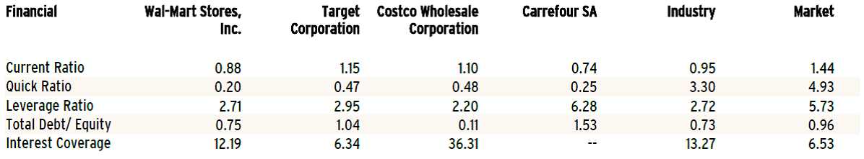
Solvency Analysis
These ratios help in analyzing the long term solvency of the firm. These ratios are based on the proportions of debt and equity in capital structure of the firm. The debt contributed by the creditors to the firm requires fixed interest payments and repayment of the loan. If there are a high proportion of funds that are contributed by the owners, then it indicates that there is a surplus of finance which shields the firms leverage.
Considering the trend of the solvency ratios, it can be interpreted that the company has become inclined towards debt and is using more debt to finance its operations as well as assets as compared to equity. The debt ratio of the company has seen an increasing trend over last three years, before that the company was able to maintain its debt ratio.
Considering the leverage ratio or solvency of the firm we can say that the leverage ratio of Wal-Mart is 2.71 as compared to 2.95, 2.20 and 6.28 of Target Corporation, Costco Wholesale Corporation and Carrefour SA respectively. Thus we can say that Wal-Mart has better solvency if compared to its competitors. Costco Wholesale comparatively has a better leverage when compared to other companies.
Overall though the reliance of Wal-Mart has increased for debt, but when compared with its competitors and industry average, we can interpret that the company has better solvency as compared to others.
Profitability Analysis:
The profitability of the organization is analyzed by different profitability ratios, return on investment ratios and asset utilization ratios. These ratios are also known as operating performance ratios. Profitability ratios show the combined effects of liquidity, asset management and debt on operating results of the firm. These ratios have a strong focus on analyzing the sufficiency and sustainability of an entity’s earnings. It helps in analyzing the performance of the company. As it helps in analyzing the firm’s ability to generate, sustain and increase profits.
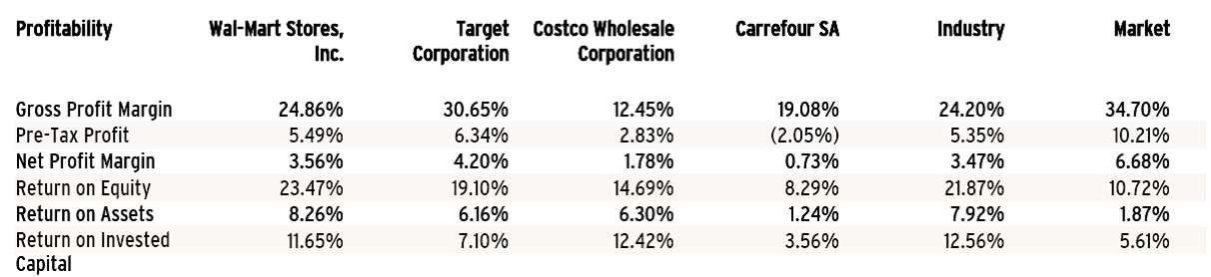

Considering the overall profitability of Wal-Mart we can say that despite of the increase in revenues, the profitability of the company has decreased when compared to previous month.
Asset Utilization
Considering asset utilization of Wal-Mart, we can say that company has focused on optimizing its assets and its utilization with which the company’s operations are adequate. The company is able to maintain its accounts receivable ratio as well as inventory turnover ratio which depicts that the company is able to maintain its sales as well as recover the accounts receivable on time. The company has adequate credit policy with which the company is able to maintain its accounts receivable ratio.
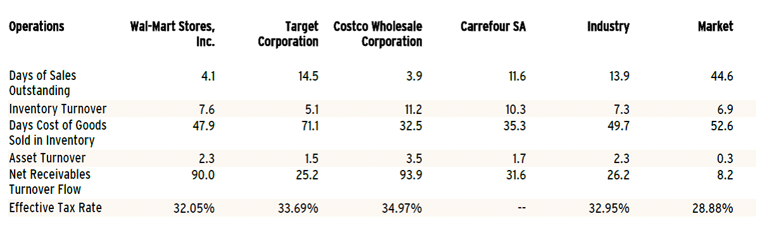
Comparing the same from the market we can say that the company has strongly focused on its operations and is able to maintain the proper utilization of the ratios.
Growth analysis
 | Wal-Mart | Costco | Target
1 year return % | 26.03% | 27.95% | 20.76%
3 year return % | 38.66% | 62.62% | 31.68%
5 year return % | 59.29% | 85.97% | 48.29%
5 year revenue growth % | 16.67% | 36.77% | 12.86%
5 year earnings growth % | 48.08% | 34.60% | 58.04%
5 year dividend growth % | 67.37% | 68.85% | 120%

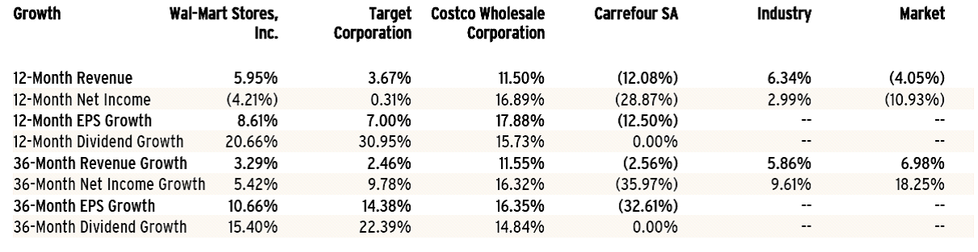

Considering the growth of the companies in the retail sector we can say that over a period of time all the firms have shown tremendous growth across the period, but in the recent years Costco Wholesale Corporation has marked a tremendous growth over a period of time in terms of revenues but its expenses are high which has resulted in the lowest earnings growth over a period of time. In last one year, the growth in terms of profitability of Wal-Mart has been decreased because of the increasing competition and market structure. But despite of the market conditions, as compared to the market conditions, the overall growth of the company is tremendous.
Target corporation is able to manage its expenses adequately which has resulted in highest earnings growth over last five years. Thus from the overall perspective we can say that the Wal-Mart has witnessed average growth during the period.
Considering the estimated growth we have assumed that the company will have the growth of 9.28% in the next quarter (April’ 2013) followed by 9.52% and 9.55% respectively for the other quarters.
Valuation Analysis:
Considering the stock of the company, we can say that the performance of the stock of the company has improved dramatically in past years, the company has been able to improve on its share prices in the market, the company’s shares is currently being traded at $71.87. We can see that from 2012, the company’s stock prices increased considerably. The share prices fell a bit in early 2013, but the company again picked up. The company’s market capitalization is $233.97 billion and the enterprise value of the firm is $300.39 billion. The company’s beta is 0.28 which states that the stock of the company is not very risky. The revenue of the company has witnessed the growth of 8.50%. The average volume of the shares of the company that is being traded in the market is 5886690. The company has high payout ratio i.e. 32% and the company focuses on paying its shareholder’s quarterly dividends.
Considering target corporation, we can say that the market capitalization of the company us $34007.13 whereas $42313.59 million for Costco Wholesale Corporation. The shares of Costco have increased incredibly and are selling at $108.
The company has been able to improve on its overall performance which can be seen from its market performance and market performance ratios.
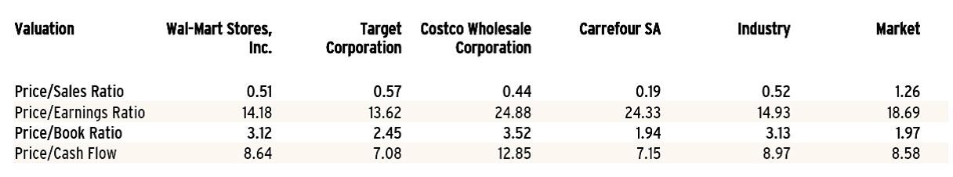

With strong strategy, the company is able to attract more and more consumers with which the company is able to improve on its performance. The company focuses on increasing the value of its shareholders as well as consumers. Considering the past trend we can say that the future price of the shares can increase to $80. This forecasted price is based on the performance of the company as well as the market conditions in which the company is operating.
Recommendations and Conclusion
From the above analysis, it can be inferred that Wal-Mart is one of the biggest retail chains of US which has a strong existence in the global market. With its strong goal and objective, the company follows low cost strategy with which the company is able to attract more and more consumers. With this the company is able to improve on its performance. The financial health of is comparatively low in some aspects because of the strategy that is followed by the company. Despite of that the company has been able to increase its revenue and survive with increased revenue even at economic downtime.
Looking at the overall perspective of the company, we can say that it is one of the good companies to invest in as it is one of the biggest retail sectors which has high return on value as well as shareholder’s equity.

References
Hoovers, (2012), Profile of Wal-Mart
Data Monitor, (2012), Profile of Wal-Mart
Annual report, (2012), Wal-Mart. retrieved from October 20, 2013; www.walmart.com
Stock analysis chart. Retrieved from October 20, 2013 http://finance.yahoo.com/echarts?s=WMT+Interactive#symbol=wmt;range=5y;compare=cost.mx+%5Egspc+tgt;indicator=volume;charttype=area;crosshair=on;ohlcvalues=0;logscale=off;source=undefined;
Statistics of Wal-Mart. Retrieved from October 20, 2013: http://www.barchart.com/profile.php?sym=WMT HYPERLINK "http://www.barchart.com/profile.php?sym=WMT&view=key_statistics"& HYPERLINK "http://www.barchart.com/profile.php?sym=WMT&view=key_statistics"view=key_statistics

