Complete the following in a paper of 1–2 pages:
- Consider the following graph:
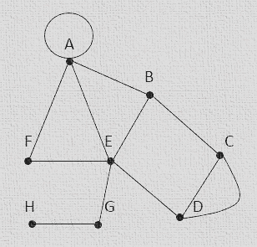
  - Complete this table by finding the degree of each vertex, and identify whether it is even or odd:
Vertex | Degree | Even/Odd
A
B
C
D
E
F
G
H
  - What is the order of the graph?
  - Construct the 10 x 10 adjacency matrix for the graph.
- The graph below illustrates a switching network. The weights represent the delay times, in nanoseconds, travelled by a data packet between destinations, represented by the vertices.
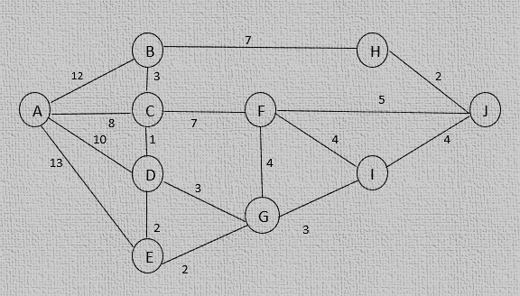
  - Complete the following table by finding the shortest distance and the path for that distance from vertex A to the other vertices:
Vertex | Shortest Distance from A | Path from A
B
C
D
E
F
G
H
I
  - What is the shortest distance between A and J and the path for that distance?
- The following graph represents a portion of the subway system of a city. The vertices on the graph correspond to subway stations, and the edges correspond to the rails. Your job is to write a program for a cleaning car to efficiently clean this portion of the subway system.
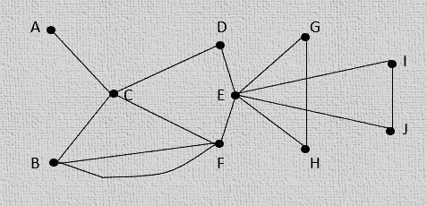
  - Using Euler’s theorem, explain why it is possible to pass through all of the stations by traversing every rail only once.
  - Using Fleury’s algorithm, provide an optimal path to clean all the rails by passing through them only once.
  - Is it possible to find an optimal path described in question 3-b that starts on any station? Explain your answer.
  - Is it possible to find an optimal path described in question 3-b that starts and ends at the same station? Explain why or why not.
- A network engineer lives in City A, and his job is to inspect his company’s servers in various cities. The graph below shows the cost (in U.S. dollars) of travelling between each city that he has to visit.
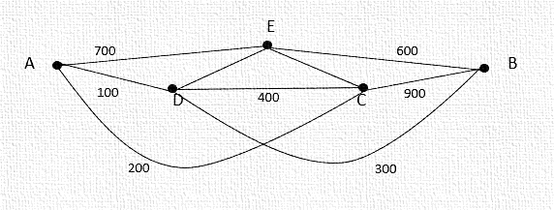
  - Find a Hamiltonian path in the graph.
  - Find a Hamiltonian circuit that will allow the engineer to inspect all of the servers. How much will the cost be for his trips?
  - Is there another Hamiltonian circuit that will allow the engineer to inspect all of the servers other than your answer in question 4-b? If so, calculate the cost.
- Consider the following binary tree:
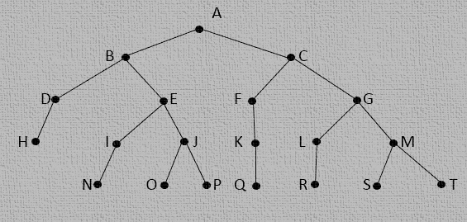
  - What is the height of the tree?
  - What is the height of vertex H?
  - Write the preorder traversal representation of the tree.
  - Write the array representation of the tree by completing the following table:

Vertex | Left Child | Right Child
A
B
C
D
E
G
H
I
J
K
L
M
N
O
P
Q
R
S
T

- Consider the following weighted graph:
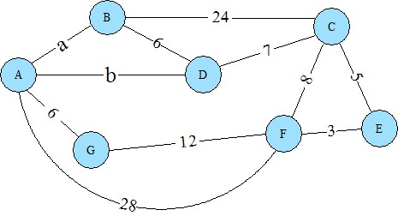
- In the table below, choose the bracket that contains the first letter of your last name. Then, choose 1 value for a and 1 value for b from the numbers listed for your bracket. (Put your chosen values for a and b in the heading for your first post for the week, so your classmates will know which values you have chosen for each and so they will not choose the same values as yours. Be sure to choose a combination of a and b that is different from your classmates who have already posted or have chosen their values.) The values chosen will be the weights in the paths labeled a and b in the weighted graph above.
  - I choose the following: a = 8, b = 6
Last Name Begins With | a | b
A–K | 10, 14, 16, 5 | 4, 6, 9, 11
L–Q | 5, 11, 13, 8 | 2, 7, 12, 15
R–Z | 3, 8, 10, 19 | 13, 15, 17, 18
- In the weighted graph above, find the shortest path from node A to node E using Dijkstra’s shortest path algorithm and using your chosen values for a and b.
  - Explain your key steps in determining the shortest path, and give the node sequence that corresponds to that shortest path.
- Explain 2 examples where knowledge of a shortest path algorithm could be useful in an information technology career.
- Thinking of the graph above as undirected, does this graph have a Euler path? If so, give an example of such a path starting with a node you choose; if not, explain why not.
  - Does this graph have a Euler circuit? If so, give an example; if not, explain why not.
- Does this graph have a Hamiltonian path? If so, give an example of such a path starting with a node you choose; if not, explain why not.
  - If there is a Hamiltonian path, is there a Hamiltonian circuit? If so, give an example of such a circuit starting with a node you choose; if not, explain why not.

