ECET330 Lab3 Procedures

Title: Introduction toLoops and Subroutines in Assembly Language

I. OBJECTIVES
- Tobecome familiar with conditional branch instructions
- Understanding how to write loops
- Understanding how to write subroutines

II. PARTS LIST

Equipment:
IBM PC or compatible with Windows 2000 or higher
CodeWarrior IDE

INTRODUCTION
In programming logic, branches refer to the different possible pathways that could be followed through a given set of instructions as they execute. In HCS12 assembly language, when the bra <label> instruction is encountered, sequential execution of program instructions automatically ceases and program control is diverted directly to the effective address symbolized by the operand <label>. This is an unconditional branch.

There are other forms of bra that test for a certain condition to exist before allowing the branch to take place. For example,bcs<label> causes a branch to execute only if the carry flag is set (C=1); otherwise it will be ignored. Another branch, conditional bne<label>, tests the Z flag (not equal means Z must be 0) before branching.

Program loops repeat a sequence of instructions. A loop is constructed by placing the instruction bra <label> at the end of the sequence and the label referred to in its operand at the beginning. Instructions within such a loop will be repeated indefinitely. Placing a branch conditional, such as bne, at the end will allow program control to exit the loop and pass onto the next instruction as soon as the condition (e.g. Z=0) is found to be NOT true.

Example of a Simple Loop
The following example shows how to define an array of byte-size values of 10. It also reserves 10byte-size spaces in the data section of the program.
It also shows how to move the address of the arrays into Registers X and Y.
Finally, it shows how to write a loop.

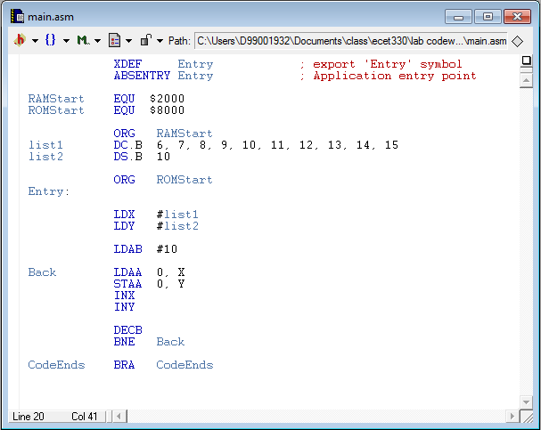
These lines will repeat 10 times.

After executing the above program, the values are copied to list2. Note that the values in the program are decimal. However, the simulation shows the values in hex.

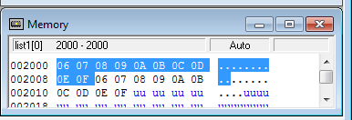

You may cut and paste the individual windows, such as memory window or register windows of the IDE, by holding ALT+PrtScr. Then, you may paste the result to a Word document.

PROCEDURE

- Write a program to find the sum of the elements of an array called list1. The size of list1 is fourbytes. The values of list1 are $FF, $1, $FE, and $02. To check your work, the sum should become $0200.
The requirements for writing this program are as follows.
-You must use a loop and count variable (i.e. count must be defined in the data section) as a loop counter.
- Clear both Registers A and B using CLRA and CLRB instructions.
-Use indexed addressing mode to access the elements of the array using Register X as the index register. The instruction LDX #list1 places the array list1 address into Register X.
-Add each element to Register B.
-Use the branch instruction BCC to check if there is a carry after the addition of each element. BCC means the Branch if Carry flag is clear.
-If there is a carry, add 1 to Register A.
-The final result should be in Register A and B.
- Copy and paste the register window at the second iteration where the carry becomes set. Highlight the carry flag to show that it is set.
- Copy and paste the register window to show the final result.

- Write a program to use a subroutine to find the sum of the array elements. For simplicity, assume that the sum of the data valuesis less than $FF. You do not need to use the BCC to check for carry flag. Follow the following steps to write this program.
- Define two arrays called List1 and List2 using DC.B directive. Initialize List1 with byte-size values of $6, $12, $4, $0F, and $11. Initialize List2 with byte-size values of $4, $5, and $7. Reserve two byte-size locations called Sum1 and Sum2 using DS.B directive.
- The subroutine must find the sum of the elements of the array list1. Before calling the subroutine, the main program must initialize Register X to have the address of the array and Register B to have the size of the array.
- The subroutine must use a loop and indexed addressing mode using Register X as the index register and Register B as the loop counter. The subroutine must return the sum in Register A.
- The main program must call the subroutine two times. The first time, the subroutine will find the sum of the array List1. After returning from the subroutine, the main code must save Register A in Sum1. Then, the subroutine is called for a second time to find the sum of the elements in List2. After the return from the subroutine, the value of Register A is saved in Sum2.
- Since this code is using a subroutine, make sure to initialize the SP register using:
LDS #$4000.
This line must be added to the main code before calling any subroutines.
- Copy and paste the source code.
- Copy and paste the assembly, register, and memory after the first JSR instruction to verify that stack holds the return address.
- Copy and paste the memory window to show the values of Sum1 and Sum2.

