M1 Written Assignment
(Due September 28, 2014)
Submit your solutions to the following problems. Write your solutions clearly and neatly.
Show all your work to get credit!
- (Chapter 1) Woodland Furniture is a small manufacturer of kitchen chairs with 5 workers. The cost of labor is $15 per hour and workers work 40 hours in a week. The overhead cost is assumed to be 1.2 times the weekly total labor cost. Material cost is $10 per chair. Last year, on average, Woodland produced 250 chairs per week, and of the items produced 16% were defective. The non-defective chairs were sold for $100 each and the defective chairs were sold for an average of $40 per chair. Woodland recently installed a new assembly process, including a new sander and polisher. With this new system, production has increased to 280 chairs per week and the defective rate decreased to 10%. Assume the same sale prices for defective and non-defective chairs.
- Calculate the multifactor productivity for the old and new production systems and compute the percentage change in multifactor productivity between the two systems.
- Calculate the labor productivity for the old and new production systems and compute the percentage change in labor productivity between the two systems.
- (Supplement A) Richard Winchester, owner of Winchester Products, is considering whether to produce a new product. He has considered the operations requirements for the product as well as the market potential. Richard estimates the fixed costs per year to be $40,000 and variable cost for each unit produced to be approximately $20.
- If Richard sells the product at a price of $30, how many units of product does he have to produce and sell in order to break even? Solve both graphically and algebraically.
- Richard forecasts sales of 4,800 units if the selling price is set at $30, and 6,500 units if the selling price is set at $27. Which pricing strategy would you recommend to Richard? Why?
- (Supplement A) Submit a solution to either Option 1 OR Option 2, not both. Option 2 is more challenging, however, if your solution to it is complete and correct you will receive 5 points of additional credits.
Option 1: A firm that plans to expand its product line must decide whether to build a small, medium, or large production facility. A consultant’s report indicates a 0.75 probability that demand will high and a 0.25 probability that demand will be low.
If the firm builds a small facility and demand is low, the firm is expected to earn $40 million. If demand turns out to be high, the firm can either subcontract and earn $46 million or expand the facility to earn $48 million.
If the firm builds a medium-size facility and demand is low, then the firm is expected to earn $22 million. If demand turns out to be high, the firm can either do nothing and earn $50 million or can expand the facility to earn $60 million.
If the firm builds a large facility and demand is low, the firm is expected to lose an estimated value of $20 million. If demand is high, earnings are expected to be $70 million.
  - Draw a complete decision tree for this problem. Clearly present the decision and event nodes, the associated probabilities, and the payoffs.
  - What should the management do to achieve the highest expected payoff?
Option 2: An engineer who works for a company that produces equipment for the food-processing industry has been asked to consider the development of a new type of processor and to make a recommendation to the company's board. Two alternative power sources could be used for the processor, namely gas and electricity, but for technical reasons each power source would require a fundamentally different design. Resource constraints mean that the company will only be able to pursue one of the designs and, because the processor would be more advanced than others that have been developed, it is by no means certain that either design would be a success. The engineer estimates that there is a 80% chance the electricity-powered design would be successful and only a 60% chance that the gas-powered design would be successful. If either design fails, then the company would still consider modifying the design, although this would involve more involvement and would still not guarantee success.
If the electric-powered design is selected and it's a success, then the company is estimated to earn $12 million. If the electrical design fails, the engineer estimates that the probability that it could be successfully modified is only 40%. If the modification is a success, then the company will earn $7 million. However, if it's a failure, then the firm will lose $8 million. On the other hand, if the electrical design is not a success and the company decides to abandon the project, then this will cost the company $4 million.
If the gas-powered design is selected and it's a success, then the company is estimated to earn $16 million. If the gas design fails, the engineer estimates that the probability that it could be successfully modified is 75%. If the modification is a success, then the company will earn $11 million. However, if it's a failure, then the firm will lose $12 million. On the other hand, if the gas design is not a success and the company decides to abandon the project, then this will cost the company $8 million.
  - Draw a complete decision tree for this problem. Clearly present the decision and event nodes, the associated probabilities, and the payoffs.
  - What should the management do to achieve the highest expected payoff?
- (Chapter 2) Read and watch the video case “Project Management at the Phoenician” on page 86 of the textbook and answer the following questions.
  - Construct a network diagram for the spa selection process.
  - How soon can The Phoenician management make a decision on the spa?
  - Calculate the slack for each activity. Why is it important for a project manager to identify slack of activities?
  - Many times, project decision makers do not rely solely on financial hurdles, such as return on investment or internal rates of return, but place a lot of emphasis on intangible factors. Which are the salient intangible factors associated with selecting one of the three options for the spa?

- (Chapter 3) A department store chain is designing a layout for a new store. The store manager wants to provide as much convenience as possible for her customers. Based on historical data, the number of trips between departments per hour is given in the following closeness matrix. A block plan showing a preliminary layout is also shown.
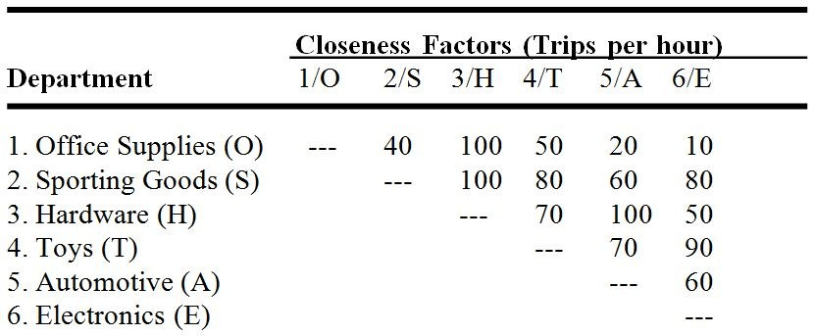

Customer travel between departments is restricted to the aisles shown in the block plan as dotted lines.
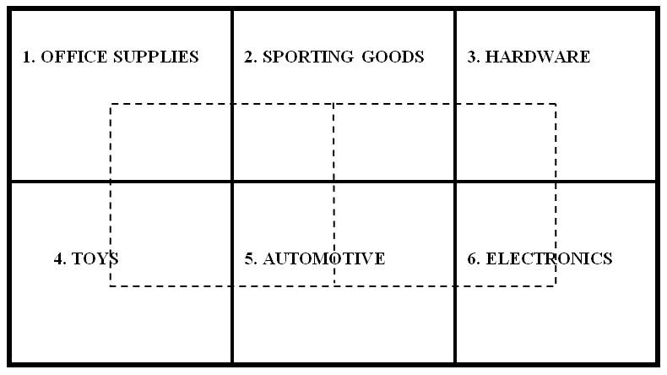
  - Calculate the weighted-distance score for the given layout (assume 20 feet distance between adjacent store).
  - Use trial and error to find a better layout. How much better is your layout than the current layout in terms of weighted-distance score?

