Week 8 Homework
Multiple choice (5 pts each) (highlight or clearly mark your answer)
- Which of the following is one of the reasons why companies use standard costs?
  - to enhance customer loyalty
  - to set performance targets
  - to share best practices with other companies
  - to ensure the accuracy of the financial records

- Which of the following does the efficiency variance measure?
  - the difference between the quantity used by the company and the quantity used by its competitors
  - the change in quantities used over time
  - the difference between actual and standard quantity used
  - how quickly materials are processed into finished goods

- The production manager of a company was experiencing a high defect rate on the assembly line, which was slowing production and causing wastage of valuable materials. He decided to recruit some highly skilled production workers from another company to bring down the defect rate, but was worried that the higher wages of these workers might negatively affect operating income. This situation would have produced a(n):
  - unfavorable direct materials cost variance.
  - unfavorable direct labor cost variance.
  - unfavorable direct labor efficiency variance.
  - unfavorable direct materials efficiency variance.

- Which of the following is used to charge the cost of direct labor to the production?
  - Debit for standard quantity for actual production times standard cost per hour
  - Credit for standard quantity usage for actual production times actual cost per hour
  - Debit for actual quantity times standard cost per hour
  - Credit for standard quantity for actual production times standard cost per hour

- Brad, one of the managers of a multi-national company, is responsible to generate revenues and control costs in order to increase the operating income of his division. However, he is not concerned with investment-related decisions. Brad is most likely to be the manager of a(n):
  - cost center.
  - investment center.
  - profit center.
  - revenue center.

- If fixed costs are $1,000, variable cost per unit is $2.00 and budgeted units of output is 1,000 unites, what is the budgeted production costs?
  - $3,000
  - $4,000
  - $0
  - $2,000
Problems (10 pts each) (please show your work for partial credit)
- Wood Designs Company, a custom cabinet manufacturing company, is setting standard costs for one of its products. The main material is cedar wood, sold by the square foot. The current cost of cedar wood is $4.00 per square foot from the supplier. Delivery costs are $0.25 per board foot. Carpenters' wages are $25.00 per hour. Payroll costs are $3.60 per hour and benefits are $5.00 per hour. How much is the direct labor cost standard (per hour)?

$25 per hour
- Emerald Marine Stores Company manufactures decorative fittings for luxury yachts that require highly skilled labor, and special metallic materials. Emerald uses standard costs to prepare its flexible budget. For the first quarter of 2015, direct material and direct labor standards for one of their popular products were as follows:

Direct materials: 3 pounds per unit; $4 per pound
Direct labor: 4 hours per unit; $15 per hour

During the first quarter, Emerald produced 5,000 units of this product. Actual direct materials and direct labor costs were $65,000 and $325,000, respectively.

For the purposes of preparing the flexible budget, calculate the total standard direct materials cost at a production volume of 5,000 units.

+5000 * 3 * 4 = 60000 – 65000 = 5000 unfavorable

- Emerald Marine Stores Company manufactures decorative fittings for luxury yachts that require highly skilled labor, and special metallic materials. Emerald uses standard costs to prepare its flexible budget. For the first quarter of 2015, direct material and direct labor standards for one of their popular products were as follows:

Direct materials: 1 pound per unit; $12 per pound
Direct labor: 4 hours per unit; $15 per hour

Emerald produced 5,000 units during the quarter. At the end of the quarter, an examination of the materials records showed that the company used 7,000 pounds of materials and actual total material costs were $98,000.

Calculate the direct materials cost variance.

5000 * 1 * 12 – 98000 = 38000 unfavorable
- Accurate Tax Returns budgets 2 direct labor hours for every tax return that it prepares, at a standard cost of $32 an hour. During the most recent year, 500 returns were completed with the labor cost totaling $18,000. The actual labor cost was $36 per hour during that period. The actual number of labor hours was 1,000. What was the direct labor cost variance?

500 * 2 * 32 – 18000 = 14000 favorable or 500 * 2 * 32 – 1000 * 26 = 4000 unfavorable
- Elite Brands Company uses standard costs for their manufacturing division. Standards specify 0.1 direct labor hours per unit of product. At the beginning of the year, the static budget for variable overhead costs included the following data:

Production volume 6,000 units
Estimated variable overhead costs $13,500
Estimated direct labor hours 600 hours

At the end of the year, actual data were as follows:

Production volume 4,000 units
Actual variable overhead costs $15,000
Actual direct labor hours 480 hours

How much is the standard cost per direct labor hour for variable overhead?

13500 / 600 = $22.50 per hour

- From the following particulars of Rose Mary Company, calculate the total direct materials variance.

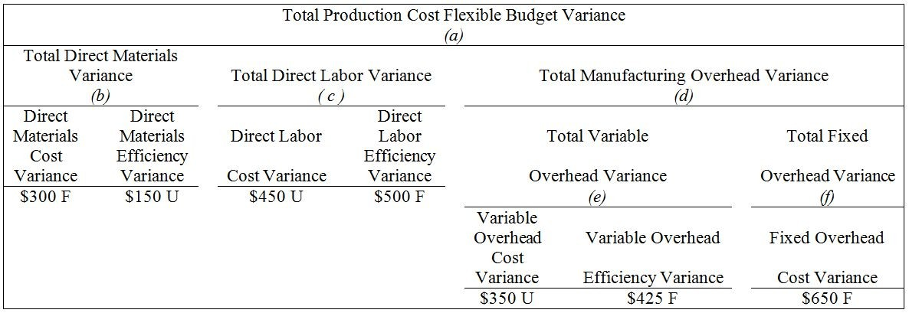

- Recreation Equipment Company has several divisions that are investment centers. Data for the Boat Division and the Trailer Division are shown here:

 | Boat Division | Trailer Division
Operating income | $90,000 | $36,000
Total assets at Jan 1 | $670,000 | $230,000
Total assets at Dec 31 | $710,000 | $220,000

With regard to the efficient use of assets, which division has a higher ROI (show your calculations)

90000 / 670000 + 710000 / 2 = 13.04 %

