Q1)
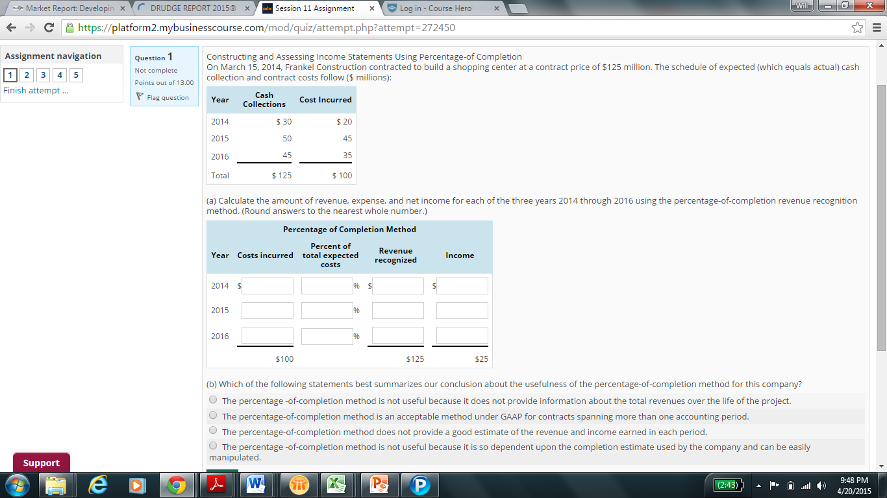

Q2) Analyzing Unearned Revenue Disclosures
The following disclosures are from the September 1, 2013, annual report of Costco Wholesale Corporation.
Revenue Recognition: Membership fee revenue represents annual membership fees paid by substantially all of the Company's members. The Company accounts for membership fee revenue, net of estimated refunds, on a deferred basis, whereby revenue is recognized ratably over the one-year membership period.
Revenue  ($ millions) | September 1, 2013 | September 2, 2012 | August 28, 2011
Net Sales | $102,870 | $97,062 | $87,048
Membership fees | 2,286 | 2,075 | 1,867
Total revenue | $ 105,156 | $ 99,137 | $ 88,915

Current Liabilities  ($ millions) | September 1, 2013 | September 2, 2012
Accounts payable | $7,872 | $7,303
Accrued salaries and benefits | 2,037 | 1,832
Accrued member rewards | 710 | 661
Accrued sales and other taxes | 382 | 397
Deferred membership fees | 1,167 | 1,101
Other current liabilities | 1,089 | 966
Total current liabilities | $ 13,257 | $ 12,260
The components of the deferred tax assets (liabilities) are as follows (in $ millions):
 | 2013 | 2012
Equity compensation | $ 80 | $ 79
Deferred income/membership fees | 130 | 148
Accrued liabilities and reserves | 530 | 461
Other | 42 | 55
Property and equipment | (558) | (522)
Merchandise inventories | (190) | (182)
Net deferred tax assets | $ 34 | $ 39
(a) Which of the following statements best explains in layman terms how Costco accounts for the cash received for its membership fees?
Because Costco does not know how many of its members will continue to the end of the year, cash received from members is recorded as a liability and recognized as revenue only at year-end.
When it receives cash, the company records it as a current liability. Then, it recognizes revenue evenly over the year.
The company records revenue when the cash is received.
Because Costco has a refund policy, the company records revenue when the cash is received, less an allowance for expected membership terminations.
(b) Use the balance sheet information on Costco's Deferred Membership Fees liability account and its income statement revenues related to Membership Fees earned during 2013 to compute the cash that Costco received during 2013 for membership fees.
Total cash received (in $ millions) = $Answer
(c) Use the financial statement effects template to show the effect of the cash Costco received during 2013 for membership fees and the recognition of membership fees revenue for 2013.
 | Balance Sheet
Transaction | Cash Asset | + | Noncash Assets | = | Liabilities | + | Contributed Capital | + | Earned Capital
Cash received for membership fees | Answer |  | Answer |  | Answer |  | Answer |  | Answer
Membership fees earned | Answer |  | Answer |  | Answer |  | Answer |  | Answer

Income Statement
Revenue | - | Expenses | = | Net Income
Answer |  | Answer |  | Answer
Answer |  | Answer |  | Answer
(d) Costco reports a deferred tax asset related to deferred income/membership fees. Explain in layman terms how this asset arises. When will Costco receive the benefit associated with this asset?
For financial reporting purposes, Costco recognizes revenue from membership fees on an accrual basis. The deferred tax asset implies that the company pays tax in cash after it reports the tax expense. This means that Costco must report GAAP revenue more quickly (in earlier periods) than for tax purposes. From this we can infer that the tax authorities use a cash basis for taxing membership fees.
For tax purposes, Costco recognizes revenue from membership fees on an accrual basis. The deferred tax asset implies that the company pays tax in cash before it reports the tax expense. This means that Costco must report GAAP revenue more slowly (in later periods) than for tax purposes. From this we can infer that Costco recognizes revenue from membership fees on a cash basis for book purposes.
For tax purposes, Costco recognizes revenue from membership fees on an accrual basis. The deferred tax asset implies that the company pays tax in cash after it reports the tax expense. This means that Costco must report GAAP revenue more quickly (in later periods) than for tax purposes. From this we can infer that Costco recognizes revenue from membership fees on a cash basis for book purposes.
For financial reporting purposes, Costco recognizes revenue from membership fees on an accrual basis. The deferred tax asset implies that the company pays tax in cash before it reports the tax expense. This means that Costco must report GAAP revenue more slowly (in later periods) than for tax purposes. From this we can infer that the tax authorities use a cash basis for taxing membership fees.

Q3)
Interpreting the Accounts receivable Footnote
Hewlett-Packard Company (HPQ) reports the following in its 2012 10-K report.
October 31  (in millions) | 2012 | 2011
Accounts receivable, net | $16,407 | $18,224
HPQ footnotes to its 10-K provide the following additional information relating to its allowance for doubtful accounts.
For the fiscal years ended October 31  (in millions) | 2012 | 2011 | 2010
Allowance for doubtful accounts-accounts receivable
Balance, beginning of period | $ 470 | $ 525 | $ 629
Increase in allowance from acquisition | -- | 27 | 7
Addition of bad debts provision | 100 | 23 | 80
Deductions, net of recoveries | (106) | (105) | (191)
Balance, end of period | $ 464 | $ 470 | $ 525
(a) What is the gross amount of accounts receivables for HPQ in fiscal 2012 and 2011?
($ millions) | 2012 | 2011
Gross accounts receivable | Answer | Answer
(b)What is the percentage of the allowance for doubtful accounts to gross accounts receivable for 2012 and 2011? (Round your answers to two decimal places.)
($ millions) | 2012 | 2011
Percentage of uncollectible accounts to gross accounts receivable | Answer% | Answer%
(c)What amount of bad debts expense did HPQ report each year 2010 through 2012 (ignore increase in allowance from acquisitions)? What amount was actually written off?
($ millions) | 2012 | 2011 | 2010
Bad debt expense | $Answer | $Answer | $Answer
Amounts actually written off | $Answer | $Answer | $Answer
Which of the following statements describes how bad debts expense compares with the amounts of its accounts receivable actually written off?
Generally, HP has overestimated its accruals, which has deflated profit by the over-accrual of bad debts.
Generally, HP has underestimated its accruals, which has inflated profit by the under-accrual of bad debts.
The difference between bad debt expense and write-off during the three years is insignificant so it appears that profit has been fairly stated.
The difference between bad debt expense and write-off during the three years has inflated HPQ's cash flows reported.
(d)Compute HPQ's write-offs as a percentage of the allowance account at the beginning of the year.
(Round your answers to two decimal places)
2012 write-offs as a percentage of beginning of year allowance: Answer%
2011 write-offs as a percentage of beginning of year allowance: Answer%
What inferences can we draw as a result of changes in the allowance for doubtful accounts from 2010 to 2012?
The allowance for uncollectible accounts has increased as a percentage of gross accounts receivable in 2012. We can , therefore, expect write-offs to increase.
HPQ's write-offs as a percentage of the allowance decreased from 2011-2012. By this measure it appears that HPQ is accurately accruing for anticipated credit losses.
The allowance for uncollectible accounts has decreased as a percentage of gross accounts receivable in 2012. This means that HPQ is over-stating its bad debt expense in the current year.
HPQ's write-offs as a percentace of the allowance increase from 2011 to 2012. This may imply that theallowance is too large.

Q4)
Applying and Analyzing Inventory Costing Methods
At the beginning of the current period, Chen carried 1,000 units of its product with a unit cost of $21. A summary of purchases during the current period follows. During the period, Chen sold 2,800 units.
 | Units | Unit Cost | Cost
Beginning Inventory | 1,000 | $ 21 | $ 21,000
Purchase #1 | 1,800 | 23 | 41,400
Purchase #2 | 800 | 27 | 21,600
Purchase #3 | 1,200 | 30 | 36,000
(a) Assume that Chen uses the first-in, first-out method. Compute both cost of good sold for the current period and the ending inventory balance. Use the financial statement effects template to record cost of goods sold for the period.
Ending inventory balance = $Answer
Cost of goods sold = $Answer
 | Balance Sheet
Transaction | Cash Asset | + | Noncash Assets | = | Liabilities | + | Contributed Capital | + | Earned Capital
Record FIFO cost of goods sold | Answer |  | Answer |  | Answer |  | Answer |  | Answer

Income Statement
Revenue | - | Expenses | = | Net Income
Answer |  | Answer |  | Answer
(b) Assume that Chen uses the last-in, first-out method. Compute both cost of good sold for the current period and the ending inventory balance.
Ending inventory balance = $Answer
Cost of goods sold = $Answer
(c) Assume that Chen uses the average cost method. Compute both cost of good sold for the current period and the ending inventory balance.
Ending inventory balance = $Answer
Cost of goods sold = $Answer
(d) Which of these three inventory costing methods would you choose to:
1. Reflect what is probably the physical flow of goods?
  LIFO | FIFO | Average Cost
2. Minimize income taxes for the period?
  LIFO | FIFO | Average Cost
3. Report the largest amount of income for the period?
  LIFO | FIFO | Average Cost

Q5)
Computing and Assessing Plant Asset Impairment
On January 1, Zeibart Company purchases equipment for $220,000. The equipment has an estimated useful life of 10 years and expected salvage value of $25,000. The company uses straight-line depreciation. Four years later, economic factors cause the fair value of the equipment to decline to $85,000. On this date, Zeibart examines the equipment for impairment and estimates undiscounted expected cash inflows from this equipment of $115,000
(a) Compute the annual depreciation expense relating to this equipment.
$Answer
(b) Compute the equipment's net book value at the end of the fourth year.
$Answer
(c) Apply the test of impairment to this equipment as of the end of the fourth year. Is the equipment impaired?
Yes, because the fair value is less than the net book value.
Yes, because the net book value is greater than the salvage value.
Yes, because the undiscounted expected cash flows are less than net book value.
No, because the net book value minus the salvage value is greater than the undiscounted expected cash flows.
No, because the net book value minus the salvage value is less than the undiscounted expected cash flows.
(d) If the equipment is impaired at the end of the fourth year, compute the impairment loss. (If the equipment is not impaired, enter 0.)
$Answer

