We have begun to experience a growing backlog of customer orders in the Plasti-Brack product line.
For the last two to three months apparently we have had a slow creep-up of order backlog in the MLD250 department, specifically the Plasti-Brack molding group. It seems that we now have a 5 to 6 week backlog which is entirely unacceptable to our customers. As you know, our customers have been accustomed to getting orders shipped almost immediately or within a week of placing their orders. So now they don’t like to have to wait. Jack Walker and I think that this could possibly adversely affect our business since these items are so popular.
It is my opinion that we need more capacity in Machine Group 251. As you know, we have four 250-Ton plastic injection molding machines, which run these six parts. However, lately one of the machines seems to be experiencing excessive downtime. There also seems to be some tool wear causing low productivity. I suggest you talk to Don Stump to get more details on the order backlog and his scheduling system. Talk to Tom Gunner in Engineering or one of his Manufacturing Engineers about the machines and tools. And you should also check with Bill Morton and someone in the Plastic Injection Molding area about the tools. And while you are talking with Bill, ask him about his opinion of capacity. Ask Don Stump his opinion as well.
What I expect you to do consists of three main activities: 1) check out our capacity problem. See what we need to do to increase capacity. There is a capital budget available for the MLD2500 group - see Harvey Lund for more details. 2) We have to get our delivery time down to acceptable levels - see Don Stump for the details. 3) And while you are at, see what you can do to improve productivity and lower our costs. I expect your report in about two weeks with your recommendations and justification.
NEW INFORMATION GATHERED
There is a high reject rate of plastic inserts coming from MG 251, as found in the Plastic-Brack Assy, MG403 – it seems to be somewhere between 12% to 20% reject rate, depending on which plastic insert.
You also discover that the molding dies are very old and some of the mold cavities are closed off because of previous poor quality, which further reduces the yield rates from the standard expectations. Dies for P90, P120B, and P135 each have one cavity closed off. Swenson thinks that more should be closed off, based on his expertise and the age of these dies.
New plastic injection molding dies cost $25,000 each, or $30,000 each if they are designed for quick changeover. The lead time for manufacturing these dies by an outside tool and die company is 6 weeks each.
One of the four molding machines, M101, has a record of high unscheduled repair and downtime. It seems to need some minor adjustments several times per week, which is causing low uptime for it. Swenson, the molding supervisor, would like to see the machine have a complete overhaul. Dick Wrangle would like to purchase a new 250-ton molding machine. The cost to overhaul is estimated to $100,000, and the cost of a new machine is $250,000.
Mark Monnin, the Purchasing Manager, tells you that there is better grade plastic resin that could be used, but it is more expensive. The better materials are RP515 at $0.28 per pound or RP625 at $0.30 per pound; the current material in use is RP502 at $0.26 per pound; the quality ranking order is RP625 > RP515 > RP502. Monnin believes the best material, RP625, would reduce some of the scrapped parts generated by MG251. He is not sure how RP515 would do.
Bill Morton, the Plant Manager, informs you that a second shift has not been approved at this time, but could be as a last resort. There is a 15% shift premium paid to those who work on the 2nd shift. Overtime could also be used, possibly 2 extra hours per day and up to 10 hours on Saturdays. OT earns employees an additional half-time for hours over 40 per week.
The setup times (die changeover) in both blanking and molding are in the three and half to four and a half hour range. You asked Tom Tucker what it would take to modify these dies with quick clamps and other mechanisms so that you could reduce the setup times. Tucker said that to modify existing dies would cost about $10,000 each. Your research in this area confirms this number is in the ballpark and that setup times can be reduced to about 0.5 to 1.0 hours.
Harvey Lund indicates that there is a capital budget for MLD250, of which $325,000 is available for MLD251. You can purchase machines, tools, overhauls and tool upgrades with this budget. He also says that you don’t need to spend all of it.
Mike Finch, the Marketing Analyst, says that the demand rate of customer orders has not increased substantially in the last quarter, nor does he think that it is going to rise much soon. He still stands by his long term forecast over the next five years.
Assignment
Analyze the situation in the Plasti-brack product line. Diagnose the problem and possible solutions to the capacity and order backlog. Determine an appropriate plan for correcting the problem. Justify your plan and make recommendations using your knowledge of productivity, process improvement, inventory, capacity, forecasting, and quality. Write a report to the VP of Operations.
Expectations
- Explore the possibilities of spending some of the capital budget on a machines and or tools. Also consider improving setup time, improving quality, increasing capacity, and determining EOQs.
- Determine a plan for solving this problem in the Plasti-brack product line. Consider there may be both a short-term solution and a long-term solution.
- Justify your plan based on the concepts of capacity management.

The following is the Income Statement from the year just completed.
 | Gross Income |  | COGS |  | Gross Margin
PRODUCT LINE | (000s) |  | (000s) |  | (000s)
Fasteners | $ 1,010 | 7.3% | $ 646 | 4.7% | $ 364 | 2.6%
Cabinet Hardware | $ 3,243 | 23.5% | $ 1,783 | 12.9% | $ 1,460 | 10.6%
Construction Hardware | $ 4,165 | 30.2% | $ 1,874 | 13.6% | $ 2,291 | 16.6%
Decorative Hardware | $ 5,388 | 39.0% | $ 2,586 | 18.7% | $ 2,802 | 20.3%
TOTALS | $ 13,806 | 100.0% | $ 6,889 | 49.9% | $ 6,917 | 50.1%
OPERATING EXPENSES
Marketing and Advertising |  |  | $ 850 | 6.2%
Commissions, Wages & Salaries |  |  | $ 1,750 | 12.7%
Benefits |  |  | $ 770 | 5.6%
Office Expenses |  |  | $ 175 | 1.3%
Depreciation |  |  | $ 734 | 5.3%
Insurance |  |  | $ 943 | 6.8%
Fixed Energy & Utility Expenses |  |  | $ 268 | 1.9%
Miscellaneous |  |  | $ 132 | 1.0%
TOTAL OPERATING EXPENSES |  |  |  |  | $ 5,622 | 40.7%
Net Income Before Taxes |  |  |  |  | $ 1,295 | 9.4%
The following is the Statement of Inventories (from the Balance Sheet) for the year just ending:
 | Beginning | Ending
Inventories | (000s) | (000s)
Raw | $ 205 | $ 167
Purch Parts | $ 148 | $ 151
WIP | $ 389 | $ 322
Fin. Goods | $ 242 | $ 243
TOTAL INVEN | $ 984 | $ 883

NOTES ON INVENTORIES AND MATERIAL MOVEMENT
EMC does not account for inventories on a product line basis. But generally, each product line uses its proportionate share of the inventories based on costs.
Plastic resin is moved to the molding machines where it is dumped into feeding hoppers for each machine. As the hopper empties, additional resin is dumped in.
The plastic parts come out of the molding machines and are trimmed where they are collected in 10 cu. ft. tubs. These tubs are moved to the Plasti-Brack assembly area.
The plain brackets are stamped out by the progressive dies in the Plasti-Brack press machine group. They are also collected in 10 cu. ft. tubs and then moved to the Plasti-Brack assembly area.
In the assembly process, the operator will do a quick visual check of the plastic insert and the plain bracket before assembly. Bad parts are discarded into tubs. The plastic is recycled via a regrind process. The steel parts cannot be used again and sold for scrap with the rest of the scrap metal.
The assembled Plasti-Brack items are collected in 10 cu. ft. tubs and are eventually moved to the Bulk Pack area. Once they are packed, they move into the Finished Goods Warehouse where they wait to be picked and packed in large shipping containers to the customers.

CAPACITY & FORECASTING
Overall, the current capacity utilization at EMC is 92%. This ranges from about 75% in the blanking machine groups to about 93% in the plastic molding groups. Assembly, packaging and packing are near 80%, while the finishing processes are around 88%.
Currently, all departments are running just one 40 hour shift. Occasionally, some departments will add some overtime on a weekly basis as needed to stay up with orders. Bill Morton, the Plant Manager, prefers to run with one shift. His opinion is that adding a second shift is not as efficient since it adds more fixed costs in energy consumption, just to have the lights on. Additional shifts require additional employees. It costs money to hire and train them. Plus employees earn a 15% shift premium. Morton would rather pay the time & a half for the additional hours over 40. And Morton would prefer that his capacity utilization be around 85%. He is a little nervous with the 92% level.
Mike Finch does the forecasting for EMC, both short-term and long-term. His short-term forecast is broken down by product line. His short-term forecast for Plasti-Brack products indicates that there will be a small increase this year of 7% to 10%.
Finch's long term forecast is across the board for all of EMC and its various products. His results indicate that there will be a 12.5% annual compound growth over the next five years. This equates to an 80% increase over the current demand in the fifth year.
Products: Construction and building items:
- FASTENERS
  - screws, bolts, nails
- CONSTRUCTION
  - Flanges
  - Brackets – Plasti-Brack (see below for more details)
- CABINET HARDWARE
  - Hinges
  - Knobs
  - Pulls
- DECORATIVE HARDWARE
  - Towel Bars
  - Towel Rings
  - Soap Dishes
  - Switch Plates
Outlet Plates
- 100 Heading
  - 101 small headers
  - 105 large headers
- 150 Blanking & Stamping

  - 151 small presses
  - 153 Bracket presses
  - 157 large presses
- 200 Zinc Die Cast Molding & Trimming
  - 201 small zinc molders
  - 203 trim, small
  - 206 large zinc molders
  - 208 trim,large
- 250 Plastic Injection Molding
  - 251 Plasti-brack insert molding
  - 253 Hinge insert molding
  - 255 Soap dish molding
- 300 Plating
  - 301 Barrel Plating – nickel
  - 303 Barrel Plating – chromium
  - 305 Rack Plating
- 330 Brushing
  - 331 Straight line brushing
  - 333 Circular line brushing
- 360 Lacquer
  - 361 Spray lacquer line
  - 363 Brush lacquer line
- 390 Painting
  - 391 Paint line 1
  - 393 Paint line 2
  - 395 Paint booth
- 400 Assembly
  - 401 Hinge Assembly
  - 402 Hinge Assembly - auto
  - 403 Plasti-brack Assembly
  - 404 Towel Ring Assembly
  - 406 Soap Dish Assembly
- 500 Packaging
  - 501 Bag Packaging
  - 503 Bar, Ring, Dish Packaging
- 700 Packing
  - 701 Bulk Packing
The Plasti-Brack Product Line: combination metal / plastic supports
- Six products, different angles. F90, F100, F120A, F120B, F130, F135
- Novel item patented by Excellent
- Unique design includes a simulated wood finish and color in the plastic insert
- Allows it to be used both for internal and external construction
- Very popular in deck, fence, and shed construction, as well as in home construction.
SAMPLE DRAWING & SAMPLE PROCESS FLOW CHART
Figure 1 shows a sample drawing of the F90. The P90 is the plastic insert, the S90 is the steel bracket and the F90 is the assembly of the P90 and S90. Figure 2 shows the process flow chart for the B-F90, which is the bulk packed F90.
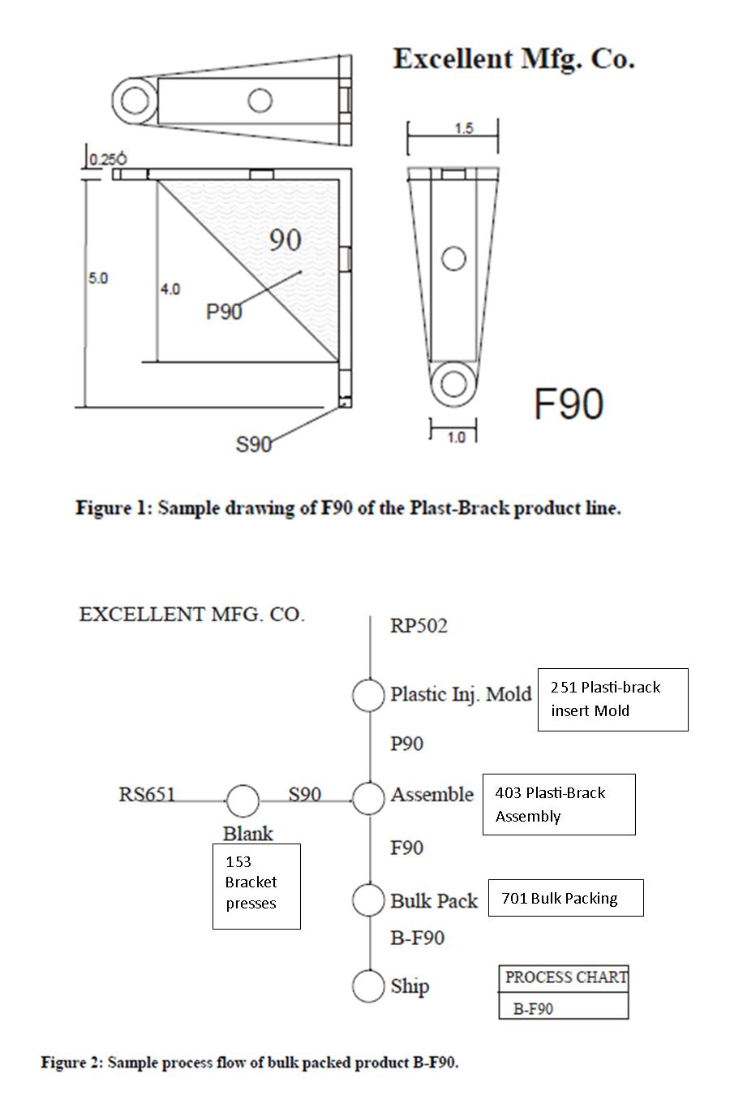
Mach hrs: hours for all machines in a production area PPM: People per machine, e.g. how many people to run a machine, e.g. 0.5 means that one person runs two machines People hrs: hours for all people in a production area
Production: Hours producing pieces Setup: Hours changing over or setting up dies Pd Non-Prod: Hours paid doing non-production work (not producing pcs), e.g. maintenance, clean-up, etc.
 |  | Production | Setup | Pd non-Prod | Total Mach Hrs | Total Ppl Hrs
Blanking | Mach hrs | 3337 | 467 | 223 | 4027
Blanking | ...PPM | 0.5 | 1 | 1
Blanking | People hrs | 1668.5 | 467 | 223 |  | 2,358.50
Molding | Mach hrs | 4195 | 712 | 250 | 5157
Molding | ...PPM | 0.25 | 1 | 1
Molding | People hrs | 1048.75 | 712 | 250 |  | 2,010.75
Assembly | Mach hrs | 33372 | 0 | 1050 | 34422
Assembly | ...PPM | 1 | 1 | 1
Assembly | People hrs | 33372 | 0 | 1050 |  | 34,422.00
Packing | Mach hrs | 667 | 0 | 50 | 717
Packing | ...PPM | 3 | 3 | 3
Packing | People hrs | 2001 | 0 | 150 |  | 2,151.00
Total hrs |  |  |  |  | 44,323.00 | 40,942.25
Total Plasti-Brack Pcs |  |  |  |  |  | 16,018,752
Total Ppl Hours |  |  |  |  |  | 40,942.25
Productivity Measure |  | Pcs produced/Ppl Hr |  |  |  | 391.25
Productivity Goal |  |  |  |  | 105% | 410.81
QUALITY MANAGEMENT

EMC has not had a quality manager or quality department. One has just been hired to develop a Quality Department.
The process operators have taken quality seriously on their own. They make sure that the tools and work stations are setup correctly. They also check the quality of parts periodically as they are produced. But they do not follow any specific quality methods or techniques. This approach to quality is the same in all of the various production departments.
The majority of the production quality issues seems to be scrapping bad plastic inserts during the assembly process. A lot of 10 cu. ft. tubs accumulate in Plasti-Brack assembly. But no one seems to be concerned since these parts are very low cost and the plastic scrap is re-processed. Plastic scrap goes to a re-grind operation, where it is ground up into fine pieces. It is then added to the virgin raw material in a 1 to 9 ratio in the Plastic Injection Molding Department.
Overall Excellent Manufacturing does not have many big issues from customer complaints. There are occasional returns of various products, mostly because of plating and finishing problems. In terms of Plasti-Brack products, complaints are about the plastic insert falling out and about sharp edges on the brackets. Last year there were 56 complaints complaints. They seem to be on the rise as there are 49 complaints this year during the first four months.
PROCESSES
Machine group 153 Bracket presses.
- Two 400-ton presses
- machine speed is 40 strokes per minute, or 2400 pieces per hour
- Progressive die process, so that one bracket part is produced per stroke
- Six progressive dies, one for each part.
- setup (die change over), approx. 3.5 hours
Machine group 251 Plasti-Brack insert Mold
- Four 250-ton plastic injection molding machines
- There are six dies, one for each plastic insert
- Cavities per die
  - P90 die 6 cavities
  - P100 die 5 cavities
  - P120A die 8 cavities
  - P120B die 4 cavities
  - P130 die 7 cavities
  - P135 die 8 cavities
- Machine speeds: Plastic injection molding speed is from 18 - 22 seconds/shot
  - see table below for Pieces/hr.
- Setup (die change over), approx. 4 hours
Machine group 403 Plasti-Brack Assembly
- Seven assembly stations – tables for operators
- One operator per station
- The rate for the manual assembly operation is 8 pieces per minute or 480 pieces per hour
- The assembly process consists of:
- grasp a plastic insert (P90)
- visually inspect insert
  - if defective, toss into scrap bin and go to step 1, OR
  - keep for next step
- grasp a bracket (S90)
- move the insert to the assembly point
- push insert into place
- check assembly
  - if insert will not assemble properly, toss into scrap bin, go to steps 1, 2, 4, & 5, OR
  - if insert does assemble properly, then
- drop assembly into 10 cu. ft. Tub at the side of the table.
- Operators are trained to also do Hinge Assembly, Towel Bar, Towel Ring and Soap Dish assembly
Machine group 701 Bulk Packing
- Three operators work together on this line
- Plasti-bracks move here from 403 Plasti-Brack Assembly
- Each Plasti-brack is dumped in bulk into a cardboard box
- Each box holds 100 of one of the items.
- Measuring the number in the box is accomplished by “weigh counting”
- A lid assembled to the full box
- A label is attached to the box
- The closed container is banded by a banding machine on the conveyer line
- The completed container is sent to the warehouse
- The speed of this line is 4 containers per minute (400 pieces/min.), or 240 containers/hour (24000 pieces/hr.)
- NOTE: Hinges are also “bare” bulk packed for cabinet makers. Otherwise hinges are bag packed first, then bulk packed to be sent to home supply stores.
MACH. GRP. 251
PIECES PER HOUR
 | M101 | M102 | M103 | M104
P135 | 1309.1 | 1600.0 | 1440.0 | 1440.0
P120A | 1309.1 | 1600.0 | 1440.0 | 1440.0
P130 | 0.0 | 1260.0 | 1145.5 | 1145.5
P100 | 818.2 | 0.0 | 900.0 | 900.0
P90 | 1080.0 | 1350.0 | 1200.0 | 1200.0
P120B | 640.0 | 800.0 | 720.0 | 720.0

MATERIAL HANDLING DATA: PIECES PER 10 CU. FT. TUB

P135 | 1937 |  | F135 | 1191
P120A | 1581 |  | F120A | 1030
P130 | 1678 |  | F130 | 1075
P100 | 1305 |  | F100 | 891
P90 | 1369 |  | F90 | 924
P120B | 816 |  | F120B | 609

Privacy Policy | Contact

