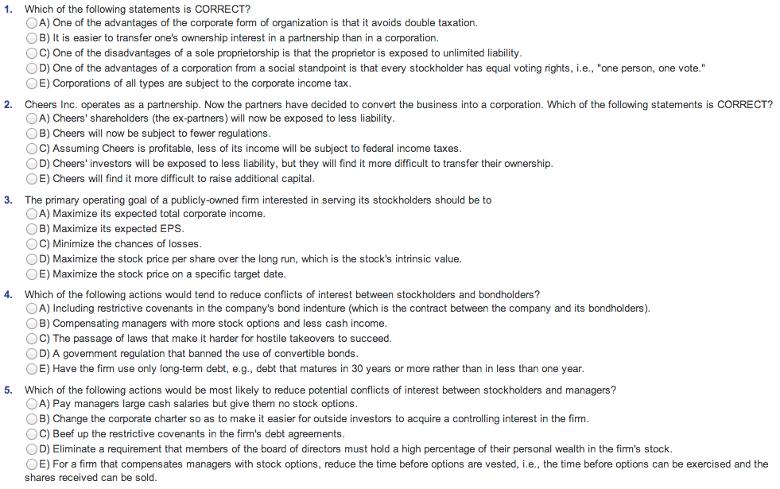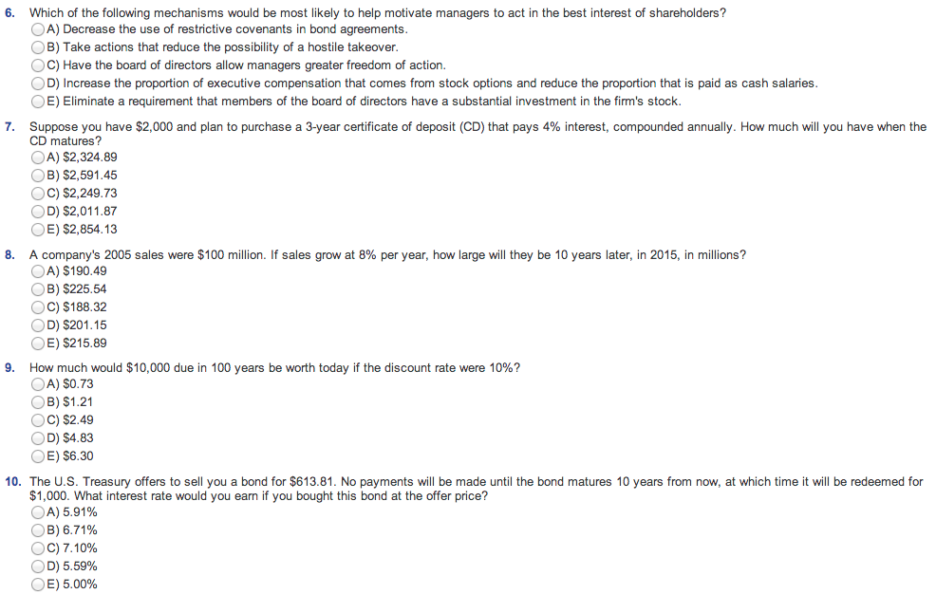
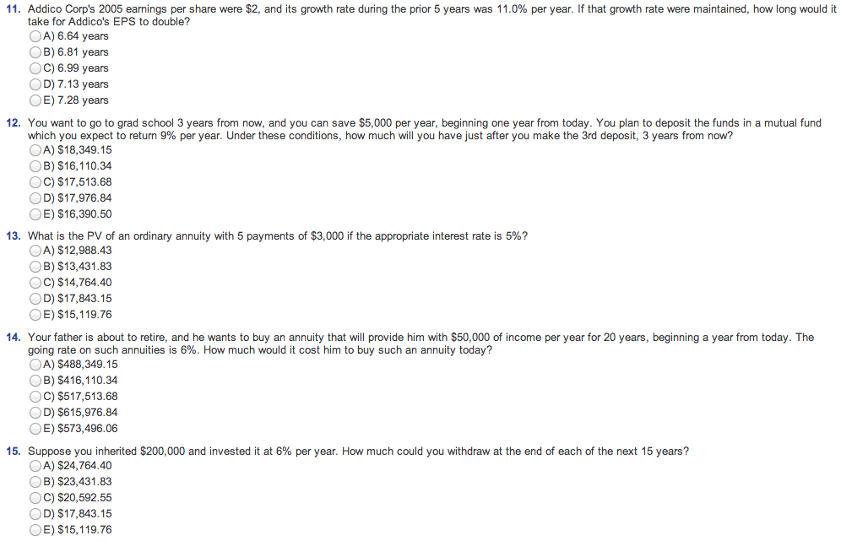
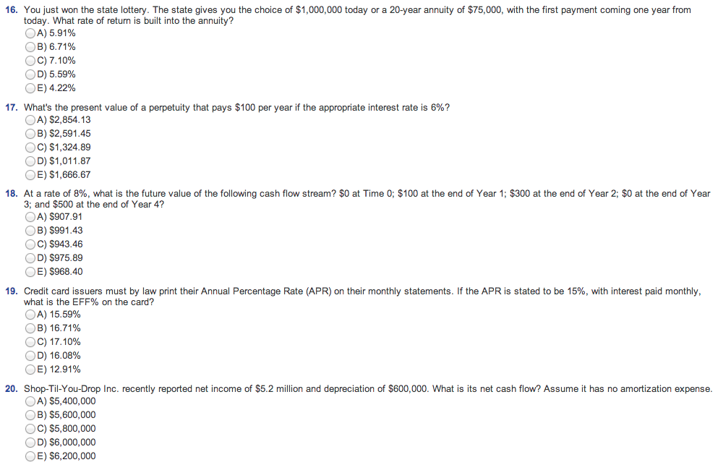
20. Shop-Til-You-Drop Inc. recently reported net income of $5.2 million and depreciation of $600,000. What is its net cash flow? Assume it has no amortization expense.
- $5,400,000
- $5,600,000
- $5,800,000
- $6,000,000
- $6,200,000
21. Companies generate income from their “regular” operations and from things like interest on securities they hold, which is call non-operating income. Mitel Metals recently reported $9,000 of sales, $6,000 of operating costs other than depreciation, and $1,500 of depreciation. The company had no amortization charges and no non-operating income. It had issued $4,000 of bonds that carry a 7% interest rate, and its federal-plus-state income tax rate was 40%. What was the firm’s operating income, or EBIT?
- $1,100
- $1,200
- $1,300
- $1,400
- $1,500
22. Temple Square Inc. reported that its retained earning for 2005 were $490,000. In its 2006 financial statements, it reported $60,000 of net income, and it ended 2006 with $510,000 of retained earnings, How much were paid as dividends to shareholders during 2006?
- $20,000
- $25,000
- $30,000
- $35,000
- $40,000
23. Which of the following statements is CORRECT?
- Four key financial statements are the balance sheets, the income statement, the statement of cash flows, the statements of retained earning.
- The balance sheet gives us a picture of the firm’s financial situation over a period of time.
- The income statement gives us a snapshot of what is happening at a point in time.
- The statement of cash flows tells us how much cash the firm has in the form of currency and demand deposits.
- The statement of cash needs tells us how much cash the firm will require during some future period, generally a month or a year.
24. Which of the following items is NOT included in current assets?
- Accounts payable.
- Inventory
- Accounts receivable
- Cash.
- Short-term highly liquid, marketable securities.
25. A start-up firm is making an initial investment in new plant and equipment. Assume that currently its equipment must be depreciated on a straight-line basis over 10 years, but Congress is considering legislation that would require the firm to depreciate the equipment over 7 years. If the legislation becomes law, which of the following would occur in the year following the change?
- The firm’s tax payments would increase.
- The firm’s reported net income would increase.
- The firm’s taxable income would increase.
- The firm’s net cash flow would increase.
- The firm’s operating income (EBIT) would increase.
26. Ramala Corp’s sales last year were $48,000, and its total assets were $25,500. What was its total assets turnover ratio (TATO)?
- 1.88
- 1.99
- 1.10
- 1.21
- 1.32
27. Ruby Corp’s sales last year were $435,500, its operating costs were $350,000, and its interest charges were $10,000. What was the firm’s times interest earned (TIE) ratio?
- 8.29
- 8.42
- 8.55
- 8.68
- 8.81
28. Roberts Corp’s sales last year were $300,000, and its net income after taxes was $25,000. What was its profit margin on sales?
- 7.65%
- 7.82%
- 7.99%
- 8.16%
- 8.33%
29. Reynolds Corp’s total assets at the end of last year were $300,000 and its net income after taxes was $25,000. What was its return on total assets?
- 8.15%
- 8.33%
- 8.51%
- 8.69%
- 8.87%
30. Rollins Corp’s total assets at the end of last year were $300,000 and its EBIT was $75,000. What was its basic earning power (BEP)
- 17.50%
- 20.00%
- 22.50%
- 25.00%
- 27.50%
31. Raleigh Corp’s total common equity at the end of last year was $300,000 and its net income after taxes was $55,000. What was its ROE?
- 18.33%
- 18.67%
- 19.00%
- 19.33%
- 19.67%
32. Rutland Corp’s stock price at the end of last year was $30.25 and its earnings per share for the year were $2.45. What was its P/E ratio?
- 11.65
- 12.00
- 12.35
- 12.70
- 13.05
33. Rand Corp’s stock price at the end of last year was $40.00, and its book value per share was $24.50. What was its Market/Book ratio?
- 1.03
- 1.18
- 1.33
- 1.48
- 1.63
34. Midwest Lumbar had a profit margin of 5.1%, a total assets turnover of 1.6, and an equity multiplier of 1.8. What was the firm’s ROE?
- 14.39%
- 14.69%
- 14.99%
- 15.29%
- 15.59%
35. An investor is considering starting a new business. The company would require $500,000 of assets, and it would be financed entirely with common stock. The investor will go forward only if she thinks the firm can provide a 15.0% return on the invested capital, which means that the firm must have an ROE of 15.0%. How much net income must be expected to warrant starting the business?
- $45,000
- $55,000
- $65,000
- $75,000
- $85,000
36. Which of the following would indicate an improvement in a company’s financial position, holding other things constant?
- The current and quick ratios both decline.
- The EBITDA coverage ratio increases.
- The total assets turnover decreases.
- The TIE declines.
- The DSO increases.
37. A firm wants to strengthen its financial position. Which of the following actions would INCREASE its current ratio?
- Borrow using short-term debt and use the proceeds to repay debt that has a maturity of more than one year.
- Reduce the company’s day’s sales outstanding ratio to the industry average and use the resulting cash savings to purchase plant and equipment.
- Use cash to increase inventory holdings.
- Use cash to repurchase some of company’s own stock.
- Issue new stock and use some of the proceeds to purchase additional inventory and hold the remainder of the funds received as cash.
38. If 10-year T-bonds have yield of 5.2%, 10-year corporate bonds yield 7.5%, the maturity risk premium on all 10-year bonds is 1.1%, and corporate bonds have a 0.2% liquidity premium versus a zero liquidity premium for T-bonds, what is the default premium on the corporate bond?
- 1.0%
- 1.1%
- 1.2%
- 2.0%
- 2.1%
39. The real risk-free rate is 3%, inflation is expected to be 2% this year, and the maturity risk premium is zero. Ignoring any cross-product terms, what is the equilibrium rate of return on a 1-year Treasury bond?
- 4.90%
- 5.00%
- 5.10%
- 5.20%
- 5.30%
40. Suppose 1-year Treasury bonds yield 3.0% while 2-year T-bonds yield 4.5%. Assuming the pure expectations theory is correct and thus the maturity risk premium is zero, what should the yield be on a 1-year T-bond one year from now?
- 5.91%
- 6.02%
- 6.13%
- 6.24%
- 6.35%

