Assignment 4
Positioning, Appeals, and Execution (pp. 54-58, 293-310)
I am going to display a variety of ads and you will identify the creative strategies being used in each of the ads. Because some of the ads will have multiple correct answers, please explain why you have identified each element.

Example 1
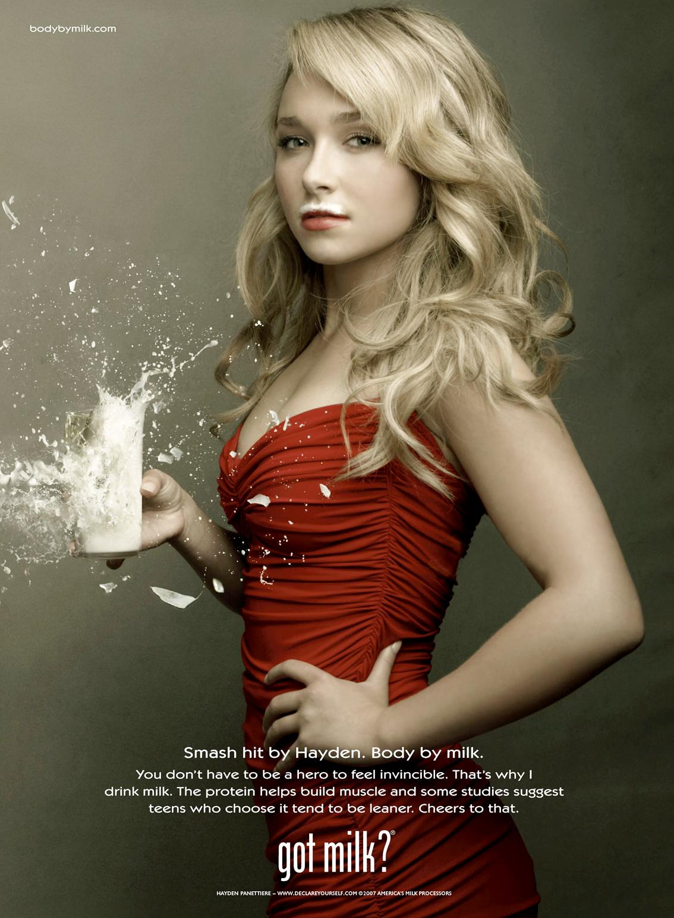
I would say that this advertisement is using an emotional appeal. There is some information in the caption, but that is not what catches our attention. The source is celebrity Hayden Panettiere from the show Heroes, so we could say that this ad is using the creative execution of personality symbol. The exploding glass of milk has an element of dramatization. So, this ad uses a combination approach. The positioning of this ad is based on the sources, both the “got milk?” campaign and Hayden are very well known cultural symbols in the United States. The caption positioning on product attributes and benefits of milk. They also specifically identify teens as the product user.

I would like you to write similar captions for each of the advertisements in this document. You can bold the creative approaches and explain how each of the appeals and execution approaches are used. If you choose emotional appeal, please specify which type the ad is using.
Below is a list of appeals and execution approaches used in the book.

Appeals

- Informational/Rational p.293
- Emotional p.295
  - Fear p.203
  - Humor p.205
- Combining Rational & Emotional p.297
- Reminder p.299
- Teaser p. 300

Execution

- Straight sell/Factual
- Scientific/Technical Evidence
- Demonstration
- Comparison
- Testimonial
- Slice of Life
- Animation
- Personality Symbol
- Imagery
- Dramatization
- Humor
- Combinations

Positioning

- Product Attributes and Benefits
- Price/Quality
- Use or Application
- Product Class
- Product User
- Competitor
- Cultural Symbols
- Repositioning

1. Walt Disney World (5 points)
Hints: Very few words, Slogan


[Type your response here. Make sure you include appeals, execution, and positioning in your answer.]

2. Papa John’s (5 points)
Hints: Founder, Deals, Technology
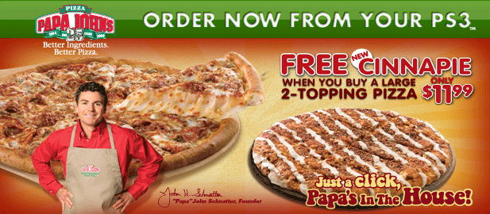
[Type your response here. Make sure you include appeals, execution, and positioning in your answer.]

3. State Farm (5 points)
Hints: Mother, not a “feeling” product
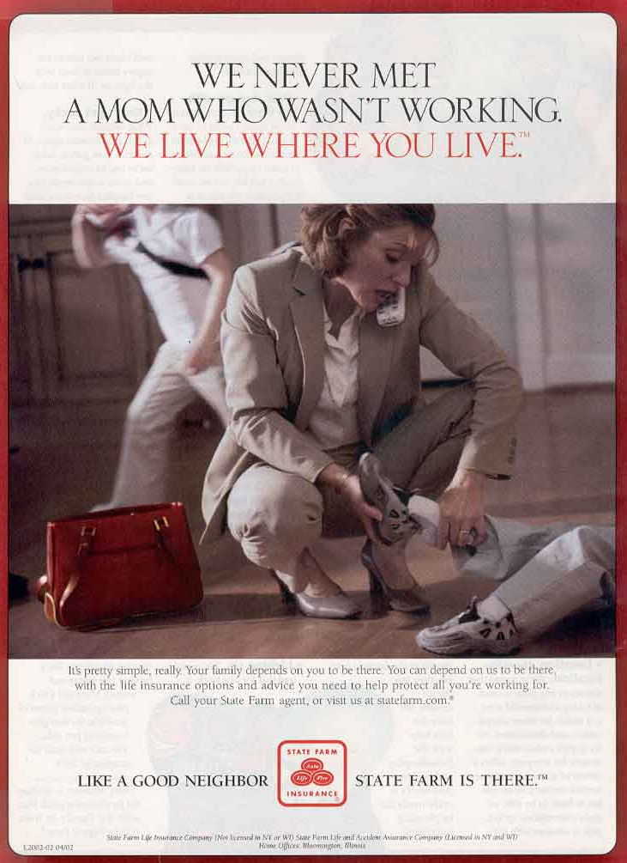
[Type your response here. Make sure you include appeals, execution, and positioning in your answer.]

4. Aflac (5 points)
Hints: Company product, New campaign

[Type your response here. Make sure you include appeals, execution, and positioning in your answer.]

5. Gatorade (5 points)
Hints: Few words, target market?, Gatorade before the repositioning

[Type your response here. Make sure you include appeals, execution, and positioning in your answer.]

