Final Exam
Operations Management
QSO 600 Operations Management

The final exam consists of five essay and five problem questions. Answer all the questions.

Essay Questions:
There is no set length for answers; students may be as verbose or brief as they feel necessary to cover the question. Use this same exam document for your answers, placing them below each question. This portion of the exam is worth 100 points

Problem Questions:
Make sure to show all your work to get full credit. The instructor needs to know the formulas and calculations you used to get to your final answer. You can do part of the exam in Excel and Paste your Excel work into this document. This portion of the exam is worth 50 points.

File Convention:
File name for the exam attachment to be
studentlastname-finalexam (Be sure there are no spaces)
Be sure to put your name on the exam paper.

Note: You may use the text and any other materials. You are NOT to work with anyone else including other students in completing the exam nor discuss it with them.
QSO 600 Final Exam Essay Questions

Question 1: What is operations management? Why is it important? Is a good knowledge of operations management more important in service or manufacturing industries? Explain your answer.

Question 2: Discuss the use of PERT/CPM techniques for managing projects. Describe what PERT/CPM does. Discuss advantages and disadvantages of using it. What other techniques might you choose to manage your project?

Question 3: What are economies of scale in a manufacturing plant? Do they continue forever? What are diseconomies of scale? How might you decide the optimal size of a plant?

Question 4: What, in your opinion, are the three most important issues in supply chain management? Discuss why you think these are the key issues.

Question 5: Discuss why (or if) inventories are necessary. What are the benefits of inventories? What are the disadvantages of holding inventories?

QSO 600 Final Exam Problem Questions

Problem 1.
Arsenal Electronics is going to construct a new $1.2 billion semiconductor plant and has selected four towns in the Midwest as potential sites. The important location factors and ratings for each town are as follows:
 | Scores (0 to 100)
Location Factor | Weight | Abbeton | Bayside | Cane Creek | Dunnville
Work ethics | 0.18 | 80 | 90 | 70 | 75
Quality of life | 0.16 | 75 | 85 | 95 | 90
Labor laws/unionization | 0.12 | 90 | 60 | 60 | 70
Infrastructure | 0.10 | 60 | 50 | 60 | 70
Education | 0.08 | 80 | 90 | 85 | 95
Labor skill and education | 0.07 | 75 | 65 | 70 | 80
Cost of living | 0.06 | 70 | 80 | 85 | 75
Taxes | 0.05 | 65 | 70 | 55 | 60
Incentive package | 0.05 | 90 | 95 | 70 | 80
Government regulations | 0.03 | 40 | 50 | 65 | 55
Environmental regulations | 0.03 | 65 | 60 | 70 | 80
Transportation | 0.03 | 90 | 80 | 95 | 80
Space for expansion | 0.02 | 90 | 95 | 90 | 90
Urban proximity | 0.02 | 60 | 90 | 70 | 80

Recommend a site based on these location factors and ratings.
Answer 1:

Problem 2.
Sawyer Furniture is one of the few remaining domestic manufacturers of wood furniture. In the current competitive environment, cost containment is the key to its continued survival. Demand for furniture follows a seasonal demand pattern with increased sales in the summer and fall months, culminating with peak demand in November.
The cost of production is $16 per unit for regular production, $24 for overtime, and $33 for subcontracting. Hiring and firing costs are $500 per worker. Inventory holding costs are $20 per unit per month. There is no beginning inventory. Ten workers are currently employed. Each worker can produce 50 pieces of furniture per month. Overtime cannot exceed regular production. Given the following demand data, use Excel Solver to design an aggregate production plan for Sawyer Furniture that will meet demand at the lowest possible cost.
Input: |  |  | Beg. Wkrs |  | 10 |  |  | Regular |  | $16 |  | Hiring |  | $500
 |  |  | Units/wkr |  | 50 |  |  | Overtime |  | $24 |  | Firing |  | $500
 |  |  | Beg. Inv. |  | 0 |  |  | Subk |  | $33 |  | Inventory |  | $20
 | Month | Demand |  | Reg |  | OT | Subk |  | Inv |  | #Wkrs |  | #Hired |  | #Fired
 | Jan | 500 |  | 500 |  | 0 | 0 |  | 0 |  | 10 |  | 0 |  | 0
 | Feb | 500 |  | 500 |  | 0 | 0 |  | 0 |  | 10 |  | 0 |  | 0
 | Mar | 1000 |  | 1,000 |  | 0 | 0 |  | 0 |  | 20 |  | 10 |  | 0
 | Apr | 1200 |  | 1,000 |  | 200 | 0 |  | 0 |  | 20 |  | 0 |  | 0
 | May | 2000 |  | 1,000 |  | 1,000 | 0 |  | 0 |  | 20 |  | 0 |  | 0
 | Jun | 400 |  | 400 |  | 0 | 0 |  | 0 |  | 8 |  | 0 |  | 12
 | Jul | 400 |  | 400 |  | 0 | 0 |  | 0 |  | 8 |  | 0 |  | 0
 | Aug | 1000 |  | 1,000 |  | 0 | 0 |  | 0 |  | 20 |  | 12 |  | 0
 | Sep | 1000 |  | 1,000 |  | 0 | 0 |  | 0 |  | 20 |  | 0 |  | 0
 | Oct | 1500 |  | 1,500 |  | 0 | 0 |  | 0 |  | 30 |  | 10 |  | 0
 | Nov | 7000 |  | 3,500 |  | 3,500 | 0 |  | 0 |  | 70 |  | 40 |  | 0
 | Dec | 500 |  | 500 |  | 0 | 0 |  | 0 |  | 10 |  | 0 |  | 60
 | Total | 17,000 |  | 12,300 |  | 4,700 | 0 |  | 0 |  | 246 |  | 72 |  | 72
Answer 2:

Problem 3.
Complete the following MRP matrix for Item X. Determine when orders should be released and the size of those orders.
Item: X | LLC: 0 | Period
Lot Size: Min 50 | LT: 2 | 1 | 2 | 3 | 4 | 5 | 6 | 7 | 8
Gross Requirements |  | 25 | 30 | 56 | 25 | 100 | 40 | 30 | 20
Scheduled Receipts |  |  | 50
Projected on Hand | 30
Net Requirements
Planned Order Receipts
Planned Order Releases
Release orders in periods 1 through 5 for quantities of 50, 50, 56, 50, and 50 respectively.
Answer 3:

Problem 4.
Fibrous Incorporated makes products from rough tree fibers. Its product line consists of five items processed through one of five machines. The machines are not identical, and some products are better suited to some machines. Given the following production time in minutes per unit, determine an optimal assignment of product to machine:
 | Machine
Product | A | B | C | D | E
1 | 17 | 10 | 15 | 16 | 20
2 | 12 | 9 | 16 | 9 | 14
3 | 11 | 16 | 14 | 15 | 12
4 | 14 | 10 | 10 | 18 | 17
5 | 13 | 12 | 9 | 15 | 11

Answer 4:

Problem 5.
The following probabilistic activity time estimates are for a CPM/PERT network.
 | Time Estimates (days) |  |  |  | Time Estimates (days)
Activity | a | m | b | Activity | a | m | b
1 | 1 | 2 | 6 | 7 | 1 | 1.5 | 2
2 | 1 | 3 | 5 | 8 | 1 | 3 | 5
3 | 3 | 5 | 10 | 9 | 1 | 1 | 5
4 | 3 | 6 | 14 | 10 | 2 | 4 | 9
5 | 2 | 4 | 9 | 11 | 1 | 2 | 3
6 | 2 | 3 | 7 | 12 | 1 | 1 | 1
Determine the following:
- Expected activity times
- Earliest start and finish times
- Latest start and finish times
- Activity Slack
- Critical Path
Expected Project duration and standard deviation.

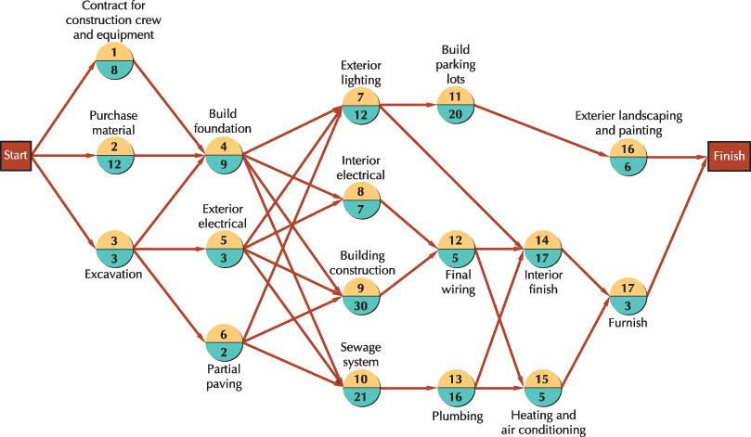
Answer 5:

