Using the selected financial statements below for Micro Chip Computer Corporation answer the following questions based on the financial data in 150-200 words.
Micro Chip Computer Corporation
Selected Financial Data

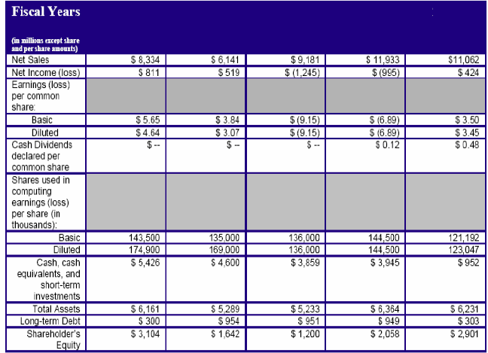
2008
2007
2006
2005
2004

- Determine the year-to-year percentage annual growth in total net sales.
This analysis will help in tracking the performance of the organization in terms of revenues. Year to Year % annual growth in total net sales= ( Current year- Previous year)/Previous year*100

For 2005= (11933-11062)/11062*100
=7.87%
For 2006= (9181-11933)/11933*100
=-23.06%
For 2007= (6141-9181)/9181*100
=-33.12%
For 2008= (8334-6141)/11062*100
=19.82%

- Based only on your answers to question #1, do you think the company achieved its sales goal of +10% annual revenue growths in 2009? Determine the target revenue figure, and explain why you do or do not feel that the company hit its target.
Yes company will be able to achieve its sales goal of +10% annual revenue growths in 2009 because previous year it has achieved growth of 19.82%.
Hence its Sales in 2009 will be: Sales in year 2008 * (1+10%)
=8334*(1+10%)
=$9167.4 mn

PART 2
Next consider Micro Chip’s Consolidated Statement of Operations for the year ended September 25, 2008.
Micro Chip Computer Corporation
Consolidated Statements of Operations for the period September 26, 2007 through
September 25, 2008 Sales | $8,334.00
Cost of Sales | $5,458.00
Gross Margin | $2,876.00
Operating expenses:
R & D | $525.00
Selling, General, and Administrative | $691.00
In‐process R & D | ‐‐‐‐‐‐‐‐‐
Restructuring costs | ‐‐‐‐‐‐‐‐‐
Total Operating Exp | $1,216.00
Operating income | $1,660.00
Total interest and other Income net | $194.00
Income before provision for Income taxes | $1,854.00
Provision for income Taxes (15%) | $278.10
Net income | $1,575.90

- Use the Percentage Sales Method and a 25% increase in sales forecast Micro Chip’s Consolidated Statement of Operations for the period of September 26, 2008 through September 25, 2009. Assume a 15% tax rate and restructuring costs of 5% of the new sales figure.

