PROBLEM 1

CitiSavings Bill-processing Operations

CitiSavings operates three bill-processing centers as a part of its credit card business. These centers are located in the Los Angeles, Chicago, and New York areas, and they can process the following numbers of bills each day:

 | Los Angeles | Chicago | New York
Daily bill-processing capacity | 60,000 | 105,000 | 100,000

Customers from around the country mail payments on their credit card bills to the three centers for processing. The numbers of bills to be processed daily from each region are as follows:

 | Number to be Processed
West | 70,000
Midwest | 50,000
East | 80,000
South | 40,000

When a bill is mailed from a region to a processing center, it spends time in the U.S. Postal Service (USPS) delivery system. The table below shows the average number of days a bill spends in transit between each region and processing center:

 | Los Angeles | Chicago | New York
West | 2 | 6 | 8
Midwest | 6 | 2 | 5
East | 8 | 5 | 2
South | 8 | 5 | 5

Each day that a bill spends in transit is a day's worth of interest CitiSavings has lost on the payment received. At a 5% annual rate, the interest lost on an average payment is approximately 10 cents per day.

CitiSavings has formulated a linear program (LP) to help it determine to which processing center customers from the various regions should mail their payments. CitiSavings would like to minimize the interest income lost due to transit times of the payments. The model they have formulated is as follows:

X_{ij} = number of bills to be mailed from region i to processing center j each day
Min 2 X_{WL} + 6 Xwc + 8 X_{WN} + 6 X_{ML} + 2 X_{MC} + 5 X_{MN} +
8 X_{EL} + 5 X_{EC} + 2 X_{EN} + 8 X_{SL} + 5 Xsc + 5 X_{SN}
s.t.

X_{WL} + X_{ML} + X_{EL} + X_{SL} ≤ 60,000 (Los Angeles capacity)
Xwc + X_{MC} + X_{EC} + Xsc ≤ 105,000 (Chicago capacity)
X_{WN} + X_{MN} + X_{EN} + X_{SN} ≤ 100,000 (New York capacity)
X_{WL} + Xwc + X_{WN} ≥ 70,000 (West requirements)
X_{ML} + X_{MC} + X_{MN} ≥ 50,000 (Midwest requirements)
X_{EL} + X_{EC} + X_{EN} ≥ 80,000 (East requirements)
X_{SL} + Xsc + X_{SN} ≥ 40,000 (South requirements)
X_{ij} ≥ 0 for all i and j (non negativity)

The spreadsheet results and sensitivity report for the CitiSavings LP are shown below:

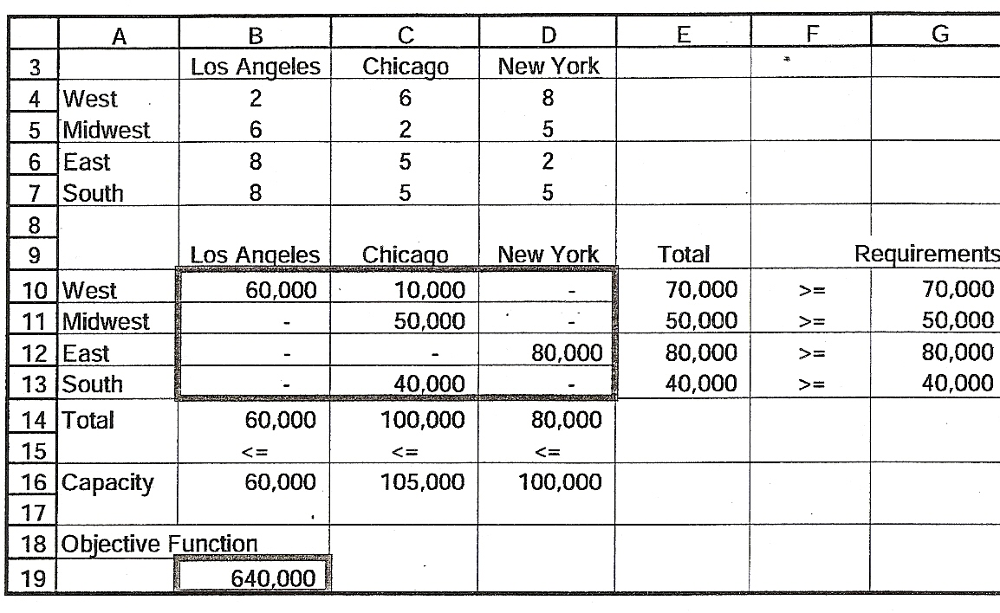

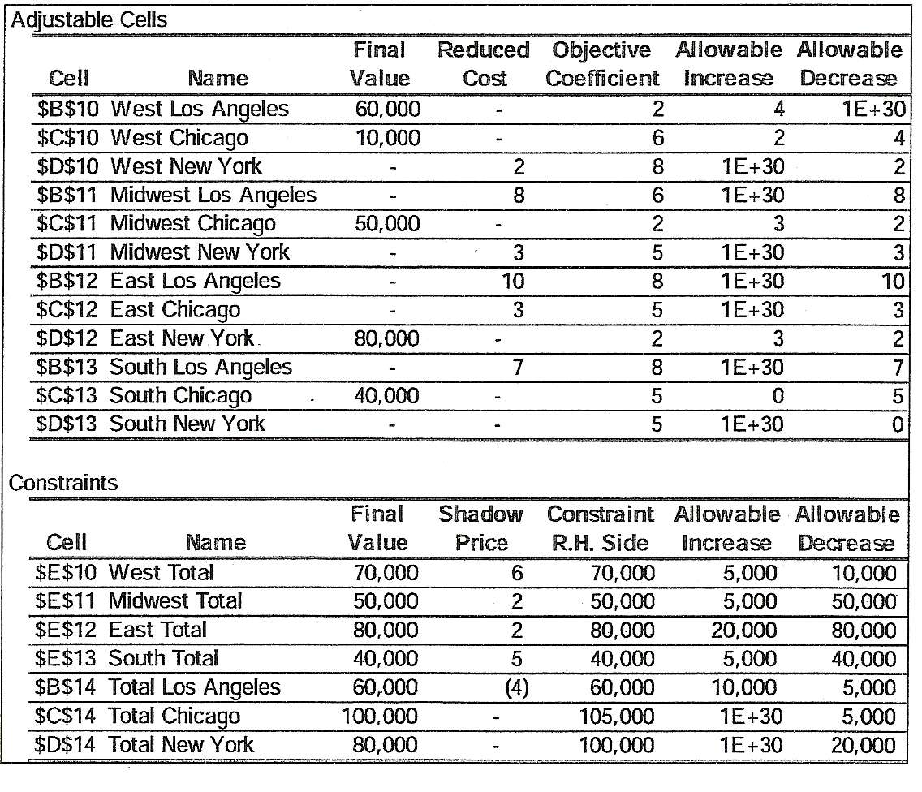

Answer questions (a) through (g) below. Each question is independent of the others. If an answer cannot be determined from the information in the spreadsheet results or the sensitivity report, write "Cannot be Determined" and explain why it cannot be determined.

a) Under the optimal plan, what is the total $ interest lost each day?

b) The USPS is changing its delivery network, and CitiSavings has discovered that the average number of days that a bill spends in transit from the West to Chicago will increase from 6 to 7 days.
- How will this change the optimal solution values?
- How much will the total interest lost each day change?

c) By how much would the bill-processing capacity in New York have to decrease before the optimal solution values would change? Explain why?

d) Suppose the company could expand the production capacity in Los Angeles by 15,000 units at a cost of $3,000 per day. Should this be done? Explain.

CitiSavings intends to merge with BankZero, which has its own set of processing centers for credit card bills. BankZero's processing centers are in Toledo (Ohio) and Atlanta. The processing capacities of the full set of processing centers are as follows:

 | Los Angeles | Chicago | New York | Toledo | Atlanta
Daily bill-processing capacity | 60,000 | 105,000 | 100,000 | 135,000 | 155,000

By region, the number of bills to be processed each day for the two companies' combined customer bases and the transit times are as follows:

 | Number to be Processed | Los Angeles | Chicago | New York | Toledo | Atlanta
West | 100,000 | 2 | 6 | 8 | 6 | 8
Midwest | 150,000 | 6 | 2 | 5 | 2 | 5
East | 100,000 | 8 | 5 | 2 | 5 | 5
South | 100,000 | 8 | 5 | 5 | 5 | 2

The new optimal solution would be found by solving the following LP:

X_{ij} = number of bills to be mailed from region i to processing center j each day

Min 2 X_{WL} + 6 Xwc + 8 X_{WN} + 6 X_{WT} + 8 X_{WA} +
6 X_{ML} + 2 X_{MC} + 5 X_{MN} + 2 X_{MT} + 5 X_{MA} +
8 X_{EL} + 5 X_{EC} + 2 X_{EN} + 5 X_{ET} + 5 X_{EA} +
8 X_{SL} + 5 Xsc + 5 X_{SN} + 5 X_{ST} + 2 X_{SA}
s.t.
X_{WL} + X_{ML} + X_{EL} + X_{SL} ≤ 60,000 (Los Angeles capacity)
Xwc + X_{MC} + X_{EC} + Xsc ≤ 105,000 (Chicago capacity)
X_{WN} + X_{MN} + X_{EN} + X_{SN} ≤ 100,000 (New York capacity)
X_{WT} + X_{MT} + X_{ET} + X_{ST} ≤ 135,000 (Toledo capacity)
X_{WA} + X_{MA} + X_{EA} + X_{SA} ≤ 155,000 (Atlanta capacity)
X_{WL} + Xwc + X_{WN} + X_{WT} + X_{WA} ≥ 70,000 (West requirements)
X_{ML} + X_{MC} + X_{MN} + X_{MT} + X_{MA} ≥ 50,000 (Midwest requirements)
X_{EL} + X_{EC} + X_{EN} + X_{ET} + X_{EA} ≥ 80,000 (East requirements)
X_{SL} + Xsc + X_{SN} + X_{ST} + X_{SA} ≥ 40,000 (South requirements)
X_{ij} ≥ 0 for all i and j (non negativity)

e) Management would like to ensure that Toledo handles at least 2/3 of all the bills processed by Toledo and Chicago combined. Extend the formulation to assure that this requirement is met.

Citisavings recognizes mat the combined operations would have significant excess capacity and would like to decide which processing facilities to keep open and which to close. Ignore the cost of closing a facility, and also ignore the Toledo - Chicago requirement described in part (e). The fixed daily cost of operating the five facilities are as follows:

 | Los Angeles | Chicago | New York | Toledo | Atlanta
fixed daily operating cost | 12,000 | 21,000 | 20,000 | 40,000 | 30,000

f) Revise the linear program to help CitiSavings decide which processing centers to close. Be sure to define any new decision variables. Make sure that part of the objective function has consistent units. Write below only the modifications you make to the formulation on page 5. Do not use IF statements in the constraints.

g) CitiSavings management would like to consider the expansion of capacity at the Los Angeles processing center as another option within the overall consolidation plan. That is, in addition to either closing the center or leaving it at the current capacity, they want to consider adding 15,000 bills-per-day of additional capacity. The additional cost would be $3,000 per day. Modify/extend the formulation of (f) to include this additional option. Be sure to define any new decision variables. Do not use IF statements in the constraints.

PROBLEM 2

The CIAA-TREF Pension Fund

Naomi Nakakura manages a pension fund for CIAA-TREF, a large financial services company that offers retirement annuities and mutual funds. She is considering a number of fixed income securities (treasury bonds) to finance a series of pension liabilities (cash outflows) over the next five years. The cash requirement a year from now is projected to be $45 million and is expected to grow by $10 million a year, as summarized in Table 1 below. (All figures are in $million):

Table 1: Annual Cash Requirements (in $mm)

Years form now (t) | 1 | 2 | 3 | 4 | 5
Expected cash liability | 45 | 55 | 65 | 75 | 85

Naomi is considering the following seven types of bonds for inclusion in her portfolio to finance the above liabilities. Each bond has a face value of $100. Table 2 below provides information on the current price, annual coupon amount, and maturity of the bonds:

Table 2: Bond Characteristics

 | Bond 1 | Bond 2 | Bond 3 | Bond 4 | Bond 5 | Bond 6 | Bond 7
Current Price | 100 | 97 | 98 | 99 | 103 | 93 | 98
Annual Coupon | 5 | 6 | 5.8 | 7 | 4.7 | 5 | 5.9
Maturity (Yr) | 1 | 1 | 2 | 3 | 3 | 4 | 5

The coupon is the annual interest payment to the bond holder. For example, Bond 4 sells for $99 today, pays $7 in Year 1, $7 in Year 2, and $107 in Year 3. In other words, if Naomi were to buy 5 million units of Bond 4, this will require $495 million today and return $35 million in Year 1, $35 million in Year 2, and $535 million in Year 3. All seven bonds are available in essentially unlimited amounts.
Naomi would like to determine the mix of bonds she should purchase now to meet the pension fund's cash liabilities over each of the next: five years with the least initial investment. Assume that a cash surplus in any year can be reinvested at an annual interest rater of 4% and will be available to meet the next year's liability.
Formulate the problem algebraically as a linear program.

a) Decision Variables (be sure to mention the units)

b) Objective Function (also mention units)
The objective is to minimize the initial investment which is given by:

c) Constraints (label each constraint clearly):

PROBLEM 3

The H.S. Daugherty Company has been manufactured industrial vacuum cleaning systems for a number of years. Recently a member of the company's. new-product research team submitted a report suggesting that the company consider manufacturing a cordless vacuum cleaner. The vacuum cleaner, referred to as a Porta-Vac, could contribute to Daugherty's expansion into the household market. Management hopes that the new product can be manufactured at a reasonable cost and that its portability and no-cord convenience will make it extremely attractive.

Given below is information about the activities that must be carried out in order to realize this project. Times are in weeks and cost in thousands of dollars.

Activity | Description | Immediate Predecessor | Expected Time | Expected Cost
A | Prepare R&D product design | --- | 6 | 90
B | Plan market research | --- | 2 | 16
C | Prepare routing (manufacturing engineering) | A | 3 | 3
D | Build prototype model | A | 5 | 100
E | Prepare marketing brochure | A | 3 | 6
F | Prepare cost estimates (industrial engineering) | C | 2 | 2
G | Do preliminary product testing | D | 3 | 60
H | Complete market survey | B, E | 4 | 20
I | Prepare pricing and forecast report | H | 2 | 4
J | Prepare final report | F, G, I | 2 | 2

a) Construct a network diagram for this project.

b) Fill in the table bellow

Activity | Earliest Start | Latest Start | Slack
A
B
C
D
E
F
G
H
I
J

c) Give the critical path for the project and the minimum completion time.

d) At the end of the 10th week, this is the situation of the project (*):

A, B, E : Completed
C: 1 week completed
D: 4 weeks completed

Will the project be completed in time? If not what is the duration of the project?
(*) If an activity is not listed below, assume that it has not been started.

e) Prepare a Pert/Cost analysis for each of the 2 points in time. For each case, show the percent overrun or under-run for the project to date, and indicate any correction action that should be undertaken. NOTE: If an activity is not listed below, assume that it has not been started.

At the end of the 10th week:
Activity | Actual Cost (th$) | Percent Complete
A | 85 | 100%
B | 16 | 100%
C | 1 | 33%
D | 100 | 80%
E | 4 | 100%
H | 10 | 25%

At the end of the 15th week:

Activity | Actual Cost (th$) | Percent Complete
A | 85 | 100%
B | 16 | 100%
C | 3 | 100%
D | 105 | 100%
E | 4 | 100%
F | 3 | 100%
G | 55 | 100%
H | 25 | 100%
I | 4 | 100%

PROBLEM 4

A major operation in an outpatient medical office is answering the telephones. This is especially true in primary care, such as pediatrics. Patients mostly use the telephone to communicate with the physician's office. In pediatrics, such interactions include calling for appointments, refills, medical advice, referrals, and forms (for example: school forms, camp forms.) Because of the frequent use of the telephone in outpatient pediatrics, it is an important focus for assessing productivity and efficiency.

A pediatric practice consists of nine physicians and two nurse practitioners. The practice has two offices. The patient population is approximately ten thousand children, with nearly fifty thousand visits per year. The phone system consists of sixteen telephone lines, most of them at the main office.

As the practice has grown, there have been increasing complaints from patients about wait time on the phone lines. All incoming calls are routed to the main office. When a patient dials the practice's office telephone number, a voicemail system directs the caller to press a number according to the purpose of the call (for example, "Press 'one' for appointments.") The system also distributes the phone calls according to whether the person calling is a patient, physician, laboratory, or hospital.
During the winter months, when the volume of sick patients is highest, a patient's wait can sometimes be as long as ten to fifteen minutes on the appointment line before speaking to a person. Since most customer service guidelines recommend telephone hold times no longer than one minute, this is an area that greatly needs improvement.

Telephone calls form a single waiting line and are served on a first-come, first-served basis. Arrival rates can be described by Poisson distribution, and service times can be described by negative exponential distribution. With these characteristics, a multiple-channel model for queuing analysis is most appropriate.

The queuing analysis of the practice's phone system can be divided into three parts of the workday, which lasts from 8:00 A.M. to 5:00 P.M. For the first hour of the day (8:00 A.M. to 9:00 A.M.) there are usually three receptionists working to answer telephone calls only. For the last hour of the day (4:00 P.M. to 5:00 P.M.), there are usually five receptionists answering phones as well as checking patients in and out. For the bulk of the day, there are usually six receptionists working. The use of fewer servers during the first and last hours is primarily because fewer patients are being seen during those hours, so fewer servers are needed for checking patients in and out.

To determine the customer arrival rate (or phone calls/hour), incoming monthly phone call data for the previous year were obtained from the telephone company (Table 1.)

TABLE 1

Month Phone Calls
January 6,640
February 6,756
March 6,860
April 6,226
May 6,671
June 7,168
July 6,802
August 6,971
September 7,205
October 6,944
November 6,623
December 6,875
Total 81,741

From examining previous studies of the office's phone call volume distribution, it is estimated that 30% of the phone calls occur between 8 A.M. and 9 A.M.; 40% between 9 A.M. and 4 P.M., and the remaining 30% arriving from 4 P.M. to 5 P.M. (Table 2).

TABLE 2

Customer Arrival Rates (λ)

8:00 A.M. to 9:00 A.M. 31 phone calls/hr
9:00 A.M. to 4:00 P.M. 42 phone calls/hr
4:00 P.M. to 5:00 P.M. 31 phone calls/hr

To estimate the service rate (or phone calls/hour/receptionist), several sample studies were performed by an office administrator. It is important to note that the receptionists perform functions other than answering phones, such as checking patients in and out. Therefore, the number of phone calls that a server can answer per hour depends on the other responsibilities that the person has that day. In order to arrive at a service rate, the assumption was made that the average maximum of phone calls per hour for the sample days would represent the servers operating at the maximum phone-call-answering capacity when having other responsibilities. While this assumption may underestimate actual server rate, for purposes of this study, the conservative estimate is acceptable in the absence of further data.

There is one exception to this assumption. During the first hour of the day, from
8:00 A.M. to 9:00 A.M., patients are not yet being seen in the office. Therefore, during that hour the servers have a faster telephone service rate, since they have no other primary duties (Table 3) From samples studied, we have determined that the maximum service capability when only answering phones is approximately four minutes per phone call, or fifteen calls per hour per server. This number was used for the service rate for the first hour.

TABLE 3
Service Rate μ.

8:00 A.M. to 9:00 A.M. 15 phone calls/hr
9:00 A.M to 4:00 P.M. 8 phone calls/hr
4:00 P.M to 5:00 P.M. 8 phone calls/hr

Cost studies were then performed based on financial data from the previous year. Capacity costs were calculated based on salary and benefits per server and a percentage of the equipment maintenance, phone line costs, rent, and other capital expenditures (Table 4). With a total of fifty employees and a total of thirty full-time equivalents (FTEs), the portion of capital expenditures was determined as 1/30 of costs. Phone line charges were determine by a per line charge, since one server would utilize one line each day.

TABLE 4

Total Hourly Cost for Busy Server Summary

Salary $13.00
Benefit $ 3.75
Telephone Charges $ 4.73
Capital Expenses $ 4.83
Total Hourly Cost for Busy Server $26.31

Capacity cost or busy server cost would be equivalent to idle server cost. Regardless of whether or not the receptionist is answering the phone, she is paid the same salary and benefits and is using the same space and utilities. In addition, the practice must pay the phone line and equipment maintenance charges, regardless of usage.

For calculation purposes, a value was assigned to the cost to the customer of waiting. A value of $50/hour was assigned to customer waiting costs. In reality, though, customer waiting costs are likely to vary with the length of time waited, with a steep exponential increase in cost to the patient for longer times waited.

The cost of being balked would represent a lost patient if a patient's call was not answered. In pediatrics, the patients generally prefer continuity of care throughout their child's life. Therefore, a truly balked customer might represent a child's lifetime worth of visits. However, one might also define a balked customer as one who will not come for a visit that day because the phone call was not answered promptly. This person would be likely to return to the practice on another day if he or she established a doctor-patient relationship with the practice. Therefore, for the purposes of this model, it is assumed that the cost of being balked is the lost revenue from an office visit, which is approximately $80. (See Table 5)

TABLE EX 14.5.5

Cost Summary

Busy server cost/hr $ 26.31
Idle server cost/hr $ 26.31
Customer waiting cost/hr $ 50.00
Cost of customer being balked $ 80.00

Using EXCEL, perform a queuing analysis for the pediatric practice's telephone system to determine the optimal server capacity for the volume of phone calls that they receive. Are there enough servers/receptionists and enough phone lines?

PROBLEM 5

Alabama Airlines opened its doors in June 2002 as a commuter service with its headquarters and only hub located in Birmingham. A product of airline deregulation. Alabama Air joined the growing number of successful short-haul, point-to-point airlines, including Lone Star, Comair, Atlantic Southeast, Skywest, and Business Express.

Alabama Air was started and managed by two former pilots, David Douglas (who had been with the defunct Eastern Airlines) and Michael Hanna (formerly with Pan' Am). It acquired a fleet of 12 used prop-jet planes and the airport gates vacated by Delta Airlines' 1996 downsizing.

With business growing quickly, Douglas turned his attention to Alabama Air's "SOO" reservations system. Between midnight and 6:00 A.M., only one telephone reservations agent had been on duty. The time between incoming calls during this period is distributed as shown in Table1. Douglas carefully observed and timed the agent and estimated that the time taken to process passenger inquiries is distributed as shown in Table 2.

TABLE 1: Incoming Call Distribution

Time Between Calls | Probability
1 | 0.11
2 | 0.21
3 | 0.22
4 | 0.20
5 | 0.16
6 | 0.10

TABLE 2: Service Time Distribution

Time Between Calls | Probability
1 | 0.20
2 | 0.19
3 | 0.18
4 | 0.17
5 | 0.13
6 | 0.10
7 | 0.03

All customers calling Alabama Air go "on hold" and are served in the order of the calls unless the reservations agent is available for immediate service. Douglas is deciding whether a second agent should be on duty to cope with customer demand. To maintain customer satisfaction, Alabama Air does not want a customer "on hold" for more than 3 to 4 minutes and also wants to maintain a "high" operator utilization.

Further, the airline is planning a new TV advertising campaign. As a result, it expects an increase in "8oo"-line phone inquiries. Based on similar campaigns in the past, the incoming call distribution from midnight to 6 A.M. is expected to be as shown in Table 2. (The same service time distribution will apply.)

TABLE 3: Incoming Call Distribution

Time Between Calls | Probability
1 | 0.22
2 | 0.25
3 | 0.19
4 | 0.15
5 | 0.12
6 | 0.07

Discussion Questions

1. What would you advise Alabama Air to do for the current reservation system based on the original call distribution? Create a simulation model to investigate the scenario. Describe the model carefully and justify the duration of the simulation, assumptions, and measures of performance.

2. What are your recommendations regarding operator utilization and customer satisfaction if the airline proceeds with the advertising campaign?

