4. Based on the BOM shown below, how many units of part F will be needed if 15 units of end item A are needed? If the company decided to purchase part D from suppliers, how would the BOM change? Assuming part D is purchased, how many units of part F are needed to make 15 units of end item A?

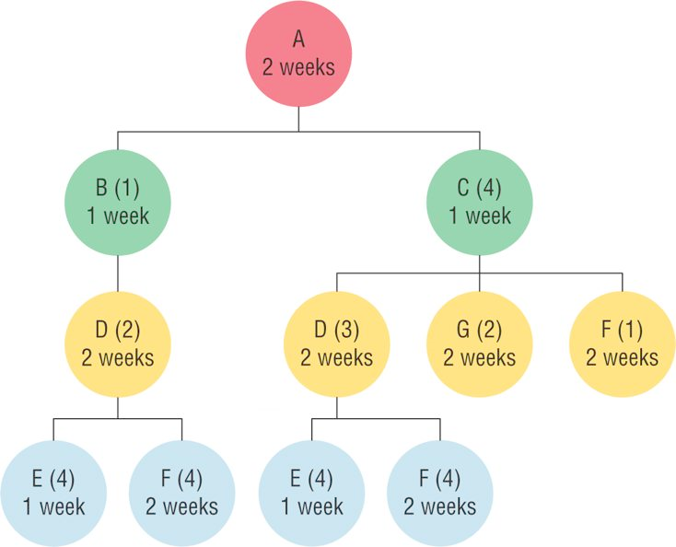

8. Using the information in problem 7, develop an indented BOM
7. Based on the BOM shown below, how many of part D will be needed if 100 units of end item A are needed? How many of part F

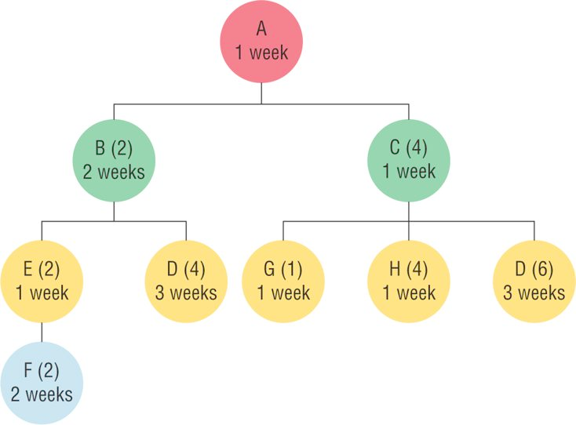

12. Complete the MRP record for a bicycle seat

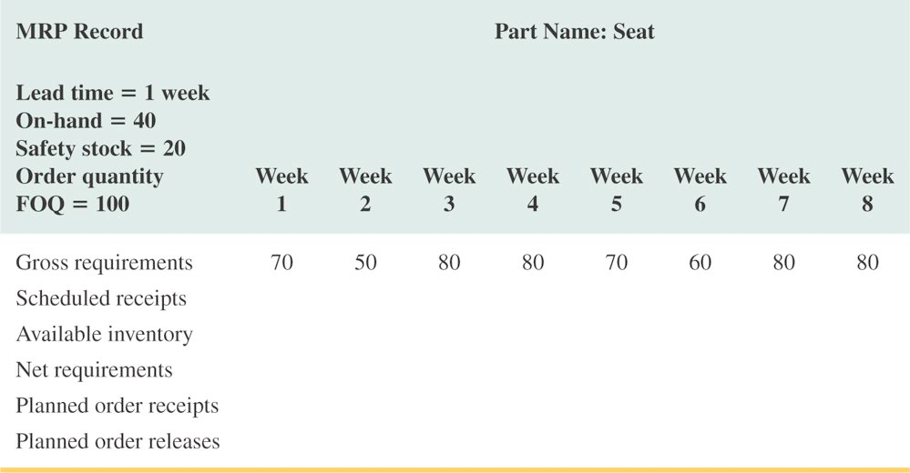

13. Given the BOM and the MPS for end item A, complete the MRP schedule for items A, C, D, and E.



