Walmart Example

We will use Walmart as an example to illustrate the various course concepts. The examples provided in this document are to assist you in understanding the concepts and applying them to the class assignments, which consist of a case study and four staged projects. The examples are provided for illustrative purposes only, and may not precisely conform to the specific directions given in the class assignments.

Business Analysis (Stage 1)

Applying Porter’s Five Forces Analysis

The Five Forces are explained in the reading assignments for Week 1. Below is an example showing the application of the Five Forces analysis to Walmart.

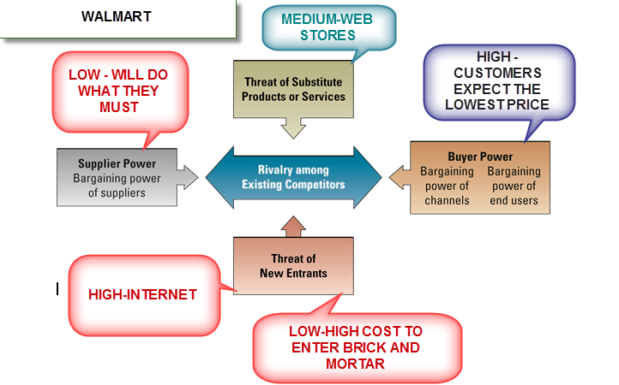

We know that Walmart’s objective is everyday low prices, which is their competitive advantage. When we look at the Five Forces model as applied to Walmart, we can determine that the Buyer Power of their customers is high because patrons have many other choices. However, customers expect and demand the lowest prices from Walmart, and they are willing to overlook, but not ignore, other factors like customer service, store location, and atmosphere.

Walmart's Suppliers have little power because of the sheer size of Walmart, and because being a Walmart supplier can provide huge sales potential. The suppliers must do what Walmart wants regarding business processes and technical requirements. They will also be pressured for lower prices, which may cause the suppliers to move production to lower priced labor markets.

The threat of substitute products means that customers can go elsewhere for the same or substitute items. There could be some threat here only because of web based stores as they may be able to have lower prices because of low overhead.

Threat of new entrants in the Brick and Mortar Store area is low, because of the costs involved in building stores and the infrastructure to support the business processes. The threat of new entrants in the Internet market would be high, because of the low costs involved and the potential to specialize in different areas with especially low prices.

Rivalry between competitors at a store level would be high and could be affected by the breadth of products and quality of customer service or even the cleanliness and appearance of the store. On a company level, Walmart’s Sales are $418 Billion and Target, their closest competitor’s has annual sales of $67 Billion, so while it may seem there is a large rivalry, the size of Walmart limits the threat.

For new entrants to compete with the Supplier: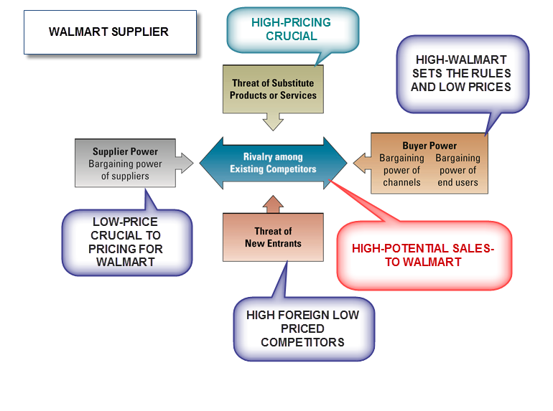

If we look at the Five Forces Model from a Walmart Supplier’s perspective, we see that the Buyer Power that Walmart exerts is very high, because they will switch suppliers or eliminate the product if the pricing and process are not what they want.

The Supplier Power of the Supplier’s Supplier is low, because if they do not adhere to economic processes and furnish their products at low prices the Walmart Supplier cannot meet the requirements of Walmart.

Threat of new entrants will be high, because in this case we are not talking about new startup companies, but rather companies that want to enter the competition for sales to Walmart or foreign affiliates of US companies that can supply the same items at a lower price. These would be existing companies who can supply products the same or similar to the ones that the Supplier provides. School supplies, clothing, shoes and healthcare products are good examples.

Threat of substitute products is high because of Walmart’s concentration on price; low cost domestic and foreign substitutes would provide a significant concern.

Rivalry to be a Walmart Supplier would be high with similar companies because of the size of the potential sales and the limited shelf space. Faster service, better processes, lower prices or higher quality would be areas where the rivalry would take place.

Strategy for Competitive Advantage

The Five Forces analysis above indicates that two areas of highest concern for Walmart would be

- Supplier-related activities, like Supply Chain Management (SCM), supplier training, supplier selection, and supplier facilitation, that would reduce Walmart’s costs; and
- Customer-related activities, like easy payment, easy return of merchandise, hours of operation, web purchasing with free delivery to the nearest store, and stocking the items wanted in the community, which would increase the number of customers and retain the ones they have.

For purposes of this example, we have chosen Customer Orientation as the Strategy for Competitive Advantage. Note that the textbook defines Customer Orientation as a strategy that will “Concentrate on customer satisfaction.” Some of the Customer-related processes would be in-store purchase processing, in-store and online payment process, returned item process, and customer Internet sale pickup.

Note that neither the Five Forces Analysis nor the table of Strategies for Competitive Advantage mentions IT or computer systems. IT is not a strategy; the initial focus is on improving the business processes, which may or may not have anything to do with IT.

Process to be Improved

If Walmart decided to improve its business processes to increase profits, it would begin with the processes related to the identified Strategy for Competitive Advantage (Customer Orientation). Each process that needs to be improved would have its own team. Walmart would then assemble a team of individuals from different areas that are involved in the process, and are familiar with the current process. The next step is for the team to document the As-Is process, its objective, its inputs and outputs, and the steps in the process. This is usually done with some kind of a process diagram or model, or written step-by-step description of the how the process works. The Customer-oriented process we have selected is the item return process. We believe that improvements in how customers return unwanted items to the store can have a significant impact on customer satisfaction.

For this Walmart Example, the following would be included in each subsequent Staged assignment:

STRATEGY FOR COMPETITIVE ADVANTAGE: Customer Orientation
PROCESS TO BE IMPROVED: Item Return Process

Background for Stage 2

For purposes of this example, the current and to-be processes are modeled so you can see how they change when technology is added as a part of the solution.

Below is a portion of the current (As-Is) Return Process for Customers to follow:

As you can see, this high level process diagram does not provide enough detailed information to fully understand the steps in the Return Process. Additional detail is required, so lower level, more detailed, diagrams need to be developed.

Below is a more detailed diagram of a portion of the As-Is process:

Once this analysis is complete, it is reviewed to determine where and how the Return Process can be improved. The team analyzing the Return Process would likely come up with several ways to improve the process for customers. At this point technology can be added as an enabler to the business process that has been reengineered. Below, you will find a description of the improved process that includes the use of technology.

To-Be Process and Technology Solution - Walmart Expedited Return Process (WERP)

When a purchase is made at the Walmart Point of Sale (POS) station (cash register), the printed receipt will include the Sales Receipt Number and the Product Bar Code. In order for this to occur, the POS system will have to be modified to include those two elements of information on the receipt.

Then, upon entering the store, the customer is met by the Greeter, who determines if the customer has an item to return. If there is no return, he assists the customer with a cart. If the customer wishes to return an item, the Greeter asks if the customer has a receipt. If the customer says “no,” the Greeter attaches a “To be returned” tag to the item and assists the customer with a cart. If the customer has a receipt, the Greeter scans the Sales Receipt Number using a hand held wireless POS device and if the item is Bar Coded, the Greeter will scan the Bar Codes of all items to be returned using the hand held device and indicate that these are returned items. If there is no Bar Code on the item the Greeter will select the appropriate item from the Sales Receipt image on the hand held device and indicate the item being returned. The Greeter will then indicate the quantity of each item being returned. The Greeter’s hand held device will print a Credit Slip that can be redeemed for credit (if it was a credit or debit card purchase) or cash at any cashier. The handheld device will also print two copies of the return receipt. One will be attached to the returned item and one will be given to the customer along with the original receipt with the returned items crossed out. The Greeter will assist the customer with a cart. The greeter will attach the appropriate documents to the returned items and place them in a cart for later processing.

This new process will minimize the customer wait time at the Checkout Counter and require extra time only to process the more difficult returns. Since the Checkout Counter staff is relieved of some return processing they can check the Customers out more quickly. During peak periods, additional staff may be required to assist the Greeter.

No new technology will be needed as the hand held POS that is used for inventory has the necessary capabilities, but three additional units will be required for the Greeters. Programming changes will be required to print the Sales Receipt Number and the Bar Code on the receipt, and to enable the hand held device to access the programs needed for returned items and the algorithm for how the credit is processed. The system is operated at the Walmart Headquarters, and the WiFi needed for this process is currently available in all stores, which are connected by the Internet to Headquarters.

This process change will not provide any manpower savings but will decrease customer wait time at the Customer Service Counter, thus it will support our Strategy for Competitive Advantage of improving the customer experience. There is potential for this process to help expedite the restocking of returned items or determining their final disposition. The costs are minimal and the equipment purchased could provide back up for handhelds used for taking inventories. The cost of the programming changes would be minor as they would be done by existing programming staff, that currently operate and maintain the system. Planning and management of the project will be done by the IT staff at Walmart Headquarters, which has the requisite resources for this project. (Note: The IT Components (the hardware, software, telecom, and facilities); the IT skills/services; and the Business/Managerial Resources are covered in the paragraphs above.)

The To-Be Process Diagram for the Walmart Expedited Return Process (WERP) is shown below:
Walmart To-Be
Return Process
Functional (Business) Requirements (Stage 2)

The Stage 2 assignment calls for a table like the following one to be completed. Using the above process model, for the step labeled "Greeter indicates returned quantity next to item on handheld" the following input, process and output entries would be appropriate:

Process Step | Input  Information/data item entered into the system as part of this step | Process  Processing or action the system must perform for this step | Output  Information/data item displayed or printed out for the user in this step
1 | Quantity of item returned (entered next to the item on the receipt shown on the handheld device) | Record quantity of item returned and calculate amount to be refunded | Printouts showing item returned, quantity and total amount to be refunded (one for customer, one to be attached to returned item(s))
2
3
4
5
6
7
8
9
10

These inputs, processing requirements and outputs will become the functional (or business) requirements for the system.

IT Requirements (Stage 3)

In addition to the functional requirements for a new system, the IT requirements must also be developed. We will do this by evaluating the applicability and importance of a list of IT characteristics. The requirements that are identified as relevant to the business process will form the IT (technical) requirements for a system. In evaluating and selecting an IT system, both the functional (business) requirements and the IT requirements need to be considered. The areas that need to be considered in developing the IT requirements are listed below in the Table of IT Requirements, which is similar to the one you will complete in the Stage 3 assignment. Only a few of the rankings and explanations are filled in here, but your table will rank and explain them all. (Be sure to use the table and instructions provided in the assignment.)

Requirement | High/Medium/Low Importance or Relevance or Not Applicable (N/A) | Explanation for Ranking
Usability
Maintainability
Scalability | Medium | The system must be able to handle an increase in the number of users and devices being used for Returns during peak hours. The same system is used for inventory and in the Checkout process, so the entire system needs to be able to handle a large volume of customers if necessary. Walmart expects its business to continue to grow, and returns will grow along with the rest of the business.
Reliability/ Availability | High | In order for the expedited process to work, the system must be up and running and be available for use. It must also process the return correctly. The system must be accurate in the information it provides.
Extensibility
Portability | N/A | There is no requirement for any or all of the system to be able to operate on multiple platforms. It does not need to work with different hardware or software. It only needs to operate in the environment as designed.
Security
Information Quality
Authentication
Business Continuity Plan
Cloud Computing
Enterprise Systems (ERP, CRM, SCM)
Communications | High | The Communication Network in the Walmart store must be operational in order for the devices to interface with the system. If the network is inoperable, the Greeter must revert to the old process. The internet connection must be operational for the data to be passed to the Corporate Headquarters system.
Database, Data Warehouse, Data Mining
Business Intelligence
Transaction Processing
Decision Support
Executive Information
Business-to-Business eCommerce
Business-to-Consumer eCommerce
In this particular case, only a few of the IT considerations evaluated above are unique to the customer return process. This is because there is a large transaction processing system (POS) and inventory system already in use. This solution is merely expanding the capability by making the return process portable and increasing the number of returns that can be processed at one time with no increase in staff. It also is important to note that some of the areas considered include not just the IT system, but could involve a business process or the physical environment.
Management Approval – Executive Presentation

Prior to beginning the project, management approval must be obtained for the allocation of resources and to start the project. This is done using a Power Point Executive Presentation. None of the assignments require a presentation, but obtaining management approval is an important step. The content of this presentation will provide insights that may assist you with Stage 4.



NOTES: WERP Walmart Expedited Return Process and the purpose of this presentation is to explain the project and its benefits and the required resources and seek your approval of funding so that we might proceed with the project.

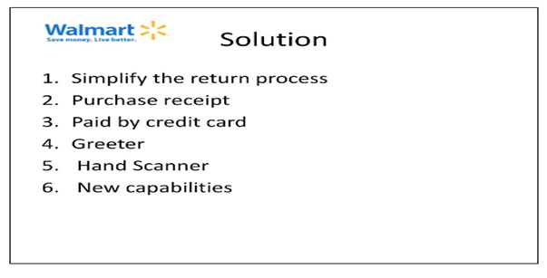
NOTES: Since all of us at Walmart are focusing on improving our Customer-Oriented processes, we have determined that improving our merchandise return process would increase our competitive advantage.
The solution that we are proposing would eliminate the need for customers who are returning merchandise to stand in line at the Customer Service Counter. We would modify the customer receipt adding a bar code identifying the purchase record. When the customer enters the store they are greeted by our Greeters who currently tag all returns and send the customers to the Customer Service Counter where the return would be processed. When the Greeter met the customer who wants to make a return they will enquire if the customer has the receipt. If the answer is no a tag will be attached to their return. If the answer is yes ,the Greeter will use new capabilities that have been added for the hand scanner to scan the receipt into our system and the scanner will show the items on the receipt from which the Greeter will select the items being returned and enter the quantity. The system will issue a credit for the purchase and print a credit receipt for the customer; the Greeter will mark through the items that were returned on the original receipt.

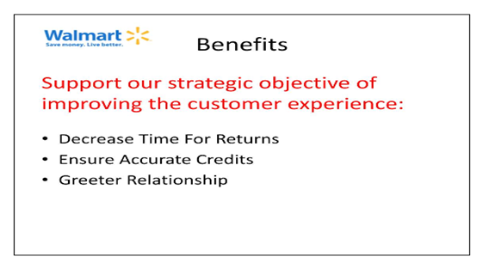
NOTES: The proposed solution will support our strategic objective to improve the customer experience by decreasing the time that it takes for a customer to return goods and minimize the time that they will spend in line waiting for service. Since the solution is using data already available and controlled, the credits will be accurate, which is important to our customers. Customers have seen our Greeters for years and they have a relationship with them. This solution will build on the customer’s relationship with our Greeters and will decrease the tension that some customers experience when they make returns.

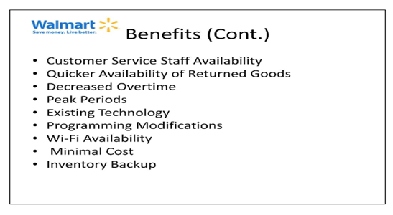
NOTES: This new process will eliminate the need for the customer to take returns to the Customer Service Counter. The Customer Service Staff will be able to concentrate on the more difficult customer issues, and not require the customer with an item to return to wait while difficult issues are addressed. Since the Customer Service Counter staff is relieved of some processing they can spend that time preparing the returned items for restocking and sorting them by department, including those items collected by the Greeter. The decrease in Customer Service Staff workload could result in a decrease in overtime during peak periods, additional staff may be required to assist the Greeter. The simplicity of the system will allow other employees to be trained and help during peak periods. No new technology will be needed as the hand held POS that is used for inventory has the necessary capabilities, but three additional units will be required. Programming changes will be required to enable the printing of the Receipt Number and Bar Code on the receipt and enable the hand held to access the programs needed for returned items, and the algorithm for how the credit is processed will need to be revised and implemented. The Wi-Fi needed for this process is currently available in all stores as it is used for inventories. Expediting the availability of returned items could result in increased sales. The costs are minimal and the equipment purchased could provide back up for handhelds used for taking inventories. The cost of the programming changes would be minor as they would be done by existing programming staff.
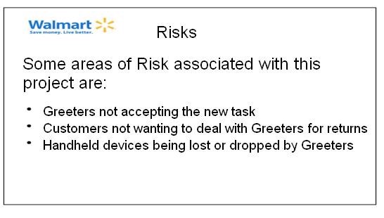
NOTES: While there are many benefits to the WERP solution, there are also some risks. These have to do with whether the Greeters and the customers will readily accept the new role of the Greeter in dealing with returned merchandise, and with Greeters possibly dropping or losing the handheld devices. In deploying the system, we need to let the Greeters know how important this new responsibility is and approach it positively. To make customers comfortable with the process change, we can use posters to announce a new quick-return service. And, to reduce loss and breakage, we can supply Greeters with a holster-type of holder for the device so when they are not using it, it will be protected.
(The slides that would provide an overview of IT solution components, IT Skills/Services & Business/Management Resources are omitted here; be sure to follow the assignment instructions and include all required information.)
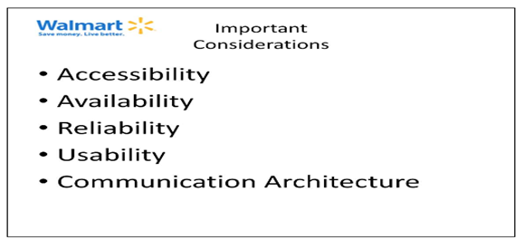
NOTES: There are some important considerations in our design of WERP that are created by adding the new return processing capabilities. There are other considerations that are external to the actual application system, and are part of the business environment or procedures used.
Accessibility to the scanner and then to the system functions must be controlled because this application allows access to financial transactions. The scanners will be kept under the control of the shift manager who will sign them out to the authorized employees who will have individual logon ids and passwords. The system must be available during the store hours so that returns can accepted. The application, being part of the larger sales system will be available during store hours, and Greeters must be at their post from store opening, which is no change from current practice. Since Financial transactions are involved the application must be reliable to ensure correct transaction processing. The use of scanning and transaction data that is already in the sales system and the fact that no new data is created ensure the reliability of the system. The application must be simple and easily learned so that all employees can become proficient and able to provide help when the volume of customers is high. Most employees are familiar with the scanners as they are used during inventories and the new steps using scanning will make training easy. The Wi-Fi communication architecture that will be needed is currently available and is robust and proven; no new capabilities will be required.

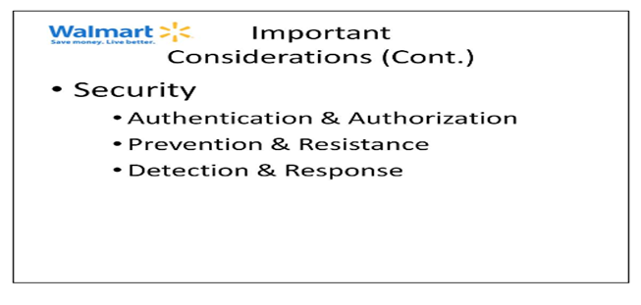
NOTES: The various aspects of Security are important, since this is a financial system that affects sales revenue and inventory control. The security requirements will be met using physical controls, security of hardware devices and the use of passwords. Since the receipt is required for these transactions nothing new can be entered and once an item is credited it cannot be credited again without management approval. There will be checks in the software that will monitor the credit card numbers used in the returns for an imbalance between purchases and credits. Security staff will monitor the security measures based on their normal procedures used for financial applications.
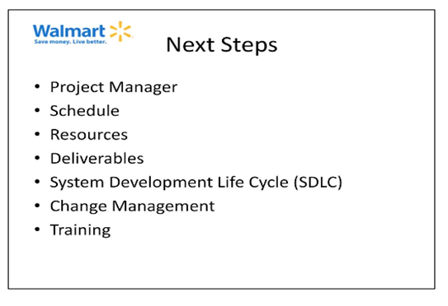
NOTES: Once we have the funding approved we will select a qualified Project Manager who will be responsible for developing a Project Plan that will include a preliminary schedule and identify the required resources and the deliverables that management can expect. Change management issues will be addressed, both to assist the employees as they begin using the new application and to manage changes to policy, procedures and/or the application. While addressed in the SDLC, training will be an ongoing need as new employees are hired and to ensure that current employees are updated on any system changes.
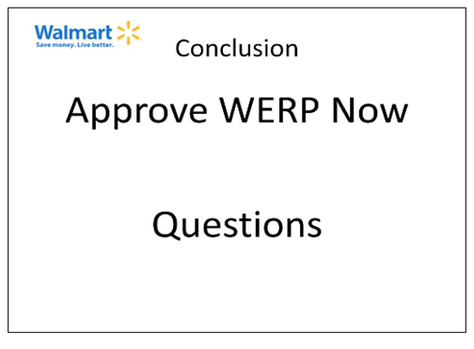
NOTES: As you consider the benefits of WERP, I hope you will remember your own experience standing in line for an extensive period to return some item, even when you had all the paperwork needed. Our customers will benefit from this change to our return process, which also supports our strategy to improve the customer experience. I hope you will approve WERP this morning.
I will be happy to answer any question that you may have.

Annotated Outline of IT Solution and Next Steps (Stage 4)

Now that we have achieved Management’s approval of WERP, the project must be initiated, a Project Manager assigned and resources allocated. We have briefly indicated the Next Steps in our presentation, but now we must develop a document of the Next Steps that can be used operationally. Please note that you will research and propose an IT solution at part of Stage 4 (which is a little different from what is shown in this example document). Below is an example of an annotated outline format; be sure to follow the assignment instructions as you develop your Stage 4 project.

IT Solution Next Steps

Project Description
- Introduction
  - Strategy for Competitive Advantage: Customer Orientation.
  - Process to be improved: Return Process.
- Proposed solution and IT components needed to implement the project
- Business resources needed to complete the project….

Project Management
- Triple Constraints
- …..

Human Resource Management
- The project team will consist of
    - Project Manager: Store Accounting Manager
    - Executive Sponsor: Store Manager
    - Project Team Members: Greeters, Cashiers, Programmers and Customer Service Staff
- Based on the schedule and the tasks required at various times the project team will need augmentation from the Store Staff for specific activities, for example accountants and auditors.
- In the store, access to the test environment must be available on identified nights to duplicate actual operation.

Risk Management
  - Greeters may not accept this new task; training and incentives will be used to encourage acceptance.
  - Customers may not want to deal with greeters for returns; greeters will be trained to make customers comfortable with new process
  - Hand-held devices may be lost or dropped; holsters to hold device will be provided to the greeters.

SDLC

System Investigation
- A high-level plan of the WERP Project and its intended goals will be developed.
- A detailed plan that will be used to manage WERP will be established.
- A completed Plan and Schedule will be approved by the Project Manager.

System Analysis
- Detailed user requirements for WERP will be developed.
- The goals will be refined into defined functions and operations of the WERP System.
- A completed Requirements Document including explanation of functions and operational requirements will be approved by the Project Manager.

System Design
- The system design will describe the desired features and functions of WERP.
- The team will develop screen layouts and receipt design.
- Functional users will develop business rules, like WERP will only handle returns of goods that are accompanied by a receipt.
- The team will develop process diagrams.
- The security officer will design a security plan and audit plan.
- The programmers will develop pseudo code and other documentation.
- The test team will develop a detailed Test Plan.
- The completed Detailed Design Document including all of the above will be approved by the Project Manager.

Programming
- The programmers will transform the Detailed Design Document into the WERP System.
- The document writers will provide detailed documentation of the work performed to meet the Design Document requirements; these will be approved by the Project Manager.

Testing
- The team will collect all aspects of the WERP System together in the special test environment and test for errors, bugs, interoperability and usability.
- The team will verify that all of the requirements and goals stated in the Requirements Document are met.
- Documentation of the completed Test Plan will be approved by the Project Manager.

Implementation
- WERP will be implemented in the first store.
- The user representative will sign off that the system meets the requirements.
- Walmart will begin realizing the benefits.

Operations and Maintenance
- Ongoing support will be provided to allow for changes, corrections, additions and upgrades to ensure that the WERP System continues to meet the business goals established.
- The system will be operated effectively.

Business Process Changes
- The human resources department will establish a process that will help employees understand the changes, impact on their jobs, the scope, objective and benefits to obtain their support and minimize concern and resistance to change.
- The marketing team will establish a process for informing customers of the changes and gaining their support.

Employee Training
- A detailed training program that can be used at our store for all employees who will be part of the WERP process will be developed.
- All personnel at our store who will be involved with WERP will be trained in their particular function as well as in the overall WERP process.
- Part of the training will be a refresher in the use of the wireless scanning equipment since all employees are familiar with its basic operation as it is used for inventory activities.
- Ongoing monitoring of the initial implementation will allow the ability to monitor the employees in the correct WERP operation and assist them with correct usage and make adjustments to the training to emphasize areas that need reinforcement.
- The training program will be prepared for use at other stores and a process for training the trainers at other stores will be developed.
- The human resources department will modify existing new employee training programs to include WERP training.

Defining Success
- User requirements and functions will be checked to ensure they perform as desired and expected.
- A key goal is that the project is completed on time and on budget.
- If wait time for returns is reduced, the project will be considered successful.
- Another success criteria is that users accept the new process and find that it improves the image of Walmart in the customers’ eyes as being concerned about customer satisfaction.

