Assignment 3 – Worth 25 total points --- Remember to scroll down to all three parts
Please submit this in Learn as a Word document.
You will evaluate two scenarios and two commercials using the model of the communications process shown in figure 5-1 on page 148 of the textbook.
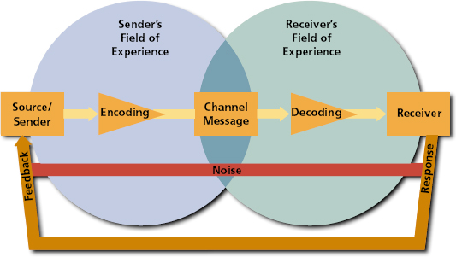

  - Part 1: Communication Process -Computer Systems (5 points)
A salesperson selling computer systems to large businesses is getting ready to give a sales presentation to a potential account. There are top managers, supervisors, front-line employees, and a representative from the purchasing department present in the audience. The salesperson wants use his/ her knowledge of the communication process found in the diagram to during the presentation. You may use bullets/lists to answer the questions.

Questions:
- In this situation, what are some of the forms of verbal communication feedback can the salesperson expect during the presentation?
- In this situation, what are some of the forms of verbal communication feedback can the salesperson expect after the presentation?
- In this situation, what are some of the forms of non-verbal communication feedback can the salesperson expect during the presentation?
- How should the salesperson respond to the non-verbal communication feedback?
- What are different types of noise that could impact the presentation for the salesperson and audience?

  - Part 2:Sprint Samsung (10 points)
Using the Model of the Communication Process provided at the beginning of the assignment, evaluate the following Sprint Samsung advertisement.


(Please make sure you answer all nine questions)
Questions:
- Who is the source/sender?

- What words, signs, symbols, etc have been used to encode the message?

- What is the channel?

- What is the message?

- When you decode this message, what do you think Sprint is trying to tell you?

- Who is the intended receiver?

- What might be some possible sources of “noise” while viewing this advertisement?

- What are some possible responses to this advertisement?

- In what ways could the sender get feedback from this advertisement?
  - Part 3:Sony Speed Reading (10 points)
Watch the following commercial and evaluate the source, message, and channel factors. Please use paragraph form for your answers.
Resources:
- http://belch9e.adforum.com/creative-work/ad/playlist/6873/34452649// (better version)
- http://www.youtube.com/watch?v=wKbqa_kjj2o (youtube clip of the same commercial)

Supplemental Resources: (If you don’t the celebrities, here are links to who they are. I don’t want answers saying you didn’t know the person, so you have no opinion about them)
- http://www.mrreader.com/ Howard Berg’s Insider Secrets
- http://www.ftc.gov/os/1998/01/berg.pkg.htm Lawsuit against Howard Berg
- http://en.wikipedia.org/wiki/Amy_Sedaris Amy Sedaris Wikipedia Page
- http://en.wikipedia.org/wiki/Justin_Timberlake Justin Timberlake Wikipedia Page
- http://en.wikipedia.org/wiki/Payton_Manning Payton Manning Wikipedia Page
This advertisement is pretty old. At the time, this Reader was selling for $199. The following link shows the newer Sony Readers.
Questions:
- Who is/are the source(s)? –Remember reading about celebrities
- What is the message?
- Who is the intended receiver?
- This ad uses celebrities. Are these celebrities likable? Trustworthy? Overshadowing? Discuss Sony’s choice and use of each celebrity in detail. (Need an answer for each four celebrities. Be very specific. These are your opinions, but be sure to support your answer with content you learned from the book.)
  - Howard Berg (I would highly recommend reading reviewing the second link before you answer this question)
  - Amy Sedaris
  - Justin Timberlake
  - Payton Manning
- This ad also uses a humor appeal. Discuss the advantages and disadvantages of using humor in an ad (This question isn’t specifically about this ad).

