Student Name
Course and Section Number | Program of Study
STA 2014

Statistics
STA 2014
Week 4 Individual Work

Assignment Instructions
To complete this assignment:

- Answer all of the questions below in the space provided.
- Reflect on the information presented in this week’s lesson and provide an insightful response to each question.

Save and Submit to Dropbox
- Save your work as a Microsoft Word 2010 (.docx) file that includes your name, course code, and title in the file name. For example: JaneSmith_STA2014_Week4.docx.
- To submit your assignment, go to the Dropbox and click "Submit Assignment."
- Click on the drop-down menu to select the Week 4: Individual Work basket in the Dropbox.

Objectives: Interpret the process of collecting unbiased data for observational studies and experiments.
Use statistical thinking in the process of data collection.

Section 2.1
26. President’s State of Birth: The following table lists the presidents of the United States (as of October 2010) and their states of birth.

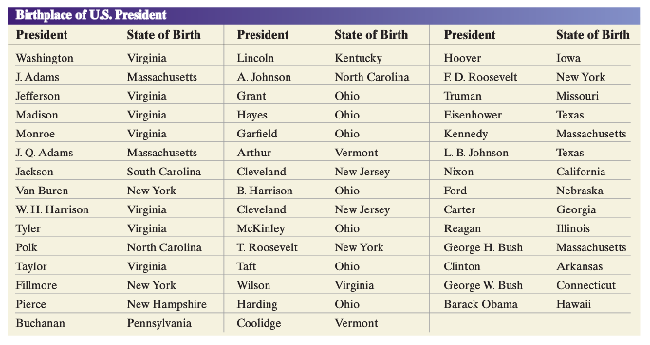
(b) Which state has yielded the most presidents?
Answer:

(c) Explain why the answer obtained in part (b) may be misleading.
Answer:

Section 2.2
36. Uninsured Rates: The following data represent the percentage of people without health insurance for the 50 states and the District of Columbia in 2009.

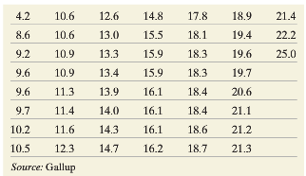

With the ﬁrst class having a lower class limit of 4 and a class width of 2:
(a) Construct a frequency distribution.
Answer:

(b) Construct a relative frequency distribution.
Answer:

(c) Construct a frequency histogram of the data.
Answer:

(d) Construct a relative frequency histogram of the data.
Answer:

(e) Describe the shape of the distribution.
Answer:

Section 2.3
6. Car Accidents: An article in a student newspaper claims that younger drivers are safer than older drivers and provides the following graph to support the claim. Explain how this graph is misleading.

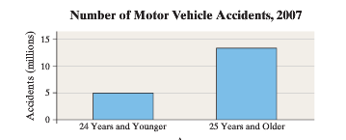
Answer:

Section 3.1
16. Flight Time: The following data represent the ﬂight time (in minutes) of a random sample of seven ﬂights from Las Vegas, Nevada, to Newark, New Jersey, on Continental Airlines.
282, 270, 260, 266, 257, 260, 267

Compute the mean, median, and mode flight time.
Answer:

34. Mr. Zuro finds the mean height of all 14 students in his statistics class to be 68.0 inches. Just as Mr. Zuro finishes explaining how to get the mean, Danielle walks in late. Danielle is 65 inches tall. What is the mean height of the 15 students in the class?
Answer:

Section 3.2
20. Travel Time: The following data represent the travel time (in minutes) to school for nine students enrolled in Sullivan’s College Algebra course. Treat the nine students as a population.

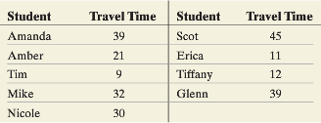
(a) Determine the population standard deviation.
Answer:

(b) Find three simple random samples of size 4, and determine the sample standard deviation of each sample.
Answer:

(c) Which samples underestimate the population standard deviation? Which overestimate the population standard deviation?
Answer:

