Math 30
The text book is:
Blitzer College Algebra 6e

Problem 1: Use the Point-Plotting Method with a table of values to establish ordered pairs that are solution points for your graphs, then plot each graph neatly on graphing paper. Be certain to answer ALL questions.
P. 102, # 23; P. 103, # 54; P. 134, # 25.
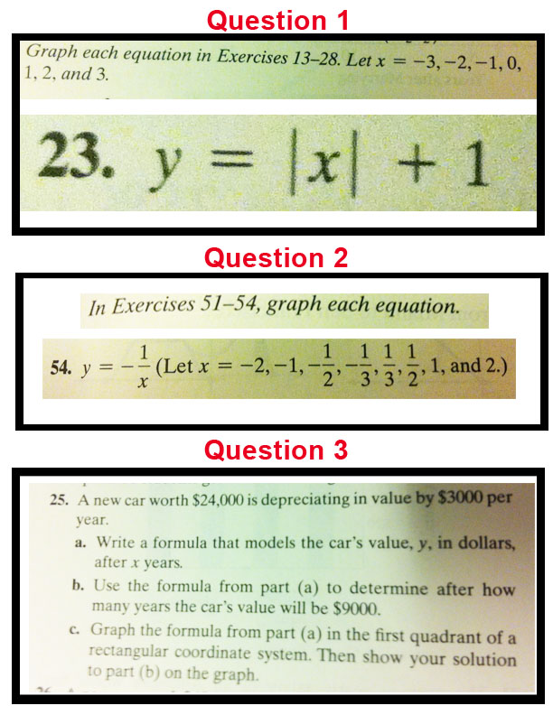
Problem 2:
P. 132, #(s): 1, 2, 3, 4, 5, 8, 9; P. 133, # 18; P. 135, # 70, # 73; P. 136, # 90, # 91.
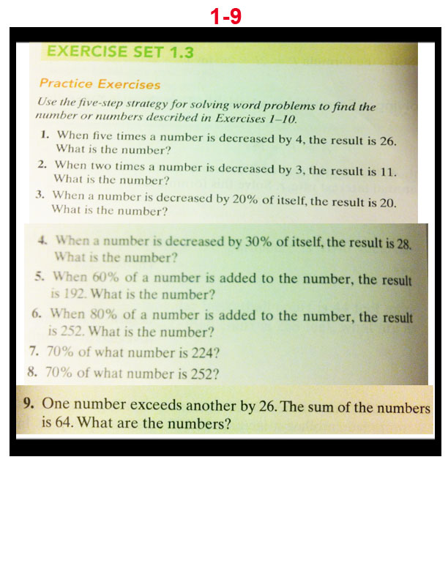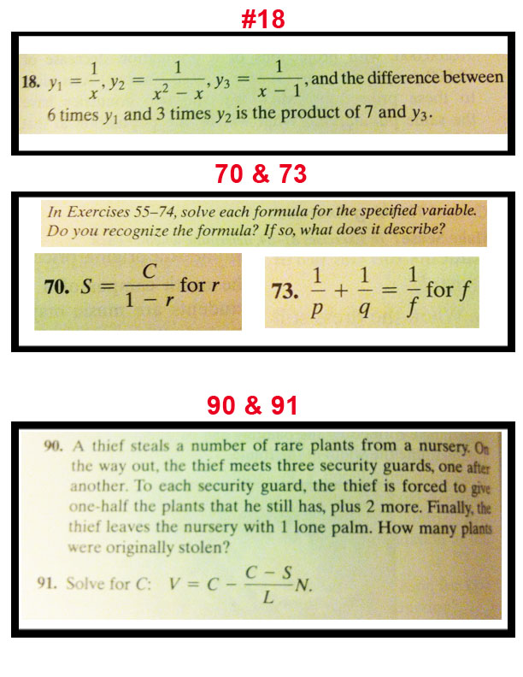
Problem 3:
P. 142, # 25, # 28, # 38, # 40, # 52, # 53, # 75.
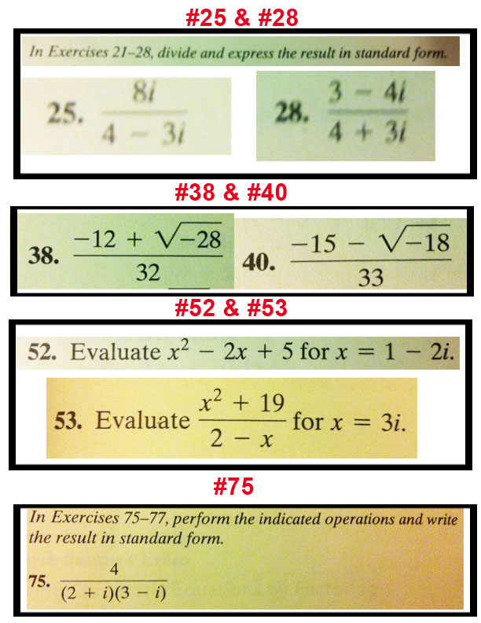
Problem 4:
P. 160, # 51, # 53, # 60, # 64.
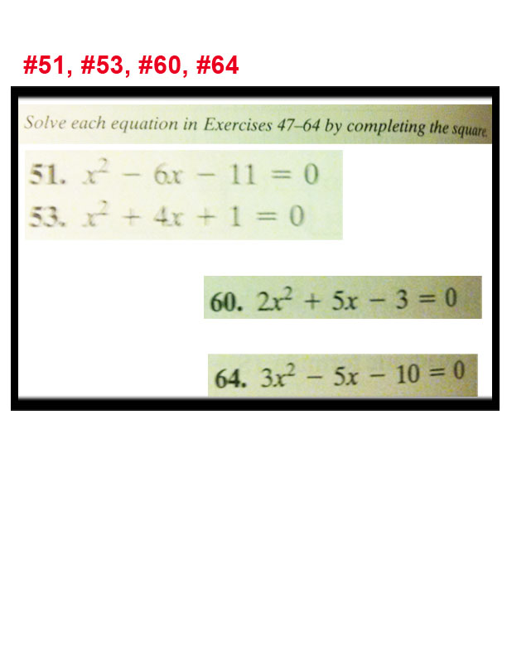
Problem 5:
P. 161, # 73, # 74, # 82, #108.
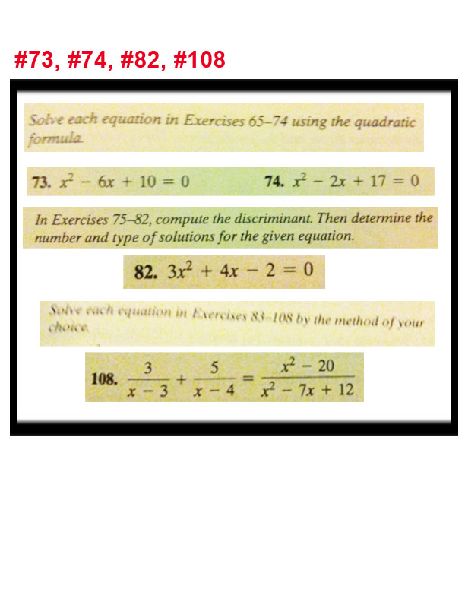
Problem 6:
P. 178, # 4, # 9
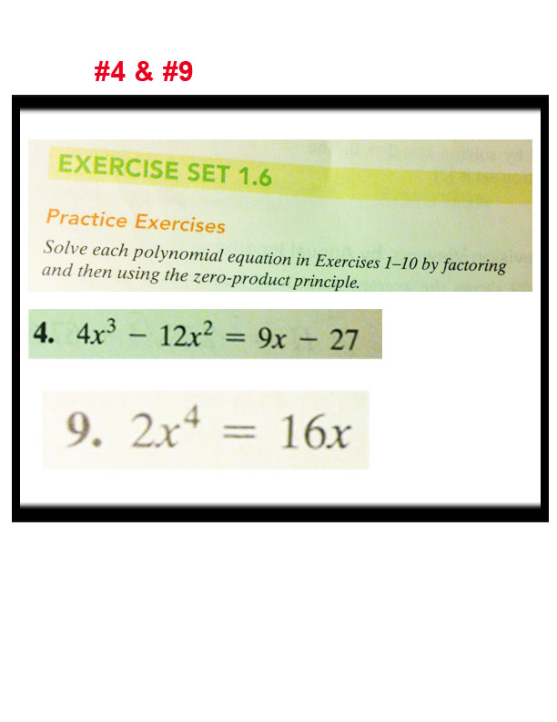
Problem 7:
P. 178, # 23, # 26.


