Math 107 Section 6384 – Exam #2 – Due February 7, 2015 – page 1 of 6

Follow these directions carefully.

- This exam is due by 11:59 PM Eastern time on February 7, 2015.
  - This is an important assignment, counting 12% of your course grade.
  - Submit this assignment in your assignments folder by the due date.

- Answer all the questions. There are 38 problems on 6 pages.
  - There are 135 points possible. I will grade all the problems and convert your total score to a

percentage out of 100.

- No work is required for the MULTIPLE CHOICE SECTION or for the SHORT ANSWER SECTION. There is no partial credit for these problems, so please work carefully.
  - Show all work for the LONG ANSWER SECTION. There is partial credit for these problems.

- Answer these questions on separate pages (not these sheets).
  - Use a separate document to solve these problems. You may type your answers in a document (like Word or Excel) or handwrite your answers and scan them in – up to you.
o Submit your assignment as an attachment.
Use filename 1501Math107_6384_E2_LastName_FirstName.*
- You must work on your own, consulting no other person except for me. You can of course use your book, calculator, and any other resources, besides people, that you may have at your disposal.

MULTIPLE CHOICE SECTION. Choose the best alternative. (2 pts each)

- On what interval is the function below constant?
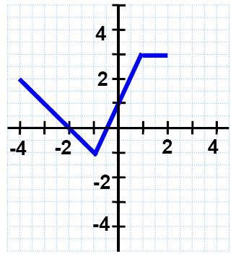

a) | (−4, −1) | c) | (−1,1)
b) | (1, 2) | d) | Not constant on any interval

- What is the slope of any line perpendicular to x + 2y = 3?

a) | 2 | c) | −2
b) | 1 / 2 | d) | −1 / 2

- The center of the circle (x + 5)² + (y + 4)² = 17 is (−5, −4).

- True

- False

4. An equation of the line with slope 3 passing through (−3,10) is not y = 3x +10. Rather, it is y = 3x +19.

- True

- False

Math 107 Section 6384 – Exam #2 – Due February 8, 2015 – page 2 of 6

- The line joining (−5, 5) and (−5, −5) has undefined slope.

- True

- False

6. | The ordered pair (−5, 3 / 4) is on the graph of the line 8y − 3x = 21.
 | T) | True
 | F) | False
7. | A horizontal line containing the point (2, 3) has equation y = 3.
- True

  - False

- Determine the domain and range of the function below.
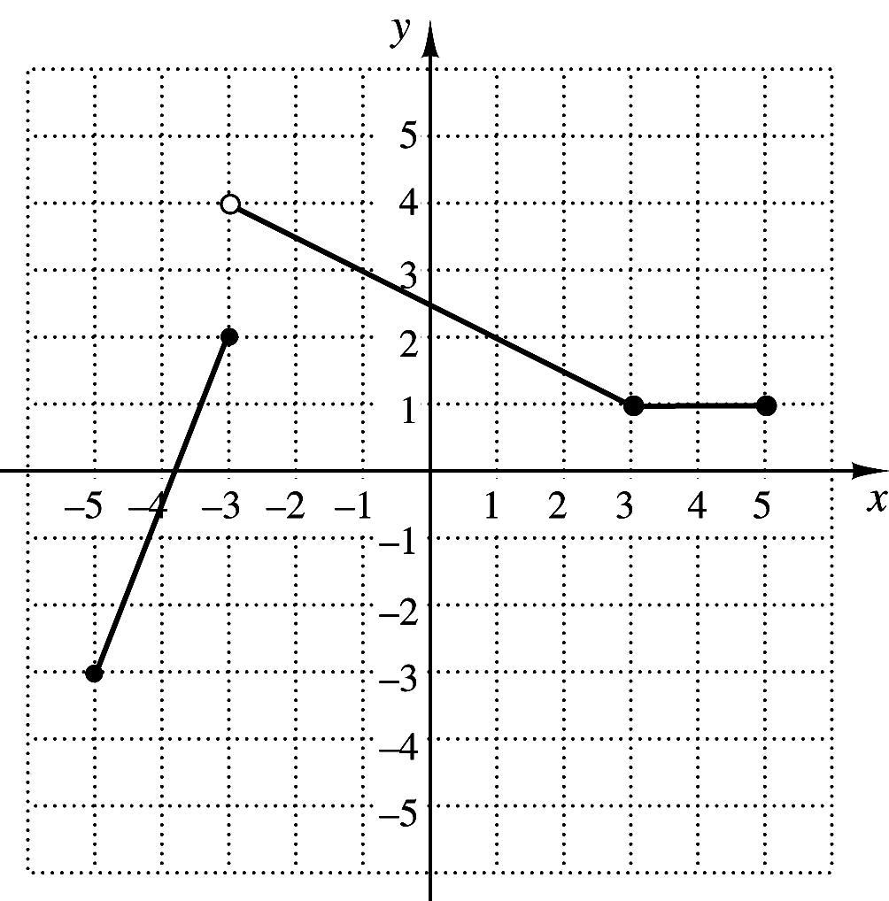

 | a) | Domain: (−5, −3) ∪ (−3, 5) |  |  |  | Range: (−3,2) ∪ (2, 4)
 | b) | Domain: [−5, 5] |  |  |  | Range: [−3, 4)
 | c) | Domain: [−5, −3) ∪ (−3, 5] |  |  |  | Range: [−3,2) ∪ (2, 4)
 | d) | Domain: (−5, 5) |  |  |  | Range: (−3, 4]
9. | Suppose that |  |  | f (x) = x² − 3x − 2 and g(x) = 4 x +1. Determine ( f − g)(−2).
 | a) | −7 |  |  | c) | 15
 | b) | 1 |  |  | d) | 4
10. | Suppose that |  |  | f (x) = x² − 5 | and g(x) = |  |  |  |  | What is the domain of ( f / g)(x)?
 |  |  |  |  |  |  | x −1.
 | a) | (−∞,1) ∪ (1, ∞) |  |  | c) |  | (−∞, − |  |  |  |  |  | ) ∪ (−
 | a) |  |  |  | c) |  |  |  |  |  |  | 5 | ) ∪ (− | 5, 5 ) ∪ ( 5, ∞)
 | b) | [1, ∞) |  |  | d) |  | (1, ∞)
11. | Find an equation of variation in which y varies inversely as x and y = 15 when x = 10.
 | a) | y = | 2 | x | c) |  | y = | 150
 |  | 3 |  |  |  |  |  |  | x
 | b) | y = | 3 | x | d) |  | y = 6x
 |  | 2
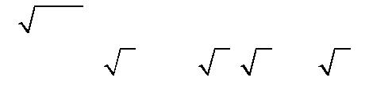
Math 107 Section 6384 – Exam #2 – Due February 8, 2015 – page 3 of 6

- Write an equation for a function that has the shape of y = x , but is shifted right 2 units and down 6 units.
a) | f (x) = |  | x + 2 |  | − 6 | c) | f (x) = |  | x − 2 |  | + 6
b) | f (x) = |  | x + 2 |  | + 6 | d) | f (x) = |  | x − 2 |  | − 6

- The function f (x) = x ³ is odd.

- True

  - False

- The graph of y = 1− x² is symmetric about the y-axis, but not the x-axis.

  - True

  - False

- The graph of the relation below is the graph of a function.
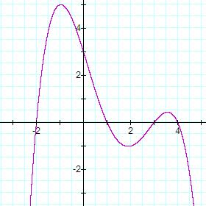

- True

  - False

- The relation {(−2,0),(−1,1),(−1, 3)} is a function.

  - True

  - False

- The width of a rectangular blanket is 4 less than twice the length l. Express the area of the blanket as a function of l.
a) | A(l) = 4l − l² | c) | A(l) = 3l − 4
b) | A(l) = 2l² − 4 | d) | A(l) = 2l² − 4l
SHORT ANSWER SECTION. Be careful; there is no partial credit for these questions. |  |  |  | (3 pts each)
For questions 18 and 19, find the distance between (1, −10) and (3, −6) :

- In simplest radical form (no decimals).

- To one decimal place. (Make sure you follow the directions here.)

Math 107 Section 6384 – Exam #2 – Due February 8, 2015 – page 4 of 6

Questions 20 and 21 involve the circle with equation (x + 5)² + (y − 3)² = 17.

- Determine its center.

- Determine its radius.

- Find the slope of the line containing the points (−5, 8) and (5, 4). Express your answer as a fraction in simplest form.

- A car travels at a constant rate of 40 miles per hour for 45 minutes. How far did the car travel?

Questions 24 and 25 involve the function graphed below.
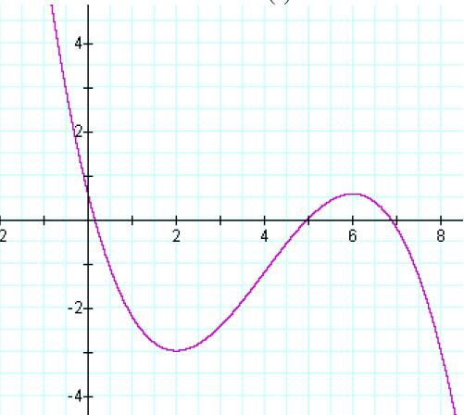

- On what interval(s) is the function increasing? Express your answer in interval notation.

- On what interval(s) is the function decreasing? Express your answer in interval notation.

26. | Find the domain of the function | f (x) = | x − 3 |  | and write your answer in interval notation.
26. | Find the domain of the function | f (x) = | 3x² − 2x |  | and write your answer in interval notation.
 |  |  | 3x² − 2x | − 5

Questions 27, 28 and 29 involve the function defined by

x² +1
x − 5
f (x) =
2x
- 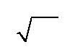Find f (−2).

- Find f (0).

- Find f (−2) + f (18).

for x ≤ −2, for − 2 < x < 1, for x ≥ 1.

[Caution: this is not f (16).]

Math 107 Section 6384 – Exam #2 – Due February 8, 2015 – page 5 of 6

Questions 30, 31, 32, 33 and 34 involve Graphs 1 and 2 appearing directly below.

Graph 1: f (x) Graph 2: g(x)
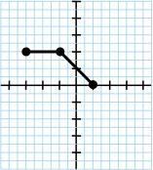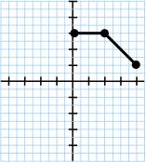

You’re given the information that Graphs 1 and 2 are piecewise linear, and that Graph 2 is a transformation of Graph 1 using horizontal and vertical translations. Each numbered and lettered part is worth 3 points. (So Question 33 is worth 12 points, 3 points per part.)

- On the interval −3 ≤ x ≤ −1, what is a formula for f (x)?

31. | On the interval −1 ≤ x ≤ 1, what is a formula for f (x)?
32a and 32b. Use your answers to #30 and #31 to fill in the blanks.
 |  |  | −3 ≤ x < −1
 | a) _________, |  | −3 ≤ x < −1
 | f (x) = | b) _________, | −1 ≤ x ≤ 1

33a, 33b, 33c, and 33d.

Choose the correct alternative and fill in the blanks.

The graph of g(x) is obtained from the graph of f (x) by shifting the graph of f (x)

a) | LEFT or RIGHT | (choose one)
by
b) | ________ units,
and then
c) | UP or DOWN | (choose one)
by
  - ________ units.

- Which of the following is correct?

a) | g(x) = f (x − 3) +1 | c) | g(x) = f (x − 3) −1
b) | g(x) = f (x + 3) +1 | d) | g(x) = f (x + 3) −1

Math 107 Section 6384 – Exam #2 – Due February 8, 2015 – page 6 of 6

LONG ANSWER SECTION. Solve the problems. You must show all work in order to receive any credit.

- Determine an equation of the line, in slope-intercept form, which contains the points (−3, 6) and

 | (5, −14). | (10 pts)
36. | Find an equation of the circle whose endpoints of a diameter are (−3, 6) and (5, −14). | (10 pts)
37. | If f (x) = x + 2 and g(x) = −x² + 2 x − 3, determine a formula for (g ! f )(x). | (10 pts)

- A salesperson earns a base salary of $3,200 per month and a commission of 5% on the amount of sales

made. If the person has a paycheck of $5,700.00 for one month, what was the amount of sales for the month? (8 pts)

