Week 3 Lab Instructions
Bipolar Junction Transistor Amplifier Circuit Analysis

I. Objectives:

- To analyze bipolar junction transistor (BJT) common emitter (CE) amplifiers using the amplifier parameters.

- To determine the BJT voltage-divider biased DC parameters based on schematic diagrams, simulated circuits, and constructed circuits.

- To verify the operations of CE amplifier based on the theatrical framework (laws and theorems).

- To determine the phase angle between input and output signals.

II. Equipment and Parts List

Equipment:

- Personal computer (PC) or compatible
- Function generator
- DMM (digital multimeter)
- Variable DC power supply
- Oscilloscope

Parts:

Qty. | Parts and Components | Tolerance Band | Wattage Rating, W
1 | 2N3904 Transistor
1 | 470 Ω Resistor | gold | ¼
1 | 2 KΩ Resistor | gold | ¼
1 | 10 KΩ Resistor | gold | ¼
1 | 47 KΩ Resistor | gold | ¼
1 | 1.0 uF Capacitor
1 | 10 uF Capacitor
1 | Proto Board
 | Hookup wires of different colors
3 | BNC to split ends cable

Software: MultiSim

III. Procedure
- Theoretical Analysis
Given the schematic diagram shown in Figure 1, calculate the BJT voltage-divider biased DC parameters (V_{B,} V_{C,} V_{E}, V_{CE,} V_{BE,} V_{CEQ,} I_{B,} I_{c,} I_{E}, and I_{CQ}) with assumption h_{FE} = 50. Enter the calculated values in Table 1 on the worksheet.

Note: V_{B,} V_{C,} V_{E} are referred to point voltages, and they are quantified with respect the circuit reference (i.e., ground); while, V_{CE,} V_{BE,} are known as voltage drop across two points.

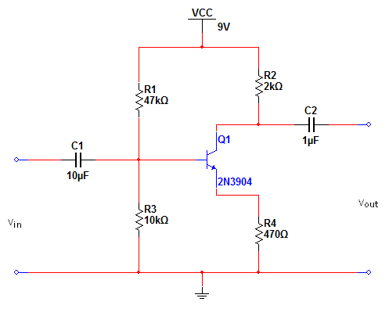
Figure 1 Voltage-Divider Biased Common Emitter (CE) Amplifier Schematic Diagram

Calculated Parameters | Voltage (V) | Current (mA)
Base Voltage (V_{B}) |  | -
Collector Voltage (V_{C}) |  | -
Emitter Voltage (V_{E}) |  | -
Collector-Emitter Voltage (V_{CE}) |  | -
Base-Emitter Voltage (V_{BE}) |  | -
Collector-Emitter Voltage @ Cutoff (V_{CE(off)}) |  | -
Collector-Emitter Voltage (V_{CEQ}) |  | -
Base current (I_{B}) | -
Collector current (I_{c}) | -
Emitter current (I_{E}) | -
Collector current @ Saturation (I_{c(STA)}) | -
Collector current (I_{CQ}) | -
Table 1

- MultiSim Simulation
- Design the circuit shown in Figure 2 using MultiSIM. Set the DC voltage source to 9V for V_{CC}.
- Measure the BJT voltage-divider biased DC parameters (V_{B,} V_{C,} V_{E}, V_{CE,} V_{BE,} I_{B,} I_{c,} and I_{E}).
- Calculate (V_{CEQ} and I_{CQ}) based on the measured values and h_{FE} = 50. Enter the measured and calculated values in Table 2 on the worksheet.

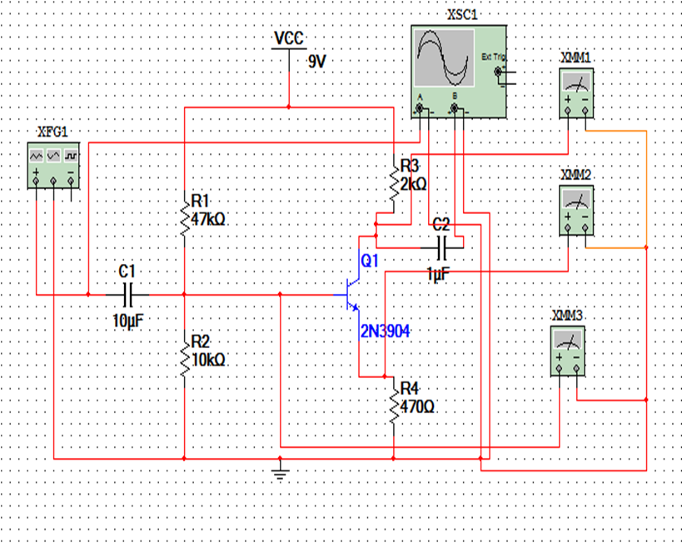
Figure 2 Voltage-Divider Biased Common Emitter (CE) Amplifier MultiSim Design

Simulated and Calculated Parameters | Voltage (V) | Current (mA)
Base Voltage (V_{B}) |  | -
Collector Voltage (V_{C}) |  | -
Emitter Voltage (V_{E}) |  | -
Collector-Emitter Voltage (V_{CE}) |  | -
Base-Emitter Voltage (V_{BE}) |  | -
Collector-Emitter Voltage @ Cutoff (V_{CE(off)}) |  | -
Collector-Emitter Voltage (V_{CEQ}) |  | -
Base current (I_{B}) | -
Collector current (I_{c}) | -
Emitter current (I_{E}) | -
Collector current @ Saturation (I_{c(STA)}) | -
Collector current (I_{CQ}) | -
Table 2

- Connect the input (V_{in}) and output (V_{out}) of the amplifier to two separate channels of an oscilloscope.
- Connect the input (V_{in}) of the amplifier to a function generator and set the parameters of the functions generator to: (a) sine-wave mode at 1 kHz, and (b) amplitude of signal to 0.5 V peak-to peak (V_{PP}). If the output signal (V_{out}) is clipped, reduce the input signal amplitude until the clipping no longer exists. A typical scope display is shown in Figure 3.

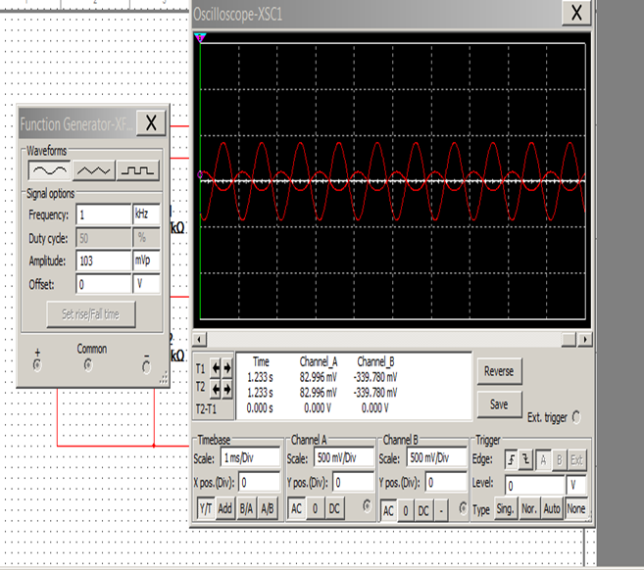
Figure 3 captured input and output signal waveforms of the simulated circuit on the oscilloscope

- Capture the input and output signal waveforms and insert them on the worksheet with proper caption. Then, answer the following questions on the worksheet.

  - What is the V_{PP} of the input signal V_{in}?__________________V
  - What is the V_{PP} of the output signal V_{out}?________________V
  - What is the phase angle between the input and output signals?_________Degrees
  - Calculate the voltage gain (A_{V}) of this amplifier? _________________

- Reduce the amplitude of the input signal to one-half the amount used in Step 3.
- Capture the input and output signal waveforms and insert them on the worksheet with proper caption. Then, answer the following questions on the worksheet.

  - What is the V_{PP} of the input signal V_{in}?__________________V
  - What is the V_{PP} of the output signal V_{out}?________________V
  - What is the phase angle between the input and output signals?_________Degrees
  - Calculate the voltage gain (A_{V}) of this amplifier? _________________

    - Breadboard Construction
- Construct the circuit in Figure 1 on a breadboard.
- Set the DC voltage source to 9V for VCC. Measure the BJT voltage-divider biased DC parameters (V_{B,} V_{C,} V_{E}, V_{CE,} V_{BE,} I_{B,} I_{c,} and I_{E}). A typical collector (V_{C}) voltage measurement is shown in figure 4.
- Calculate (V_{CEQ} and I_{CQ}) based on the measured values and h_{FE} = 50. Enter the measured and calculated values in Table 3 on the worksheet.

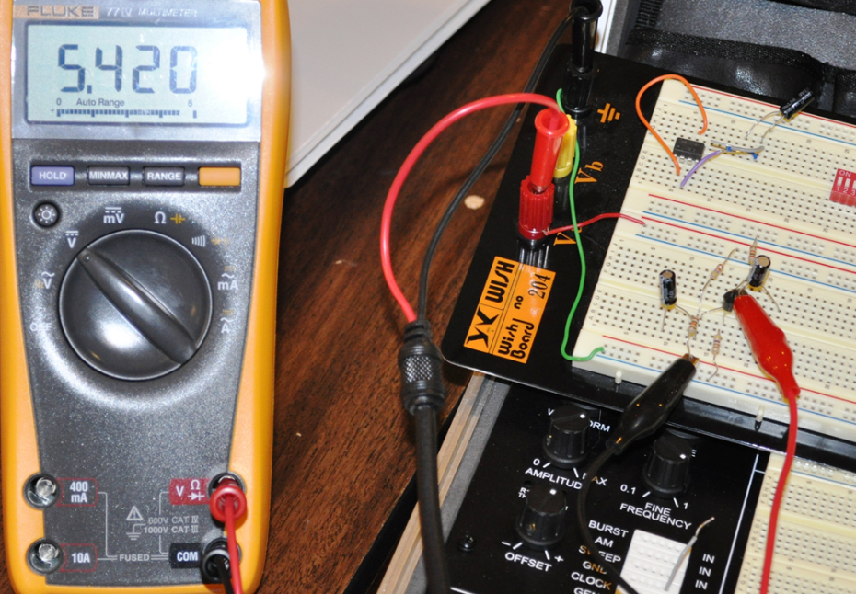
Figure 4 Voltage-Divider Biased Common Emitter (CE) Amplifier constructed circuit

Measured and calculated Parameters | Voltage (V) | Current (mA)
Base Voltage (V_{B}) |  | -
Collector Voltage (V_{C}) |  | -
Emitter Voltage (V_{E}) |  | -
Collector-Emitter Voltage (V_{CE}) |  | -
Base-Emitter Voltage (V_{BE}) |  | -
Collector-Emitter Voltage @ Cutoff (V_{CE(off)}) |  | -
Collector-Emitter Voltage (V_{CEQ}) |  | -
Base current (I_{B}) | -
Collector current (I_{c}) | -
Emitter current (I_{E}) | -
Collector current @ Saturation (I_{c(STA)}) | -
Collector current (I_{CQ}) | -
Table 3

- Connect the input (V_{in}) and output (V_{out}) of the amplifier to two separate channels of an oscilloscope.
- Connect the input (V_{in}) of the amplifier to a function generator and set the parameters of the functions generator to: (a) sine-wave mode at 1 kHz, and (b) amplitude of signal to 0.5 V peak-to peak (V_{PP}). If the output signal (V_{out}) is clipped, reduce the input signal amplitude until the clipping no longer exists. A typical scope display is shown in Figure 5.
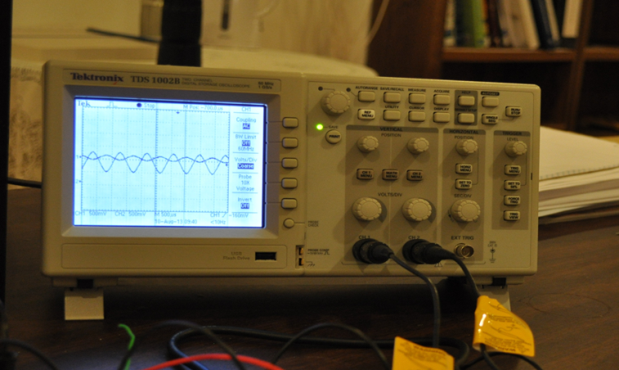
Figure 5 captured input and output signal waveforms of the constructed circuit on the oscilloscope.

- Capture the input and output signal waveforms and insert them on the worksheet with proper caption. Then, answer the following questions on the worksheet.

  - What is the V_{PP} of the input signal V_{in}?__________________V
  - What is the V_{PP} of the output signal V_{out}?________________V
  - What is the phase angle between the input and output signals?_________Degrees
  - What is the voltage gain (A_{V}) of this amplifier? _________________

- Reduce the amplitude of the input signal to one-half the amount used in Step 5.
- Capture the input and output signal waveforms and insert them on the worksheet with proper caption. Then, answer the following questions on the worksheet.
  - What is the V_{PP} of the input signal V_{in}?__________________V
  - What is the V_{PP} of the output signal V_{out}?________________V
  - What is the phase angle between the input and output signals?_________Degrees
  - What is the voltage gain (A_{V}) of this amplifier? _________________

IV. Results Analysis
- Compare the calculated, simulated, and measured parameter values, and enter your comments on the worksheet. Be sure to calculate the percentage of error in each method and to identify the source/s of error.
- Plot the DC load-line and identify the Q-point for the calculated, simulated, and measured methods. Explain the significance of shifting the Q-point on the DC line and which method will result in better Q-point.

IV. Troubleshooting
Describe any problems encountered and how those problems were solved.

V. Questions
Please provide the answer to the following questions on the worksheet.
- Did your theoretical calculations closely match the results obtained from the MultiSim simulation? (Yes/ No).
Comments:

- Did your theoretical calculations closely match the results obtained from the constructed circuit? (Yes/ No).
Comments:

- Did your results obtained from the Multisim simulation closely match the results obtained from the constructed circuit? (Yes/ No).
Comments:

VI. Grading

Deliverable | % of Grade | Points Achieved
Statistics (calculations, accurate values) | 15
Diagrams (labels, accuracy) | 6
Analysis (interpretation and discussion results) | 6
Organization (format of results and style) | 3
Total Points | 30

