101) Consider the regression model Y = 389.10 - 14.6X. If the r2 value is 0.657, what is the correlation coefficient?
102) Bob White is conducting research on monthly expenses for medical care, including over the counter medicine. His dependent variable is monthly expenses for medical care while his independent variables are number of family members and insurance type (government funded, private insurance and other). He has coded insurance type as the following:

X2 = 1 if government funded, X3 = 1 if private insurance

Below is his Excel output.

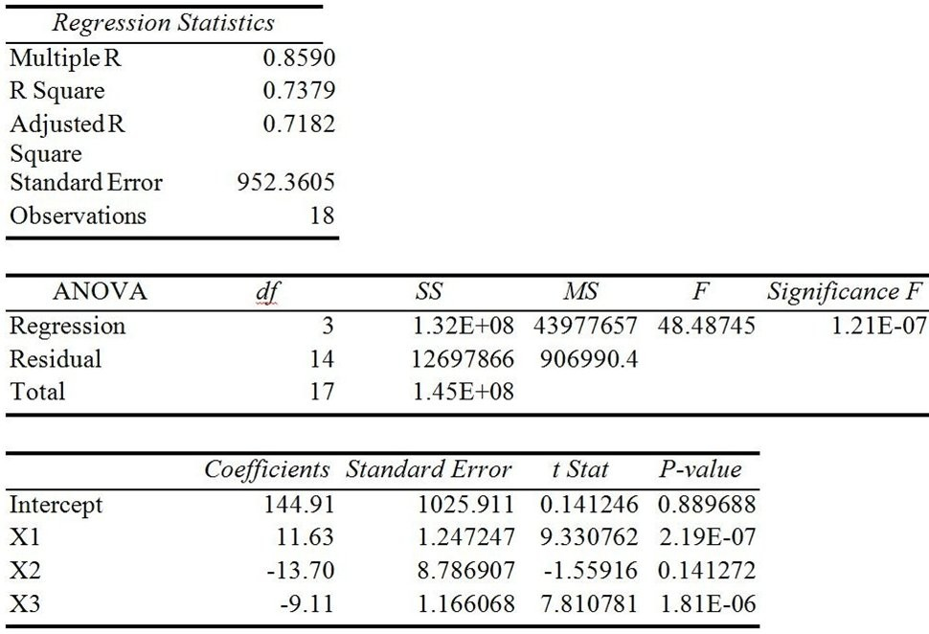

(a) What is the prediction equation?
(b) Based on the significance F-test, is this model a good prediction equation?
(c) What percent of the variation in medical expenses is explained by the independent variables?
(d) Based on his model, what are the predicted monthly expenses for a family of four with private insurance?
(e) Based on his model, what are the predicted monthly expenses for a family of two with government funded insurance?
(f) Based on his model, what are the predicted monthly expenses for a family of five with no insurance?
103) A large school district is reevaluating its teachers' salaries. They have decided to use regression analysis to predict mean teacher salaries at each elementary school. The researcher would like to examine the significance of the following quadratic model for predicting salary based on years of experience.

Y = β0 + β1X1 + β2X2 + ε where X1 = Yrs Exp and X2 = Yrs Exp2

Salary | Yrs Exp
$24,265.00 | 8
$27,140.00 | 5
$22,195.00 | 2
$37,950.00 | 15
$32,890.00 | 11
$40,250.00 | 14
$36,800.00 | 9
$30,820.00 | 6
$44,390.00 | 21
$24,955.00 | 2
$18,055.00 | 1
$23,690.00 | 7
$48,070.00 | 20
$42,205.00 | 16

(a) What is the adjusted r2?
(b) What is the prediction equation?
104) An air conditioning and heating repair firm conducted a study to determine if the average outside temperature could be used to predict the cost of an electric bill for a home during the winter months in Richmond, VA. It was determined that a quadratic model could be used and the following prediction equation was established:

Y = $1557.76 - 55.05X1 + 0.56X2
where Y = monthly cost, X1 = average temperature, and X2 = average temperature2

(a) If December has an average temperature of 43 degrees, what is the forecasted monthly electric bill?
(b) If January has an average temperature of 40 degrees, what is the forecasted monthly electric bill?
105) A large school district is reevaluating its teachers' salaries. They have decided to use regression analysis to predict mean teacher salaries at each elementary school. The research has come up with the following prediction equation:

Y = $18012.24 + 1432.37X1 - 4.07 X2 where X1 = Yrs Exp and X2 = Yrs Exp2

(a) If a teacher has 7 years of experience, what is the expected salary?
(b) If teacher has 10 years of experience, what is the expected salary?

106) In regression, the variable to be predicted is called the ________ variable.
107) Explain the purposes of regression models.

108) Describe the purpose and structure of a scatter diagram.

109) In regression, the X variable is known as the ________ variable.
110) What is the formula for r2?

