71) Which of the following conditions can be detected from residual analysis?
A) Nonlinearity Nonconstant variance
B) Multicollinearity
C) A and B
D) A, B, and C

72) A dummy variable is also called a(n)
A) indicator variable.
B) dependent variable.
C) continuous variable.
D) response variable.
E) None of the above
73) If a qualitative variable has three categories, how many dummy variables are needed?
A) 0
B) 1
C) 2
D) 3
E) 4
74) The mean square error (MSE) is
A) denoted by s.
B) denoted by k.
C) the SSE divided by the number of observations.
D) the SSE divided by the degrees of freedom.
E) None of the above

75) Which of the following represents the underlying linear model for hypothesis testing?
A) Y = b0 + b1 X + ε
B) Y = b0 + b1 X
C) Y = β0 + β1 X + ε
D) Y = β0 + β1 X
E) None of the above

76) Which of the following statements is false concerning the hypothesis testing procedure for a regression model?
A) The F-test statistic is used.
B) The null hypothesis is that the true slope coefficient is equal to zero.
C) The null hypothesis is rejected if the adjusted r2 is above the critical value.
D) An α level must be selected.
E) The alternative hypothesis is that the true slope coefficient is not equal to zero.

77) Suppose that you believe that a cubic relationship exists between the independent variable (of time) and the dependent variable Y. Which of the following would represent a valid linear regression model?
A) Y = b0 + b1 X, where X = time3
B) Y = b0 + b1 X3, where X = time
C) Y = b0 + 3b1 X, where X = time3
D) Y = b0 + 3b1 X, where X = time
E) Y = b0 + b1 X, where X = time1/3
78) A prediction equation for starting salaries (in $1,000s) and SAT scores was performed using simple linear regression. In the regression printout shown below, what can be said about the level of significance for the overall model?

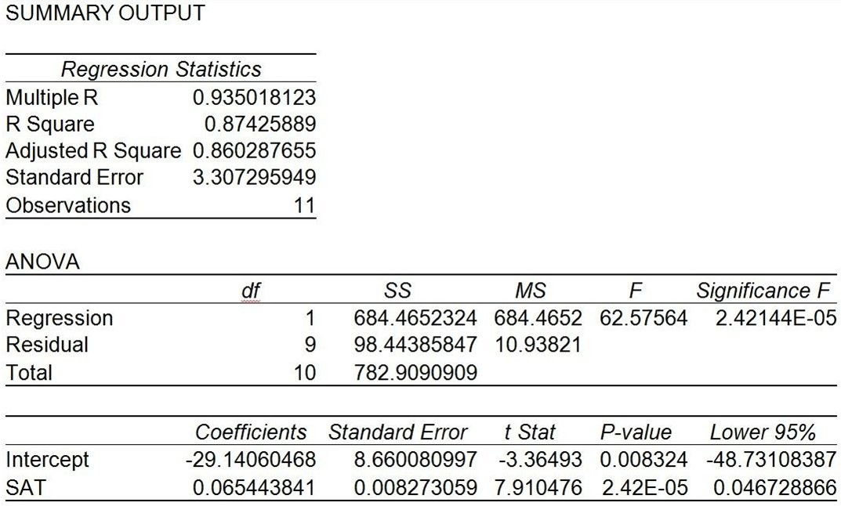

A) SAT is not a good predictor for starting salary.
B) The significance level for the intercept indicates the model is not valid.
C) The significance level for SAT indicates the slope is equal to zero.
D) The significance level for SAT indicates the slope is not equal to zero.
E) None of the above
79) A prediction equation for sales and payroll was performed using simple linear regression. In the regression printout shown below, which of the following statements is/are not true?

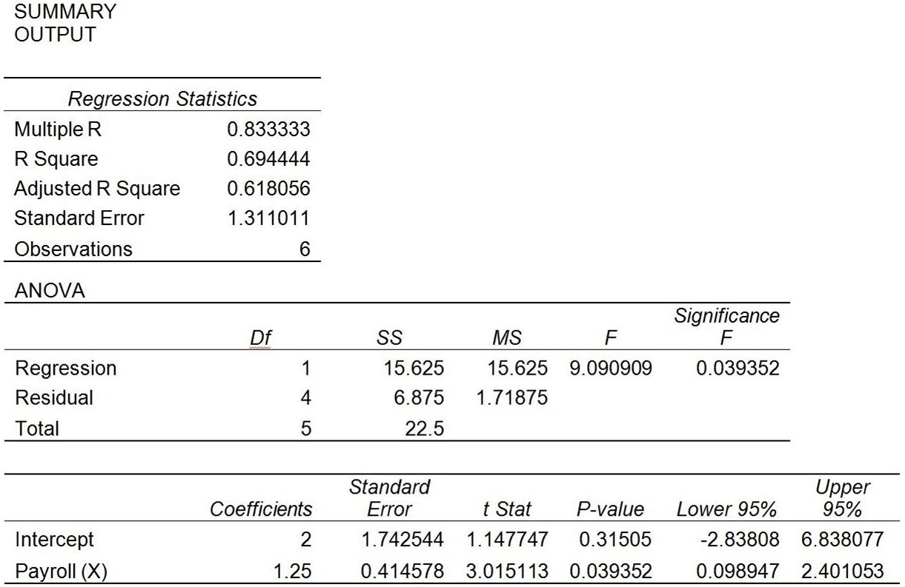

A) Payroll is a good predictor of Sales based on α = 0.05.
B) There is evidence of a positive linear relationship between Sales and Payroll based on α = 0.05.
C) Payroll is not a good predictor of Sales based on α = 0.01.
D) The coefficient of determination is equal to 0.833333.
E) Payroll is the independent variable.

80) A healthcare executive is using regression to predict total revenues. She has decided to include both patient length of stay and insurance type in her model. Insurance type can be grouped into the following categories: Medicare, Medicaid, Managed Care, Self-Pay, and Charity. Which of the following is true?
A) Insurance type will be represented in the regression model by five binary variables.
B) Insurance type will be represented in the regression model by six dummy variables.
C) Insurance type will be represented in the regression model by five dummy variables.
D) Insurance type will be represented in the regression model by four binary variables.
E) Neither binary nor dummy variables are necessary for the regression model.

