41) The following is a payoff table giving profits for various situations.

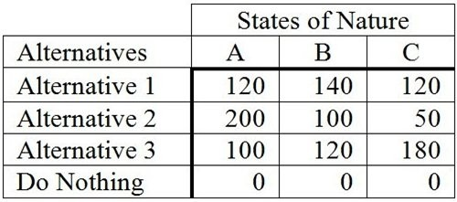

What decision would a pessimist make?
A) Alternative 1
B) Alternative 2
C) Alternative 3
D) Do Nothing
E) State of Nature A
42) The following is an opportunity loss table.

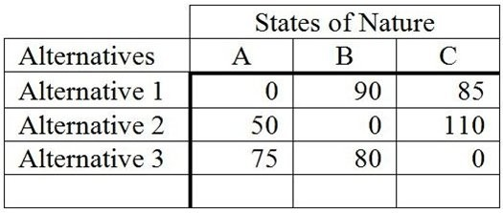

What decision should be made based on the minimax regret criterion?
A) Alternative 1
B) Alternative 2
C) Alternative 3
D) State of Nature A
E) Does not matter
43) The following is an opportunity loss table.

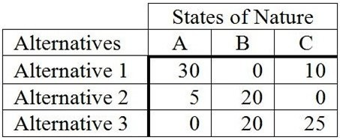

What decision should be made based on the minimax regret criterion?
A) Alternative 1
B) Alternative 2
C) Alternative 3
D) State of Nature C
E) Does not matter
44) The following is a payoff table.

What decision should be made based on the minimax regret criterion?
A) Alternative 1
B) Alternative 2
C) Alternative 3
D) State of Nature C
E) Does not matter
45) The following is a payoff table.

What decision should be made based on the minimax regret criterion?
A) Alternative 1
B) Alternative 2
C) Alternative 3
D) State of Nature C
E) Does not matter

46) The following is an opportunity-loss table.

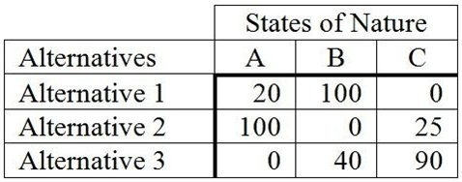

The probabilities for the states of nature A, B, and C are 0.3, 0.5, and 0.2, respectively. If a person were to use the expected opportunity loss criterion, what decision would be made?
A) Alternative 1
B) Alternative 2
C) Alternative 3
D) State of Nature C
E) State of Nature B
47) The following is a payoff table giving profits for various situations.

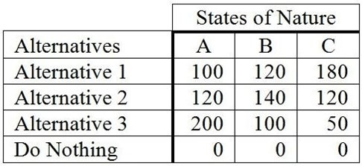

The probabilities for states of nature A, B, and C are 0.3, 0.5, and 0.2, respectively. If a person selected Alternative 1, what would the expected profit be?
A) 120
B) 133.33
C) 126
D) 180
E) None of the above
hat mode of treatment to use on Mr. Samuels. There are three modes of treatment: Mode A, B, and C; and three possible states of nature: 1. Treatment succeeds and patient leads a normal life, 2. Patient survives treatment but is permanently disabled, and 3. Patient fails to survive treatment. Dr. Mac has prepared the decision table below. What mode of treatment maximizes the expected value?

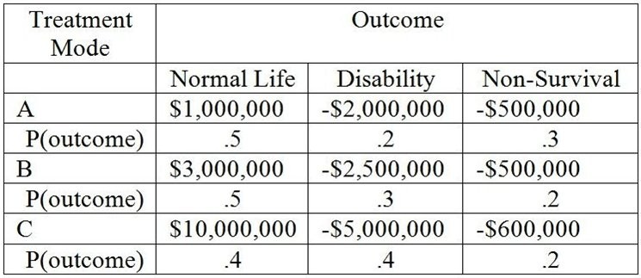

A) Mode A
B) Mode B
C) Mode C
D) All three treatments are equally desirable.
E) Normal Life
49) Consider the following payoff table.

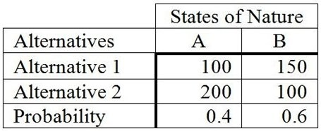

Based upon these probabilities, a person would select Alternative 2. Suppose there is concern about the accuracy of these probabilities. It can be stated that Alternative 2 will remain the best alternative as long as the probability of A is at least
A) 0.33.
B) 0.50.
C) 0.40.
D) 0.60.
E) None of the above
50) Consider the following payoff table.

How much should be paid for a perfect forecast of the state of nature?
A) 170
B) 30
C) 10
D) 100
E) 40

