FINANCE – EXAM 1
- Which of the following is the fundamental accounting equation?

- Current assets + Current liabilities = Owners' equity
- Assets + Owners' equity = Liabilities
- Cash = Debts + Common stock
- Assets = Liabilities + Owners' equity

- On December 31, 2004, Track Record Inc.'s sales people have firm outstanding orders totaling $1.66 million, which, it has guaranteed its customers, will be fulfilled during the month of January 2005.
If Track Record includes the $1.66 million in its sales figures for 2004, it will be violating the:
Materiality concept
Historical cost concept
Dual-aspect concept
Realization concept

- Which one of the following best describes a balance sheet?
A description of the entity's operations over a period of time
A snapshot at a point in time of an entity's assets, liabilities and owners' equity
A reconciliation of an entity's bank account balance
A description of the company's cash flows over a period of time

- To be recorded as an asset, an item must meet four specific conditions. Three of them are: it must have been acquired at measurable cost, it must be obtained or controlled by the entity, and it must have been obtained or controlled in a past transaction.
Which one of the following is the fourth condition?

The item must have a measurable resale value
It must be expected to have future economic benefits
It must have been fully paid for
The entity must have a legal document confirming ownership of the item

- Neura Pharma, Inc. has purchased a drug patent with a remaining useful life of 13 years. How should this new asset be classified?
A current tangible asset
A non-current tangible asset
A non-current intangible asset
A current intangible asset

- June Smith, a process engineer, has sold her 15-year patent for a new etching process to Silica Labs, Inc. In return, she has received $500,000 in cash and, based on its value on the sale date, $200,000 in common stock in Silica Labs. The stock is forecasted to double in market value over the next two months.
How would this transaction be recorded by Silica Labs?
Debit patent account $700,000; credit cash $500,000; credit common stock $200,000
Debit cash $500,000; debit common stock $200,000; credit patent account $700,000
Debit cash $500,000; credit patent account $500,000
Debit patent account $500,000; credit cash $500,000

- Consider the same scenario as in the previous question:
June Smith, a process engineer, has sold her 15-year patent for a new etching process to Silica Labs, Inc. In return, she has received $500,000 in cash and, based on its value on the sale date, $200,000 in common stock in Silica Labs. The stock is forecasted to double in market value over the next two months.
Assuming that Silica Labs holds some long-term debt, which of the following describes the effect of the transaction on Silica Labs?

Current ratio will decrease and total debt to equity ratio will increase
Current ratio will increase and total debt to equity ratio will decrease
Current ratio will increase and total debt to equity ratio will increase
Current ratio will decrease and total debt to equity ratio will decrease

- Lucky Lee, a video-game store in New York city, purchases a game machine directly from Taiwan for $30,000. In the U.S., the same machine will probably cost at least $36,000. Pick the most appropriate accounting action for Lucky Lee:
Record the machine at $36,000
Record the machine at $30,000
Record the machine for [($30,000+$36,000)/2] = $33,000
Have the machine examined by an independent appraiser and record it at the appraised value

- Which one of the following is an item of owners' equity?
Bank loan
Suppliers' monetary claims
Prepaid expenses
Earnings generated by the entity
- Complete the following sentence: The Conservatism Concept directs an entity to consider recognizing a liability when it is __________________.
absolutely certain economic resources may be sacrificed in the future
remotely possible economic resources may be sacrificed in the future
reasonably possible economic resources may be sacrificed in the future
reasonably certain economic resources may be sacrificed in the future

- The realization concept states that revenue is recorded when:
It has been earned and realized or realizable
All the associated costs have been paid in cash
It has been received in cash

- On its June 30, 2005 balance sheet, Barrows Corporation has total assets of $100,000, current liabilities of $40,000, and owners' equity of $60,000.
Which one of the following statements must be true on June 30, 2005?
It has current assets of $40,000
It has no long-term liabilities
It has a cash balance of $40,000 raised through short-term debt
None of the above

- Turnadot & Sons is a small wholesaler of decorative cast iron objects. The following events, related to a special customer order, occur as described below:
August 5, 2005: Turnadot receives the special order for 200 outdoor planters at a selling price of $50 each, including delivery at a future convenient time and location. The customer, with whom Turnadot has had a long-term, trouble-free relationship, pays $3,000 as a deposit and agrees to pay the rest on delivery. Turnadot immediately orders $4,000 worth of planters from its supplier and pays a $1,000 deposit for them.
August 27, 2005: Turnadot pays $3,000 balance due to the supplier upon delivery of the planters to its warehouse.
September 5, 2005: The customer calls for delivery of the planters, and pays the balance of $7,000 when they arrive at the customer site.
On August 5, 2005, which one of the following accounting entries, related to the $10,000 special order, should be recorded in Turnadot's financial accounting system?
Debit accounts receivable $10,000; credit revenues $10,000
Debit cash $3,000; credit revenues $3,000
Debit cash $3,000; credit a liability 'advances from customers' $3,000
Debit cash $3,000; debit accounts receivable $7,000; credit revenues $10,000

- Turnadot & Sons is a small wholesaler of decorative cast iron objects. The following events, related to a special customer order, occur as described below:
August 5, 2005: Turnadot receives the special order for 200 outdoor planters at a selling price of $50 each, including delivery at a future convenient time and location. The customer, with whom Turnadot has had a long-term, trouble-free relationship, pays $3,000 as a deposit and agrees to pay the rest on delivery. Turnadot immediately orders $4,000 worth of planters from its supplier and pays a $1,000 deposit for them.
August 27, 2005: Turnadot pays $3,000 balance due to the supplier upon delivery of the planters to its warehouse.
September 5, 2005: The customer calls for delivery of the planters, and pays the balance of $7,000 when they arrive at the customer site.
On August 5, 2005, which one of the following accounting entries, related to the $1,000 deposit paid to the supplier for the planters, should be recorded in Turnadot's financial accounting system?
Debit the current asset 'advances to suppliers' $1,000; credit cash $1,000
Debit inventory $1,000; credit cash $1,000
Debit cost of goods sold $4,000; credit cash $1,000; credit accounts payable $3,000
Debit cost of goods sold $1,000; credit revenues $1,000

- Turnadot & Sons is a small wholesaler of decorative cast iron objects. The following events, related to a special customer order, occur as described below:
August 5, 2005: Turnadot receives the special order for 200 outdoor planters at a selling price of $50 each, including delivery at a future convenient time and location. The customer, with whom Turnadot has had a long-term, trouble-free relationship, pays $3,000 as a deposit and agrees to pay the rest on delivery. Turnadot immediately orders $4,000 worth of planters from its supplier and pays a $1,000 deposit for them.
August 27, 2005: Turnadot pays $3,000 balance due to the supplier upon delivery of the planters to its warehouse.
September 5, 2005: The customer calls for delivery of the planters, and pays the balance of $7,000 when they arrive at the customer site.
On August 27, 2005, upon delivery of planters to Turnadot's warehouse and payment of $3,000 balance due to the supplier, which one of the following journal entries best reflects the economic impact of the transaction?
Debit inventory $3,000; credit cash $3,000
Debit inventory $4,000; credit the current asset 'advances to suppliers' $1,000; credit cash $3,000
Debit cost of goods sold $4,000; credit cash $3,000; credit accounts payable $1,000
Debit inventory $4,000; credit revenues $4,000

- Turnadot & Sons is a small wholesaler of decorative cast iron objects. The following events, related to a special customer order, occur as described below:
August 5, 2005: Turnadot receives the special order for 200 outdoor planters at a selling price of $50 each, including delivery at a future convenient time and location. The customer, with whom Turnadot has had a long-term, trouble-free relationship, pays $3,000 as a deposit and agrees to pay the rest on delivery. Turnadot immediately orders $4,000 worth of planters from its supplier and pays a $1,000 deposit for them.
August 27, 2005: Turnadot pays $3,000 balance due to the supplier upon delivery of the planters to its warehouse.
September 5, 2005: The customer calls for delivery of the planters, and pays the balance of $7,000 when they arrive at the customer site.
On September 5, 2005, when the planters are delivered and the balance of $7,000 due from the customer is collected, which one of the following journal entries best reflects the full economic impact of the special order on Turnadot's financial condition?
Dr. Cash 7,000, Cr. Revenues 7,000 and
Dr. COGS 4,000, Cr. Inventory 4,000
Dr. Cash 7,000, Cr. Revenues 7,000 and
Dr. Inventory 4,000, Cr. COGS 4,000
Dr. Cash 7,000, Dr. Advances from customers (liability) 3,000, Cr. Revenues 10,000 and
Dr. COGS 4,000, Cr. Inventory 4,000

- Turnadot & Sons is a small wholesaler of decorative cast iron objects. The following events, related to a special customer order, occur as described below:
August 5, 2005: Turnadot receives the special order for 200 outdoor planters at a selling price of $50 each, including delivery at a future convenient time and location. The customer, with whom Turnadot has had a long-term, trouble-free relationship, pays $3,000 as a deposit and agrees to pay the rest on delivery. Turnadot immediately orders $4,000 worth of planters from its supplier and pays a $1,000 deposit for them.
August 27, 2005: Turnadot pays $3,000 balance due to the supplier upon delivery of the planters to its warehouse.
September 5, 2005: The customer calls for delivery of the planters, and pays the balance of $7,000 when they arrive at the customer site.
What is the dollar gross margin earned by Turnadot on the special order for 200 planters?
$2,000
$7,000
$9,000
$6,000

- The next 6 questions refer to Quentin Company's December 31, 2004 Balance Sheet.
Quentin began 2004 with the following non-current asset balances: Plant and equipment (net) $59,000; Patent (net) $28,000. No long-term assets were purchased or sold during the year. How much amortization and depreciation expense did Quentin record during 2004?

$3,000
$4,000
$7,000
Cannot be estimated
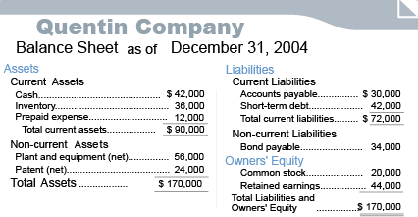

19. Quentin's 2004 net income was $5,000. No dividends were declared or paid during 2004. What was Quentin's retained earnings balance on December 31, 2003?

$39,000
$49,000
$34,000
Cannot be estimated
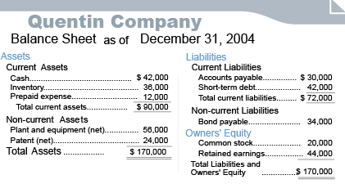
20.Quentin's current ratio on December 31, 2004 is:
1.25
0.80
0.53
1.125
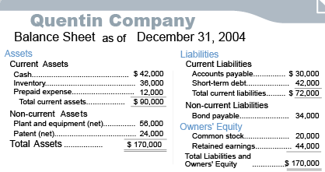
21. Quentin's total debt to equity ratio on December 31, 2004 is:
2.12
1.52
1.19
0.53

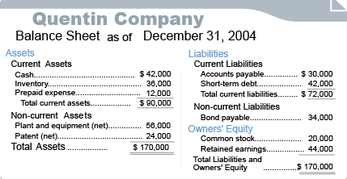

22. Quentin Company's year-end 2004 total assets equals its year-end 2004 total liabilities and owners' equity. This is most likely the result of the company following the:
Historical Cost concept
Dual-aspect concept
Materiality concept
Money measurement concept

23. Quentin's December 31, 2003 inventory T-account debit balance was also $56,000. During 2004, its inventory purchases amounted to $25,000, and there were no inventory-related write-downs or losses. What was Quentin's 2004 cost of goods sold expense?

$5,000
$67,000
$20,000
$45,000

24. The next 6 questions refer to Carlita Company's 2004 Income Statement.
Carlita's 2004 gross margin percentage is:

50%
33%
30%
25%
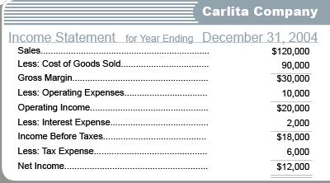

25.During 2004, Carlita's competitor Farside had double the sales of Carlita, but it also earned a gross margin of $30,000. Farside's 2004 gross margin percentage was:

25%
50%
12.5%
Insufficient information; cannot be calculated

26. Carlita began 2004 with a retained earnings account balance of $132,000. During 2004, it declared and paid dividends of $5,000. Its December 31, 2004 retained earnings account balance is:

$132,000
$120,000
$139,000
Cannot be calculated

27. Carlita's 2004 return on sales percentage is:

25%
16.67%
15%
10%

28. Carlita began 2004 with an interest payable account balance of $13,000. During 2004, it paid $5,000 in interest to its lenders. On December 31, 2004, its interest payable account balance is:

$15,000
$10,000
$13,000
Cannot be calculated

29. Carlita began 2004 with a taxes payable account balance of $3,000. On December 31, 2004, its taxes payable account balance is $7,000. How much did Carlita pay to the tax authorities during the year?

$2,000
$6,000
$4,000
Cannot be calculated

30. On January 1, 2005, Jon Sports has a bond payable of $200,000. During 2005, it pays off $20,000 of the outstanding bond principal and issues a new $70,000 bond. There are no other transactions related to the bond payable account.
What is Jon Sports' December 31, 2005 bond payable balance?
A debit balance of $250,000
A credit balance of $150,000
A debit balance of $150,000
A credit balance of $250,000

31. The next 7 questions are based on Panjim Trading Company's cash T-account for 2005.
Based on Panjim's 2005 cash T-account, which one of the following statements must be true?

During 2005, Panjim's total merchandise sales were $60,000
During 2005, Panjim's total merchandise purchases were $44,000
During 2005, Panjim issued $75,000 of debt
Panjim did not record any tax expense for 2005
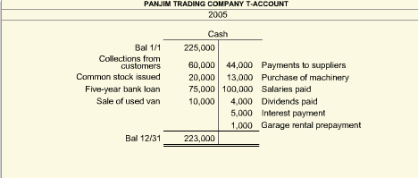

32. Panjim began 2005 with salaries payable balance of $75,000. It had 2005 salary expense of $80,000. Its 2005 ending salaries payable balance must be:

$95,000
$55,000
$155,000
$105,000

33.Panjim's 2005 cash flow from operations is:

A net outflow of $90,000
A net inflow of $90,000
A net inflow of $85,000
A net outflow of $85,000

34. Panjim's 2005 cash flow from investing activities is:

A net outflow of $7,000
A net inflow of $3,000
A net inflow of $7,000
A net outflow of $3,000

35. Panjim's 2005 cash flow from financing activities is:

A net outflow of $91,000
A net inflow of $86,000
A net outflow of $86,000
A net inflow of $91,000

36. Panjim recorded an interest expense of $6,000 for 2005. Which one of the following line items would be included in the operating section of the Panjim's 2005 indirect method statement of cash flows?

Add increase in interest payable...$1,000
Subtract increase in interest payable...($1,000)
Add increase in interest payable...$6,000
Subtract decrease in interest payable...($5,000)

37. Panjim's prepaid expense account consists only of garage rental prepayments. Its 2005 beginning and ending balance were the same. Which one of the following statements must be true?

Panjim had no garage rental expenses during 2005
Panjim's prepaid expense account balance never varied during 2005
Panjim's prepaid expense account balance varied during 2005
None of the above statements is true

38. Juan Foods purchases a computer system in 2005 for $20,000. Its expected useful life is 5 years. At the end of 2005, it has to record depreciation on the computer system of $2,000.
What is the correct journal entry to record the depreciation?

Debit computer system $2,000; credit depreciation expense $2,000
Debit accumulated depreciation $2,000; credit computer system $2,000
Debit depreciation expense $2,000; credit accumulated depreciation $2,000
Debit computer system $2,000; credit accumulated depreciation $2,000

39. Jackie's Crafts is a successful retailer of fabric by the yard and other sewing supplies. If Jackie were to shut down the store, the bolts of fabrics and the bins of lace and trim, inventory valued at $20,000, on average, at any point in time, would have to be sold for about 10% of that value. But, Jackie's accountant does not feel the need to reduce the value of the inventory on the books.
This is a reflection of the:

Consistency concept
Materiality concept
Historical cost concept
Going-concern concept

40. Weldon Engineering owes one of its creditors $20,000. To settle the debt, Weldon pays $5,000 cash and also issues common stock valued at $15,000 to the creditor.
How would this repayment of the $20,000 debt be recorded in Weldon's books?

Debit debt owed $20,000; credit cash $5,000; credit common stock $15,000
Debit common stock $15,000; debit cash $5,000; credit debt owed $20,000
Debit common stock $15,000; debit debt owed $5,000; credit cash $20,000
Debit debt owed $5,000; credit cash $5,000

