Name____________________________________________________Section________________Date___________

Week 4: Exploring Earth – Igneous Rocks and Coordinate Systems

Invitation to Inquiry

Survey the use of rocks used in building construction in your community. Compare the type of rocks that are used for building interiors and those that are used for building exteriors. Are any trends apparent for buildings constructed in the past and those built in more recent times? If so, are there reasons (cost, shipping, other limitations) underlying a trend or is it simply a matter of style?

Part 1: Rocks on Earth
Background

Igneous rocks are rocks that form from the cooling of a hot, molten mass of rock material. Igneous rocks, as other rocks, are made up of various combinations of minerals. Each mineral has its own temperature range at which it begins to crystallize, forming a solid material. Minerals that are rich in iron and magnesium tend to crystallize at high temperatures. Minerals that are rich in silicon and poor in iron and magnesium tend to crystallize at lower temperatures. Thus, minerals rich in iron and magnesium crystallize first in a deep molten mass of rock material, sinking to the bottom. The minerals that crystallize later will become progressively richer in silicon as more and more iron and magnesium are removed from the melt.

Igneous rocks that are rich in silicon and poor in iron and magnesium are comparatively light in density and color. The most common igneous rock of this type is granite, which makes up most of the earth’s continents. Igneous rocks that are rich in iron and magnesium are dark in color and have a relatively high density. The most common example of these dark-colored, more dense rocks is basalt, which makes up the ocean basins and much of the earth’s interior. Basalt is also found on the earth’s surface as a result of volcanic activity. Other common igneous rocks are obsidian, pumice and gabbro that you will investigate through the lab.

Procedure

- For this experiment you can chose to either measure 5 different rocks (options given by your instructor – likely basalt, granite, obsidian, pumice and gabbro) or 5 different specimen of the same rock. Decide with your lab partners which you’d like to do.

- Use a balance to find the mass of your first rock. Record the mass in Data Table 4.1. Tie a 20-cm length of nylon string around the rock so you can lift it with the string. Test your tying abilities to make sure you can lift the rock by lifting the string without the rock falling.

- Place an overflow can on a ring stand, adjusted so the overflow spout is directly over a graduated cylinder.

- Hold a finger over the overflow spout, then fill the can with water. Remove your finger from the spout, allowing the excess water to flow into the cylinder. Dump this water from the cylinder, then place it back under the overflow spout.

- Grasp the free end of the string tied around the first rock, then lower the rock completely beneath the water surface in the overflow can. The volume of water that flows into the graduated cylinder is the volume of the rock. Remembering that a volume of 1.0 mL is equivalent to a volume of 1.0 cm³, record the volume of the rock in cm³ in Data Table 4.1.

- Calculate the mass density of this first rock and record the value in the data table.

- Repeat procedure steps 1 through 5 with 4 more rocks.

Results

1. In what ways do igneous rocks have different properties?

- Explain the theoretical process or processes responsible for producing the different properties of igneous rock

- According to the experimental evidence of this investigation, propose an explanation for the observation that the bulk of the earth’s continents are granite, and that basalt is mostly found in the earth’s interior.

- Was the purpose of this lab accomplished? Why or why not? (Your answer to this question should show thoughtful analysis and careful, thorough thinking.)

Part 2: Coordinate systems on Earth
Background

The continuous rotation and revolution of the earth establish an objective way to determine directions and locations on the earth. If the earth were an unmoving sphere there would be no side, end, or point to provide a referent for directions and locations. The earth’s rotation, however, defines an axis of rotation which serves as a reference point for determination of directions and locations on the entire surface. The reference point for a sphere is not as simple as on a flat, two-dimensional surface, because a sphere does not have a top or side edge. The earth’s axis provides the north-south reference point. The equator is a big circle around the earth that is exactly halfway between the two ends, or poles of the rotational axis. An infinite number of circles are imagined to run around the earth parallel to the equator. The east- and west-running parallel circles are called parallels. Each parallel is the same distance between the equator and one of the poles all the way around the earth. The distance from the equator to a point on a parallel is called the latitude of that point. Latitude tells you how far north or south a point is from the equator by telling you on which parallel the point is located.

Since a parallel is a circle, a location of 40˚ N latitude could be anyplace on that circle around the earth. To identify a location you need another line, one that runs pole to pole and perpendicular to the parallels. North-south running arcs that intersect at both poles are called meridians. There is no naturally occurring, identifiable meridian that can be used as a point of reference such as the equator serves for parallels, so one is identified as the referent by international agreement. The reference meridian is the one that passes through the Greenwich Observatory near London, England, and is called the prime meridian. The distance from the prime meridian east or west is called the longitude. The degrees of longitude of a point on a parallel are measured to the east or to the west from the prime meridian up to 180˚.

Locations identified with degrees of latitude north or south of the equator and degrees of longitude east or west of the prime meridian are more precisely identified by dividing each degree of latitude into subdivisions of 60 minutes (60’) per degree, and each minute into 60 seconds (60”). In this investigation you will do a hands-on activity that will help you understand how latitude and longitude are used to locate places on the earth’s surface.

Procedure

- Obtain a lump of clay about the size of your fist. Knead the clay until it is soft and pliable, then form it into a smooth ball for a model of the Earth.

- Obtain a sharpened pencil. Hold the clay ball in one hand and use a twisting motion to force the pencil all the way through the ball of clay. Reform the clay into a smooth ball as necessary. This pencil represents the earth’s axis, an imaginary line about which the earth rotates. Hold the clay ball so the eraser end of the pencil is at the top. The eraser end of the pencil represents the North Pole and the sharpened end represents the South Pole. With the North Pole at the top, the earth turns so the part facing you moves from left to right. Hold the clay ball with the pencil end at the top and turn the ball like this to visualize the turning Earth.

- The Earth’s axis provides a north-south reference point. The equator is a circle around the Earth that is exactly halfway between the two poles. Use the end of a toothpick to make a line in the clay representing the equator.

- Hold the clay in one hand with the pencil between two fingers. Carefully remove the pencil from the clay with a back and forth twisting motion. Reform the clay into a smooth ball if necessary, being careful not to destroy the equator line. Use a knife to slowly and carefully cut halfway through the equator. Make a second cut down through the North Pole to cut away one-fourth of the ball as shown in Figure 4.1. Set the cut-away section aside for now.
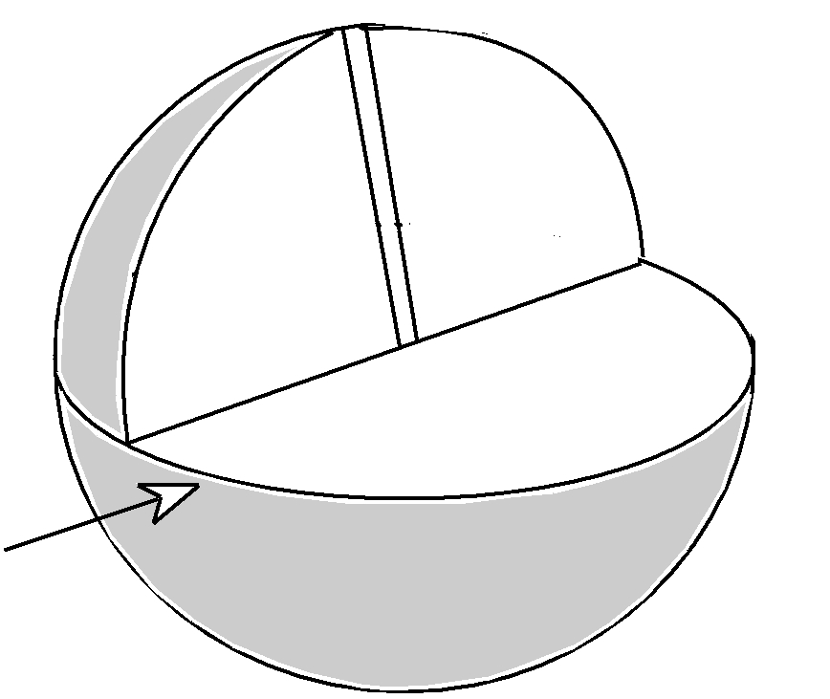

Equator

Figure 4.1

- Place a protractor on the clay ball where the section was removed. As shown in Figure 4.2, the 0˚ of the protractor should be on the equator and the 90˚ line should be on the axis (the center of where the pencil was). You may have to force the protractor slightly into the clay so the 0˚ line is on the equator. Directly behind the protractor, stick toothpicks into the surface of the clay ball at 20˚, 40˚, and 60˚ above the equator on both sides. Remove the protractor from the clay and return the cut-away section to make a whole ball again.

- Use the end of a toothpick to make parallels at 20˚, 40˚, and 60˚ north of the equator, then remove the six toothpicks. Recall that parallels are east and west running circles that are the same distance from the equator all the way around the earth (thus the name parallels). The distance from the equator to a point on a parallel is called the latitude of that point. Latitude tells you how far north or south a point is from the equator. There can be 90 parallels between the equator and the North Pole, so a latitude can range from 0˚ North (on the equator) up to 90˚ North (at the North Pole).

90˚
60˚
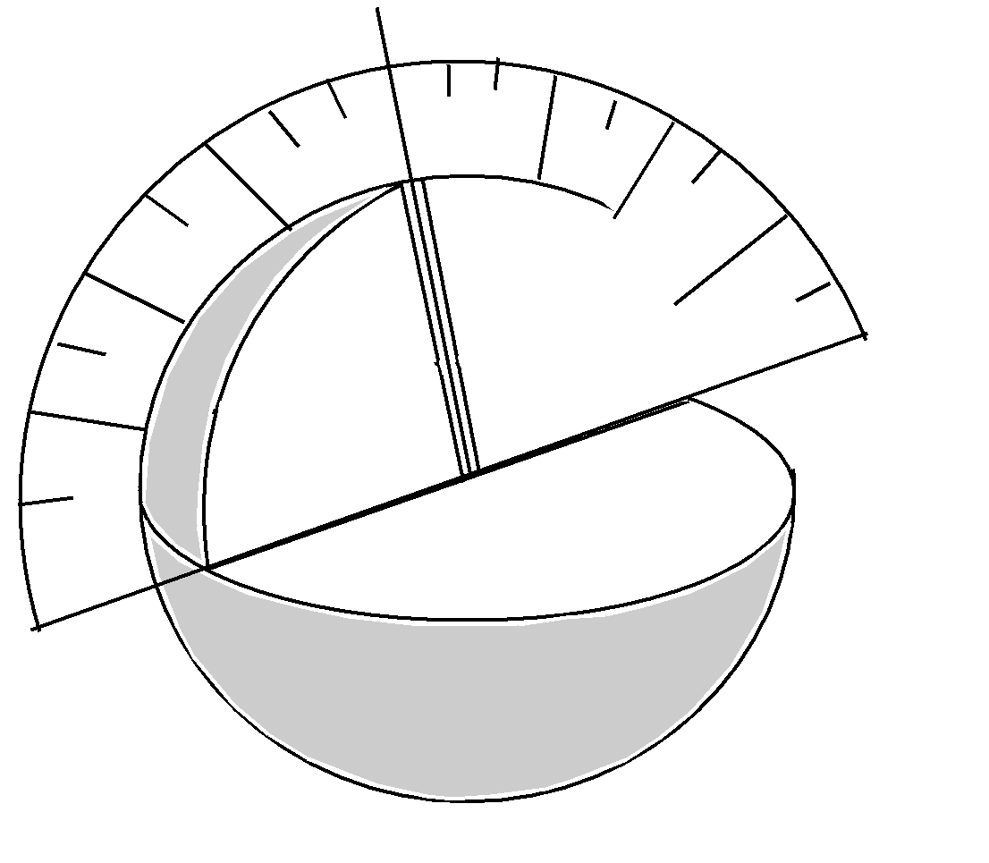
40˚
60˚

20˚

40˚

0˚

20˚

Figure 4.2

- Since a parallel is a circle that runs all the way around the earth, a second line is needed to identify a specific location. This second line runs from pole to pole and is called a meridian. To see how meridians identify specific locations, again remove the cut section from the ball of clay. This time place the protractor flat on the equator as shown in Figure 4.3, with the 90˚ line perpendicular to the axis. Stick toothpicks directly below the protractor at 0˚, 60˚, 120˚, and 180˚, then remove the protractor and return the cut-away section to make a whole ball again. Use a toothpick to draw lines in the clay that run from one pole, through the toothpicks, then through the other pole. By agreement, the 0˚ line runs through Greenwich near London, England and this meridian is called the prime meridian. The distance east or west of the prime meridian is called longitude. If you move right from the prime meridian you are moving east from 0˚ all the way to 180˚ East. If you move left from the prime meridian you are moving west from 0˚ all the way to 180˚ West.

- Use a map or a globe to locate some city that is on or near a whole number latitude and longitude. New Orleans, Louisiana, for example, has a latitude of about 30˚ N of the equator. It has a longitude of about 90˚ W of the prime meridian. The location of New Orleans on the earth is therefore described as 30˚ N, 90˚ W. Locate this position on your clay model of the earth and insert a toothpick. Compare your model to those of your classmates.
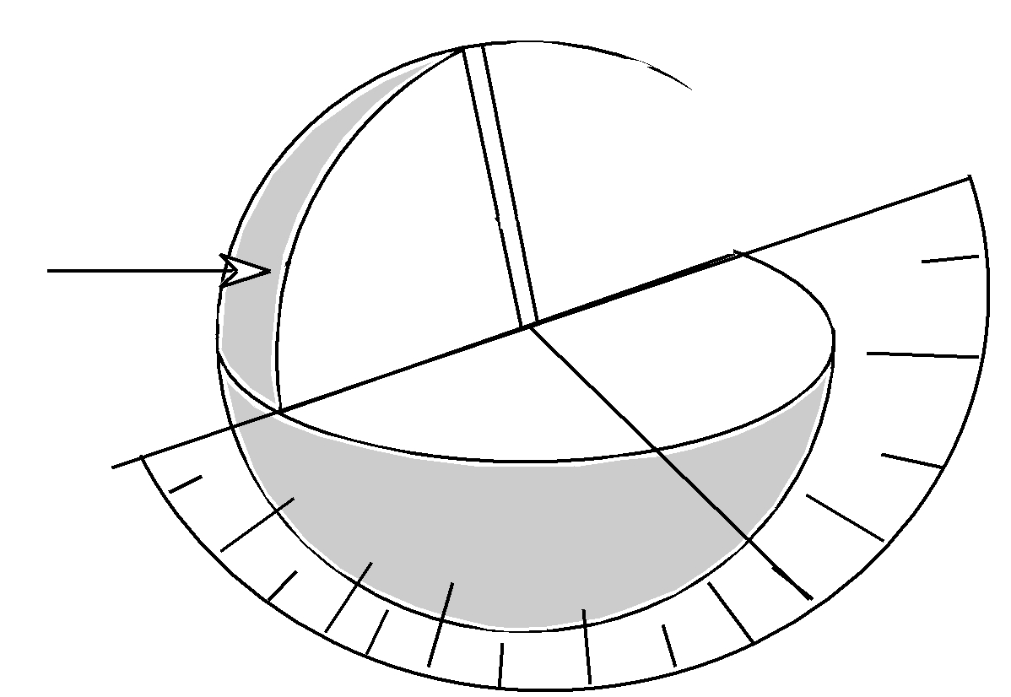

180˚

Prime
Meridian

120˚

90˚
30˚

60˚

Figure 4.3

Results

1. What information does the latitude of a location tell you?

2. What information does the longitude of a location tell you?

- According to a map or a globe, what is the approximate latitude and longitude of the place where you live?

4. Explain how minutes and seconds are used to identify a location more precisely.

- Was the purpose of this lab accomplished? Why or why not? (Your answer to this question should show thoughtful analysis and careful, thorough thinking.)

Data Table 4.1 Density of Igneous Rocks
 | Type of Rock | Mass  (g) | Volume  (cm^3) | Density  (g/cm^3)
Rock 1
Rock 2
Rock 3
Rock 4
Rock 5

