A General Manger of Harley-Davidson has to decide on the size of a new facility. The GM has narrowed the choices to two: large facility or small facility. The company has collected information on the payoffs. It now has to decide which option is the best using probability analysis, the decision tree model, and expected monetary value.

Options:

Facility Demand Options Probability Actions Expected Payoffs
Large Low Demand 0.4 Do Nothing ($10)
Low Demand 0.4 Reduce Prices $50
High Demand 0.6 $70

Small Low Demand 0.4 $40
High Demand 0.6 Do Nothing $40
High Demand 0.6 Overtime $50
High Demand 0.6 Expand $55

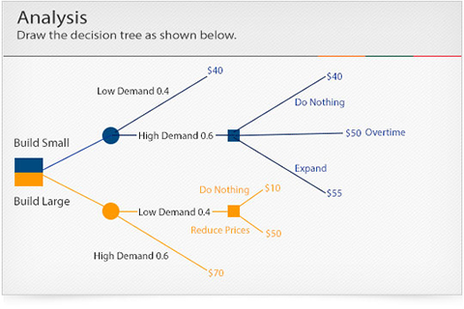
Determination of chance probability and respective payoffs:

Build Small:
Low Demand 0.4($40)=$16
High Demand 0.6($55)=$33

Build Large:
Low Demand 0.4($50)=$20
High Demand 0.6($70)=$42

Determination of Expected Value of each alternative
Build Small: $16+$33=$49
Build Large: $20+$42=$62

- The diagram is accurate and labeled correctly. The diagram clearly illustrates the sequence of events and their probability of occurrences.

- A step-by-step breakdown of the calculations for the chance of probability and respective payoff is clearly communicated. The results of the calculations are accurate.

- A step-by-step breakdown of the calculations for expected value is clearly communicated. The results of the calculations are accurate.

- Clear and concise statement explaining the decision and a description of elements that lead to the decision.

