Chapter 3 Assignment

These problems are adapted from problems in the textbook.
Each of the twelve lettered parts carries equal weight.
**You must show work and give an explanation for each answer.**

1. Susan Solomon is thinking about starting her own independent gasoline station. Susan’s problem is to decide how large her station should be. After a careful analysis, Susan developed the following table:

Size of Station | Good Market $ | Fair Market $ | Poor Market $
Small | 50,000 | 20,000 | -10,000
Medium | 80,000 | 30,000 | -20,000
Large | 100,000 | 30,000 | -40,000
Very Large | 300,000 | 25,000 | -160,000

For example, if Susan constructs a small station and the market is good, she will realize a profit of $50,000.

(a) What is the maximax decision?
(b) What is the maximin decision?
(c) What is the equally likely decision?
(d) What is the criterion of realism decision using an α value of 0.8?

2. Kenneth Brown is the principle owner of Brown Oil, and has to choose which new piece of equipment to purchase. His alternatives are shown in the following table:

Equipment | Good Market $ | Poor Market $
Sub100 | 300,000 | -200,000
OilerJ | 250,000 | -100,000
Texan | 75,000 | -18,000

For example, if Ken purchases a Sub100 and the market is good, he will realize a profit of $300,000.

(a) Ken believes that the chances of a good market are 70%, while the chances for a poor market are 30%. Find the EMV for each piece of equipment and determine the optimal decision.
(b) Calculate the expected value with perfect information (EVwPI). Given that answer, what is the most Ken should be willing to pay for a perfect forecast of the market?

3. Kenneth from the previous problem has decided that he should base his decision on utility rather than number of dollars. Kenneth is risk averse, and has the utility curve shown here:
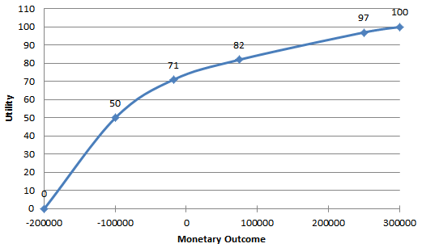
(a) Using the utility curve above, replace the dollar figures in the table below with utility values.
Equipment | Good Market $ | Poor Market $
Sub100 | 300,000 | -200,000
OilerJ | 250,000 | -100,000
Texan | 75,000 | -18,000

(b) Find the expected utility for each piece of equipment and determine the optimal decision. If his decision has changed from the previous problem, explain why.

4. Jerry Smith is thinking about opening a bicycle shop in his hometown. He can open a small shop, a large shop, or no shop at all. If the market is favorable, a large shop will earn $60,000 while a small shop will earn $30,000. If the market is unfavorable, a large shop will lose $40,000 while a small shop will lose $10,000. Opening no shop earns $0. At the moment, his best guess is that there is a 50% chance of a favorable market (and a 50% chance of an unfavorable market).

Jerry has the opportunity to have a market survey conducted for $5,000. It is estimated that there is a 60% chance that the market survey will come back favorable. With a favorable market survey result, there is a 90% chance that the market will actually be favorable. If on the other hand the market survey comes back unfavorable (40% chance), then there is only a 12% chance that the market will actually be favorable.

A decision tree for this scenario is below.

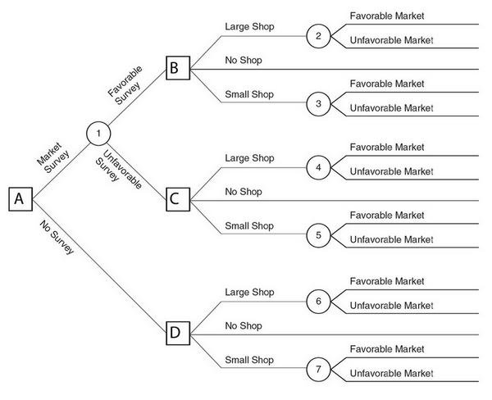
(a) Find the EMV at node 6, then find the EMV at node 7, then determine the decision that should be made if Node D is reached.
(b) Find the EMV at node 4, then find the EMV at node 5, then determine the decision that should be made if Node C is reached. (Hints: Remember to include the cost of the market survey in the payoffs, and remember that “No Shop” is an option).
(c) Find the EMV at node 2, then find the EMV at node 3, then determine the decision that should be made if Node B is reached.
(d) Find the EMV at node 1, then determine if the market survey should be conducted. If the survey is conducted, determine what he should do if the survey is favorable and what he should do if the survey is unfavorable.

