Question 3

Statistical Process Control

You own and operate a restaurant and you decided to track meal temperatures using statistical process control.

Given:
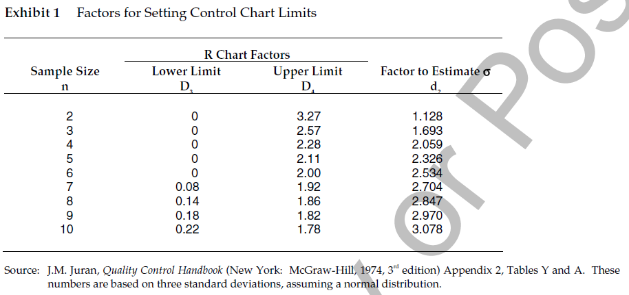

Complete this data table:

Day
Readings in Degrees F
Range
X-Bar
1
140
145
150
2
140
140
145
3
150
155
160
4
160
160
155
5
180
140
160
6
130
130
130
7
160
150
150
8
145
165
125
9
125
125
125
10
150
145
145
Avg. Range
(R-Bar)
Avg. Mean
(X Double-Bar)

Calculate your X-Bar Chart Limits (LCL, UCL, Center)

Calculate your Range Chart Limits (LCL, UCL, Center)

Draw your X-Bar and R Charts and describe what the data is telling you (any out of control points?)

