Table 3.2
Dana Dairy Products Key Ratios
Income Statement
Dana Dairy Products
For the Year Ended December 31, 2010
Balance Sheet
Dana Dairy Products
December 31, 2010
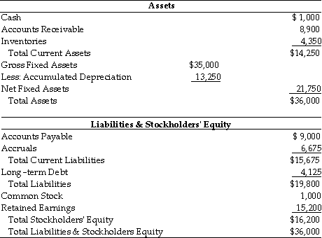
The inventory management at Dana Dairy Products ________ since 2009. (See Table 3.2)
Answer
has deteriorated
remained the same
has improved slightly
cannot be determined

Question 2

Table 3.2
Dana Dairy Products Key Ratios
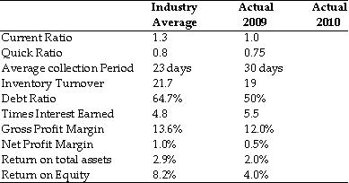
Income Statement
Dana Dairy Products
For the Year Ended December 31, 2010
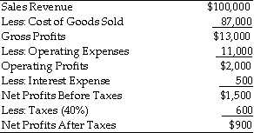
Balance Sheet
Dana Dairy Products
December 31, 2010
If Dana Dairy Products has credit terms which specify that accounts receivable should be paid in 25 days, the average collection period ________ since 2009. (See Table 3.2)
Answer
has deteriorated
remained the same
has improved
cannot be determined

Question 3

Table 3.2
Dana Dairy Products Key Ratios
Income Statement
Dana Dairy Products
For the Year Ended December 31, 2010
Balance Sheet
Dana Dairy Products
December 31, 2010
The return on equity for Dana Dairy Products for 2010 was ________. (See Table 3.2)
Answer
0.6 percent
5.6 percent
0.9 percent
50 percent

Q4
Table 3.2
Dana Dairy Products Key Ratios
Income Statement
Dana Dairy Products
For the Year Ended December 31, 2010
Balance Sheet
Dana Dairy Products
December 31, 2010

The current ratio for Dana Dairy Products in 2010 was ________. (See Table 3.2)
Answer
1.58
0.63
1.10
0.91

Q5
Table 3.2
Dana Dairy Products Key Ratios
Income Statement
Dana Dairy Products
For the Year Ended December 31, 2010
Balance Sheet
Dana Dairy Products
December 31, 2010

Since 2009, the liquidity of Dana Dairy Products ________. (See Table 3.2)
Answer
has deteriorated
remained the same
has improved
cannot be determined

Q6
Table 3.2
Dana Dairy Products Key Ratios
Income Statement
Dana Dairy Products
For the Year Ended December 31, 2010
Balance Sheet
Dana Dairy Products
December 31, 2010
Using the modified DuPont formula allows the analyst to break Dana Dairy Products return on equity into 3 components: the net profit margin, the total asset turnover, and a measure of leverage (the financial leverage multiplier). Which of the following mathematical expressions represents the modified DuPont formula relative to Dana Dairy Products' 2010 performance? (See Table 3.2)
Answer
5.6(ROE) = 2.5(ROA) x 2.24(Financial leverage multiplier)
5.6(ROE) = 3.3(ROA) x 1.70(Financial leverage multiplier)
4.0(ROE) = 2.0(ROA) x 2.00(Financial leverage multiplier)
2.5(ROE) = 5.6(ROA) x 0.44(Financial leverage multiplier)

Question 7
You are given the following information: Stockholders' equity = $1,250; price/earnings ratio = 5; shares outstanding = 25; and market/book ratio = 1.5. Calculate the market price of a share of the company's stock.
$ 33.33
b. $ 75.00
c. $ 10.00
d. $166.67
e. $133.32

Question 8

Calculate net operating profit after taxes (NOPAT) if a firm has sales of $1,000,000, operating profit (EBIT) of $100,000, interest expense of $50,000, and a tax rate of 30%.
Answer
$35,000
$700,000
$70,000
None of these

Question 9

A firm had year end 2004 and 2005 retained earnings balance of $670,000 and $560,000, respectively. The firm reported net profits after taxes of $100,000 in 2005. The firm paid dividends in 2005 of ________.
Answer
$10,000
$100,000
$110,000
$210,000

Question 10

Table 4.1
Ruff Sandpaper Co.
Balance Sheets
For the Years Ended 2009 and 2010
*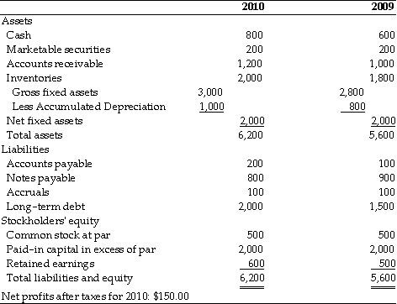
The firm ________ fixed assets worth ________. (See Table 4.1)
Answer
purchased; $0
purchased; $200
sold; $0
sold; $200

Question 11

In its recent income statement, a firm reported $25 million of net income, and in its year-end balance sheet, the firm reported $405 million of retained earnings. The previous year, its balance sheet showed $390 million of retained earnings. What were the total dividends paid to shareholders during the most recent year?
Answer
$ 3,500,000
$ 5,000,000
$ 6,750,000
$10,000,000
$11,250,000

Question 12

On its 2009 balance sheet, a firm had retained earnings equal to $510 million. On its 2010 balance sheet, retained earnings were also equal to $510 million. Which of the following statements is most correct?
Answer
The company must have had net income equal to zero in 2010.
The company did not pay dividends in 2010.
If the company's net income in 2010 was $200 million, dividends paid must have also equaled $200 million.
If the company lost money in 2010, they must have paid dividends.
None of the statements above is correct.

uestion 13

The average tax rate of a corporation with pretax income of $105,000 and a tax liability of $24,200 is
Answer
46 percent.
23 percent.
34 percent.
15 percent.

Question 14

Table 3.1
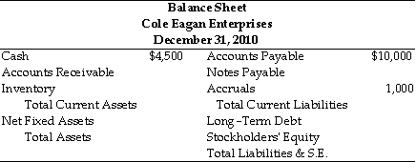
Information (2010 values)
1. Sales totaled $110,000
2. The gross profit margin was 25 percent.
3. Inventory turnover was 3.0.
4. There are 360 days in the year.
5. The average collection period was 65 days.
6. The current ratio was 2.40.
7. The total asset turnover was 1.13.
8. The debt ratio was 53.8 percent.
Inventory for CEE in 2010 was ________. (See Table 3.1)
Answer
$36,667
$32,448
$27,500
$ 9,167

Question 15

Table 3.1
Information (2010 values)
1. Sales totaled $110,000
2. The gross profit margin was 25 percent.
3. Inventory turnover was 3.0.
4. There are 360 days in the year.
5. The average collection period was 65 days.
6. The current ratio was 2.40.
7. The total asset turnover was 1.13.
8. The debt ratio was 53.8 percent.
Total assets for CEE in 2002 were:
A) $58 603
B) $45 895
C) $97 345
D) $124 300

Question 16

Table 3.1
Information (2010 values)
1. Sales totaled $110,000
2. The gross profit margin was 25 percent.
3. Inventory turnover was 3.0.
4. There are 360 days in the year.
5. The average collection period was 65 days.
6. The current ratio was 2.40.
7. The total asset turnover was 1.13.
8. The debt ratio was 53.8 percent.
Accounts receivable for CEE in 2010 was ________. (See Table 3.1)
Answer
$14,056
$19,861
$14,895
$18,333

Question 17

A firm had the following accounts and financial data for 2005:
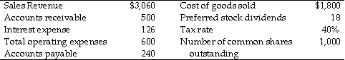
The firm's earnings per share, rounded to the nearest cent, for 2005 was ________.
Answer
$0.5335
$0.5125
$0.3204
$0.3024

Question 18

A firm had the following accounts and financial data for 2005.
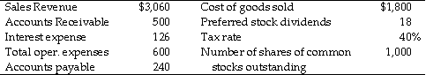
The firm's earnings available to common shareholders for 2005 were ________.
Answer
-$224.25
$195.40
$302.40
$516.60

Question 19

Calculate a firm's free cash flow if it has net operating profit after taxes of $60,000, depreciation expense of $10,000, net fixed asset investment requirement of $40,000, a net current asset requirement of $30,000 and a tax rate of 30%.
Answer
$0
$30,000
-$30,000
None of these

Question 20

If Nico Corporation has annual purchases of $300,000 and accounts payable of $30,000, then average purchases per day are ________ and the average payment period is ________.
Answer
36.5; 821.9
36.0; 833.3
821.9; 36.5
833.3; 36.0

