Marigold Company’s budgeted sales and direct materials purchases are as follows.
 |  | Budgeted  Sales |  | Budgeted D.M. Purchases
January |  | $220,000 |  | $33,000
February |  | 242,000 |  | 39,600
March |  | 275,000 |  | 41,800
Marigold’s sales are 30% cash and 70% credit. Credit sales are collected 10% in the month of sale, 50% in the month following sale, and 36% in the second month following sale; 4% are uncollectible. Marigold’s purchases are 50% cash and 50% on account. Purchases on account are paid 40% in the month of purchase, and 60% in the month following purchase.
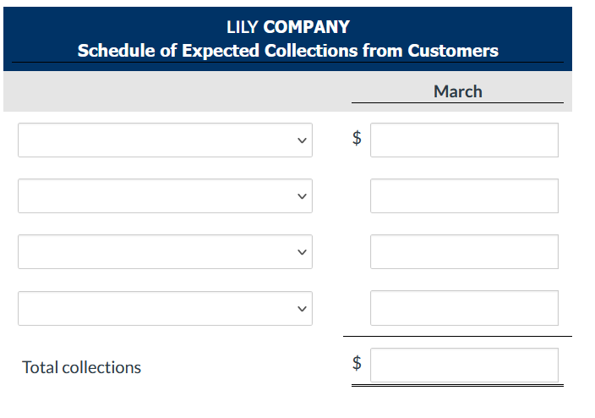
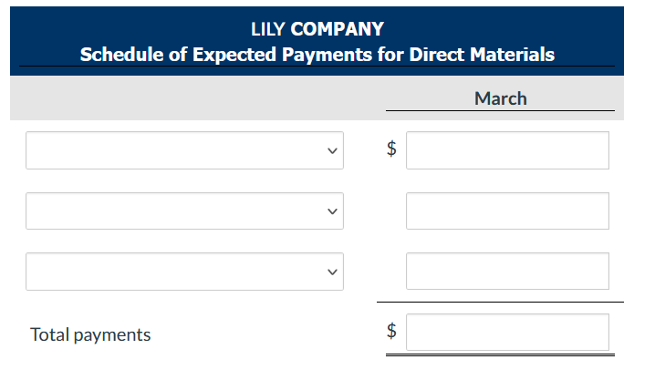
Waterway Company expects to have a cash balance of $57,600 on January 1, 2022. Relevant monthly budget data for the first 2 months of 2022 are as follows.
Collections from customers: January $108,800, February $192,000.
Payments for direct materials: January $64,000, February $96,000.
Direct labor: January $38,400, February $57,600. Wages are paid in the month they are incurred.
Manufacturing overhead: January $26,880, February $32,000. These costs include depreciation of $1,920 per month. All other overhead costs are paid as incurred.
Selling and administrative expenses: January $19,200, February $25,600. These costs are exclusive of depreciation. They are paid as incurred.
Sales of marketable securities in January are expected to realize $15,360 in cash. Waterway Company has a line of credit at a local bank that enables it to borrow up to $32,000. The company wants to maintain a minimum monthly cash balance of $25,600.
Prepare a cash budget for January and February.


