TOPIC 2 DQ2

Review Cases 2.29 and 2.30 in your textbook. Respond to the questions in 2.30, supported by data that you calculate for 2.29. Discuss how a company's policy can encourage or prevent employees from engaging in unethical behavior in order to meet quotas.
To participate in follow up discussion, ask questions and post comments regarding classmates' posts, or respond to follow-up questions posted by the instructor.
Please include proper citations in your discussion post. Points will be deducted if proper citations are not used.

2.29
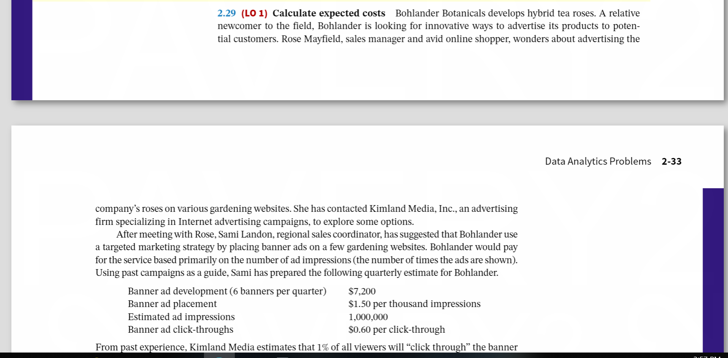

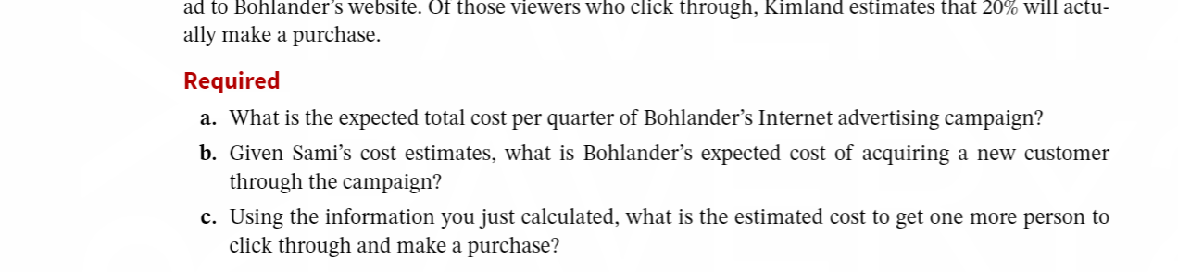

2.30


