Unit 6 Assignment – McGraw Hill
Compute the net pay for Karen Wilson and Katie Smith. Assume that they are paid a $2,560 salary biweekly, subject to federal income tax (use the wage-bracket method) in Appendix C and FICA taxes, and have no other deductions from their pay. They have a state tax rate of 3 percent. If they choose to participate in the cafeteria plan, the deduction for the pay period is $100; otherwise, there is no deduction for the cafeteria plan. The cafeteria plan qualifies under Section 125. You do not need to complete the number of hours. Additional information for Karen: Box 2 is not checked and the dependents are under 17. Additional information for Katie: Box 2 is checked. (Round your intermediate calculations and final answers to 2 decimal places.)
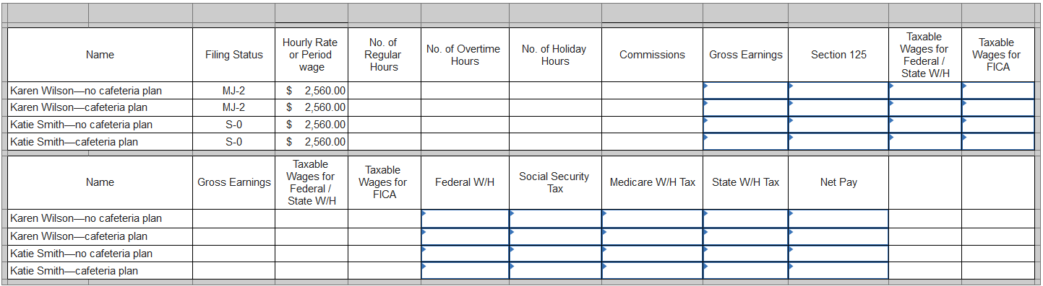
Tooka's Trees in Auburn, Tennessee, has six employees who are paid biweekly. Assume that all wages are subject to Social Security and Medicare taxes. All 401(k) and Section 125 amounts are pre-tax deductions. The wages are not subject to state taxes. You do not need to complete the number of hours.
Required:
Calculate the net pay from the information provided below for the November 15 pay date. Use the percentage method in Appendix C (or the IRS federal income tax assistant or IRS Publication 15-T) to compute federal income taxes. Assume that box 2 is not checked for all employees. (Round your intermediate calculations and final answers to 2 decimal places.)
a.
T. Taylor
Single, two dependents <17
Gross pay: $1,100 per period
401(k) deduction: $50 per pay period

b.
B. Walburn
Married/Joint, two dependents <17
Gross pay: $1,375 per period
401(k) deduction: $140 per period

c.
H. Carpenter
Single, no dependents
Gross pay: $1,300 per period
Section 125 deduction: $65 per period
401(k) deduction: $40 per period

d.
J. Knight
Married/Joint, one dependent <17
Gross pay: $1,915 per period
United Way deduction: $50 per period
Garnishment: $50 per period

e.
C. Lunn
Single, no dependents
Gross pay: $1,400 per period
Section 125 withholding: $50 per period
401(k) deduction: 5% of gross pay

f.
E. Smooter
Married/Joint, 3 dependents <17
Gross pay: $2,000 per period
401(k) deduction: $75 per period
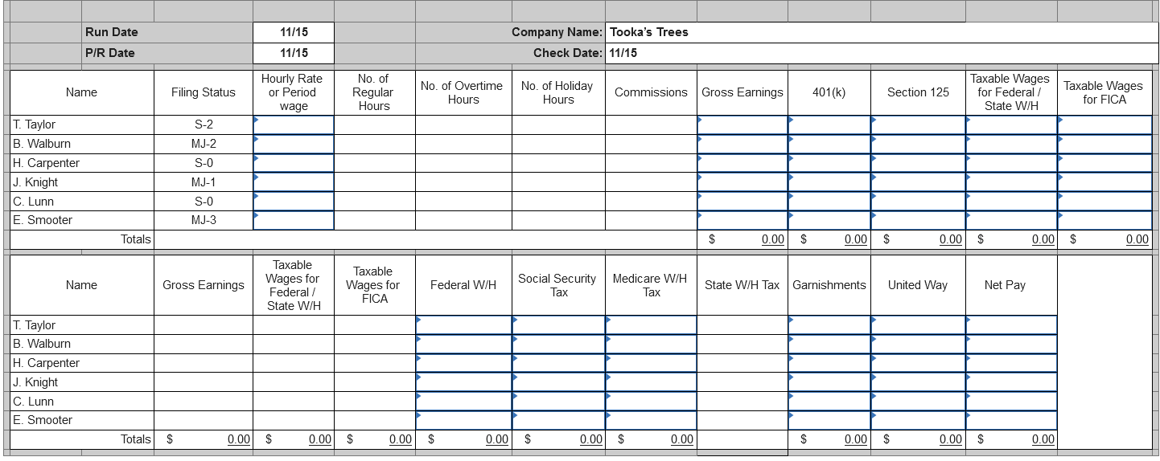
The following employees of CIBA Ironworks in Bristol, Illinois, are paid in different frequencies. Some employees have union dues or garnishments deducted from their pay.
Required:
Calculate their net pay using the percentage method in Appendix C (or the IRS federal income tax assistant or IRS Publication 15-T). Include Illinois income tax of 4.95 percent of taxable pay. No employee has exceeded the maximum FICA limits. You do not need to complete the number of hours. Assume that box 2 is not checked for all employees. (Round your intermediate calculations and final answers to 2 decimal places.)
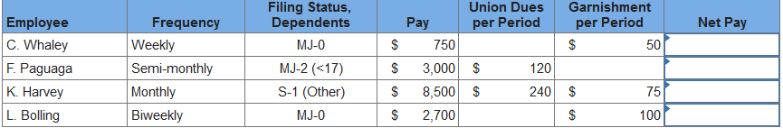
Required:
Compute the Federal income tax withholding for each employee using the percentage method in Appendix C (or the IRS federal income tax assistant). Assume that no pre-tax deductions exist for any employee, all W-4s are from 2020 and box 2 is checked for all employees. (Round your intermediate calculations and final answers to 2 decimal places.)



