Week 6 Assignment Template: Outline Final Draft
Title Page
General Topic: Interpersonal communication
Specific Topic: Public speaking
Thesis Statement: Improving self-concept through public speaking
Introduction
Interpersonal communication includes interacting with other people (McLean, 2018). Public speaking is a desirable interpersonal skill, and it is a process through which information is communicated to the audience. Therefore, an individual with public speaking skills is able to communicate to a large audience, such as in the workplace or in a school. Self-concept implies an overall idea of who individuals think they are (Lumen Learning, n.d). Since self-concept is formed by interacting with others and the reactions these people have on other individuals, it can be improved through public speaking.
Body
Skills To Improve Public Speaking
Main Point #1: There are important skills that can enhance public speaking.
- When addressing a large audience, individuals should speak with their words and body language. This can include maintaining eye contact, adopting the right posture, movement around the stage, and facial expressions (McNatt, 2019). As a result, body language will add up to the truth the speaker is communicating.
- Adaptability and flexibility are crucial in forming self-concept in challenging or unfamiliar situations. A public speaker who is adaptable has the ability or willingness to change to fit in a different situation, and flexibility implies the ease of doing that.
Attaining Public Speaking Goals
Main Point #2: Public speaking is a learnable skill, and organization is essential to become a better speaker and develop a good self-concept.
- Appropriate planning and practice are needed to structure communication effectively (Connolly, 2018). Becoming a compelling and confident speaker who intrigues the audience requires practice, and as a result, early preparation will allow sufficient time for practice.
- A public speaker needs to assess the audience, understand their demographics, and gather materials that are easy for them to understand depending on the presentation topic (Connolly, 2018).
Relating With the Audience
Main Point #3: A speaker needs to become familiar with his/her audience to ensure that the tone and interaction are appropriate.
- When speaking to the audience, engaging them is very important to help them feel involved in the message and make the speaker feel less isolated (Raja, 2017). Thus, a public speaker can involve the audience by asking them leading questions or encouraging them to ask questions and participate.
- The authenticity of the speaker shows the audience that the outer expression and the inner reality match (McLean, 2018). This aspect promotes the self-confidence of the speaker and reputation from the audience, who develops confidence in the truths being expressed.
Conclusion
Public speaking is an essential skill that can help develop self-concept from the perspective of self and reaction from the audience. Skills that are needed include proper utilization of body language, adaptability, and flexibility. A successful public speaking experience can be realized through sufficient planning and practice. Also, the presentation should match the needs of the audience to whom the message is intended.
Visuals
Visual #1: Interpersonal communication

Source: (Jouany & Martic, 2020)
The image shows interpersonal communication in the workplace where colleagues exchange information. It creates motivation, satisfaction and helps develop self-concept.
Visual #2: Self-Concept
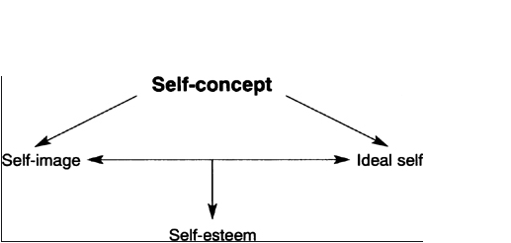
Source: (Lawrence, 2020)
Self-concept is how individuals perceive themselves, and self-image, self-worth, self-esteem, and ideal self can be realized through public speaking.
Visual #3: Body Language
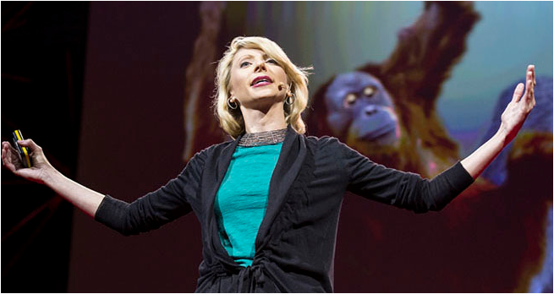
Source: TED (Cuddy, 2012)
Video Link: https://www.ted.com/talks/amy_cuddy_your_body_language_may_shape_who_you_are
(Explanation) This is an image of a public speaker at a Ted Talk using body language-power pose- to increase confidence. The speaker appears more powerful, and the audience feels included.
Visual #4: Effects of Proper Preparation And Planning
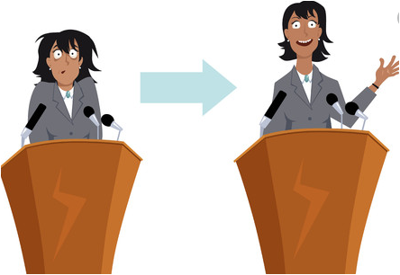
Source: (123rf.com, n.d)
This shows that proper preparation/planning and practice in public speaking can improve a speaker's confidence and interaction with the audience.
Visual #5: Audience Engagement

Source: (Steen, 2015)
This image shows a speaker engaging the audience. It makes public speaking more interesting raises the self-esteem and self-image of the speaker.

References
123rf.com. (n.d). Public Speaking Stock Photos And Images. Retrieved from 123RF: https://www.123rf.com/stock-photo/public_speaking.html?sti=nx9uvn5ok5qv5mkfy7|
Connolly, A. (2018). Public speaking skills for dummies. John Wiley & Sons.
Cuddy, A. (Director). (2012). Your Body Language May Shape Who You Are [Motion Picture].
Jouany, V., & Martic, K. (2020, 07 02). Interpersonal Communication: Definition, Importance, and Must-Have Skills. Retrieved from Smarp: https://blog.smarp.com/interpersonal-communication-definition-importance-and-must-have-skills
Lawrence, D. (2020). Building Self-Esteem with Adult Learners. The Self-Concept. http://dx.doi.org/10.4135/9781446217511.n1
Lumen Learning. (n.d). SPCH 1311: Introduction to Speech Communication. Retrieved from Lumen: https://courses.lumenlearning.com/atdcoursereview-speechcomm-1/chapter/self-concept/
McLean, S. (2018). Exploring Interpersonal Communication. Flat World Knowledge. ISBN: 978-1-4533-9042-9.
McNatt, D. B. (2019). Enhancing public speaking confidence, skills, and performance: An experiment of service-learning. The International Journal of Management Education, 17(2), 276-285. https://doi.org/10.1016/j.ijme.2019.04.002
Raja, F. (2017). Anxiety Level in Students of Public Speaking: Causes and Remedies. Journal of education and educational development, 4(1), 94-110. http://dx.doi.org/10.22555/joeed.v4i1.1001
Steen, K. (2015, 01 07). Use the 10-20-30 rule to become an engaging presenter. Retrieved from LinkedIn: https://www.linkedin.com/pulse/use-10-20-30-rule-become-engaging-presenter-kristian-steen-holme?trk=portfolio_article-card_title

