Nursing Informatics: Introduction to Concepts and Health Information Technologies
Terminologies and Standards

Sensmeier begins Chapter 7 with the profound statement, “standards are the foundation to the development, implementation, and exchange of electronic health records” (2015, p. 101). The chapter author continues that “the effectiveness of healthcare delivery is dependent on the ability of clinicians to securely access health information when and where it is needed” (2015, p. 101). Sensmeier notes that data standards reduce ambiguity in communication. | 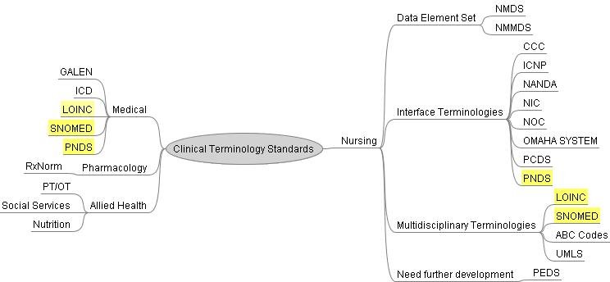
Hammonds (2005) identified that standards are created by including
- A group of interested parties comes together and agrees upon a standard
- The government sanctions a process for standards to be developed
- Marketplace completion and technology adoption introduce a de facto standard
- A formal consensus is used by a standards development organization (SDO)

Institute of Electrical and Electronics Engineers (IEEE) provides more information regarding the standards development process. The IEEE provides this informative flowchart (Figure 1) of the process.

Figure 1
The IEEE depiction of the standards development process presented as flowchart (IEEE, 2018)

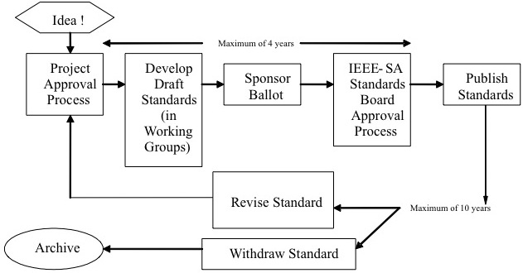
Note. Standard development process.
This flowchart illustrates the length of time to develop a standard. The process is lengthy. IEEE notes a standard will undergo multiple iterations. IEEE notes (2018) “It is important to remember that standards are “living documents", which may initially be published and iteratively modified, corrected, adjusted and/or updated based on market conditions and other factors” (2018, para. 8).

Sensmeier identifies the following standards
- Transport Standards
  - Accredited Standards Committee X12N/Insurance
  - Institute of Electrical and Electronic Engineers
  - National Electrical Manufacturers Association
  - World Wide Web Consortium
  - Communication Protocols
- Vocabulary Standards
  - Current Procedural Terminology
  - International Statistical Classification of Diseases and Related Health Problems: Ninth Revision and Clinical Modification
    - International Statistical Classification of Diseases and Related Health Problems: Tenth Revision
  - Nursing and other Domain Specific Terminologies
  - RxNorm
  - Unified Medical Language System
- Content Standards
  - American Society for Testing and Materials
  - Clinical Data Interchange Standards Consortium
  - Health Level Seven (HL7)
  - International Health Terminology Standards Development Organization
  - Logical Observational Identifiers Names and Codes (LOINC)
  - National Council for Prescription Drug Programs
  - National Uniform Claim Committee Recommended Data Set for a Noninstitutional Claim
- Security Standards
  - HIPAA Security Standards for the Protection of Electronic Health Information at 45 CFR Part 160 and Part 164, Subparts A and C
  - ISO IEC 27002:2005 Standard
- Implementation Guides

Sensmeier presents a succinct overview regarding standardization and harmonization. The chapter author states (2015, p. 107) “It has become clear to both public and private sector standards development efforts that no one entity has the resources to create an exhaustive set of health data standards that will meet all needs. New emphasis is being placed on leveraging and harmonizing existing standards to eliminate the redundant and siloed efforts that have contributed to a complex, difficult to navigate health data standards environment. Advances are being made to in the areas of standard harmonization through the coming together of industry groups to accelerate and streamline the standards development and adoption process.” A brief overview of the major national and international organizations is provided for the following:
- American National Standards Institute
- European Technical Committee for Standardization
- Health IT Standards Committee
- Integrating the Healthcare Enterprise (IHE)
- International Organization for Standardization
- Object Management Group
- Public Health Data Standards Consortium
Importantly, a synopsis is provided for the ONC Standards and Interoperability (S&I) Framework. The S&I Framework was launched in 2011. Each S&I Initiative typically includes the following:
- Development of clinically oriented user stories and robust user cases
- Harmonization of interoperability specifications and implementation guidance
- Provision of real-world experience and implementer support through new initiatives, workgroups, and pilot projects
- Mechanisms for feedback and testing of implementation often in conjunction with ONC partners such as NIST
Interestingly, Sensmeier discusses the business value of health care data standards. The author recognizes that “other state holders for health IT include software vendors or suppliers, software implementers, and users. “Defining clear business measures will help motivate the advancement and adoption of interoperable health IT systems, thus ensuring the desired outcomes can be achieved (Sensmeier, 2015, p. 112). Notably, “The importance of data standards to enhancing the quality and efficiency of healthcare delivery and improving health outcomes is being recognized by national and international leadership” (Sensmeier, 2015, p. 111). Sensmeier continues “A standardized nursing language is necessary so that nursing knowledge can be represented and communicated consistently among nurses and other healthcare providers” (2015, p. 2011).

Hardiker, Saba, and Kim continue the discussion of standards in Chapter 8. The chapter authors bring attention to standardized nursing terminologies. Hardiker, Saba, and Kim cite numerous authors in the following quotation “To become visible nursing needs to electronically document nursing practice using a standardized nursing terminology with coded concepts in order to measure the effectiveness of their care delivery and thus generate the evidence (2015, p.. 115). It is further explained that standardized nursing terminologies are needed to
- Provide valid clinical care data
- Allow data sharing across HIT and EHR systems
- Support evidence-based decision making
- Facilitate evaluation of nursing processes
- Permit the measurement of outcomes

Nursing has thirteen (13) recognized terminologies. The terminologies include:
- Nursing Minimum Data Set
- Nursing Management Minimum Data Set
- Clinical Care Classification (CCC) System
- International Classification of Nursing Practice
- NANDA
- Nursing Intervention Classification
- Nursing Outcome Classification
- Omaha System
- Perioperative Nursing Data Set
- ABC Codes
- Logical Observation Identifiers Names and Codes
- Systematic Nomenclature of Medicine-Clinical Terms

The chapter authors importantly describe ISO 18104:2003, Integration of a Reference Terminology Model for Nursing. The terminology model covers both Nursing Diagnoses and Nursing Actions. Development of the reference model was attributed to harmonization with other standards and to be consistent with the goals and objectives of other health terminology models. The authors note the standard is not to be of direct benefit to the practicing nurse but to those who develop coding systems.

The chapter concludes with the important statement, “Interoperability is a prerequisite to meeting the information demands of today’s complex healthcare, management, and nursing environment (Hardiker, Saba, Kim, 2015, p. 125).

Learning Objectives
- Discuss the need for health data standards
- Describe the standards development process and related organizations
- Delineate the importance of health information exchange and interoperability
- Describe the current health data standards initiatives
- Explore the business value of health data standards
- Define “standardized nursing terminology”
- Describe the impact of terminologies on nursing
- Describe the features of advanced nursing terminology systems

Activities
Read and review
Sensmeier, J. (2015). Chapter 7 Health data standards: Development, harmonization, and interoperability. In V. Saba & K. McCormick (Eds.), The essentials of nursing informatics (6th ed., pp. 101-113). McGraw-Hill.
Hardiker, N. R., Saba, V. K., & Kim, T. Y. (2015). Chapter 8 Standardized nursing terminologies. In V. Saba & K. McCormick (Eds.), The essentials of nursing informatics (6th ed., pp. 115-129). McGraw-Hill.
MBL Technologies, Clinovation. (2017). Standard nursing terminologies: A landscape analysis. The Office of the National Coordinator for Health Information Technology. https://www.healthit.gov/sites/default/files/snt_final_05302017.pdf

ASSIGNMENT

As an individual, explore the Clinical Care Classification (CCC) System available at (www.clinicalcareclassification.com or www.sabacare.com). Review the website Home, About, Framework, and Tools.
- From Tools dropdown menu select Code Builder.

Step 1. Assessment: Select a Component
From the list select O Self Care

Step 2. Select a Major Diagnosis
From the list select Code 38.0 Self Care Deficit Impaired ability to maintain oneself

Step 3. Select a Sub-Diagnosis
From the list select Code 38.1 Activities of Daily Living (ADLs) Alteration Change in modification of ability to maintain oneself

Step 4. Select an Expected Outcome
Select Code 1 Improve Condition will change over time

Step 5. Select an Intervention
Select Code 43 Personal Care Actions performed to care for oneself

Step 6. Select a Sub-Intervention
Select Code 43.1 which refers to the sub-intervention code: Activities of Daily Living (ADLs) and may be described as: Personal activities to maintain oneself

Step 7. Select Action
Select Code 3 Teach/Educate/Instruct/Supervise Action educating patient or caregiver

Step 8. Select Possible Actual Outcome
Select Code 1 Improved Condition changed and/or recovered

Step 9. Take a screen print of the completed plan

Be sure to submit the screen print
Label the screen print as a figure following APA

Write a 150-200 summary of what did you learn about using a standardized terminology to create a plan of care. Be sure to reference the CCC.

Write a 150-200 word summary of what nursing or other terminologies are used in your organization? How are the terminologies used?

- Submit
  - Use a cover page and headings following APA to structure the submission.
  - Develop a plan of care for Self Care using CCC.
  - Label the screen print as a figure following APA style.
- Write a 150-200 summary of what did you learn about using a standardized terminology to create a plan of care. Be sure to reference the CCC and the website.
- Write a 150-200 word summary of what nursing or other terminologies are used in your organization? How are the terminologies used? If no terminologies are used what would you recommend? Use references.
- Submit as one Word document.

Grading Rubric
Activity | Points Possible | Points Earned | Comments
Develop a plan of care for Self-Care using CCC | 35
Write a 150-200 summary of what did you learn about using a standardized terminology to create a plan of care. Be sure to reference the CCC and the website. Label the screen print as a figure following APA style. | 25
Write a 150-200 word summary of what nursing or other terminologies are used in your organization? How are the terminologies used? If no terminologies are used what would you recommend? Use references. | 25
APA in the text references | 1
APA Reference List | 1
Headings, Readability, Grammar, Spelling | 13
- Submit  - Use a cover page and headings following APA to structure the submission.  - Develop a plan of care for Self-Care using CCC.  - Label the screen print as a figure following APA style.  - A 150-200 summary of what did you learn about using a standardized terminology to create a plan of care. Be sure to reference the CCC and the website.  - Write a 150-200 word summary of what nursing or other terminologies are used in your organization? How are the terminologies used? If no terminologies are used what would you recommend. Use references.  - Submit as one Word document. | 0
Total | 100

