Nursing Informatics:

Chapters 22 and 35, novel and promising areas in health informatics, are introduced. In Chapter 22, Barton provides an introduction and overview of eHealth. The author notes that eHealth is an emerging field within informatics (2015, p. 334). eHealth is broadly defined as “the use of information and communication technologies (ICT) for health” (World Health Organization (WHO), 2018,  p. 1).  eHealth technologies can provide opportunities for customized and meaningful communications which is customized to the patient (Barton, 2015, p 334). Furthermore, | 
eHealth can empower consumers and patients.

Of particular interest, Barton (2015) identifies a number of eHealth applications including
- The Internet
- Personal health record
- Wearable and portable monitoring systems
- Virtual worlds
- Health portals
- Web 2.0: Social media (Facebook, Twitter, and YouTube)
- mHealth
Notably, Barton succinctly identifies and describes various challenges and issues. These include
- Licensure
- Ethical issues (Privacy and Confidentiality)
- Data security
- System security
Markedly, Barton postulates emerging issues and challenges. Baron has identified the following
- Regulation of mHealth applications
- Public policy
As part of the Health IT Strategic Plan, the ONC (2015) addresses various aspects of mHealth. Specifically, the ONC (2015) proposes to “Increase the use of telehealth, virtual medicine, and innovative technologies (e.g., sensors, mobile technology, medical devices, assistive technologies, eVisits) in federal care delivery systems and programs (p. 34).

In summarizing the chapter, Barton states, “healthcare professionals need to seize the opportunities made possible by advanced technologies and create powerful and human-centered applications to facilitate consumers’ full participation in health and wellness” (2015, p. 340).

Similarly, Frink (2015) continues the discussion of eHealth and patient engagement and the influence of health informatics.
As shown in the graphic, patient engagement is multifactorial and without an agreed-upon definition. Coulter’s definition of patient engagement is often cited. Coulter explains that patient engagement should “promote and support active patient and public involvement in health and healthcare and to strengthen their influence on healthcare decisions, at both the individual and collective levels” (2011, p. 10). | 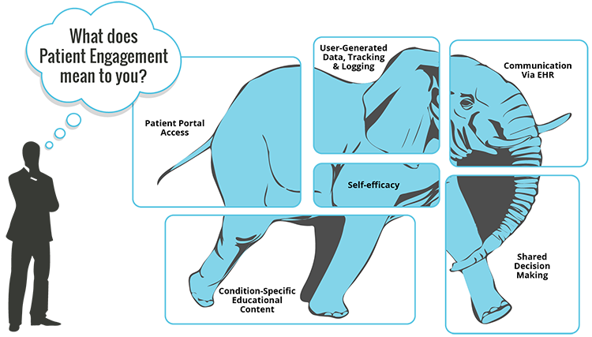
The HIMSS website provides a number of resources regarding patient engagement.
Frink differentiates between empowerment and patient engagement. Frink exemplifies the difference using Brennan and Safran’s definition of patient engagement. Brennan and Safran stated, “granting power to a dependent group or enhancing an individual’s ability for self-determination (2005, p. 8).

Frink brings attention to Patient Engagement Core Measure Requirements for Eligible Providers (EPs) in Meaningful Use Stage 2, as explained by CMS (2013). Patient engagement Stage 2 objectives include:
- “Providing patients the ability to view online, download and transmit their health information
- Using secure electronic messaging to communicate with patients on relevant health information.”

It is further explained by CMS that in order to meet Stage 2 of Meaningful Use, Eligible Hospitals must
- “Provide the patients the ability to view online, download and transmit information about a hospital admission
- Use clinically relevant information from a Certified EHR Technology to identify patient-specific education resources and provide those resources to the patient.”
Impetus continues for patient engagement through Meaningful Use Stage 3 and Medicare Access and CHIP Reauthorization Act (MACRA). More information can be obtained from CMS and various publications various publications

Frink concludes the chapter by stating, “there is much to be done in clarifying the interactions between consumer/patient engagement, the use of eHealth resources, and outcomes of care. There is ample opportunity to
- Participate in consumer provider groups to establish criteria for effective e-communication
- Explore the possibilities of providing more effective interactive education content for patient portals
- Partner with consumers in developing governance structures for managing patient and consumer access to institutional eHealth resources
- Establish methods for measuring and evaluating consumer, patient and family, and providers’ satisfaction with the developing process” (Frink, 2015, p. 507).
Learning Objectives
- Define concepts of e-Health, telehealth, and m-Health
- Explore applications of e-Health for healthcare, education, and research
- Examine evidence on the impact of e-Health in health promotion and health
- Analyze the transformational nature of e-health with the healthcare industry
- Discuss a telemedicine case study
- Describe the concept of patient engagement from the patient, health system, and provider perspective
- Discuss several influences of health policy, specifically the HITECH Act and the American Recovery and Reinvestment Act of 2011, on the development of patient engagement strategies within an EHR framework
- Describe three characteristics of a learning healthcare organization, and the potential role of patient engagement
- List the primary components and functions of patient portals, and how they differ from other eHealth resources
Activities
Read and review
Barton, A. J. (2015). Chapter 22 Informatics and the healthcare industry. In V. Saba & K. McCormick (Eds.), The essentials of nursing informatics (6th ed., pp. 333-343). McGraw-Hill.
Frink, B. B. (2015). Chapter 35 Consumer/patient engagement and eHealth resources. In V. Saba & K. McCormick (Eds.), The essentials of nursing informatics (6th ed., pp. 499-509). McGraw-Hill.
Office of the National Coordinator (ONC). (2017). Patient engagement playbook. https://www.healthit.gov/playbook/pe/guide/
Brennan, P. F., & Safran, C. (2005). Empower-consumers. In D. Lewis, W. V. Slack, G. Eysenbach, R. Kukafka, P. Z. Starvi, & H. Jimison (Eds.), Consumer health informatics: Informing consumers and improving health care (pp. 8-21). Spring Science + Business Media. http://eknygos.lsmuni.lt/springer/98/8-21.pdf
Individual Activity
Interview a consumer (DO NOT interview a health care professional) regarding their perception of patient engagement through the use of a patient portal. You must select someone that uses a patient portal. It is not acceptable to interview someone that does not use a patient portal.

- Use the interview questions provided in the template. The template is provided must be submitted. You must select someone that uses a patient portal. It is not acceptable to use someone that does not use a patient portal. You may need to ask several people to identify someone that uses a portal. You are encouraged to ask clarifying questions to learn more about the patient’s use of the portal. Comments must be completed.
- Use the template provided in Canvas
- References are required both in the text and reference list
- Use headings to organize the content.
- Label figures following APA style

Grading Rubric
Activity | Points Possible | Points Earned | Comments
Interviewed a consumer (DO NOT interview a health care professional) regarding their perception of patient engagement through the use of a patient portal.  You must select someone that uses a patient portal. It is not acceptable to use someone that does not use a patient portal. You make need to ask several people to identify someone that uses a portal. Comments must be completed. | 45
Introduction and purpose | 15
Conclusion | 15
Used the template provided. Comments must be completed. | 13
In the text references follows APA 7 style | 1
Reference list follows APA 7 style | 1
Follows APA 7 style including headings and figures. | 10
Total | 100

Suggested Readings
Atienza, A. A., & Patrick. K. (2011). Mobile health the killer app for cyberinfrastructure and consumer health. American Journal of Preventative Health, 40(5), suppl. S151 – S153. https://doi.org/10.1016/j.amepre.2011.01.008
Carman, K. L., Dardess, P., Maurer, M., Sofaer, S., Adams, K., Bechtel, C,, et al. (2013). Patient and family engagement: a framework for understanding the elements and developing interventions and policies. Health Aff, 32(2), 223-31. https://www.healthaffairs.org/doi/abs/10.1377/hlthaff.2012.1133?url_ver=Z39.88-2003&rfr_id=ori%3Arid%3Acrossref.org&rfr_dat=cr_pub%3Dpubmed
ONC. (2015). Health IT strategic plan: 2015-2020. https://www.healthit.gov/sites/default/files/9-5-federalhealthitstratplanfinal_0.pdf
ONC. (2012). Patient generated health data. https://www.healthit.gov/sites/default/files/rti_pghd_whitepaper_april_2012.pdf

ONC. (2014). Your mobile device and health information privacy and security. https://www.healthit.gov/providers-professionals/your-mobile-device-and-health-information-privacy-and-security

Owen, J. E., Jaworski, B. K., Kuhn, E., Makin-Byrd, K. N., Ramsey, K. M., & Hoffman, J. E. (2015). mHealth in the wild: Using novel data to examine the reach, use, and impact of PTSD Coach. JMIR Mental Health, 2(1), e7. http://doi.org/10.2196/mental.3935
World Health Organization (WHO). (2016). Patient engagement: Technical series on safer primary care. http://apps.who.int/iris/bitstream/10665/252269/1/9789241511629-eng.pdf

References

CMS. (2013). Stage 2: Engaging patients in their health care. https://www.cms.gov/eHealth/ListServ_Stage2_EngagingPatients.html
Coulter A. (2011). Engaging patients in healthcare (p. 10). New York, NY: McGraw-Hill Education.
Brennan, P. F., & Safran, C. 2005. Empower-consumers. In D. Lewis, W. V. Slack, G. Eysenbach, R. Kukafka, P. Z. Starvi, & H. Jimison (Eds.), Consumer health informatics: Informing consumers and improving health care (pp. 8-21). New York, NY: Spring Science + Business Media. Retrieved from http://eknygos.lsmuni.lt/springer/98/8-21.pdf
WHO. (2018). eHealth. Retrieved from http://www.who.int/ehealth/en/

